Student Work Annotations

Based upon the Science ERQ Rubric

Planning for a
Playground

Grade Level:
3

Designed and revised by Kentucky Department of Education staff
in collaboration with teachers from Kentucky schools and districts.

This work is licensed under a Creative Commons Attribution-NonCommercial-NoDerivatives 4.0 International License.

Background Information About the Task

Task Overview

Students will analyze and interpret data about the advantages and disadvantages of different types of grass and describe how artificial grass may affect the plants and animals in an environment in order to construct a design solution about which grass provides the best solution.

Dimensions

Disciplinary Core Idea (DCI)
- LS4.D Biodiversity and Humans
  - Populations live in a variety of habitats, and change in those habitats affects the organisms living there.

Science and Engineering Practice (SEP)
- Constructing Explanations and Designing Solutions
  - Generate and compare multiple solutions to a problem based on how well they meet the criteria and constraints of the design solution
- Analyzing and Interpreting Data
  - Compare and contrast data collected by different groups in order to discuss similarities and differences in their findings

Crosscutting Concepts (CCC)
- Cause and Effect
  - Cause and effect relationships are routinely identified, tested, and used to explain change

Performance Expectations (PE) to which task is correlated
- 3-5 ETS1-2
  - Generate and compare multiple possible solutions to a problem based on how well each is likely to meet the criteria and constraints of the problem.
- 3-LS4-4
  - Make a claim about the merit of a solution to a problem caused when the environment changes and the types of plants and animals that live there may change.

Planning a Playground Task

The original version of this Life Science & Engineering 3rd grade task may be found at: https://snapgse.stanford.edu/snap-assessments/short-performance-assessments

Planning for a Playground
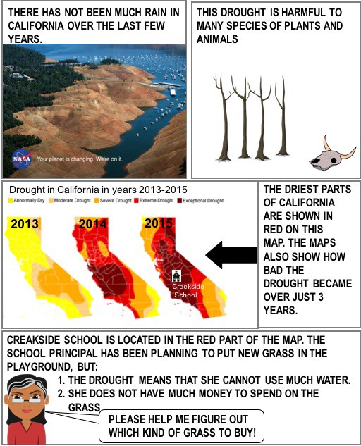

THE PRINCIPAL IS TRYING TO CHOOSE BETWEEN FOUR DIFFERENT TYPES OF GRASS TO USE ON THE PLAYGROUND. SHE STUDIES DATA TO HELP HER DECIDE WHICH ONE IS BEST FOR THE PLAYGROUND.

1. DATA THAT COMPARES HOW MUCH WATER EACH GRASS NEEDS:

2. DATA THAT COMPARES HOW MUCH EACH GRASS COSTS

Question 1. SHE USES THE DATA TO DESCRIBE THE REASONS EACH GRASS COULD BE A GOOD CHOICE (ADVANTAGES) AND THE REASONS IT COULD BE A BAD CHOICE (DISADVANTAGES). USE THE DATA TO HELP HER COMPLETE THE TABLE.

Grass | Advantages | Disadvantages
AUGUSTINE
BERMUDA | None | Needs a lot of water AND
 |  | costs a lot of money
CENTIPEDE
ARTIFICIAL

Question 2:

ARTIFICIAL GRASS IS NOT REALLY GRASS. IT IS NOT A PLANT AT ALL—IT’S MADE OF PLASTIC!

WHAT COULD HAPPEN TO OTHER LIVING THINGS IF THE SCHOOL TAKES REAL GRASS (PLANTS) OUT OF THE PLAYGROUND AND PUTS IN ARTIFICIAL GRASS (PLASTIC)?

DESCRIBE ONE WAY THAT CHANGING FROM REAL GRASS TO ARTIFICIAL GRASS COULD AFFECT OTHER PLANTS OR ANIMALS IN THE PLAYGROUND. EXPLAIN YOUR ANSWER.

Question 3
THE PRINCIPAL SAYS THAT IT IS IMPORTANT THAT THE PLANTS AND ANIMALS AROUND THE SCHOOL ARE NOT AFFECTED BY HAVING A NEW TYPE OF GRASS IN THE PLAYGROUND.

WHICH GRASS DO YOU THINK WOULD BE THE BEST FOR THE PRINCIPAL TO BUY? USE ALL OF HER CONSTRAINTS (BELOW) TO MAKE YOUR DECISION.
The principal’s constraints:
- The drought means she cannot use a lot of water.
- She does not have a lot of money to spend on the grass.
- She does not want other plants and animals to be harmed by the new grass.

Circle one:
AUGUSTINE
BERMUDA
CENTIPEDE
ARTIFICIAL

WHY IS YOUR CHOICE THE BEST GRASS TO BUY? DESCRIBE HOW THE GRASS YOU CHOSE MEETS EACH OF THE PRINCIPAL’S CONSTRAINTS LISTED ABOVE:

Annotated Task

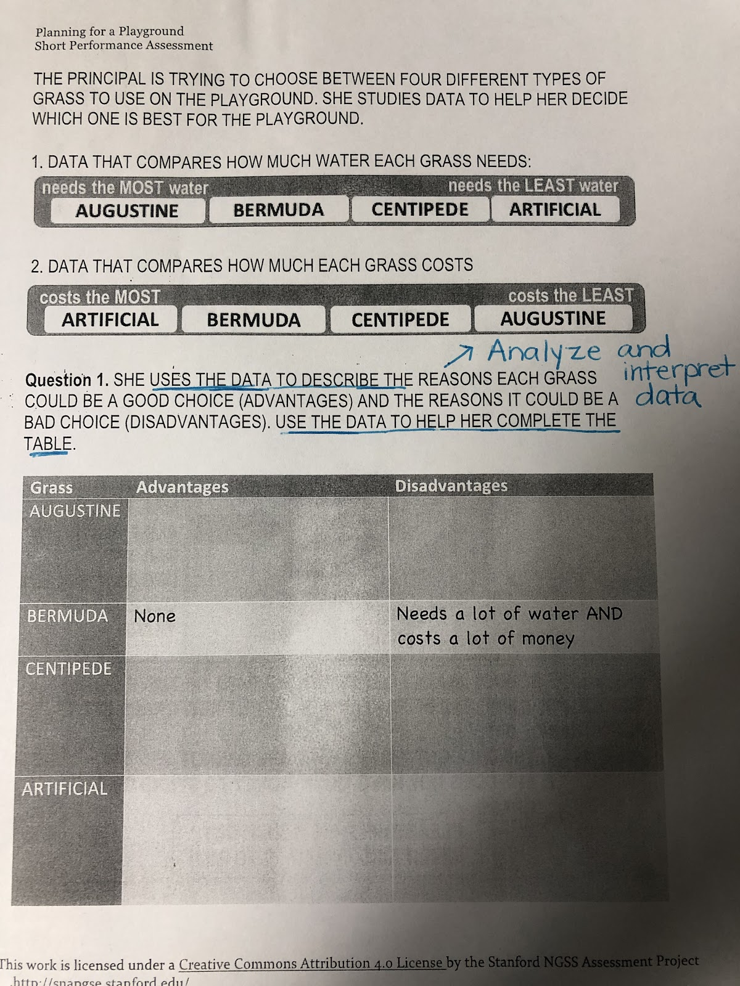

Question one: Students will analyze and interpret data about four different types of grass. They will complete a data table in order to show similarities and differences (advantages and disadvantages) of each type of grass.
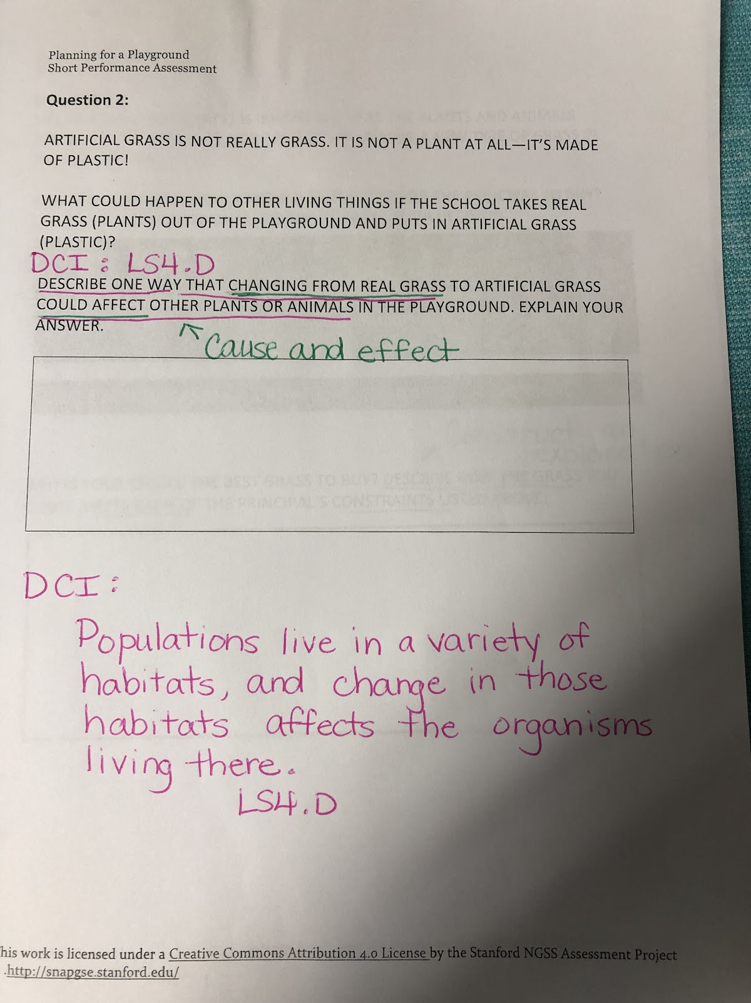

Question two: Students are asked to describe how artificial grass would affect the plants and animals on the playground. They must show how one change in the environment affects the other organisms that live there.

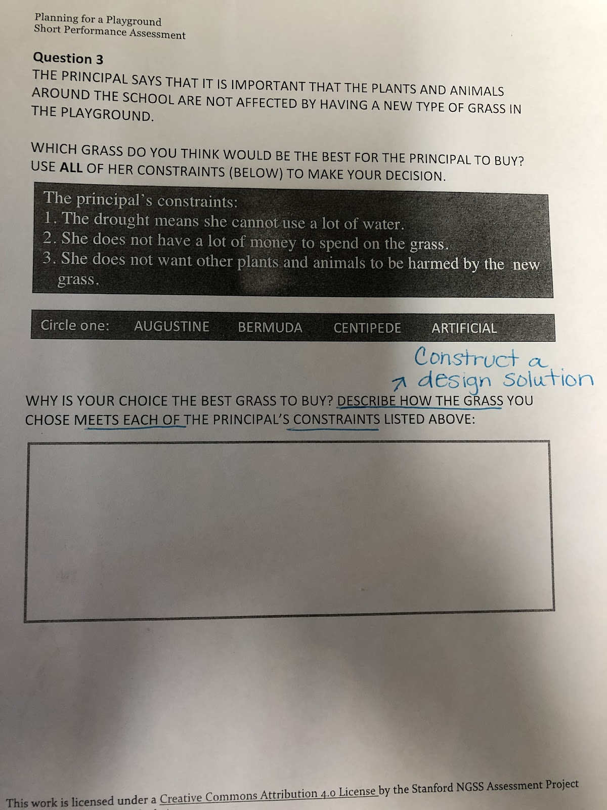

Question three: The students compare multiple solutions (types of grass) to generate a design solution based on the principal’s criteria and constraints about which type of grass is best. The student must include evidence to support the claim.

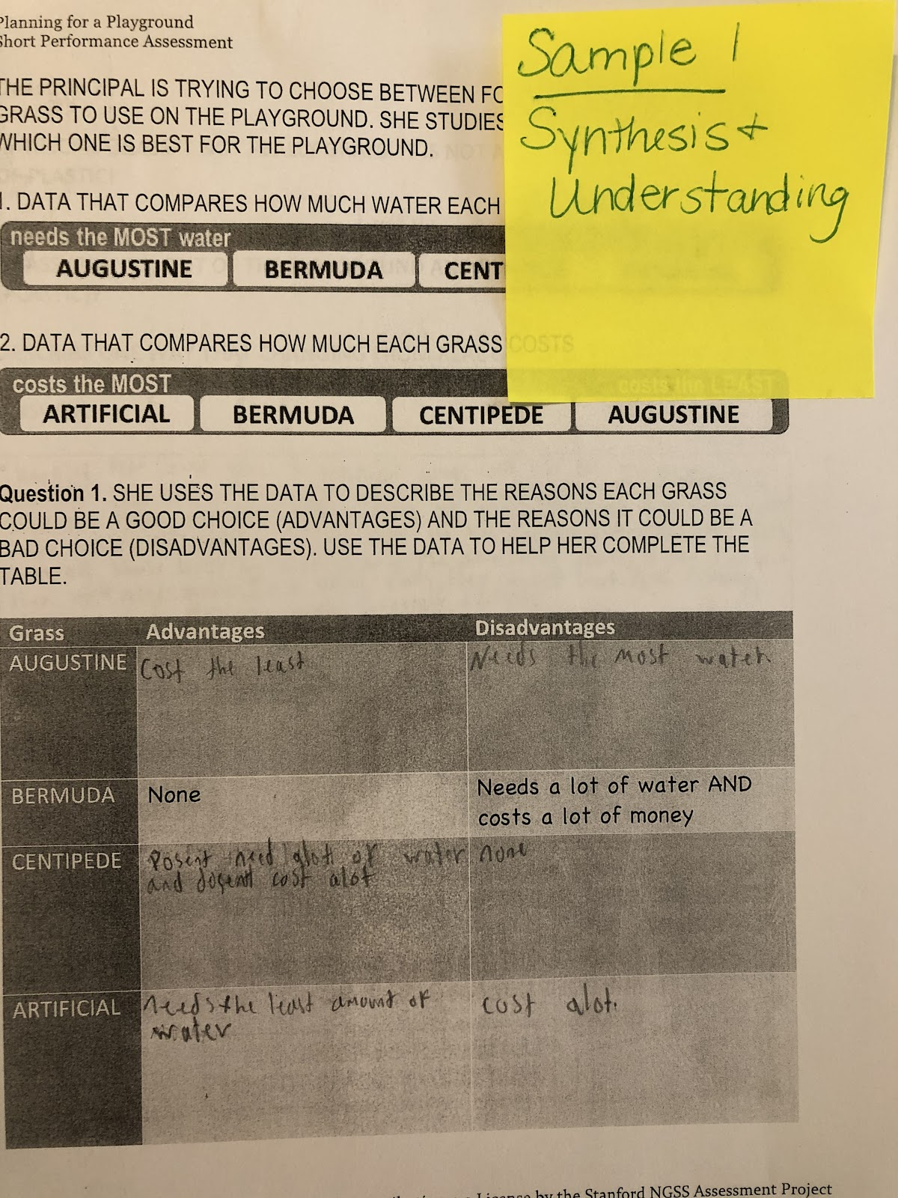

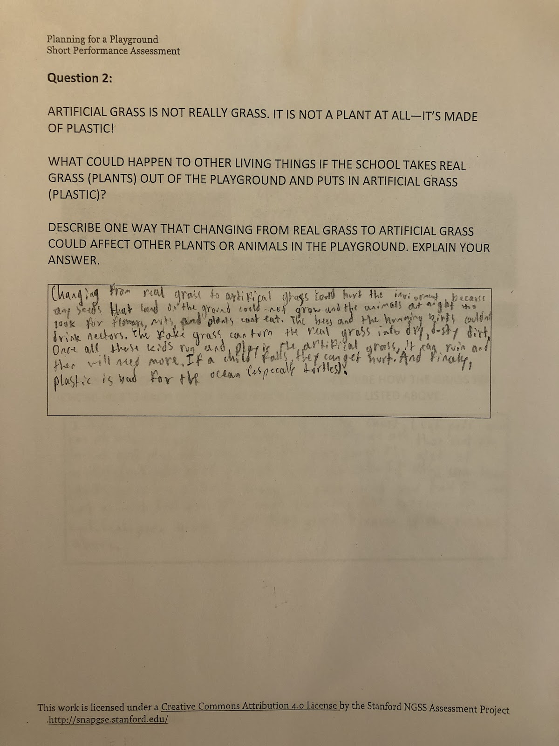
In this response, the student demonstrates a general understanding that a change to the ecosystem would affect both the plants and animals living there. The response demonstrates a general synthesis and understanding of complex ideas. There is a general understanding of the DCI and the CCC (cause and effect).
- “Any seeds that land on the ground could not grow”
- “The animals who look for flowers, nuts, and plants could not eat”
- “The bees and the hummingbirds could not drink nectars.”
- “Plastic is bad for the ocean, especially turtles.”

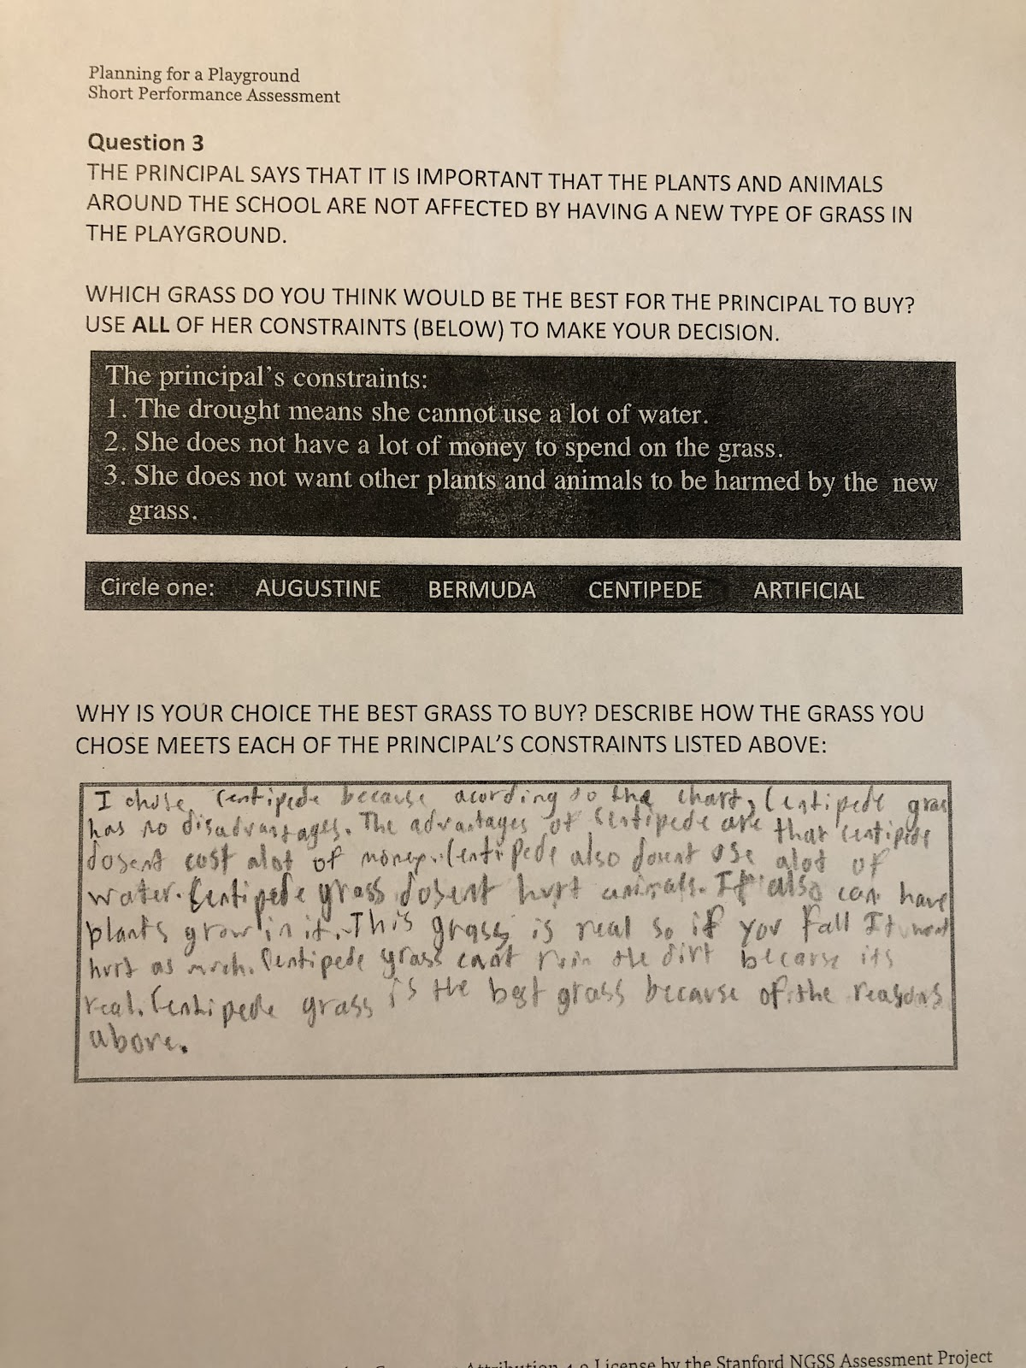
In this response, the student refers to the information in the chart to construct a design solution that fits the principal’s constraints. The response shows a general coherence and understanding of the practices (analyzing and interpreting data and constructing a design solution).
“According to the chart, centipede grass has no disadvantages. The advantages are that centipede grass doesn’t cost a lot of money. Centipede grass doesn’t use a lot of water. Centipede grass doesn’t hurt the animals.”
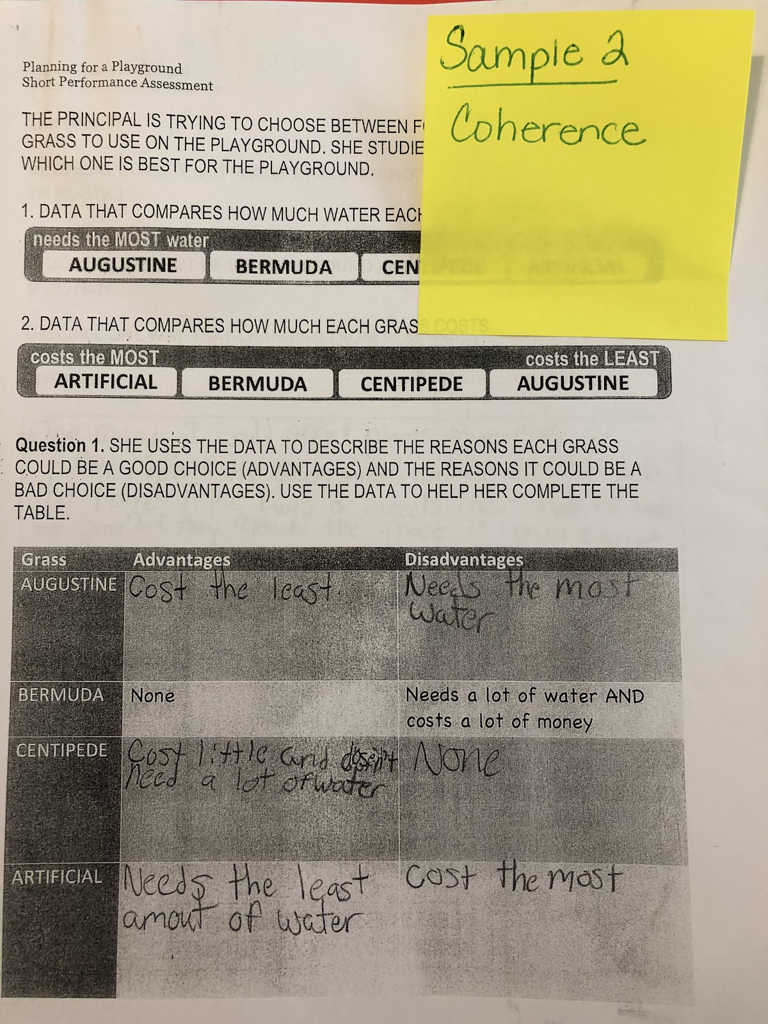

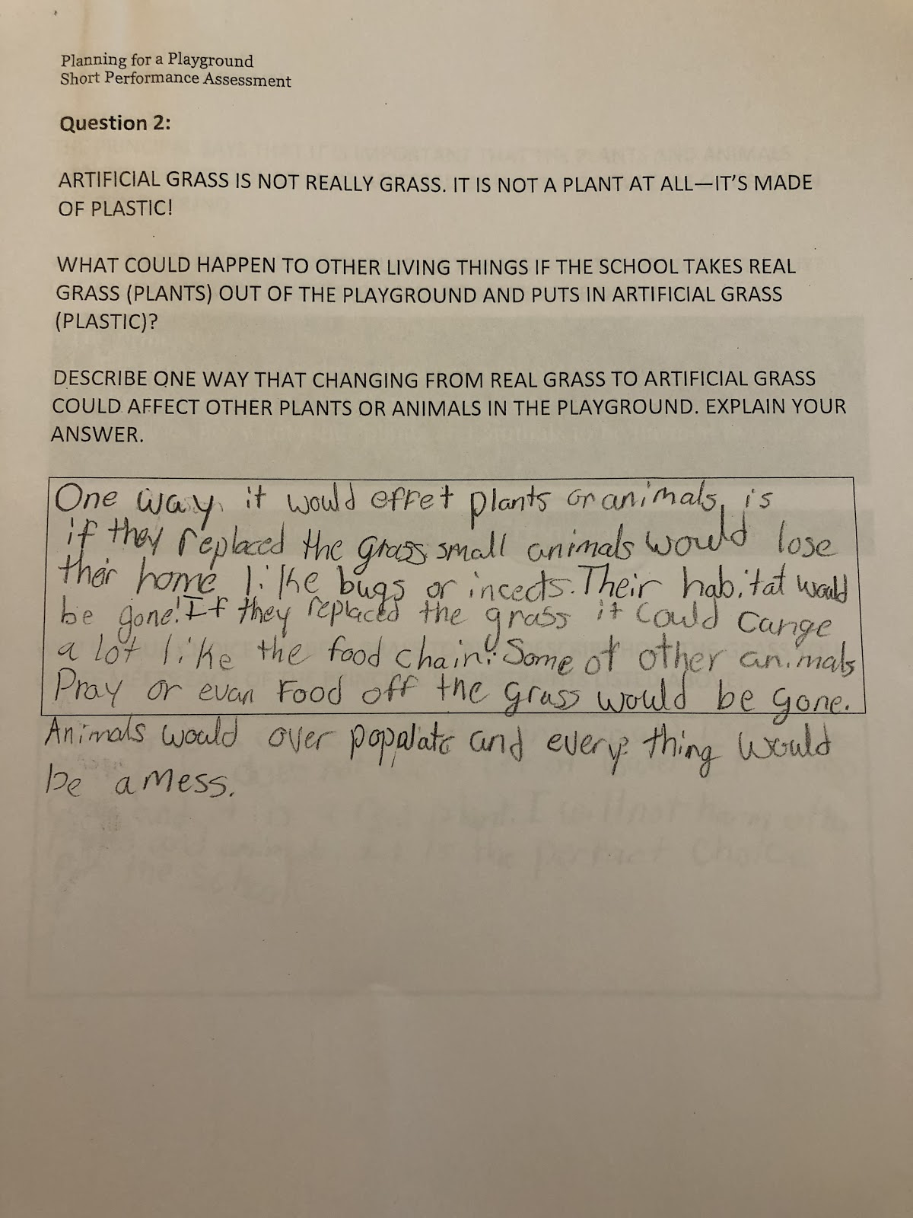

In this sample, there is evidence of a general understanding of the DCI. “If you replace the grass, small animals would lose their home.” The response does not address how replacing real grass with artificial grass would affect the plants on the playground.
There is some evidence of coherence when the student identifies “effects” of changing the grass (CCC). The student does not develop these ideas.
- “Bugs and insects would be gone.”
- “It could change a lot like the food chain.”
- “Animals would overpopulate.”
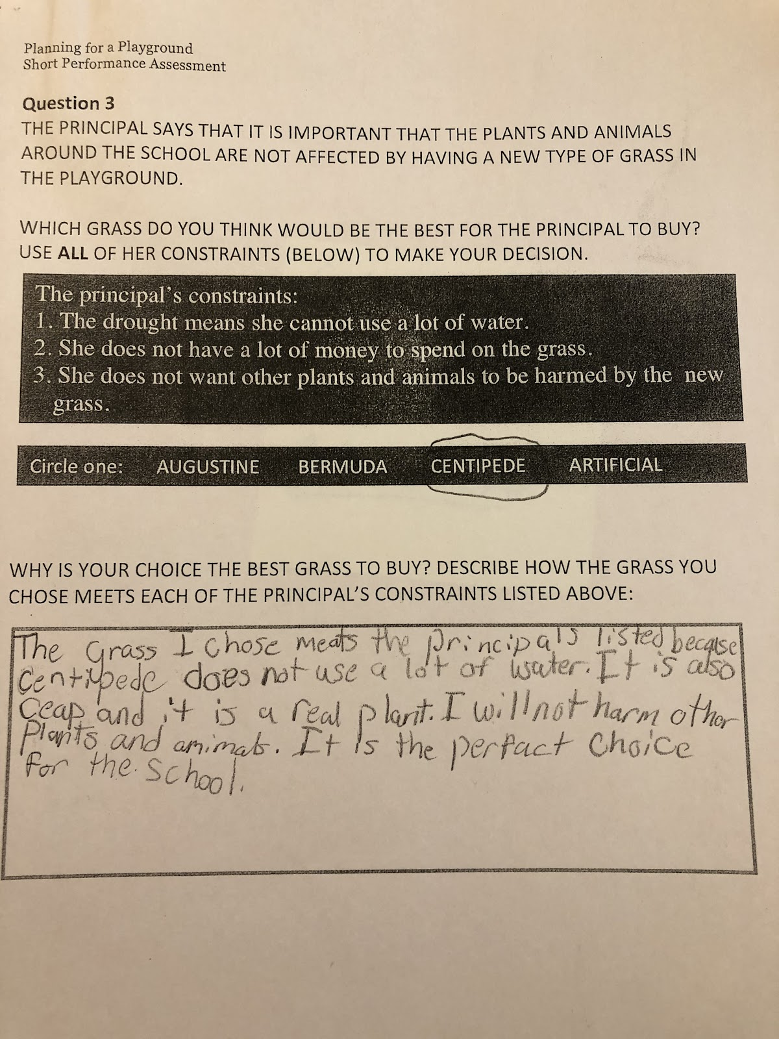

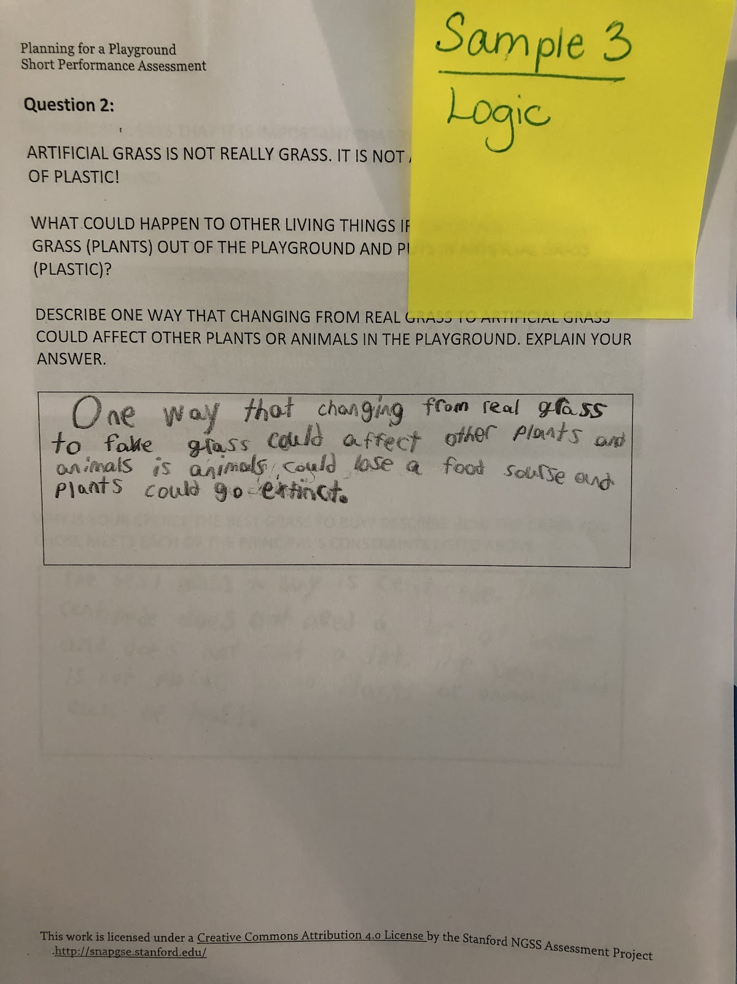

In the sample, the student demonstrates a limited understanding of the DCI and the CCC. The response shows significant errors and flaws in logical thinking.
“Plants could go extinct.”

Sample 4
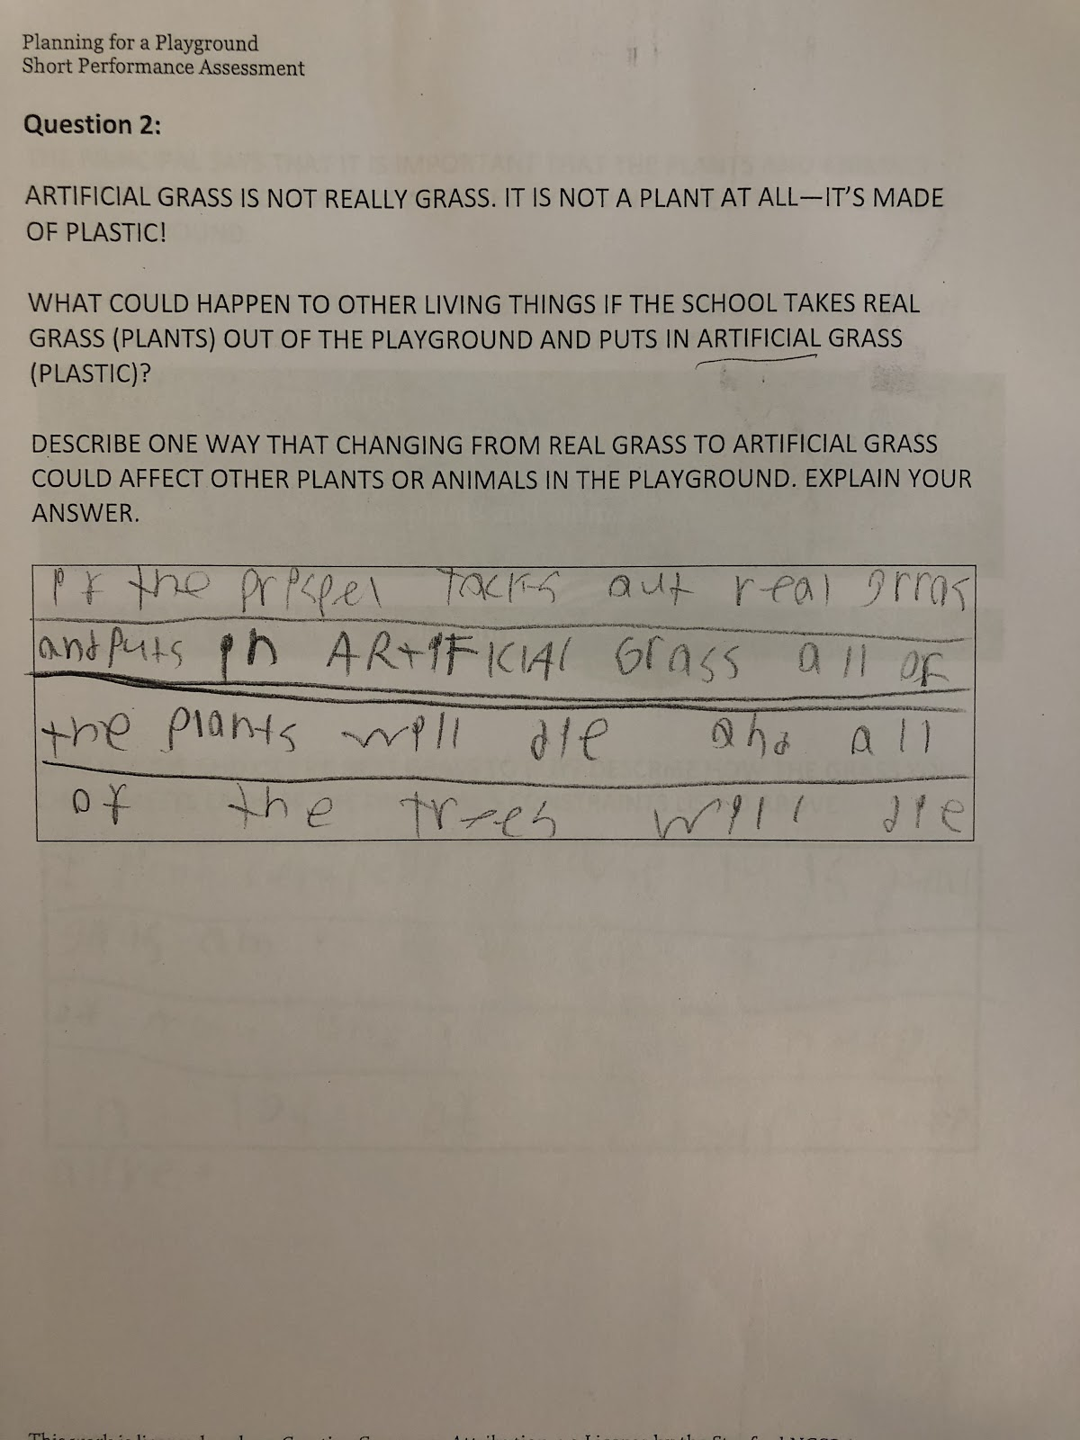
In the sample, the student demonstrates a limited understanding of the DCI and the CCC. The response shows significant errors and flaws in logical thinking.
“All of the plants will die and all of the trees will die.”

