Audit acceptance statement submission process
The “Audit Acceptance Statement” (AAS) information is to be submitted to the Kentucky Department of Education (KDE) electronically through a web form within SharePoint, which is part of Office 365. This information can only be submitted by the Finance Officer or the Superintendent. The window for submission will be open on April 15th or the next business day. Please follow the step-by-step instructions below.
- To access the Audit Acceptance Statement web form please click on the following link Audit Acceptance Statement. NOTE: Please note that SharePoint works better in a modern web browser like Microsoft Edge or Google Chrome.
- If you are asked to sign into Office 365, then you will use your computer log in information.
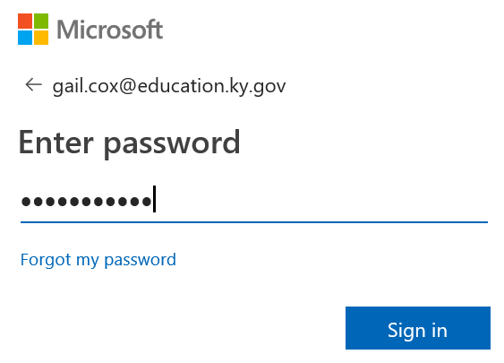
- To enter the “Audit Acceptance Statement” information you will need to click the “New Item” link.
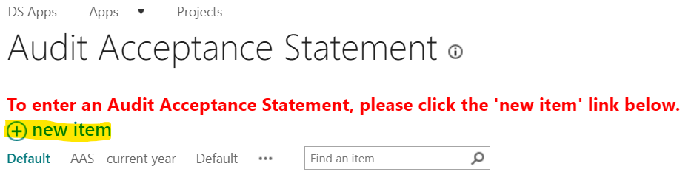
- The screen that appears should have your “District” already populated along with the “Fiscal Year”. The Fiscal Year should follow the current Audit Contract. These fields cannot be changed.
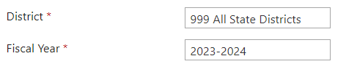
- Next you will see a dropdown box beside “Audit Firm”. You can choose the audit firm from the dropdown box. NOTE: A few audit firms have more than one office location so be sure to choose the correct location according to your contract. Also NOTE that if a firm has merged or changed their name since last year, then they are considered a new audit firm. This is a required field.
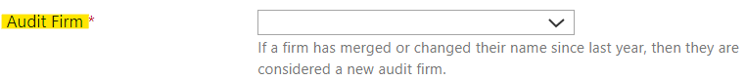
- Once you click on the name of the audit firm, a separate window will open for you to verify the auditor’s information. Be sure to review all the information. If you need to make changes just click on the box and make your revision. Once you are finished, click on the “SAVE” button. NOTE: Please include all email addresses that the auditor wishes for KDE to have on file for communication purposes.
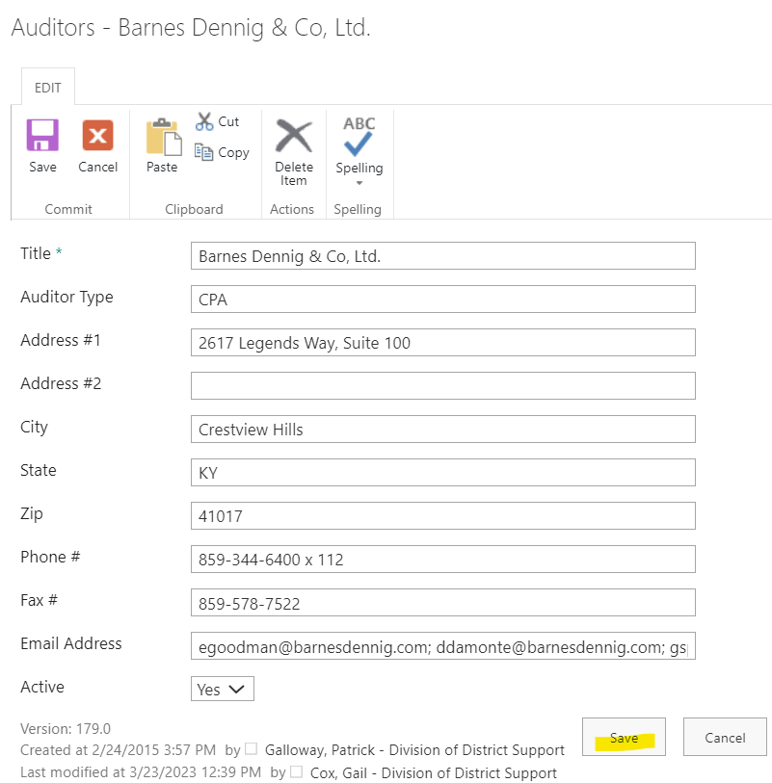
- If your auditor is NOT listed, then click on “Auditor Not In List”. A separate window will open where you can enter all your auditors’ information. All the yellow highlighted boxes are required fields that must be completed. Once all the required information is filled in click on the “SAVE” button.
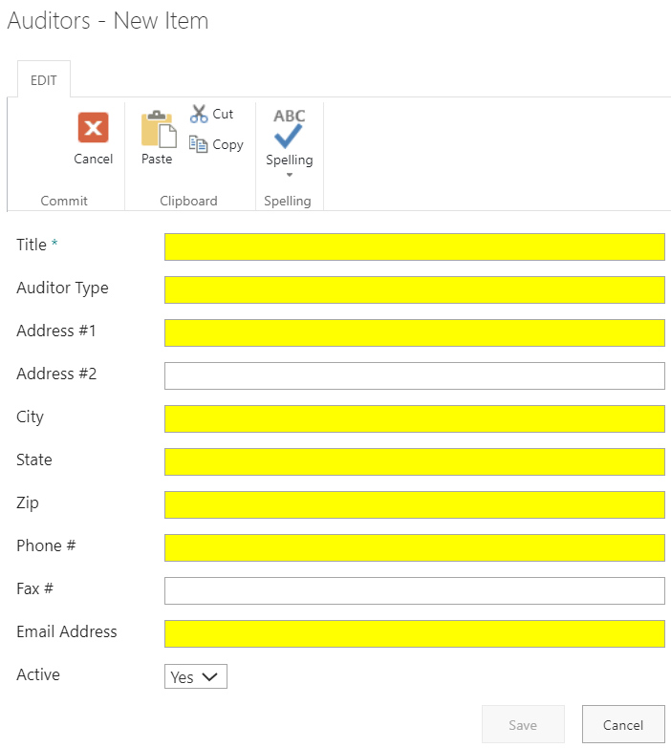
- If the audit firm selected is different than the audit firm from prior fiscal year the system will automatically check the box beside “New Audit Firm For District”.
- The next item is “Consecutive Fiscal Years With This Audit Firm”. Select the dropdown box and choose the number of consecutive years that you have been with this audit firm. NOTE: This is excluding the current fiscal year. If this is a new audit firm for this fiscal year, then you will choose zero. This is a required field.
- If your district has had the “Same Audit Firm for More than 5 Consecutive Fiscal Years”, then you will need to check this box. NOTE: If this audit firm has completed the audit process for 5 consecutive years with your district which makes this fiscal year is the 6th fiscal year with this same audit firm, then this box would need to be checked. Once you check this box, an additional required items will appear.
- The additional required item is “Reason For Same Audit Firm”. In the empty box you will need to list the determining factors for choosing to keep this same audit firm for more than 5 consecutive fiscal years. This is a required field.
- The next item is “Date of last obtained bid for Audit Services”. Select the calendar or type in the date that you last obtained bids for the audit services. Please note the format. This is a required field.
- Next you will type in the “Estimated Audit Cost” in the empty box provided. This is a required field.
- The “Estimated Prior Year Audit Cost” will automatically be populated according to the districts previous year’s information.
- Next you will type in the “Actual Prior Year Audit Cost”.
- If there is a difference in the audit cost, then it will automatically populate in the box beside the “Difference in Audit Cost” and the box beside the “Percent Increase/Decrease”.
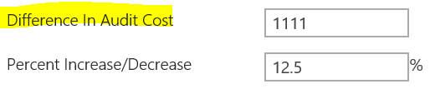
- If there is a difference, please check the most appropriate box located beside the “Reason for Fee Increase/Decrease”. You will need to check all the reason(s) that are applicable. If your reason is not listed then you may choose, “Other”. It is also important to note that you should be sure the reason you’re checking coincides with the percent increase/decrease. For example, the price may vary a lot when a district changes auditor.
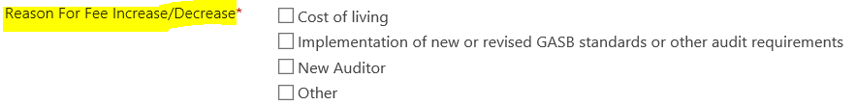
- If you check “Other” an empty box will open so that you can type your reason. Please NOTE there is a limit of 256 characters, so please be brief in your description.
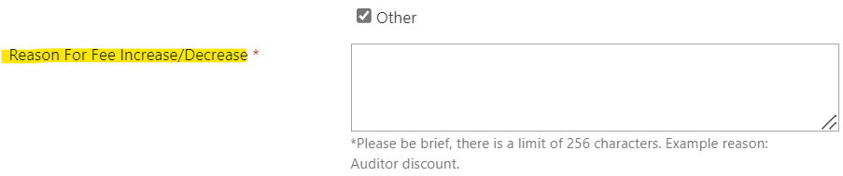
- The last step to be completed before submitting to KDE is to check the box beside the “Statement of Certification”. This statement certifies that the districts local board of has chosen the selected audit firm to conduct an audit of the board’s financial records in accordance with the current auditing standards and procedures adopted by the SCSDA for the current fiscal year audit contract. This is required to be checked.
- Once you have completed all the required fields and you have checked the box by the “Statement of Certification”, then you will need to click on the “Submit To KDE” button. NOTE: If the button is grayed out, then you will need to review the information to see if anything is missing.
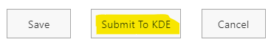
- If when submitting you get a pop-up box like the one below, please read what issues(s) it says to fix and click on the “Submit to KDE” button again. NOTE: Clicking on the SAVE button does NOT submit the information to KDE.
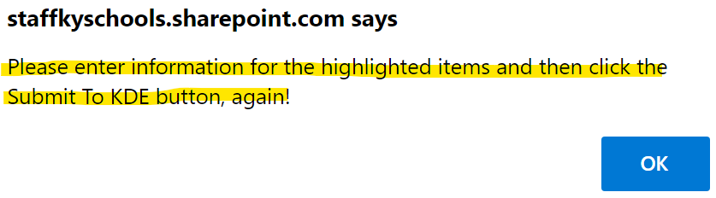
- If you need to exit the form before you are ready to submit it to KDE, then you will click on the “SAVE” button. This will save all the information that has been entered so far, so that you can log back in later and resume where you left off.
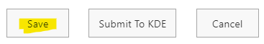
- If you click on the SAVE button you will get an automated email. When you are ready to complete the process, go into the SAVED email and click on the link in the email and it will open the saved information. NOTE: Clicking on the SAVE button does NOT submit the information to KDE.
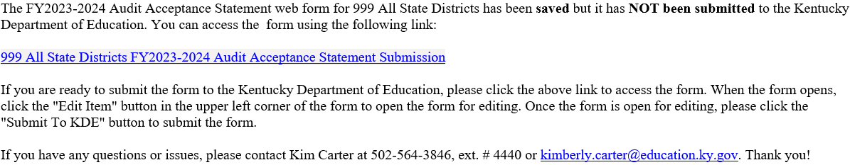
- From the SAVED email, once your form opens you will need to click on the “Edit Item” button in the upper left corner of the form. This opens the form so that you can make your edits.
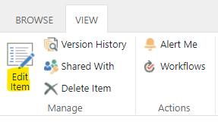
- After you have completed your edits and you are ready to submit to KDE, just follow all the steps for submission. Be sure to click on the “Submit To KDE” button.
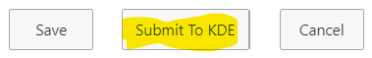
- Once your “Audit Acceptance Statement” has been submitted to KDE, you will receive an automated email stating that it has been submitted to KDE and is pending review. Please NOTE that there is a link in the email to the KDE “Financial Audit Contract Information” website, where you will find the current fiscal year’s “Audit Contract and Requirements”.
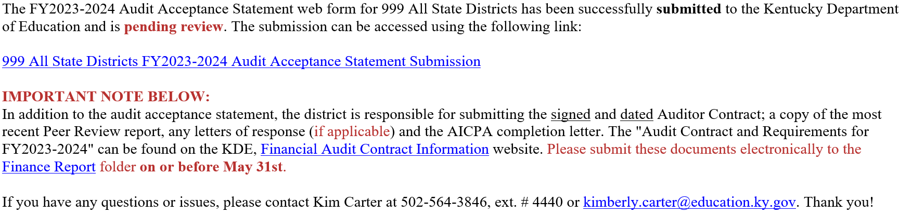
- If your Audit Acceptance Statement is declined, you will receive an email stating that it has been declined along with the NOTE REASON DECLINED. At that time, you will need to click on the link within the email to open the form and click on “Edit Item”. Correct any issues and resubmit the information to KDE.
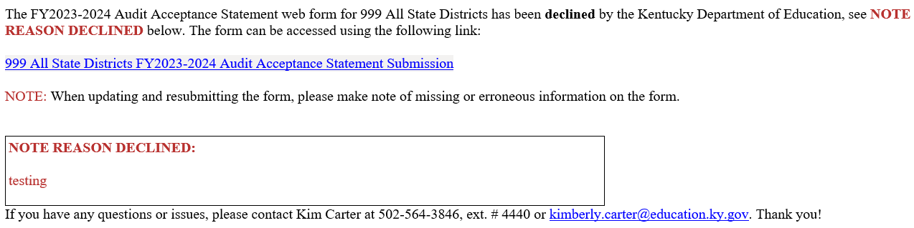
- Once your “Audit Acceptance Statement” has been resubmitted to KDE, you will receive an automated email stating that it has been resubmitted successfully to KDE and is pending review. Please NOTE that there is a link in the email to the KDE “Financial Audit Contract Information” website, where you will find the current fiscal year’s “Audit Contract and Requirements” document.
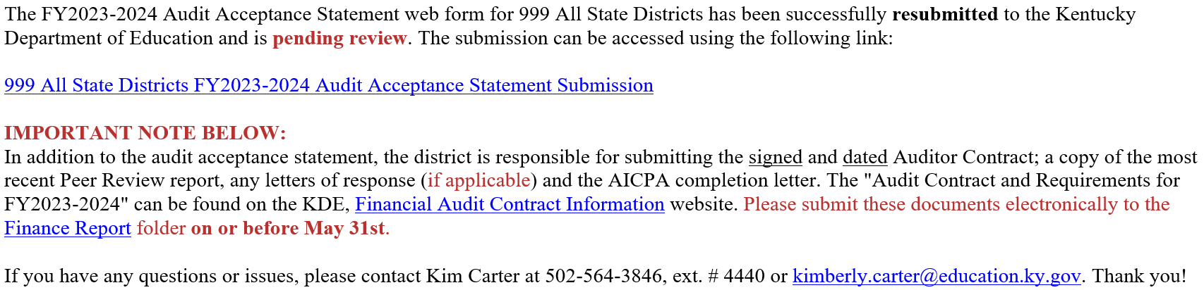
- Once it has been reviewed by KDE and accepted you will receive another email stating that it has been accepted. NOTE: This does NOT mean that the contract has been approved by the “State Committee for School District Audits”.
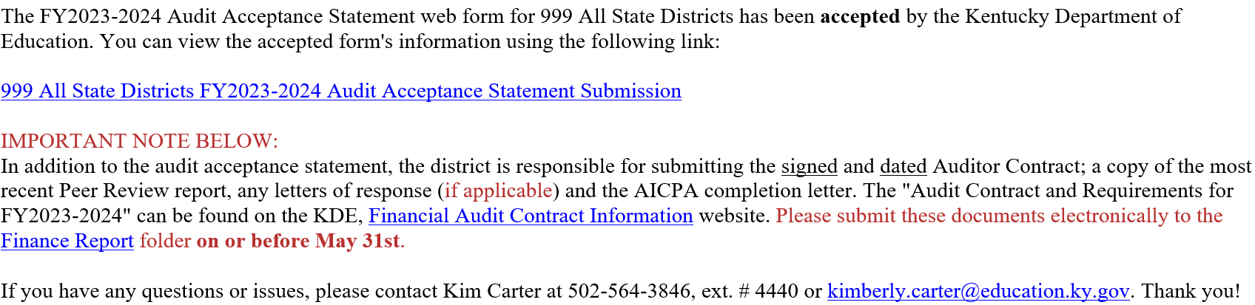
- Once KDE has received the “Audit Acceptance Statement”, the signed and dated “Auditor Contract”, the “Peer Review Report”, any letters of response (if applicable), and the “AICPA Peer Review Committee completion letter”, then these documents will be reviewed for all the required information. Once the review is complete the auditor contract will be sent to the “State Committee for School District Audits” for approval. IMPORTANT NOTE: The Auditor Contract and any additional documents are to be submitted electronically to the Finance Report folder on or before May 31st.
- The audit contract and required documents are due to KDE on or before May 31st. For your convenience in the “Audit Acceptance Statement” webform, to the left of the screen under “Documents”, we have provided a link to the current fiscal year’s “Audit Contract and Requirements”.
Once the audit contract has been approved by the “State Committee for School District Audits” and signed by the “State Committee Chair” the Superintendent will receive an email notification from the “Commissioner of Education” stating that the auditor contract has been approved. The approved contracts will be maintained within KDE.
If you would like a copy of the approved signed contract, please contact one of the following representatives at KDE’s District Financial Management Branch at (502) 564-3846:
- Marshall Smith, extension 4463 or via email at marshall.smith@education.ky.gov
- Kim Carter, extension 4440 or via email at kimberly.carter@education.ky.gov
- Jackie Chism, extension 4445 or via email at jackie.chism@education.ky.gov
- Kelli Young, extension 4417 or via email at kelli.young@education.ky.gov

KDE USE: F:\audits_trans\Audit Branch SOP's\Audit Acceptance Statement SOP's\District Use DATED: 4/11/24

