Kentucky Department of Education

Direct Certification Web Download Tool User Reference

Version History
Author | Description | Date
Brad Blunt | Original | 6/30/2011
Brad Blunt | Added information on Infinite Campus template | 7/5/2011
Brad Blunt | Updated information regarding foster care DC data | 4/4/2012
Brad Blunt | Updates for the 12-13 school year | 7/2/2012
Brad Blunt | Updates based on Medicaid DC | 9/20/2012
Brad Blunt | Updated FRAM screen prints based on Campus enhancement | 3/27/2013
Brad Blunt | Updates based on direct certification type | 7/02/2013
Brad Blunt | Minor edits | 8/17/2015
Tim Cooper | Updated points of contact for support. | 11/13/2015
Tim Cooper | Updated screenshots for new webapps UI, KIDS/OET name change and At-Risk IC support contact. | 11/28/2018
Jessica Carlton | Updated the Infinite Campus training links. | 1/29/2018
Tim Cooper | Updated SCN point of contact. | 1/20/2023

Contents
Contents 3
Overview 4
User ID Registration 4
Data Access 4
Data Confidentiality 4
Security 4
Help 4
Navigation 4
Direct Certification Steps 5
Importing the Direct Certification File – KTAP/SNAP/Medicaid ONLY 8
Direct Certification Template 8
Data Import into Infinite Campus 8
Notes on Infinite Campus Direct Certification Import Process 13
Frequently Asked Questions 13
Resources 15
Appendix 16
Glossary 17

Overview
The SCN direct certification Web download tool provides access to SNP sponsors for the purpose of downloading the direct certification file through a secure Web portal. SNP sponsors will use the direct certification to determine which students are eligible for free meal eligibility. The direct certification file will be updated on a monthly basis. The tool is available to private, parochial and public schools. Access to the tool will be granted through the Division of School and Community Nutrition’s (SCN) schools branch.

User ID Registration
All users must complete the user self-registration form for access to the tool. Only the Food Service Director and their appointed designee may have access to the system. The additional designated user users must be reviewed, approved and submitted by the Food Service Director before access will be granted. The direct certification contains sensitive and confidential information and thus SCN will limit access. The user registration form may be obtained by contacting SCN’s Sheri McFarland (sheri.mcfarland@education.ky.gov).

Note: Users who leave their position within food service should notify SCN, who will remove their user ID from the system.

Data Access
Users have been assigned county level direct certification data based on their district/diocese county location. Some districts have attendance areas that stretch across county lines. Additional counties will be granted based on a review by SCN. Districts may request access to additional counties through an email to Sheri McFarland (sheri.mcfarland@education.ky.gov). The request should include justification for the additional counties. SCN will review and grant approval based on a valid, demonstrated need.

Data Confidentiality
The direct certification data, as it contains sensitive and confidential information, should be stored in a secure location on your network. Keep all hard copies of any printouts in a locked storage area.

Security
User IDs and passwords should not be shared with other users. The passwords have no expiration date attached to them. Forgotten or misplaced user IDs or passwords can be retrieved by following the help process on the user registration site (https://applications.education.ky.gov/login) or by contacting the KETS Service Desk.

Help
Users who need their password reset should contact the KETS Service Desk at (502) 564-2002.

Navigation
The user should have followed the self-registration process to obtain a user ID and password. An email from SCN will confirm that the user has been set up in the tool.

Direct Certification Steps
- Navigate to the SCN Direct Certification Web Download tool: https://applications.education.ky.gov/login
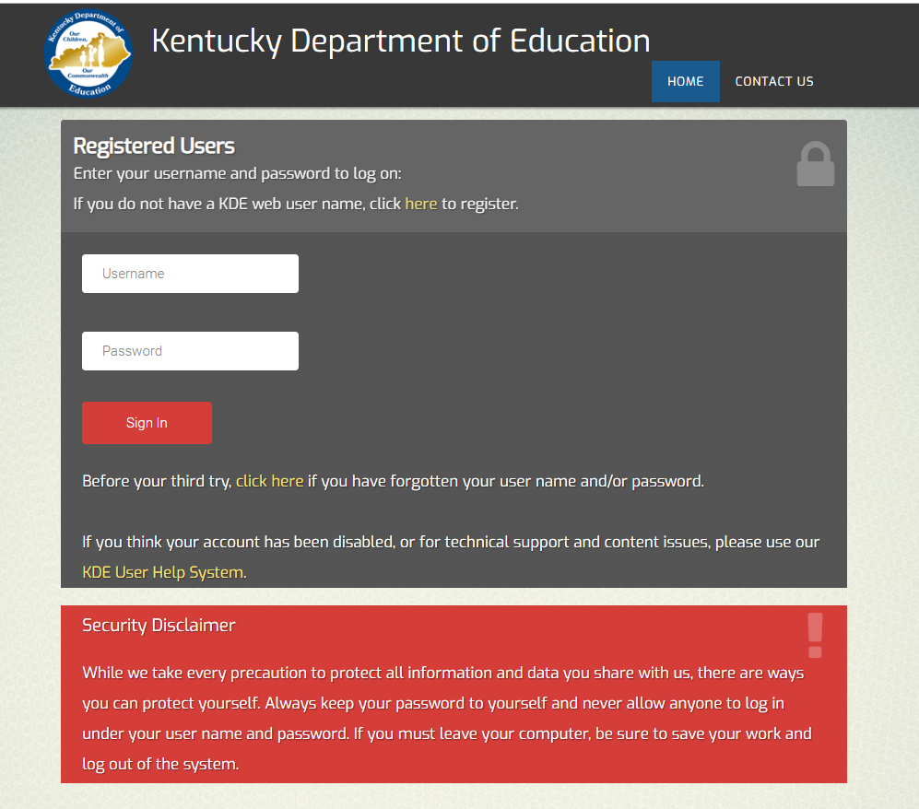
- Enter in your user ID and password.

- Click on the “SCN Direct Certification” link.
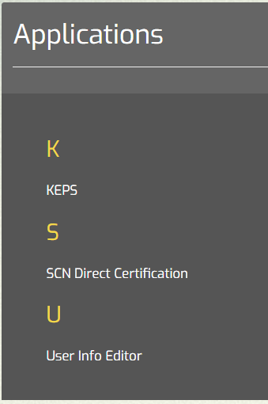
Tip! Users should always have their current email address on file under ‘User Info Editor’ as automatic email notifications are sent from the system to all users once a new DC file has been posted.

The download screen shall appear. A description of the key information follows:
User name
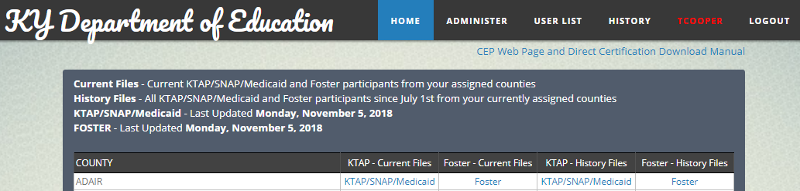
Most current file update
County information contained in download file
  - Logged in as – your current username
  - Logout – to log out of the system
  - File are up to date as of – date the files were last updated
  - Current Files – the current month’s KTAP/SNAP/Medicaid and foster care recipients for your assigned counties
  - History Files – a unique list of all KTAP/SNAP/Medicaid and foster care recipients from your assigned counties from July 1st to the current month
  - County Name – the assigned counties for your user ID
  - {Current File} - the hyperlink to download the current direct certification file in .csv format
  - {History File} – the hyperlink to download the historical direct certification file in .csv format
  - Contact Us/Help – access for assistance from the KETS Service Desk

KTAP/SNAP/Medicaid – a list of all KTAP/SNAP/Medicaid participants for which DC eligibility can be extended to other members in the household.
Foster - a list of all active foster children in Kentucky; DC eligibility cannot be extended to other members in the household

- Users will click on the “Current File” link and then click “Open”:
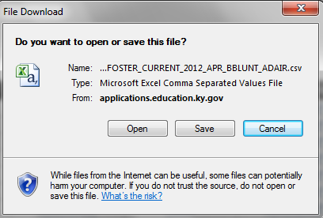
- The file will automatically open in Excel. Automatically size the columns by clicking on the upper left hand portion of the worksheet area.
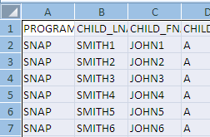
Click once here.
  - Place your cursor until it appears as a double arrow then double-click.

- The data has been placed in a logical order. The definitions of the fields follow in the appendix. Following below are comments on the file layout:
  - The county name appears in the final column. You should verify this contains the counties you are interested in.
  - The guardian SSN contains only the last 4 digits to protect privacy.
  - The Zip + 4 and the guardian SSN will omit any leading zeroes from displaying, which is an Excel issue. However, the data does appear in the file itself.

- Save the file format in the original .csv type. When Excel prompts you to save the file in a .csv format, select ‘Yes’.
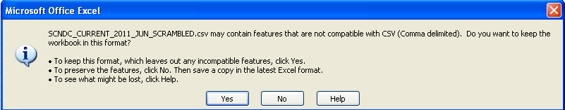
Select ‘Yes’

- Return to the tool. Click on “Logout” to exit the system.

Importing the Direct Certification File – KTAP/SNAP/Medicaid ONLY
All of the necessary software to import the direct certification file into Infinite Campus is available to districts at no charge.

The POS system and Infinite Campus should be kept in synch with each other. The FRAM WebEx presentation provides detailed instructions on how to accomplish that. The POS system is the official system of record for all SCN reporting requirements.

Direct Certification Template
Infinite Campus placed a direct certification mapping template on all district sites in July 2011. The template will be named “SCN Direct Certification Import” and will have all the settings established for steps 5 & 7 below.

Data Import into Infinite Campus
- Log in to Infinite Campus. If you do not have a user ID contact your district IT administrator.
Important!: Districts must select the current school year from the ‘School Year’ dropdown menu when importing their DC file.
- Ensure the correct year and other information is shown on the top menu bar for the current year: in this example, the ’14-15 school year’ is selected.
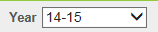
- Navigate to FRAM>Eligibility Import Wizard. Choose the import mapping.
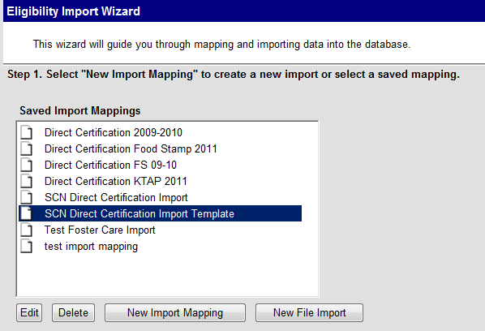
- Click “Edit”.
- Complete the fields below as follows:
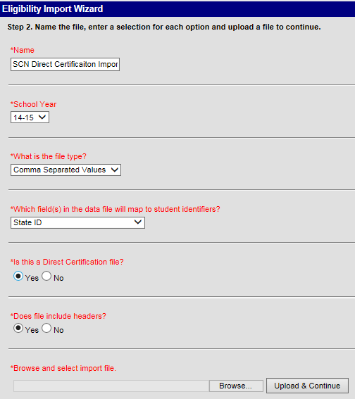
Select the DC file here.
SSID was chosen since it usually results in a higher number of data matches since the inception of the COT SSID matching algorithm.
Ensure the current school year is selected here.

- Once you have completed the fields, you will then click ‘Upload & Continue’.
- In this next screen you will define the student ID field. Input a ‘7’ into the field as below:
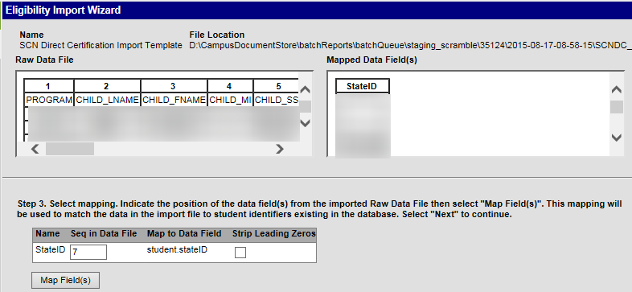
- Click ‘Map Field’.
- Scroll down and click ‘Next’.
- Key in the appropriate Start and End dates:
  - The ‘Start Date’ will be when the DC data is imported into Infinite Campus.
  - The ‘End Date’ will be the last day of June within the school year; in this example for school year 2014-2015 the date will be 6/30/2015.
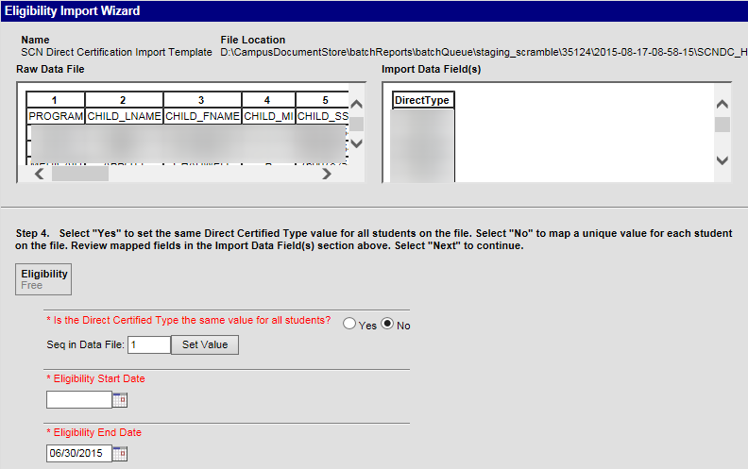
- With regards to “Is the Direct Certified Type the same value for all students?” select ‘No’. (For importing the DC Foster file you can mark ‘Yes’ – and select Foster for the selection.)
- Enter a ‘1’ for the sequence in the data file.
- Click ‘Set Value’.
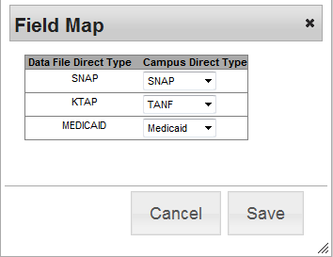
- Enter in the values as shown.
- Enter in today’s date for the “Eligibility Start Date”
- Click ‘Save’.
- Scroll down and click ‘Next’.
- Confirm the following information:
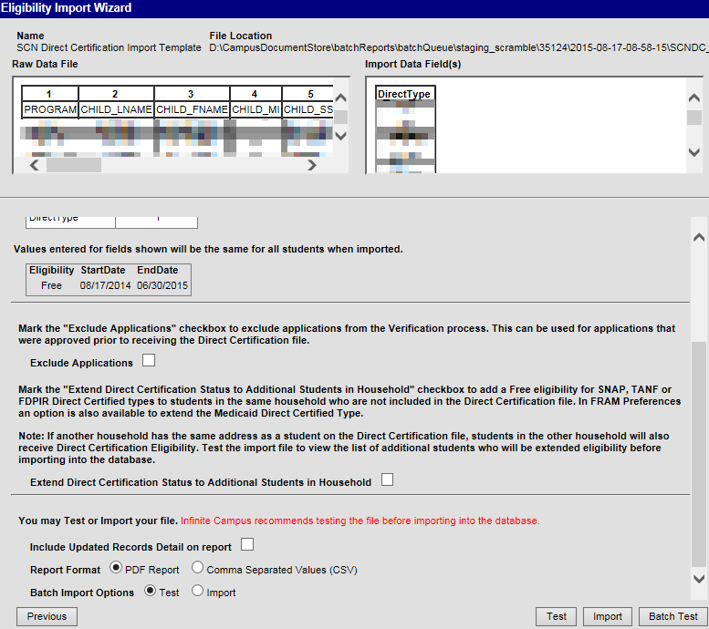
Should only be marked for SNAP/KTAP/Medicaid file
Verify your information is correct.
Important!: Review the information to ensure it is correct, especially the start/end dates. Records will have to be manually corrected for each student in the event of any errors or through a Campus support ticket.

  - Extend direct certification status to additional students within the household by checking the checkbox for the DC download file of KTAP/SNAP/Medicaid recipients.
  - It is recommended to include updated records detail on the report.
- Click ‘Test’.
- Review the test report (see example below).
- Finally, if everything appears correct, then click ‘Import’.
Tip!: Larger districts of >3,000 students should consider using the Batch Import Option to import large batch files. More information on this option is available in the Infinite Campus – Eligibility Import Guide.
- Review the report.
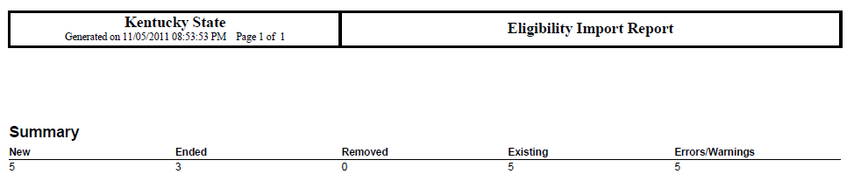

This shows duplicate students were located in Campus. Please run the Duplicate Student Search Report in IC; submit a support ticket in Campus to have this situation corrected.
The Eligibility Import Report from IC provides a summary description of the import results. Focus on ‘Errors/Warnings’.

Private/Parochial Schools: To the extent possible all public school students have been identified with KDE’s State Student Identifier (SSID) on the DC file. Outside of a few public school students who are transferring in to your system, nearly all of your potential DC students will not have an SSID assigned to them. Thus, you can either filter out those students with an SSID or sort the file to only view those without an SSID. This is helpful if you intend to manually match the DC list to your POS student roster.
The SSN (or SSID) were not matched in Campus. This may be because the:
1) SSN is incorrect in the DC import file or Campus; or
2) the child is not enrolled in your district/diocese

Tip!: More matches will be found if do a second DC import based on SSN. Simply change the dropdown value on the first screen to SSN and then enter a value of 5 on the second screen for sequence in data file: all other settings remain the same.

Notes on Infinite Campus Direct Certification Import Process
- Continuation of Direct Certification Status: Students who appear on a previous direct certification file will not be removed or end dated if they do not appear on subsequent direct certification files.
  - Example: Mary Jones, a student in your school, appears on the July direct certification file but does not appear on the August direct certification file. Mary’s direct certification and free meal status will remain once the August direct certification file is imported.

- Missing SSIDs: Students who do not have an SSID on the direct certification file will not be imported. Districts may want to scan through students with missing SSIDs to see if any of the children noted are in their district. It may be helpful to either sort the Excel file by SSID or apply a filter to the SSID field, selecting only blank records.

Frequently Asked Questions
What is the purpose of the ‘History’ DC file?
The DC ‘History’ file contains a unique list of all students who have been on a DC file during the school year. The ‘most recent month’ field displays when the student was last on the file. It is useful for the following reasons:
- Auditing – SCN can pull the DC file to compare your DC identified students against a master list
- Re-Import – If you neglected to download a DC file in a particular month this will help you get caught up. Also, districts are encouraged to import the DC History file prior to reporting their April DC counts in CNIPS since students may have been missed as DC. Transferring students, new students, kindergartners, etc. may have been missed as DC due timing: your DC import occurred prior to them enrolling, their SSN was incorrect but since has been fixed, etc.

How often should I update my POS/IC with the DC information?
Sponsors should update their student information on a monthly basis.

How often will the foster child data be updated?
The file will be updated on a monthly basis.

Why are out-of-state foster children appearing on our file?
These are children for whom 1) CHFS does not have an address yet in their system; 2) the child is placed in an out-of-state placement. In either instance the child may be attending your school. SCN will monitor this to determine the value of including out-of-state students on every DC download list.

Why is the foster child DC list a separate file?
Direct certification cannot be extended to other members in the household. Thus, a separate file had to be created.

Why is the guardian information missing for foster children?
CHFS could not provide us that information on the file.
I have foster children that are not on this file.
Some foster children may be placed voluntarily with a relative or other type living situation---are not wards of the state. However, due to the transient nature of foster care, some foster children under care of the state may not appear on your list until a later month until after their foster care location has been updated.

What if the foster child is already marked as DC?
You won’t need to do anything for this student since they are already noted as being DC.

Many of our students live in another county but attend our school. Can I obtain that county’s DC list?
By default access is provided to the SFA home county and all bordering counties. The SCN schools branch manager reviews any additional requests outside of the bordering counties. Please send an email to Sheri McFarland (sheri.mcfarland@education.ky.gov) to request access to more counties.

I’m a new food service director and need access to the DC file.
Please contact Sheri McFarland (sheri.mcfarland@education.ky.gov).

I’ve lost my user ID/password.
Please contact the KETS Service Desk at (502) 564-2002.

Which student identifier results in more data matches – SSN or SSID?
SSID. However, see the note below.

What if I want to maximize the number of DC matches?
Match your student roster on both SSN and SSID. This will entail creating a separate data mapping, one for each student identifier, and running the DC import two times – one for each data mapping.

What if I am only able to use SSID (or SSN) to match against my student roster?
- Only SSN – Filter the DC file in Excel based on blank SSNs. Look for any students with SSIDs. These are potential matches to your student roster.
- Only SSID - Filter the DC file in Excel based on blank SSIDs. Locate any additional students who may be on your student roster.

I forgot to download a monthly DC file.
Download the DC history file and import that into IC or your POS. This will bring you up to date to the current calendar month.

What is new with the addition of Medicaid recipients?
As part of a demonstration project with the USDA, Medicaid DC recipients are now included on the DC download file. Per CHFS, a single case is assigned if a family receives both SNAP/KTAP and Medicaid. Thus, you
are receiving an unduplicated file of KTAP/SNAP/Medicaid recipients.

With Medicaid DC can eligibility be extended to other members in the household?
Yes, this is the same as with KTAP/SNAP.

Resources
Several resources are available to districts for assistance.

Here is a list of suggested resources.

Infinite Campus
- Campus Community
  - https://community.infinitecampus.com
    - Resource guides, forums
- WebEx Sessions
  - https://university.infinitecampus.com/learn/global-search/FRAM
    - FRAM Verification
    - FRAM Eligibility Import Wizard
    - FRAM Managing Paper Applications
    - FRAM Online Applications

- For policy questions or questions on the Direct Certification Web Download tool please contact Sheri McFarland (sheri.mcfarland@education.ky.gov).
- For Infinite Campus Import and SEEK At-Risk questions please contact Samantha Engstrom (samantha.engstrom@education.ky.gov)
- For Point of Sale (POS) Import questions please contact your POS vendor support.

Appendix
Direct Certification Fields – KTAP/SNAP
Field | Description
PROGRAM | SNAP, KTAP or Medicaid public assistance programs
CHILD_LNAME | Child’s last name
CHILD_FNAME | Child’s first name
CHILD_MI | Child’s middle initial
CHILD_SSN | Child’s SSN
CHILD_DOB | Child’s date of birth
CHILD_SSID | Child’s State Student Identifier
GUARD_FNAME | Guardian’s first name
GUARD_MI | Guardian’s middle initial
GUARD_LNAME | Guardian’s last name
GUARD_SSN_LAST4 | Guardian’s last 4 digits of SSN
ADR_LINE1 | Address line 1
ADR_LINE2 | Address line 2
ADR_CITY | City
ADR_STATE | State
ADR_ZIP_5 | Zip code
ADR_ZIP_4 | 4 digit zip code (if available)
PHONE | Household phone number
MOST_RECENT_MTH* | Most recent month child appears on direct certification file
COUNTY | County of direct certification record
*History file only
Direct Certification Fields – Foster
Field | Description
CHILD_LNAME | Child’s last name
CHILD_FNAME | Child’s first name
CHILD_MI | Child’s middle initial
CHILD_SSN | Child’s SSN
CHILD_DOB | Child’s date of birth
CHILD_SSID | Child’s State Student Identifier
ADR_LINE1 | Address line 1
ADR_LINE2 | Address line 2
ADR_CITY | City
ADR_STATE | State
ADR_ZIP_5 | Zip code
ADR_ZIP_4 | 4 digit zip code (if available)
PHONE | Household phone number
MOST_RECENT_MTH* | Most recent month child appears on direct certification file
COUNTY | County of direct certification record
*History file only

Glossary
Title | Definition
Campus Community | Location of support documents, videos and other tools to assist in learning Infinite Campus
Categorically Eligible | Automatic eligibility for free meal status based on participation in mean tested program (SNAP, KTAP, Head Start) or the student's status (migrant, runaway, or homeless)
CHFS | Cabinet for Health and Family Services: administers KTAP and SNAP programs; provides data extract files of KTAP and SNAP recipients (including both parent and their children) to OET in a text delimited format; also provides current list of foster child data for use in direct certification
Direct Certification | Process to determine a student’s eligibility for free meal status; any KTAP or SNAP recipients are automatically designated with a free meal status
FRAM | Free and Reduced Application Module: data module in Infinite Campus, Kentucky’s Student Information System, which has tools to manage student meal status eligibility, including a direct certification data import tool
FSD | Food Service Director
Infinite Campus | Vendor that provides Kentucky's Student Information Services; web-based interface to track attendance, grades, student enrollment and other key information
KSIS | Kentucky Student Information System: web-based system to track grades, attendance, student enrollment and other key information; main data repository for all student tracking information
KSIS & More | Monthly KSIS newsletter produced by the Office of Knowledge, Information and Data Services
KTAP | Kentucky Transitional Assistance Program: provides cash assistance to needy families (formerly known as public aid)
Mapping | Used for data import process; defines the location of each field in a data file by column number.
Medicaid | Provides health care for low-income families
NSLP | National School Lunch Program: federally funded program designed to provide nutritious meals in a school or institutional setting
OET | Office of Education Technology; Parses the CHFS data extract files to county-based data files and produces the data CDs for SCN; the data CD contains both KTAP and SNAP data files for each county
POS System | Point of Sale/Point of Service: school cafeteria’s system for processing students’ meal cards; several different systems are used by Kentucky schools
SCN | School and Community Nutrition: administers NSLP program using federal funds; responsible for program monitoring and compliance by NSLP sponsors
SNAP | Supplemental Nutrition Assistance Program: assists families with obtaining food (formerly known as food stamps)
SSID | State Student Identifier: a unique 10 digit number assigned to public school students

