MILITARY CONNECTED PARENT/GUARDIAN FORM
Student Name:
Please complete a form for each parent/guardian currently serving as an active duty member of the U.S. Armed Forces. If at any time throughout the school year the military status of a parent/guardian changes, please contact your child’s school to report the change.
As part of the Every Student Succeeds Act (ESSA) requirements, the U.S. Department of Education requires school districts to identify students who are armed forces family members. These students will be part of a new accountability subgroup for federal reporting purposes. The collection of this data will be done within the Kentucky Student Information System and then reported to the federal government and used in some state reporting. As this is a new data collection requirement, all parents/guardians are being asked to indicate below the family’s military status.
What is the definition of an “armed forces family member” for ESSA?

A student is considered to be an Armed Forces Family Member (military connected) if at least one parent or guardian is a member of the armed forces, or serves on active duty, or serves on full-time National Guard duty. The terms ‘‘armed forces,’’ ‘‘active duty,’’ and ‘‘full-time National Guard duty’’ as defined by Sections. 101(a)(4), 101(d)(1), and 101(d)(5) of the United States Code are:
- 101(a)(4) Armed Forces includes: Army, Navy, Air Force, Marine Corps, and Coast Guard.
- 101(d)(1) Active Duty Status means full-time duty in the active military service of the United States. Such term includes full-time training duty, annual training duty, and attendance, while in the active military service…..Such term does not include full-time National Guard duty.
- 101(s)(5) The term ‘‘full-time National Guard duty’’ means training or other duty, other than inactive duty, performed by a member of the Army National Guard of the United States or the Air National Guard of the United States in the member’s status as a member of the National Guard of a State or territory, the Commonwealth of Puerto Rico, or the District of Columbia under section 316, 502, 503, 504, or 505 of title 32 for which the member is entitled to pay from the United States or for which the member has waived pay from the United States.

Where can I find out more information about this data submission?

More information regarding this data collection can be found on the U.S. Education Department’s website under ESSA Transition.

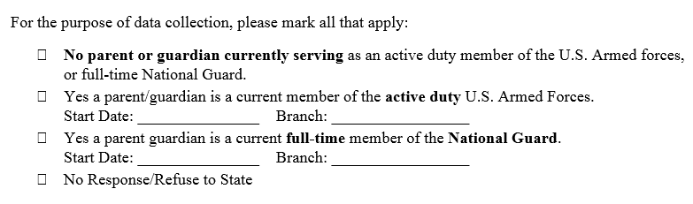
Parent/Guardian Name: _________________________________________________________________
Parent/Guardian Signature: _________________________________________ Date: ________________

