**Elementary Social Studies Learning Experience**

**Integrated with a Reading and Writing Instructional Resource**

Kindergarten: Kentucky Geography

*This example was adapted from a teacher submission.*

|  |
| --- |
| **Social Studies Experience Overview** |

Students will explore symbols in their local communities. Then, students will expand upon this knowledge to learn about symbols in Kentucky. After learning about many different state symbols and how they represent important aspects of our state, students will respond to the compelling question by creating a page that will be assembled into a class book about Kentucky symbols for students to reference.

***KAS for Social Studies* alignment:**

* K.I.Q.1 Ask compelling questions about their community.
* K.C.KGO.2 Identify local and Kentucky state symbols and events.

*Educators may have to engage with a standard multiple times throughout a year in order to meet the full intent of the standard. As a result, the following assignment example may not encompass the entire scope of the standards identified*.

|  |
| --- |
| **Reading and Writing Connection** |

Vibrant student experiences in Social Studies differ from those in Reading and Writing. However, intentionally aligning the topics enhances learning in both. The following green-rated High-Quality Instructional Resource (HQIR) is used in Reading and Writing during the same time period as this Social Studies learning experience:

HQIR: Wonders 2020

Knowledge-Building Topic: Where can you go that is far and near; My USA

Grade-Level Complex Text(s): *Ana Goes to Washington D.C.* by Rene Colato Lianez

The following Reading and Writing standards and tasks, along with Interdisciplinary Literacy Practices, play a supporting role and are integrated in this vibrant Social Studies Learning Experience:

Text-Dependent Tasks: Writing to Demonstrate Learning

*Kentucky Academic Standards for Reading and Writing*: RI.K.1, RI.K.2, RI.K.3, RI.K.4, RI.K.10, L.K.4, C.K.5, C.K.6

*Interdisciplinary Literacy Practices*: 1, 2, 3, 4, 6, 8

|  |
| --- |
| **Setting the Stage: Compelling Question** |

|  |
| --- |
| **K.I.Q.1** Ask compelling questions about their community.  **Compelling Question**: What symbols represent Kentucky? |

Compelling questions are open-ended, enduring and center on significant unresolved issues. For more information on compelling questions, visit Section B: “What are Compelling Questions and how do students ask them?” from the [Inquiry Practices of the *KAS for Social Studies*](https://education.ky.gov/curriculum/standards/kyacadstand/Documents/Inquiry_Practices_of_KAS_for_Social_Studies.pptx)module.

Introduce the compelling question to students. Display and read the question, defining community if needed. Introduce the concept of community symbols by displaying your school’s mascot. Ask students to identify the mascot and explain what they think about when they see this image. Support students in understanding that a symbol is a recognizable image that represents, or stands for, a place.

Support students in understanding the meaning of “symbol” by working together to identify different symbols that represent their local community. Ask students to think about different pictures and logos they see throughout their community, in addition to their school mascot. Students may think of other school mascots, the logo for their school district, their city government seal, or different logos from notable businesses in their community.

Below are some examples that can be adapted to fit your local community:

|  |  |  |
| --- | --- | --- |
| University of Kentucky logo with blue UK letters  https://en.wikipedia.org/wiki/Kentucky_Wildcats | Louisville Cardinal bird logo  https://www.sportslogos.net/logos/view/2519/Louisville_Cardinals/1978/Primary_Logo | McDonald's logo (golden arches)  https://en.wikipedia.org/wiki/McDonald%27s |
| Louisville Free Public Library logo with a colorful column building icon  https://www.lfpl.org/ | Jefferson County Public Schools logo  https://www.jefferson.kyschools.us/ | Churchill Downs logo with twin spires  https://en.wikipedia.org/wiki/Churchill_Downs |
| Louisville metro government seal with fluer de lis  https://en.wikipedia.org/wiki/Louisville,_Kentucky | National Park Service Logo, shaped like an arrowhead with a mountain, tree and bison pictured.  https://www.nps.gov/articles/create-your-own-park-logo-or-arrowhead.htm | Target logo (red bullseye)  https://corporate.target.com/media/collection/b-roll-and-press-materials/target-logos |
| Big Lex blue horse logo  https://www.visitlex.com/about/lexington-ky/big-lex/ | City of Paducah seal  https://en.wikipedia.org/wiki/Paducah,_Kentucky#/media/File:Paducah,_KY_Seal.png | Toyota logo  https://brand.toyota.com/guidelines/visual/logos.html |

Once you have compiled a list of several different symbols in your community, ask students to think about why we might have symbols that represent different things in our community. Ask students to [Turn and Talk](https://www.theteachertoolkit.com/index.php/tool/turn-and-talk) to a partner to discuss their thoughts on the following question:

|  |
| --- |
| Why do we have symbols in our community? |

After students have had time to discuss with a partner, discuss as a whole group. Ensure students understand that symbols are images that represent something and are easily recognized by everyone. Additionally, symbols can represent things that are special about our community. As an example, students in Johnson County identified an apple as a symbol for their community because of the Kentucky Apple Festival that takes place each year.

Now that students have identified examples of symbols within their communities, explain that they will expand their learning to investigate symbols in Kentucky.

**Investigation: Kentucky symbols**

|  |
| --- |
| **K.C.KGO.2** Identify local and Kentucky state symbols and events. |

**Sources**

* KET. (2022, August 1). *Kentucky symbols: Social Studies shorts*. PBS LearningMedia. <https://www.pbslearningmedia.org/resource/kentucky-symbols-video/social-studies-shorts/>
* Frankfort. (2015, February 10). State Symbols USA. <https://statesymbolsusa.org/place/kentucky/capitals-historic-buildings/frankfort>
* Welcome - Kentucky Department of Fish & Wildlife. (n.d.). [https://fw.ky.gov/More/Documents/fwactivitybook[1].pdf](https://fw.ky.gov/More/Documents/fwactivitybook%5B1%5D.pdf)

Now that students have identified symbols in their local community, explain to students that there are many symbols that represent the state of Kentucky as well. To provide context and geographical awareness for students, provide a map of Kentucky, such as the one below:

|  |
| --- |
| Map of Kentucky showing the different counties.  https://en.m.wikipedia.org/wiki/File:Kentucky_counties_map.png |

Ask students to identify their county within the map of Kentucky. Explain that the symbols they previously discussed were recognizable in their community, but now they are going to look at symbols that represent our entire state. Students may have learned about some United States symbols in their reading program; if so, it may be helpful to also show a map of the United States and explain that those symbols represent all of the 50 states combined, including Kentucky, but these symbols will be special to just our state of Kentucky.

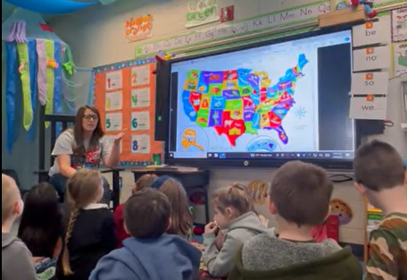

To introduce Kentucky symbols, show students the [*Kentucky Symbols | Social Studies Shorts*](https://www.pbslearningmedia.org/resource/kentucky-symbols-video/social-studies-shorts/)*.* Ask students to pay attention to the Kentucky symbols that are discussed during the video.

During and/or after the video, review some of Kentucky’s state symbols. On chart paper, record the type of symbol and its name, and if possible, include a quick sketch or image of each one for students to reference. An example is below:

|  |  |  |
| --- | --- | --- |
| **State symbol** | **Symbol for Kentucky** | **Image** |
| **Flag** | Kentucky State Flag | Kentucky state flag, blue with a seal showing a pioneer and a statesman shaking hands. |
| **Bird** | Northern Cardinal | image of a cardinal bird |
| **Fish** | Spotted Bass | image of a spotted bass |
| **Fossil** | Brachiopod | image of a brachiopod |
| **Flower** | Goldenrod | image of a goldenrod |
| **Tree** | Tulip poplar | image of a tulip poplar |
| **Mineral** | Coal | clipart of coal in a barrel |

Provide students the opportunity to practice identifying these symbols with a partner. Mix up the images and descriptions and have partners work together to match and describe them to each other. After reviewing the different symbols, ask students to think about what they learned in the video about each of these symbols and pose the question:

|  |
| --- |
| Why do these symbols represent Kentucky? |

Again, ask students to [Turn and Talk](https://www.theteachertoolkit.com/index.php/tool/turn-and-talk) to a partner before sharing as a whole group. Ensure that students understand that these items are found commonly in Kentucky and are special to our state. To further explore additional state symbols for Kentucky, visit another source with the class, [State Symbols USA](https://statesymbolsusa.org/states/united-states/kentucky). View the additional state symbols for Kentucky. Choose a few that the class finds interesting to add to the chart paper for students’ reference.

To assess students’ mastery of “K.C.KGO.2 Identify local and Kentucky state symbols and events”, students will now respond to the compelling question, “What symbols represent Kentucky?”

**Task Aligned to the Compelling Question**

|  |
| --- |
| * K.I.Q.1 Ask compelling questions about their community. * K.C.KGO.2 Identify local and Kentucky state symbols and events. |

Now that students have been introduced to state symbols and explored different symbols for Kentucky, they will work as a class to compile this information to demonstrate their learning and teach others. Place students in small groups and assign a different symbol from the chart paper of symbols to each group. Ask students to create a page for a classroom book collection of state symbols. Students may use information they learned from the video, the website, any other sources you provide them, as well as their own knowledge, to write 1-2 sentences and include images that describe the symbol and/or provide more information.

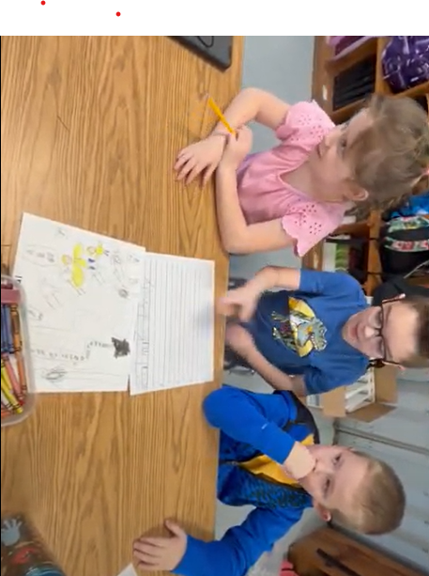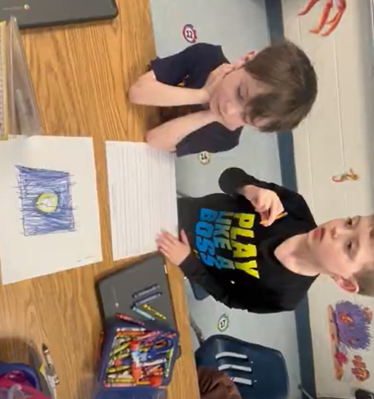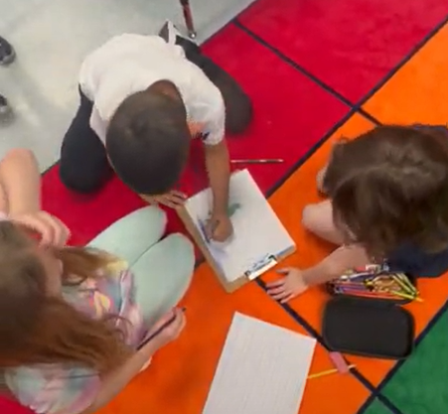

|  |
| --- |
| **Task:**  Create a page for a classroom book that identifies one Kentucky symbol. Include an illustration and 1-2 sentences that describe the symbol. |

Support groups as they work, checking for accuracy and clearing up any misconceptions. Encourage students to elaborate with their descriptions to explain the significance of this symbol. When they finish, compile their work into a book students can reference. Below is a sample from a Kentucky classroom:

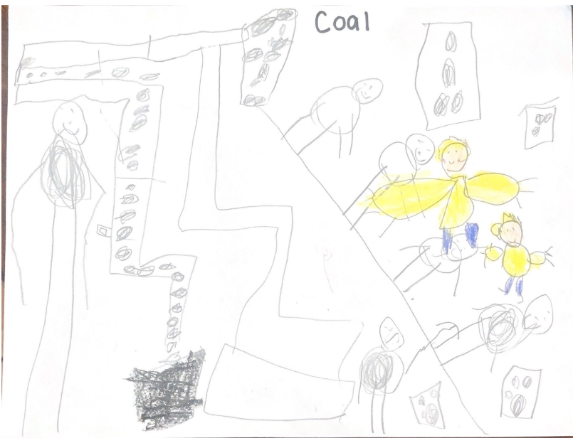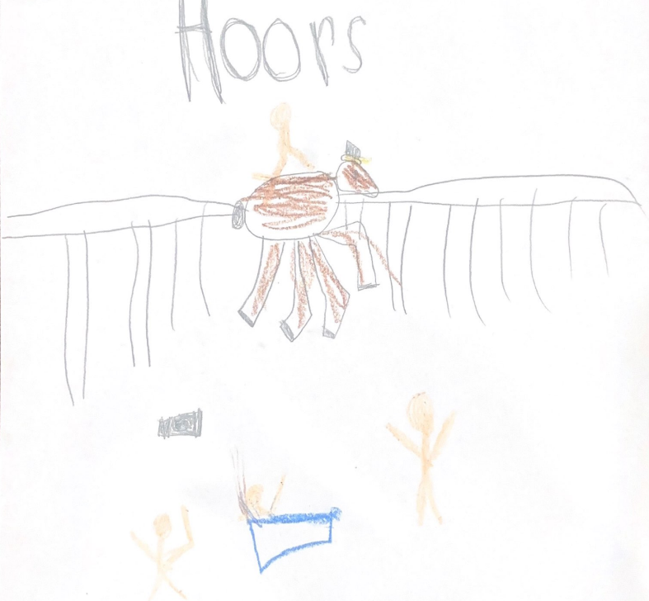

Student writing: Coal makes electricity. Because it was ...
Because it was useful.