**Elementary Social Studies Learning Experience**

**Integrated with Reading and Writing Instructional Resource**

Grade 2 Geography

|  |
| --- |
| **Reading and Writing Connection** |

Knowledge-Building Topic: Early American history.

Grade-Level Complex Text(s): “Walking to the New World” by Kathryn Thomas; *The Very First Americans* by Cara Ashrose

Text-Dependent Tasks: Writing to Learn, Writing to Demonstrate Learning

*Kentucky Academic Standards for Reading and Writing*: RI.1.1, RI.1.2, RI.1.3, RI.1.4, RI.1.7, RI.1.9, RI.1.10

*Interdisciplinary Literacy Practices*: 1, 2, 3, 4, 8, 9

|  |
| --- |
| **Social Studies Experience Overview** |

Students will learn about migration and examine how patterns of human settlement have changed in North America over time. They will compare settlement patterns from the past to today.

***KAS for Social Studies* alignment:**

* 2.I.Q.1 Ask compelling questions about communities found in North America.
* 2.I.Q.2 Identify supporting questions that help answer compelling questions about communities found in North America.
* 2.G.MM.1 Explain patterns of human settlement in North America.
* 2.I.CC.1 Construct an explanation, using correct sequence and relevant information, to provide information on a community in North America.

*Educators may have to engage with a standard multiple times throughout a year in order to meet the full intent of the standard. As a result, the following assignment example may not encompass the entire scope of the standards identified*.

|  |
| --- |
| **Setting the Stage: Compelling Question** |

|  |
| --- |
| **2.I.Q.1** Ask compelling questions about communities found in North America.  **Compelling Question**: Why do people migrate? |

To engage students in the learning experience, ask students to raise their hands if they have ever moved someplace new before. Ask the class to [Think-Pair-Share](http://www.pz.harvard.edu/resources/think-pair-share) about reasons why people might move to a new home. Tell students that, since the beginning of time, people have moved to new places for a variety of reasons. To better understand our world and the people in it, we are going to investigate why people move to certain places instead of others. Have them complete this [vocabulary four square](https://docs.google.com/presentation/d/1IXYUETu2si5RnoNhayDw07TiTh6yC0uEIj2ITrKNWbs/edit?usp=sharing) for migration to support students in understanding this concept. An example of a completed vocabulary four square is below:

Definition: When people or animals move to somewhere new
Picture: (drawing of a bus)
Vocabulary word; migration
Make up your own sentence: this youtube guy migrated from a state that is far, to Texas.
Related words: move, go, relocate

Introduce the compelling question: “Why do people migrate?” Post this question to reference throughout their learning.

|  |
| --- |
| **Supporting Question** |

| **2.I.Q.2** Identify supporting questions that help answer compelling questions about communities found in North America.  **Supporting Question:**Why have people migrated and settled in North America in the past and today? |
| --- |

Introduce the supporting question to students, explaining that they are going to investigate migration and settlement in the past and today in North America. Provide them with a physical map, such as the one below, to examine the features of North America:

|  |
| --- |
| This is an image of a physical map of North America.  GIF Map. (n.d.). *Physical Map of North and Central America*. <https://www.gif-map.com/maps/north-america/physical-map-of-north-and-central-america.gif> |

Explain to students that the different colors show changes in elevation; the brown areas show higher elevation/mountains and the green areas show lower areas/grassland. Also, explain that North America is surrounded by the Pacific Ocean on the west and the Atlantic Ocean on the east, and that many large rivers can be found throughout. Give students a blank [map](https://docs.google.com/presentation/d/1s0oijo-IXBAi28aJ-_Gn-iFw61ZH4_NrhDcrXfKpSmY/edit?usp=sharing) of North America. Using the physical map as a guide, ask them to highlight or color in areas where they think most people live now based on what they know about the geography of North America. Below is an example of a student’s prediction:

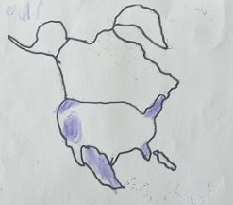

Have students share their thinking with a partner and then discuss as a whole group. Ask students to justify why they believe some areas will be more populated than others. Students may bring in some background knowledge about different areas and may use landforms/bodies of water to influence their decisions. For example, students may respond that places with mountains may have fewer people living there because it is harder to get around, or that places near rivers may have more people living there because they need water to live. Hold onto these maps to reflect upon at the end of this learning experience.

Explain to students that they are going to investigate the supporting question, “What factors influenced migration and settlement in North America in the past and today?” As a class, complete the K and W sections of the “Know, Want to know and Learned (KWL)” chart below on chart paper. The L section will be completed later on. Students may bring in background knowledge they have from their own experiences, or from information they learned from the related texts in reading and writing.

|  |
| --- |
| Why have people migrated and settled in North America in the past and today? |

|  |  |  |
| --- | --- | --- |
| K  What do we already know? | W  What do we want to know? | L  What have we learned? |
|  |  |  |

**Investigation**

|  |
| --- |
| **2.G.MM.1** Explain patterns of human settlement in North America. |

**Sources**

* Thomas, K. (2020, October 23). *Main topic and key details-walking to the new world*. YouTube. <https://youtu.be/bOpVW6hKtXM?si=bm63TJWNE5y5bI12&t=84>
* SVS. (2007, September 21). *NASA Scientific Visualization Studio | Population Density at Night*. SVS. <https://svs.gsfc.nasa.gov/30214>
* Native Land Digital. “NativeLand.ca.” *Native Land Digital*, 2023, <https://native-land.ca/>
* Bookroot Readings. (2021, May 31). *Kids Book Read Aloud: The Very First Americans by Cara Ashrose, Illustrated by Bryna Waldman* [video]. [youtu.be/Iq3PC1kkc6E?si=SqVwiXNO4jcvvUf0](https://youtu.be/Iq3PC1kkc6E?si=a4AoO13aT4lOpdAD).

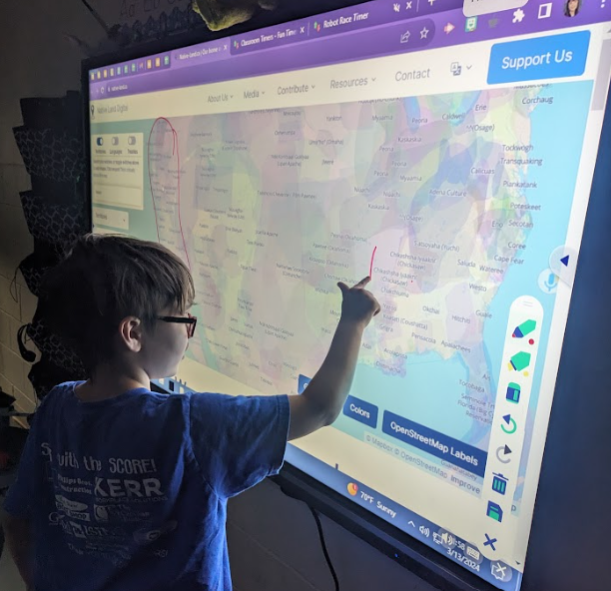

Explain to students that they are going to explore what North America’s settlement looked like in the past. Access [Native Land Digital](https://native-land.ca/) and display this interactive map to students. Explain that this map shows the territories where each of the identified Native groups inhabited in the past. If possible, allow students to access the site independently or with a partner. As students investigate the digital map, ask them to do a [See, Think, Wonder](https://pz.harvard.edu/sites/default/files/See%20Think%20Wonder.pdf). Ask students:

|  |
| --- |
| * What do you see (or notice) on this map? * What do you think about that? * What does it make you wonder? |

After they have had time to think independently and/or discuss with a partner, discuss as a whole class and record their answers on chart paper. During discussion, look for students to notice that there were native groups throughout the entire continent and that there was a high concentration of native groups around the coastal areas near the ocean. They also may notice that the areas inhabited by groups near the ocean are smaller and the areas of native groups in the inland part of the continent are much bigger and wonder why that might be. Additionally, they may notice a higher concentration of native groups in the southern half of North America than the northern half.

Next, explain that students are going to investigate different groups of Native Americans and how they lived. Show them a map that provides the cultural regions of indigenous North Americans, such as the one below, and compare it to the physical map they examined earlier.

|  |
| --- |
| This is a map showing the different cultural regions of Native Americans in North America.  Wikipedia. (n.d.). *North American Ethnic Regions* [image]. <https://upload.wikimedia.org/wikipedia/commons/0/00/North_American_cultural_areas.png> |

While comparing the two maps, ask students the following questions:

|  |
| --- |
| * Which regions have lots of mountains? * Which regions are in lower, grassier areas? * Which regions are near an ocean? * Which regions contain many rivers? |

This will help students already have an idea about where each region is located in North America and some basics about what the land and resources might be like in each region prior to learning about indigenous tribes in each region. Then,

read the book [*The Very First Americans*](https://youtu.be/Iq3PC1kkc6E?si=R4UMknOZm6Ne0V4w) with students. Explain that this book will provide information about how Native Americans in different regions of North America lived in the past. Provide a graphic organizer, such as the one below, for students to use to record information about how Native Americans from each region lived as they follow along in the book:

|  |  |  |  |  |
| --- | --- | --- | --- | --- |
|  | **Climate and landforms** | **food** | **shelter** | **other** |
| **Northwest Coast** |  |  |  |  |
| **Southwest** |  |  |  |  |
| **Plains** |  |  |  |  |
| **Woodlands** |  |  |  |  |

Below is an example of a completed graphic organizer:

|  |  |  |  |  |
| --- | --- | --- | --- | --- |
|  | **Climate and landforms** | **food** | **shelter** | **other** |
| **Northwest Coast** | *Pacific Ocean* | *Most came from the sea*  *Had feasts lasting several days where the host gives away gifts* | *Large wooden homes facing the sea* | *Made canoes from trees for hunting/fishing*  *Totem poles carved as animals* |
| **Southwest** | *Desert, very little rain* | *They farmed but it was difficult* | *Clay houses in high, hard to reach places for protection, with holes in roofs and ladders that could be removed.* | *Had rituals that they hoped would bring rain* |
| **Plains** | *Grassy* | *Hunted buffalo and followed their herds* | *Teepees that could easily be put up and taken down* | *Used buffalo parts for food, clothing, toys, and more* |
| **Woodlands** | *Forest* | *Hunted animals* | *Longhouses made of tree and bark*  *Chickees with roofs made of palm leaves in warmer southern areas* | *Had leaders called chiefs* |

Pose the following questions to check for students’ understanding of the factors that influenced migration and settlement in the past and how people had to adapt to their surroundings to survive:

|  |
| --- |
| * What resources were available in the places where Native Americans migrated and settled? * How did they adapt to their environment? * Why might these groups have chosen to migrate to and/or settle in these places? * Why might the groups living in the southwest and plains areas have occupied larger areas than the groups near the coast? |

During discussion, ensure that students understand that Native Americans migrated and settled based on the availability of resources and their ability to adapt to their environment. They may have chosen their settlement based on being near a water source, having favorable climate, availability of plants and animals for food, etc. It is also possible that groups in the southwest and plains areas occupied larger areas because they had fewer resources and they were more spread out. For example, in the desert, they may have needed more area to find plants and animals for food since they are more sparse than other climates. The groups in the plains may have been more spread out since they were nomadic and followed herds of buffalo as they migrated.

Then, explain to students that now that we know what the early days of North America’s population looked like, we can compare it to what our population looks like today. Pass out the maps the students initially made their highlighted predictions about where most people live now. [Think-Pair-Share](https://www.readingrockets.org/classroom/classroom-strategies/think-pair-share#:~:text=Think%2Dpair%2Dshare%20is%20a%20collaborative%20learning%20strategy%20where%20students,2)%20share%20ideas%20with%20classmates.) about what changes they would make now knowing what they know about migration and the different factors that influence it.

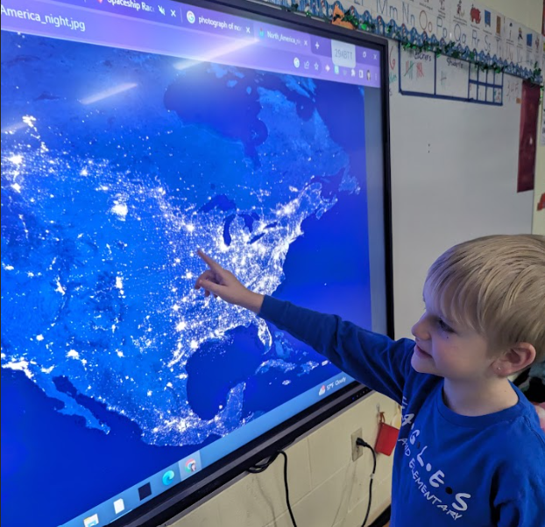

Then display the [NASA Scientific Visualization Studio](https://earthobservatory.nasa.gov/features/NightLights) map of the world. Explain that this is a nighttime map. Zoom in on North America and ask the students what they think the different shades of brightness mean. They should determine that the brighter areas are where more lights are located, therefore, more people live there. Discuss as a class what this map means for population locations. Ask students the following questions as they explore the map:

|  |
| --- |
| * Which areas of North America are the most populated? * Which areas of North America are the least populated? * What similarities do you see between the modern map and the locations of the Native American groups of the past? What differences? * Why do you think these larger cities are located where they are today? What factors might influence others to migrate and settle there? |

Ask students, “What have we learned so far about factors that influenced migration and settlement in the past?” Ask students to add this learning to the L section of the KWL chart. Students should be able to explain how the resources they had available and the climate and landforms were factors that influenced Native Americans’ migration and settlement patterns in the past. They settled in places where they had the resources they needed to provide food, clothing and shelter, and where they were able to use the land and water to help meet these needs.

**Task Aligned to the Supporting Question**

|  |
| --- |
| * 2.I.Q.1 Ask compelling questions about communities found in North America. * 2.I.Q.2 Identify supporting questions that help answer compelling questions about communities found in North America. * 2.G.MM.1 Explain patterns of human settlement in North America. * 2.I.CC.1 Construct an explanation, using correct sequence and relevant information, to provide information on a community in North America. |

Now that students have investigated patterns of human settlement in North America in the past and today, assess their understanding by having students complete the task below:

|  |
| --- |
| **Task:**  Address the supporting question: “Why have people migrated and settled in North America in the past and today?” by labeling the maps of North America and answering the questions on this [Google Slide](https://docs.google.com/presentation/d/1CItD6MG6tu98WGMYUO0CRBR5VBq9IKoehglv5sdO2_8/edit?usp=sharing). |

Alternatives to answering the questions in written format include acting out a skit about migration factors/changes, making a poster about migration factors/changes or creating a video response on a resource such as flipgrid where the students can orally explain their thought process.

An example of a rubric for scoring this assignment can be found below:

|  |  |  |  |
| --- | --- | --- | --- |
|  | 1 | 2 | 3 |
| Maps | Incorrect or blank | The maps partially show where populations were in the past and where they are today | Correct based on what we have observed and discussed during the unit |
| Factors (#1, #2) | Blank or irrelevant | One factor is correct/relevant | Both factors are correct/relevant |
| Explanation (#3) | Blank or irrelevant | Prediction is partially based on factors discussed during the unit | Prediction is creative and/or grounded in the factors discussed during the unit |

**Student Work Samples**

**Student shaded areas near the ocean on the map outline of North America. 
What factors influenced migration and settlement in North America in the past and today?
One factor is "they wanted to move from the cold."
A second factor is "they needed water."
How do you think our population will change in the future? "I think that it will be different because people from Russia and other places will move to America."**Student shaded areas near the ocean on the map outline of North America. 
What factors influenced migration and settlement in North America in the past and today?
One factor is "other people controlling you like a king."
A second factor is "bad bad weather like tornadoes, hurricanes, thunderstorms."
How do you think our population will change in the future? "I think it will change a lot because people might think other people in other places are nicer."