# Elementary Science Learning Experience

# Integrated with Reading and Writing Instructional Resource

Grade 1 Example 2

*This example was adapted from a teacher submission.*

## Science Experience Overview

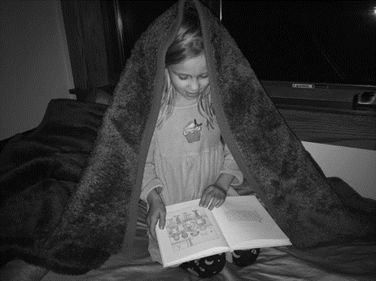Anchoring Phenomenon:

Picture of a child with a book under the covers.

Driving Question:

How can I read under the covers when it’s dark?

Lesson Focus Questions:

1. What happens when we try to read in bed under the covers?
2. What happens when we shine light on different objects?
3. How can we model the ways that light interacts with different objects?

Open Educational Resource:

[SOLID Start Curriculum](https://education.msu.edu/research/projects/solid-start/curriculum/), Grade 1: Reading Under Cover

Developed by Michigan State University with funding through the National Science Foundation

*Kentucky Academic Standards (KAS) for Science:*

1-PS4-3 Plan and conduct an investigation to determine the effect of placing objects made with different materials in the path of a beam of light.

|  |  |  |
| --- | --- | --- |
| **Science and Engineering Practices** | **Disciplinary Core Idea** | **Crosscutting Concepts** |
| **Planning and Carrying Out Investigations** | **PS4.B: Electromagnetic Radiation** | **Cause and Effect** |

*Educators may have to engage with a standard multiple times throughout a year to meet the full intent of the standard. As a result, the following example may not encompass the entire scope of the standards identified*.

## Reading and Writing Connection

Vibrant student experiences in science differ from those in reading and writing. However, intentionally aligning the topics enhances learning in both. The following green-rated High-Quality Instructional Resource (HQIR) is used in reading and writing during the same time period as this science learning experience:

HQIR: Into Reading

Knowledge-Building Topic: Why Light and Dark Come and Go

Grade-Level Complex Text(s): *Oscar and the Moth* by Geoff Waring

The following reading and writing standards and tasks, along with Interdisciplinary Literacy Practices, play a supporting role and are integrated in this vibrant science learning experience:

Text-Dependent Tasks: Writing to Learn, Writing to Demonstrate Learning

*Kentucky Academic Standards for Reading and Writing*: RI.1.1, RI.1.2, RI.1.3, RI.1.4, RI.1.8, RI.1.9, C.1.6, L.1.4, L.1.5

*Interdisciplinary Literacy Practices*: 1, 2, 3, 4, 6, 7, 8, 9

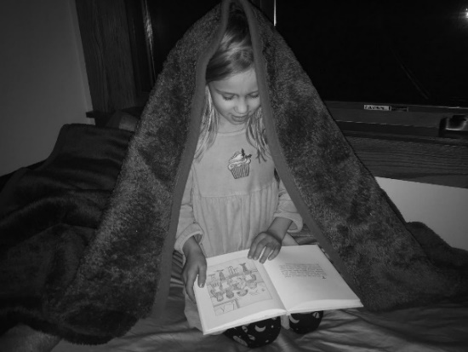To set the stage for learning, present students with a phenomenon regarding a picture of a child underneath a blanket with a book. Describe the situation, but not the result. For example, I remember a time when I was about your age, and I was reading a very good book. I was almost to the end of the book and didn’t want to put it down! It felt like I needed to find out what happened! Unfortunately, it was bedtime, and I had to turn off the lights. I thought, ‘if only I could read under the covers for three more pages, then my parents wouldn’t be able to see me reading!’ Has that ever happened to you? What happens when we try to read under the covers when it’s dark? Look at this picture and see what you think.

**Overall Learning Objective**: Students explore reading under covers using forts made of different materials. Students share initial ideas about why some of the materials are easier than others to read under.

**Launching the Anchoring Phenomenon**

**Driving Question: How can I read under the covers when it’s dark?**

Michigan State University SOLID Start Curriculum Materials (2024). Grade 1 Reading Under Cover. Google Slide Deck Lesson. [Curriculum Materials - Research (msu.edu)](https://edwp.educ.msu.edu/research/projects/solid-start/curriculum-materials/)

Explain that scientists make a model to show how something looks or how it works. Have students draw an initial model to explain why the child cannot read under the covers in the dark. Some models may have different features and naïve ideas because these are initial models. While some may include a light source, others may not. It is important to allow students to share their current thinking without fear of being wrong. The purpose of the initial model is to make the student thinking visible to the teacher, so the teacher knows how to support the students in growing their science ideas.

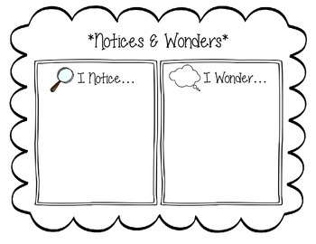Introduce the driving question, How Can I Read Under the Covers When It’s Dark? Explain that they will be investigating this together. Ask students to share their ideas, experiences and questions. Record initial ideas in the “I notice, I wonder chart”. This learning experience calls for student led discussion facilitated by the teacher. Possible questions and phrases to support the discussion include:

* Tell me more about that.
* Why do you think that is?
* Can you explain your thinking?
* Does anyone have a different experience/idea?

**Learning Objective:** Students investigate to make observations about how easy or hard it is to read under different types of covers.

## Learning Experience #1: What happens when we try to read in bed under the covers?

Ask students*, What happens when we try to read in bed under the covers?* Explain they will investigate the phenomenon by trying to read a book placed under different types of covers set up as “forts” in the classroom. Ask*, have you ever made a fort in your home? What did you use?* Explain to students that they will investigate forts made of different materials (clear shower curtain, thin sheet, thick blanket or comforter”) to see how the light travels through those materials to allow us to read a book. Provide time for students to feel and see the material up close before making the forts. Have students draw each of the materials to show how they are different.

As we think about getting under our forts, what else might we need in order to read our book? Students should acknowledge that we need light to read our book. Read aloud the book, *Oscar and the Moth* by Geoff Waring. Ask, *where does light come from*? This fictional book addresses sources of light. After reading aloud as a class, have the students recall all the sources of light identified in the book on pages 18-21. Now, identify sources of light both inside and outside of the classroom with students. Turn off the lights so students can identify light sources still present in the classroom. Have students make observations about what they can see in the room with the lights off.

Turn the lights back on and ask the students to make predictions on how well they will be able to read under each type of cover. Record student predictions on a class chart to refer to after the investigation. This record of student ideas will allow the class the opportunity to see how their ideas grow, and change based on the findings from their investigation.

Divide students into small groups and give a book to the group. With the lights turned off in the room, provide time for each group to rotate from one fort to another making observations about seeing their book. Make sure the room is dark, so they start to recognize that it is easier to read under the clear shower curtain compared with the other forts. Provide time at each fort for students to record their observations on the student response sheet provided in [SOLID Start Lesson 1: Reading in the Dark Model](https://edwp.educ.msu.edu/research/projects/solid-start/curriculum-materials/).

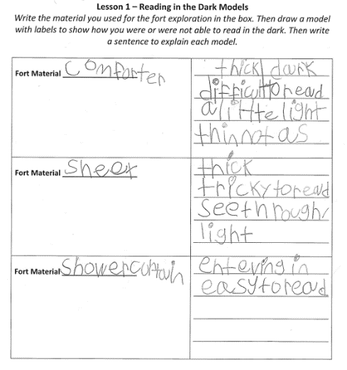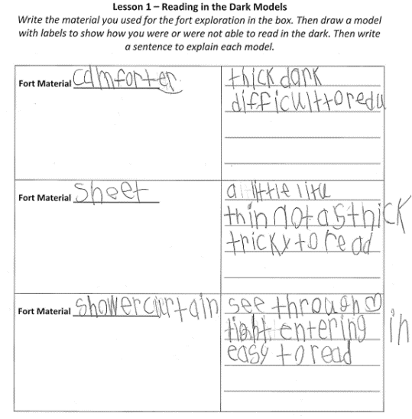

As students investigate, walk around and listen for students’ ideas about which forts they could read under and why they think it is easier to read under certain forts compared with other forts.

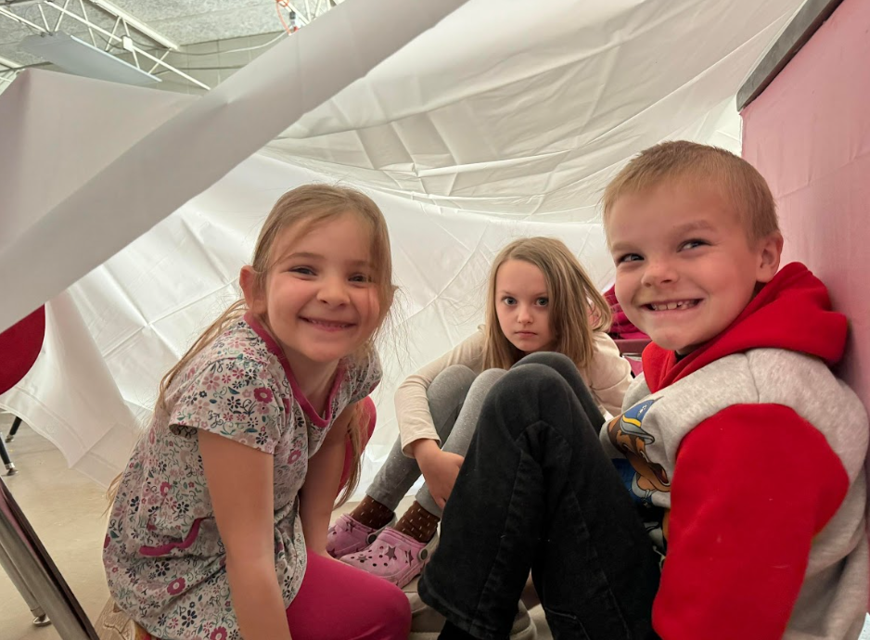 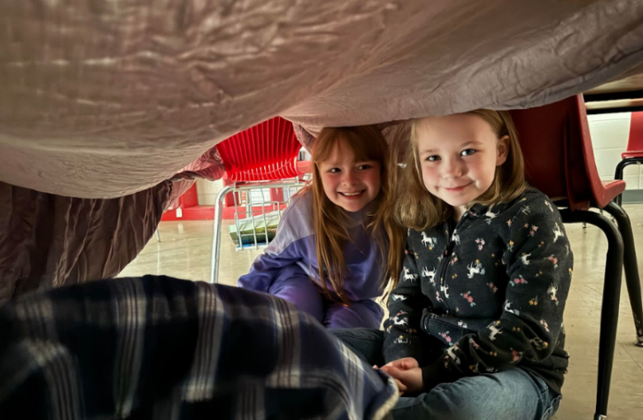

After students have investigated the phenomena, in whole group, discuss differences between the covers. Encourage

multi-word responses. Write down children’s observations on the board to help them recall and build on theirs and each

other observations. Allow students to add their observations to their student response sheet. While leading the discussion, include questions such as:

* What did you notice about the differences in forts?
* Which forts were easier or harder to read under? Why?
* How would you describe the materials that made the forts?
* Why do you think it is easier to read under the clear shower curtain?
* What do you think was the cause of the forts being easy or hard to read under? Why do you say that?

During the discussion, support student ideas and connections made between theirs and other students’ ideas. If students are struggling connecting to other’s ideas, model this for them. To support discussion, consider the following:

* Who can add on to ____’s ideas?
* How would you response to ____’s observations? Was that the same as your observation?
* Did anyone else notice something different than ____ when they were experimenting with the fort materials?
* It sounds like you disagree with ____. Can you explain your thinking?

Explain that we want to record what we noticed in our “forts” and why we think that happened. To do so, we are going to make a model by drawing our ideas on the student response sheet about how we can read under some covers, but not others. To help students make a model, without telling them exactly what to do, make a list of what needs to be included in the models. Refer to the initial models created during the launch of the phenomenon and their investigation for students to draw ideas from. For example,

* We used blankets and a shower curtain in our exploration today. What else did we use?
* Next, let’s think about what happened once you were inside your fort and holding your book. Could you read it? How can we show that?
* Students may observe light getting in through the shower curtain. How can we show this on our model? What symbols could we use?

Look over students' models to gauge how students are developing their models. These are their first attempts at modeling how light interacts with different materials. Students should share multiple ideas and how they might represent them, to be sure that they are able to think through what is happening with each fort cover. Once students share their ideas, have students think about common symbols they saw in the models that helped them understand the model better. During this discussion support students in forming the science idea of what light rays are, where they come from, and how they travel. Determine how these can be represented when making models. Create a class consensus of agreed on symbols and their meanings. Students should use these symbols in the models as they continue learning how light interacts with different materials. Teachers may need to revisit and add to this list of symbols as student understanding deepens.

**Learning Objective:** Students investigate how light interacts with different materials.

## Learning Experience #2: What happens when we shine light on different objects?

Remind students of the puzzling phenomenon and the unit driving question, *How Can I Read Under the Covers When It’s Dark?* Ask students what they did yesterday that started to help them answer the unit driving question. Discuss the materials used to make forts from the previous lesson. Ask students to turn and talk to their shoulder partner about what it was like to read under each of the materials. Call on a few pairs of partners to share with the class.

Explain that you have brought some new materials that students will get to work with to answer our focus question, what happens when we shine light on different objects? Students will be investigating objects like the different materials in the fort to consider how light is interacting with those materials. Examples to consider: shower curtain (sheet protectors), sheet (tissues), comforter (thick construction paper).

Collaboratively plan the investigation with students to answer the question, *How might light interact with these materials*? The materials in this investigation are not as big as the blankets and sheets used for the forts in previous learning experience, but students can examine how light interacts with similar materials. Have students select some materials they think are like the materials used in the forts. Elicit student ideas and guide them to plan out what steps they should follow to test each material. Guide the student discussion with the following questions:

* What will be our light source?
* How do we position our light source with our materials?
* What are some things to think about to protect our eyes and hands?
* What observations do we need to make?
* How should we collect our findings?

Example: Turn off the lights in the classroom. With a partner, choose one object and a light source (flashlight). Turn the flashlight on. Do not look directly into the light source. One partner holds the material while the other partner shines the light directly on the material. One partner places a hand under the material. Observe how much light hits the hand through the material. Observe how much light can be seen through the material. Record your observations.

Co-create a data table by passing out Lesson 2: Data Table (below): How Much Light Passes Through? Ask students to help name and fill out each of the columns. For example, the first row of a table often has a heading for each column. Headings help organize the information because they tell us where the data belongs. Our first column will be a list of all the materials we are going to test. The next three columns will show the results of our investigation.

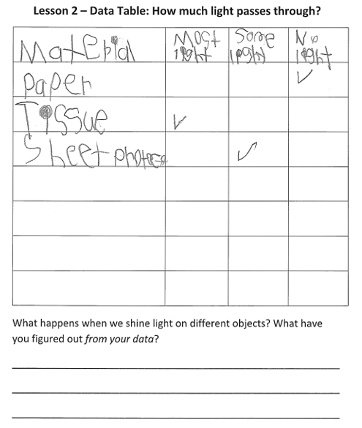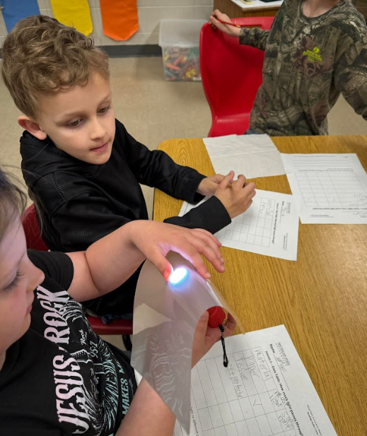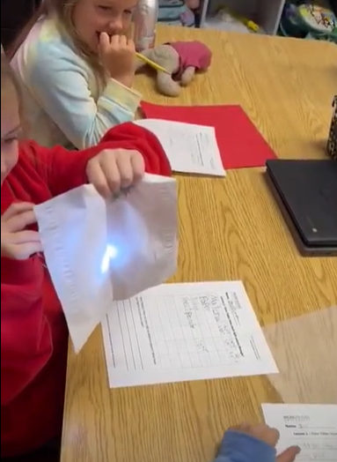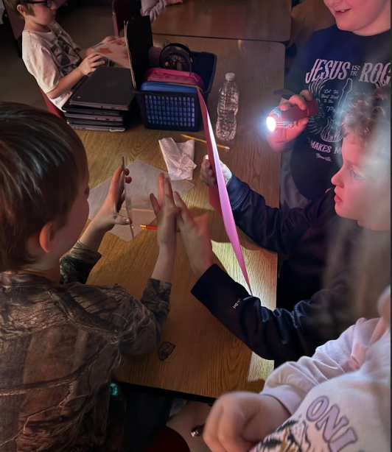Let’s try a similar format. On this table, we want to answer the question in our title, “How much light passes through?” What are words we could use that represent how much light passed through? Think back to our forts and how we talked about light. (Consideration: most, some and none). Have students make predictions prior to investigating by taking a class vote. Tally student responses and record on the board to revisit after the investigation. Have students carry out their investigation in groups and record their data.

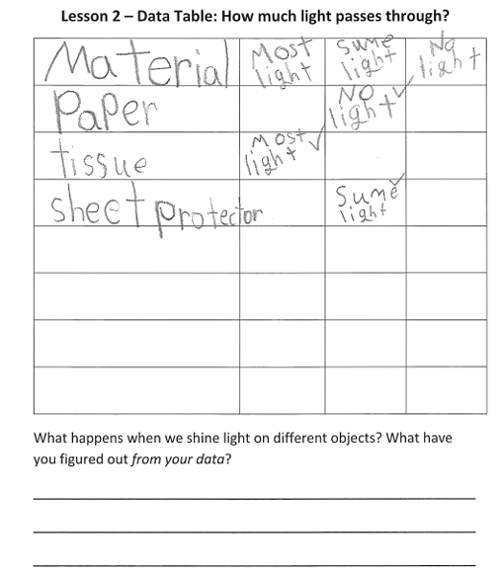

Discuss how much light passes through the materials using their recorded data. Start by using the questions below. During the conversation, create or display a blank data table and record what the different groups found for each of the different types of materials. Refer to the record of the students’ predictions. Compare the data from the investigation with their predictions. Encourage students to use the following discussion stems to compare their predications to the data:

* I see…/I notice…
* I think that…
* I think it looks like…
* The reason I think that…
* The chart shows…
* I agree/disagree with _____because…
* I want to add on to what ________said…

Then lead a discussion about the similarities in the materials that allow all, some, and no light through. Make a chart of the similarities in the materials.

Ask questions such as:

• What did you notice about the materials that allowed most of the light to pass through?

• What did you notice about the materials that allowed some light to pass through?

• What did you notice about the materials that allowed no light to pass through?

Present a new material to the class and use the exit slip below to check students' understanding. Consider allowing students to explain their thinking.

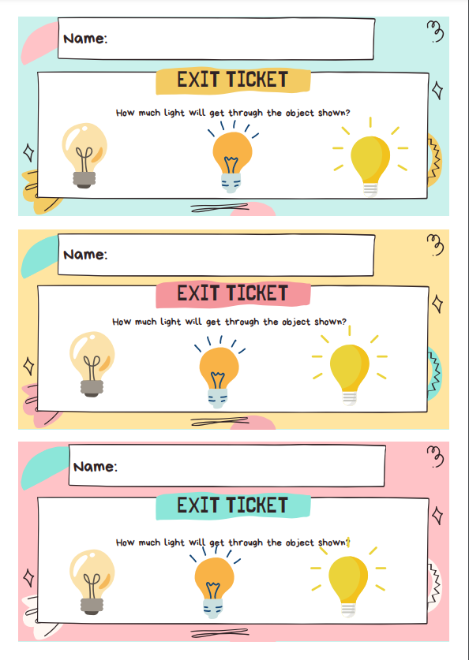

**Learning Objective:** Students model the different ways light interacts with materials.

## Learning Experience #3: How can we model the ways that light interacts with different objects?

Ask students to turn and talk to a classmate about one material they investigated in the previous lesson and what happened to the light rays when they interacted with that material. Encourage different pairs to share their ideas with the class. Encourage students to use the following discussion stems:

* I noticed…
* My idea is….
* The reason I think this is…
* My evidence is…
* Are you saying that…
* Can you say more about…
* That idea makes sense to me because…

Refer to the similarities chart of the materials that allow all, some and no light through. Using specific scientific vocabulary is important, even in early years. With the class, label each group of materials using the terms transparent, translucent and opaque. Connect these vocabulary words with the common words students have been using in the classroom which are most, some or no light coming through. Use a [Frayer Model](https://www.theteachertoolkit.com/index.php/tool/frayer-model) to work through the meaning of each word. This vocabulary work can be done as a whole class, or in small groups over a period of time.

Vocabulary Words

* Transparent: lets most light pass through.
* Translucent: lets some light pass through.
* Opaque: does not let light pass through.

For example: Begin with one object used in a previous learning experience such as the shower curtain or a page protector. Rebuild the physical model using the light source (flashlight) and talk about the path of the light beams. As students refer to the class findings, confirm the science idea that these types of materials allow most light to pass through the materials. Identify this material as transparent. Have students paste a Frayer Model in their science notebooks to work alongside the one being built as a class. Work through the Frayer Model identifying the definition, characteristics, examples and non-examples that represent the word transparent. Once students have built an understanding of the meaning of the word, individual students will develop a model of how light rays interact with a transparent material. Encourage students to select one of their examples from their Frayer Model to include in this model. Students can draw or build their model, based on individual needs. Repeat this process for the other two words translucent and opaque.

At this point, the students are ready to read more about light. Introduce the text, *Light! It Helps Us See* by Alan Walker. Have students pull key details from the text that would help them to understand more about how light interacts with materials.

Remind students of the puzzling phenomenon and the driving question, *How Can I Read Under the Covers When It’s*

*Dark?* Use the focus questions to help guide the conversations and remind students how they have grown in their understanding. Ask students how their investigations have helped them start to answer the driving question. They should support their ideas with evidence from previous investigations.

Focus Questions

Learning Experience 1: What happens when we try to read in bed under the covers?

Learning Experience 2: What happens when we shine light on different objects?

Learning Experience 3: How can we model the ways that light interacts with different objects?

Return to the initial model from the launch of the phenomenon. What changes might you make to the model based on new understanding? Provide time for students to revise their models to show their how their thinking has grown and changed. Encourage students to use their model and scientific vocabulary learned to answer the driving question.

## Culminating Task:

To demonstrate understanding on how light interacts with materials, students explore a way light helps many people on land and sea.

Show a video or read a book about how lighthouses work for mariners.  Pause and discuss aspects of the lighthouse to help with any questions or naïve ideas students may have.  After the video or book, share the assessment tasks below with the students.

**Student Work Examples:**

*Please note that the following are samples of students’ work and should not be interpreted as exemplars.*

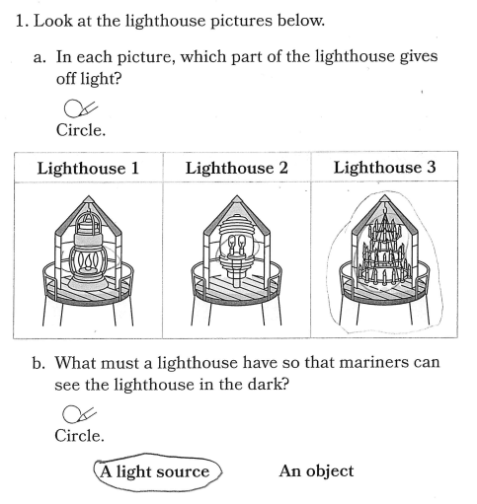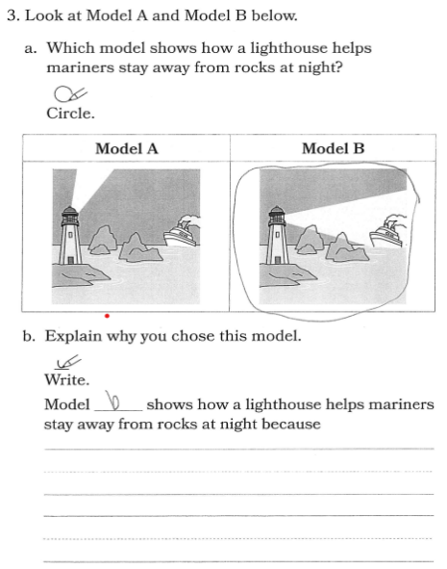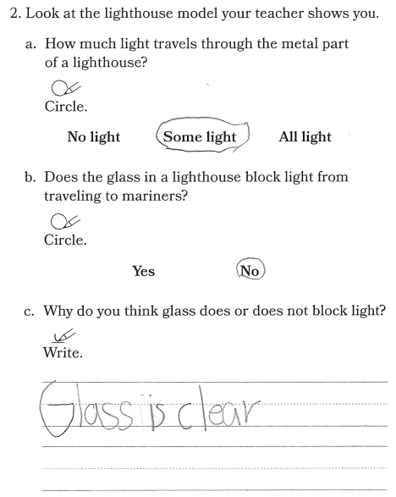**Student 1:**

***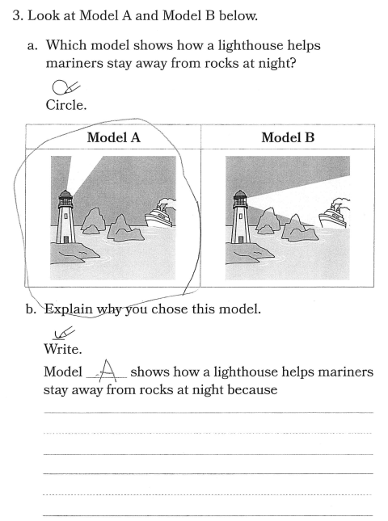*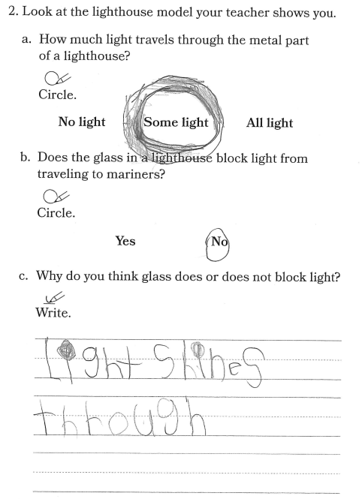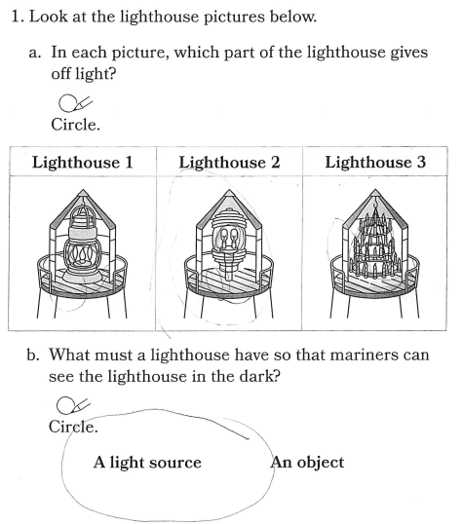Student 2:**

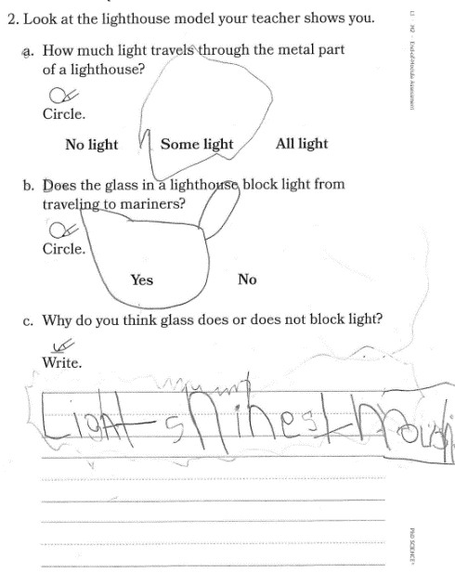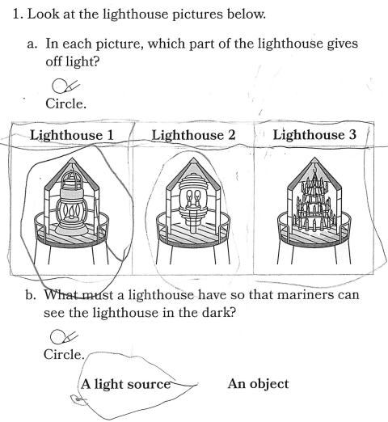**Student 3:**

