**WondersElementary Social Studies Learning Experience**

**Integrated with a Reading and Writing Instructional Resource**

Grade K Civics Example 2

*This example was adapted from a teacher submission.*

|  |
| --- |
| **Social Studies Experience Overview** |

By the end of this learning experience, students will understand why it is important for them to help out at home and be able to identify roles and responsibilities of themselves as well as other members of their household.

***KAS for Social Studies* alignment:**

* K.I.Q.1 Ask compelling questions about their community.
* K.C.RR.1 Identify roles and responsibilities of self and others at home, in school, and neighborhood settings.

*Educators may have to engage with a standard multiple times throughout a year in order to meet the full intent of the standard. As a result, the following assignment example may not encompass the entire scope of the standards identified*.

|  |
| --- |
| **Reading and Writing Connection** |

Vibrant student experiences in Social Studies differ from those in Reading and Writing. However, intentionally aligning the topics enhances learning in both. The following green-rated High-Quality Instructional Resource (HQIR) is used in Reading and Writing during the same time period as this Social Studies learning experience:

HQIR: Wonders 2020

Knowledge-Building Topic: How Things Change; Helping Out at Home

Grade-Level Complex Text(s): *Peter’s Chair* by Ezra Jack Keats

The following Reading and Writing standards and tasks, along with Interdisciplinary Literacy Practices, play a supporting role and are integrated in this vibrant Social Studies Learning Experience:

Text-Dependent Tasks: Writing to Learn, Writing to Demonstrate Learning

*Kentucky Academic Standards for Reading and Writing*: RI.K.1, RI.K.2, RI.K.3, RI.K.4, RI.K.9 RI.K.10, L.K.4, C.K.5, C.K.6

*Interdisciplinary Literacy Practices*: 1, 2, 3, 4, 5, 6

|  |
| --- |
| **Setting the Stage: Compelling Question** |

|  |
| --- |
| **K.I.Q.1** Ask compelling questions about their community  **Compelling Question**: How can family members work together so that the household runs smoothly? |

Compelling questions are open-ended, enduring and center on significant unresolved issues. For more information on compelling questions, visit Section B: “What are Compelling Questions and how do students ask them?” from the [Inquiry Practices of the *KAS for Social Studies*](https://education.ky.gov/curriculum/standards/kyacadstand/Documents/Inquiry_Practices_of_KAS_for_Social_Studies.pptx)module.

Introduce the compelling question to students by reading it aloud to the class. Facilitate a class discussion to determine what background knowledge students already have on this topic. If they read Peter’s Chair by Ezra Jack Keats during their reading instruction, they may discuss how they learned that their household chores may change as they get older. They may also share additional information about ways people work together in their household. Ensure that students understand the compelling question and what they will be investigating before moving on.

**Investigation**

|  |
| --- |
| **K.C.RR.1** Identify roles and responsibilities of self and others at home, in school, and neighborhood settings. |

Explain to students that they will now begin investigating the compelling question, “How can family members work together so that the household runs smoothly?”, by exploring different types of sources. If needed, review the following vocabulary words:

|  |
| --- |
| Chores: jobs you do to help at home  Contribute: to give something or help someone |

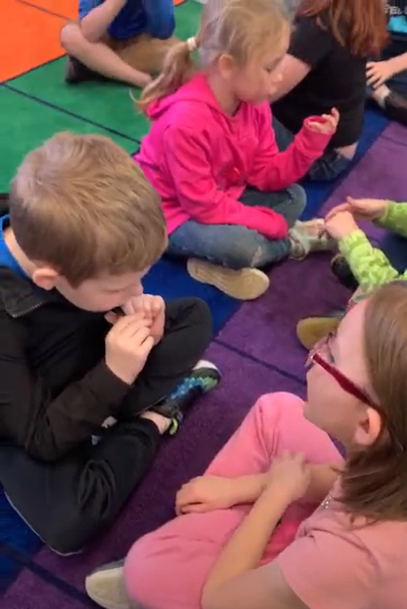

If students have read Peter’s Chair, remind them that they learned about how they can help with a new baby at home. Explain to students that this is one reason they may need to help out at home, but there are many other reasons and ways to help.

Ask students to [Turn and Talk](https://www.theteachertoolkit.com/index.php/tool/turn-and-talk) with a partner about other reasons why their adults at home may need extra help. Student responses may include, but are not limited to: if there is a new pet, if a family member is sick, etc. After pairs have had time to discuss, allow them to share out during a whole group discussion.

Explain to students that they will now examine some different sources (images) showing children helping out around their homes. Ask students to work in small groups to view each image and describe what is happening in each one:

|  |
| --- |
| A photo of a girl folding clothes.  Barts, Nicola. (n.d.). *Close-Up Shot of a Girl Folding Clothes* [image]. Pexels. <https://www.pexels.com/photo/close-up-shot-of-a-girl-folding-clothes-7943537/>  A photo of a little boy sweeping with a dust pan.  Lucia, J. (2023, December 20). *Untitled* [image]. Flickr. <https://www.flickr.com/photos/theloushe/4908427309>  A picture of a father and daughter in the kitchen looking at a cook book.  Lach, Ron. (n.d.). *A girl looking at a cook book with her father*. Pexels. <https://www.pexels.com/photo/a-girl-looking-at-a-cook-book-with-her-father-8188918/>  A photo of a boy washing a pan.  Luck, R. (2011, September 9). *Gabriel rinses a bowl*. [image]. Flickr. <https://www.flickr.com/photos/royluck/6129972548>  A photo of a baby helping his mom put clothes in the washer.  Cda. (2017, March 21). *Woman doing laundry with child*. Flickr. <https://www.flickr.com/photos/148434301@N05/33410836912> |

After students have had time to discuss these images with each other, discuss them together as a class. Ask students to share the children’s actions in the photos and why those are helping their homes run smoothly. On chart paper that is displayed for the class, create a list of ways children are able to help at home, using both the images and their personal experiences and ideas. Here is an example of a list from a Kentucky classroom:

I can help at home by...
1. clean up my room
2. vacuuming the floor
3. feeding the cats
4. doing the dishes
5. doing laundry
6. dusting
7. tidy outside
8. take out trash

Then, ask students to choose a way they can start helping in their homes and explain using words and/or drawing. Provide a sentence starter such as “I plan to help at home by…” to support students, and allow students to reference the class generated list. Here are some examples from a Kentucky classroom:

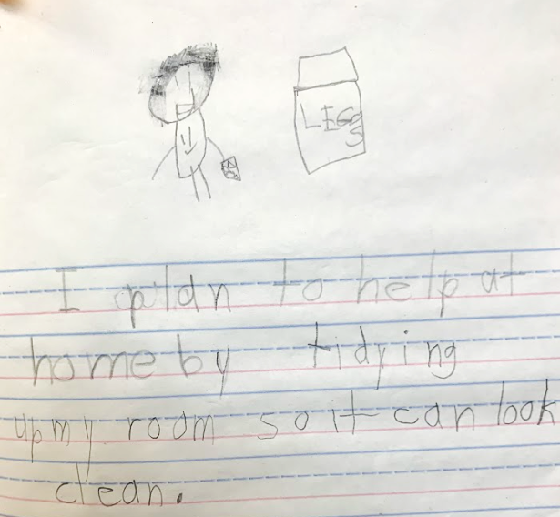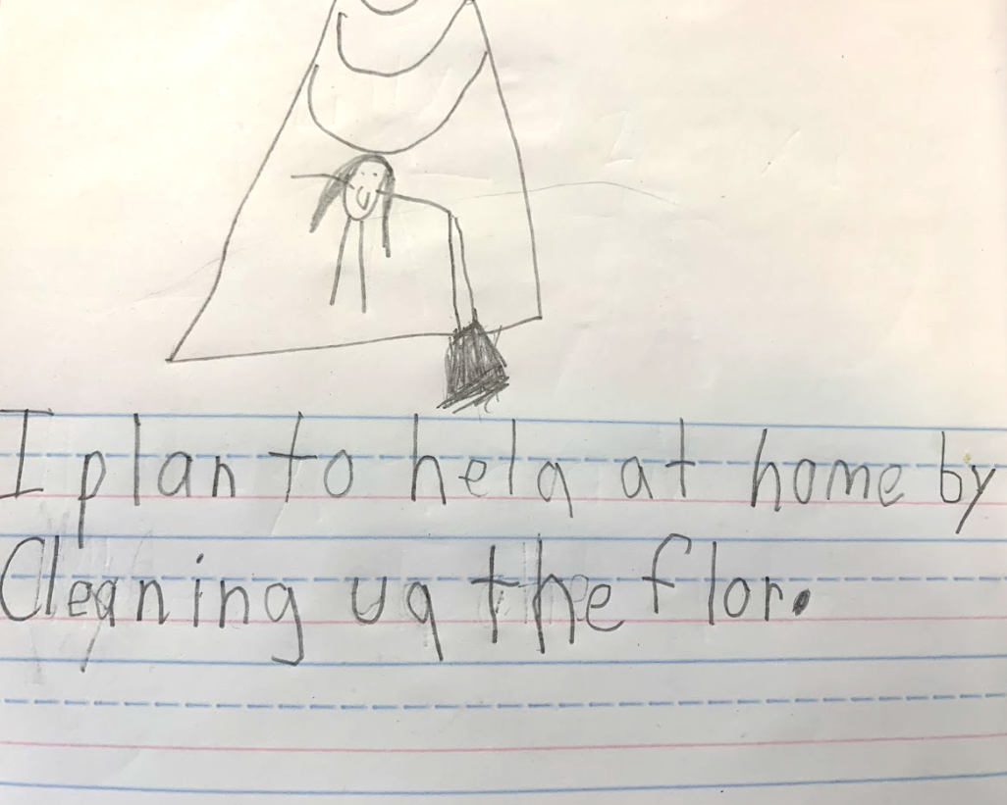

Now that they have identified ways children can help out at home, they will investigate other members of their household and their responsibilities. Provide the following sources for students to examine that show adults helping around the house. Ask students to identify the actions they are taking that are helping the household to run smoothly:

|  |
| --- |
| Photo of a person cutting vegetables.  PickPik. (n.d.). *person chopping vegetable using gray knife* [image]. <https://www.pickpik.com/cut-food-cooking-meal-kitchen-cutting-117303>  Photo of a man at the grocery store.  Allen, Ben. (2010, August 4). *Alg_man_grocery_shopping* [image]. <https://www.flickr.com/photos/bennel/4859598297>  Photo of a man with a lawn mower.  Fring, Gustavo. (n.d.). Man in Black and White Checkered Long Sleeve Shirt and Denim Pants Sitting beside Black Grass Cutter  [image]. <https://www.pexels.com/photo/man-in-black-and-white-checkered-long-sleeve-shirt-and-denim-pants-sitting-beside-black-grass-cutter-5163433/>  Photo of a woman fixing the sink.  TWP inc. (2018, October 19). Sink repair by female plumber [image]. <https://www.flickr.com/photos/twpinc/43619960520>  Photo of a woman mopping.  Miroshnichenko, Tima. (n.d.). Woman in Gray Sweater Mopping a Tiled Floor [image]. <https://www.pexels.com/photo/woman-in-gray-sweater-mopping-a-tiled-floor-6196575/> |

After students have had time to discuss each of these images, discuss them together as a class. Ask students to share the adults’ actions in the photos and why those are helping their homes run smoothly. On chart paper that is displayed for the class, create a list of ways adults help at home, using both the images and their personal experiences and ideas. Here is an example of a list from a Kentucky classroom:

My grown ups help by...
Dad and mom cook
Mom vacuums
Mom mops
Mom uses the vacuum-mop
Mom and Dad take care of the baby
The adult takes the trash to the bin
Mom washes the dog

After a list is complete, discuss how different members of the household may help in different ways. For example, why might some chores be different for children and adults? Students may note that some chores might be more difficult for children or more dangerous. Ensure that students understand that different members of our household may be responsible for different chores and that they are all important so that the household can run smoothly.

Ask students to think about how others in their household help out around the home. Ask them to use writing and/or drawing to provide an example of how someone else in their household helps out. Provide a sentence starter to support students, such as “_______ helps by ______.”

Now that students have identified ways different members of their household can help out to make things run smoothly, ask them to respond to the compelling question with the task below.

**Task Aligned to the Compelling Question**

|  |
| --- |
| * K.I.Q.1 Ask compelling questions about their community. * K.C.RR.1 Identify roles and responsibilities of self and others at home, in school, and neighborhood settings. |

Students will now respond to the compelling question: “How can family members work together so that the household runs smoothly?” Consider other ways students can demonstrate their learning in addition to words and drawings. One option is to allow students to create a video using a program such as Flipgrid where students verbally respond to the question.

|  |
| --- |
| **Task:**  Respond to the following question: “How can family members work together so that the household runs smoothly?” In your answer, identify each member of your household and at least one way they can help at home. |

Students’ responses can be evaluated to assess their ability to identify roles and responsibilities of self and others at home. Note that this is only part of the standard and students will need additional instruction to learn about the roles and responsibilities of self and others in school and neighborhood settings.