# Elementary Science Learning Experience

# Integrated with a Reading and Writing Instructional Resource

Grade 2 Example 3

*This example was adapted from a teacher submission.*

## Science Experience Overview

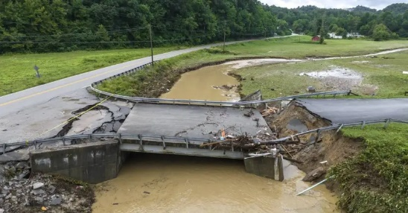Engineering Problem:

The KY 343 in McRoberts, Kentucky, was among the bridges washed out in historic flooding on August 2, 2022 and many families were unable to get to school due to the damage caused by the flood.

Driving Question:

How can we build a bridge to get safely across a river?

Lesson Focus Questions:

Ryan C. Hermens/TNS. (2022). Government Technology. <https://www.govtech.com/em/safety/scores-of-bridges-damaged-in-record-kentucky-flooding>

1. How do engineers solve a problem?
2. What materials are best suited for making bridges strong?
3. What type of bridge would be best to solve our problem?
4. How can we test and refine our bridge design?

## *Kentucky Academic Standards (KAS) for Science*:

* 2-PS1-2 Analyze data obtained from testing different materials to determine which materials have the properties that are best suited for an intended purpose. *
* K-2-ETS1-3 Analyze data from tests of two objects designed to solve the same problem to compare the strengths and weaknesses of how each performs. *

|  |  |  |
| --- | --- | --- |
| **Science and Engineering Practices** | **Disciplinary Core Idea** | **Crosscutting Concepts** |
| **Analyzing and Interpreting Data** | **PS1.A: Structure and Properties of Matter**  **ETS1.C: Optimizing the Design Solution** | **Cause and Effect** |

*Educators may have to engage with a standard multiple times throughout a year to meet the full intent of the standard. As a result, the following example may not encompass the entire scope of the standards identified*.

## Reading and Writing Connection

Vibrant student experiences in science differ from those in Reading and Writing.  However, intentionally aligning the topics enhances learning in both.  The following, green-rated High-Quality Instructional Resource (HQIR) is used in reading and writing during the same time period as this science learning experience:

HQIR: EL Education

Knowledge-Building Topic: Schools and Community

Grade-Level Complex Text: Readers Theater Script: Boat School “Water, Water Everywhere”

The following reading and writing standards and tasks, along with Interdisciplinary Literacy Practices, play a supporting role and are integrated in this vibrant science learning experience:

Text-Dependent Tasks: Writing to Learn, Writing to Demonstrate Learning

*Kentucky Academic Standards for Reading and Writing*: RI.2.1, RI.2.3, RI.2.4, RI.2.9, RI.2.10, C.2.5, C.2.6, L.2.4, L.2.5

*Interdisciplinary Literacy Practices*: 1, 2, 3, 4, 6, 7, 8, 9, 10

## Engineering Problem

**Driving Question: How can we build a bridge to get safely across a river***?*

**Overall Learning Objective:** Students identify the engineering problem and havean opportunity to brainstorm possible solutions.

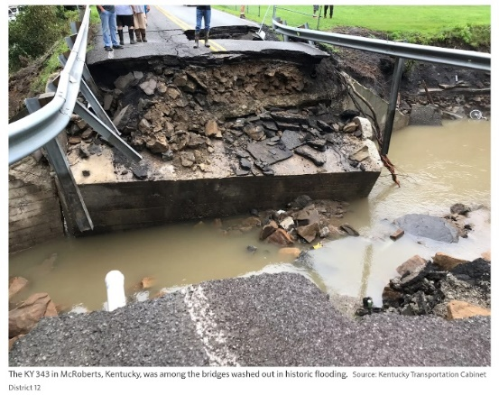As part of the knowledge building topic, Schools and Community, students read Readers Theater Script: Boat School “Water, Water Everywhere”. This unit is about challenges that communities have faced which caused school closures. This text is a play about a group of students in Chalanbeel Region, Bangladesh. This area was hit by a season of great flooding, causing students difficulties getting to school. The community had to figure out a solution where all students could get to school. To help students connect the problem from the play to their life, ask students to think of a time they experienced a storm when there was a lot of rain similar to the play. Have them share their stories with a partner briefly. Acknowledge the students’ experiences and any damage they witnessed. Show students image 1 of a collapsed bridge following the historic flooding in eastern Kentucky in 2022. The KY 343 in McRoberts, Kentucky, was among the bridges washed out in historic flooding.

Image 1: McLoud, Don. (2022). Equipment World. <https://www.equipmentworld.com/roadbuilding/article/15295248/crews-work-to-reopen-roads-bridges-after-kentucky-floods>

Guide students to use the [Notice and Wonder Strategy](https://sadlerscience.com/notice-and-wonder/) to think about what they notice and wonder about the photograph, discuss in small groups and share out. Record student responses on an anchor chart.

Students said that they noticed when the concrete broke the railing broke, there is a second hole farther back on the road, there is a white pipe coming out under the road, and the rocks at the bottom of the water so it might not be deep there. The students wondered what is the pipe for, why is the pipe white, why are there people standing at the edge, how did heavy rain break through the rock, and why is the water and the ground deeper on the right than on the left. 



After students have observed the photograph, ask students to think about the question, “Why did the bridge collapse?” using the [Think-Pair-Share Strategy](https://letstalkscience.ca/educational-resources/learning-strategies/think-pair-share) with a partner. Allow students to share with the class. Record student responses on why the bridge collapsed and make a list of what a bridge might need.

Connect this back to the play, by asking *What was the problem in Water, Water Everywhere?* What other damages could occur as a result of a major rainstorm that could prevent students from getting to school? Relate this back to the picture of the collapsed bridge in McRoberts, KY. Acknowledge that the bridge collapsed, and the citizens could not travel across the bridge.

Ask the students, In the play, Water, Water Everywhere, what was the solution to their problem? What are some possible solutions to our problem in McRoberts? Brainstorm a list of solutions to the problem. Now that students have had time to consider the problem and discuss possible solutions, pose the question: *How can we build a bridge to get safely across a river?*

Have students work in small groups to develop a solution to the problem of the collapsed bridge. Give each group a piece of paper to sketch or write any ideas. Circulate the room while students are discussing to make note about their potential strategies. Once students are finished, post each group’s initial design around the room. Provide time for each group to look at other designs to see similarities and differences between design solutions.

Gather students together in a scientist circle to create a group consensus model showing what ideas are similar between all design solutions. List the differences between the solutions beside the consensus model for students to reference throughout the learning experience.

Introduce the engineering task to the students.

You have been hired as engineers to build a bridge to replace a fallen one. The bridge was used by the community to get across the river. Your job is to construct a bridge that can sustain (hold) the weight of a school bus loaded with students. Engineers must test their plans and models for a project. You will be supplied with a variety of materials. With a group, you will choose two different materials to construct a bridge. Each group will also get one roll of tape. After the initial design process, each group will be given the opportunity to test their bridge model one time. You may then revise your design to improve your bridge performance. After everyone has revised their designs, we will test the final model. If your bridge can successfully sustain the weight of a school bus loaded with students, you will receive a civil engineering certificate.

## Learning Experience #1: How do engineers solve a problem?

**Overall Learning Objective**: Understand the role of an engineer and how they identify a problem while relating it to their own problem.

As students identify as engineers within this task, tell students to solve this problem, they will need to use skills common to the field of engineering. Explain that an engineer is a person who designs and builds complex products, machines, systems, or structures. Engineers want to know how and why things work. They have scientific training that they use to make practical things. Engineers often specialize in a specific branch of engineering. The type of engineer who constructs buildings and bridges is called a civil engineer. Show students the [What’s an Engineer](https://www.youtube.com/watch?v=owHF9iLyxic) video. Ask students to recall the three questions engineers always ask when they’re working.

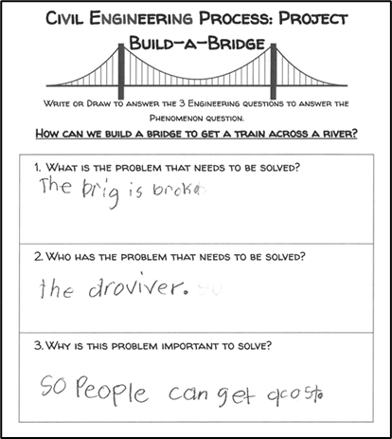

1. What is the problem that needs to be solved?

2. Who has the problem that needs to be solved?

3. Why is this problem important to solve?

Write these questions on the board or chart paper so that they can be referenced throughout the learning experience.

Review with students their engineering task for the learning experience. Guide students to answer these questions around their identified problem using the [Civil Engineering Process: Project Build-A-Bridge](https://www.education.ky.gov/curriculum/standards/kyacadstand/Documents/Civil_Engineering_Process_Project_Build_a_Bridge.pdf).

## Learning Experience 2: What materials are best suited for making bridges strong?

**Overall Learning Objective**: Investigate properties of various materials to identify the best material to use in building the bridge.

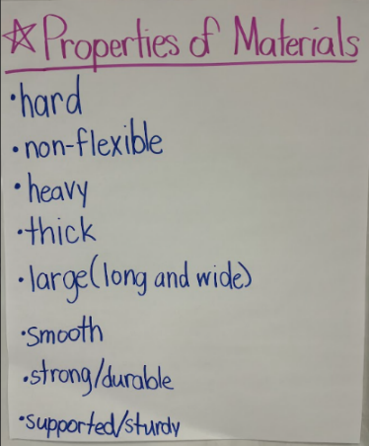To be successful in building a bridge, we must make sure our materials are the right materials for the task. Investigating the properties of various materials will help to identify the best material for the bridge. All materials have specific properties. Ask, “When you hear the word properties/characteristics, what do you think of?” Record student ideas on a chart. Collect a few commonly known items around the room (paper towel, aluminum foil, textbook, stuffed animal, sponge, white board, Styrofoam, straw, wooden dowel rod, large washer, sandpaper and a coin). Have students describe the properties/characteristics of those items to develop their thinking on properties of matter.

Prepare in advance a large chart with the title, “Properties of Materials”. As students investigate the commonly known items, record words to describe the uniqueness of each material. Ensure the properties hardness, flexibility, strength, texture, and absorbency are revealed as these are good properties for students to consider later when students selecting what properties they want to look for in their materials. Place the chart in a location that can be easily referenced. Ideas can be added to this at several points throughout the learning experience.

Since this is only a model, remind students we do not need to use the same materials engineers would use to construct an actual bridge. Brainstorm a list of materials needed to construct a bridge model. Collect materials suggested such as cardboard, popsicle sticks, construction paper, paper towel rolls, or lasagna noodles. Using the list of properties of material, ask *which of these properties* *should you consider when choosing materials for your bridge?* Have students select five important properties they want to investigate.

Create a large chart to classify the materials identified for the task of building a bridge. In the first row, list the properties the class selected. Rank each material based on the given property. Select one material from the list to model with the students. Then have the students select three more materials they are interested in using to build their bridge. An example is shown below using a water bottle and a wooden block. Have students share their findings with the group.

|  |  |  |  |  |  |
| --- | --- | --- | --- | --- | --- |
| **Properties/**  **Characteristics** | **Hardness**  *How can you determine whether this material is or is not hard?* | **Flexibility**  *Does the material bend easily without breaking?* | **Strength**  *Can the material withstand weight being applied without breaking or becoming deformed?* | **Texture**  *What does the material feel like? Is it smooth or rough?* | **Absorbency**  *Does the material soak up water?* |
| **Material #1**  **(water bottle)** | 1/5-Not very hard because it changes shape when pressure is applied | 5/5-Very flexible, bends easily without breaking | 3/5-Medium strength, it can withstand weight but becomes deformed | 3/5-Has some big bumps | 0/5-Soaks up no water |
| **Material #2**  **(wooden block)** | 5/5-Very hard, does not change shape when pressure is applied | 0/5-Does not bend at all | 5/5-Does not break or become deformed when weight is applied | 1/5-very smooth, no bumps | 2/5-Soaks up a little water, water leaves a spot on the wood |

Since we are talking about bridges, we will imagine these materials we investigated are being used to build bridges. When investigating materials to be considered, be explicit about what each component represents. Create an analogy map for students to relate how these items might be used to represent parts of a real bridge. Display or draw the outline of this analogy map on the board without writing the blue words just yet. Select items where students would identify three important parts of the bridge such as support beams, deck, and the school bus that will travel over the bridge. In the provided example, students use popsicle sticks, cardboard and a heavy book (textbook) to demonstrate this concept. The popsicle sticks and cardboard represent materials that engineers might build with such as concrete, lumber, metal, or wire to construct the support beams and deck of the bridge. Students determine the heavy book represents a school bus that might drive over the bridge.

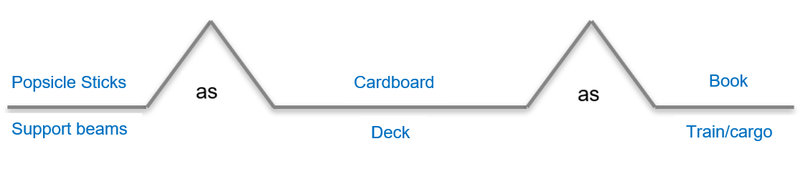

School Bus

After building the analogy map ask students what additional information, they need to be able to choose their materials. Students may ask*How heavy is their model school bus?* *How far will the model school bus need to travel?* Acknowledge that some materials would not be good choices for building bridges because they are not strong enough to withstand the weight of the school bus.  Provide time for students to place a heavy item on each selected material and record their observations.

Gather in a scientist circle and share out findings with the class. Students may share some materials crumbled while other materials did not change. Revisit the materials list and determine, based on our investigation, what materials are better than others for our intended purpose. Come to a class consensus and circle the best materials to use based on class data on students original list.

At this point, reflect on what observations and discoveries have been made so far. Ask students what questions they still have and record these on a “Questions We Have” Anchor Chart.

**Learning Experience 3: What type of bridge would be best to solve our problem?**

**Overall Learning Objective**: Research different type of bridges and select a bridge design to optimize a design solution.

Remind students of the local problem where a bridge collapsed in Kentucky due to flooding. Locate the consensus model to review how students initially planned to solve that problem. Review the engineering task assigned to the group and reflect with students what they have learned in lesson experience one and two. Explain that once engineers have selected the best materials for their project, they must research effective designs.

There are different types of bridges that all serve different purposes. Show students the [What Makes Bridges So Strong?](https://www.youtube.com/watch?v=oVOnRPefcno) video. After watching the video, ask students to recall the three types of bridges discussed in the video (beam bridge, truss bridge, and suspension bridge). Have students discuss, in small groups, the differences between these three bridge designs and determine which bridge structure would be the most suitable for their task. Since the focus of this learning is on the properties of materials rather than the design of the bridge, come to class consensus of which bridge design the class will use. The [Consensus Placemat](https://ctlonline.org/placemat-2/) strategy is intended to provide students with an opportunity to share their individual perspectives and thinking before working collaboratively to build on one another’s individual thinking. Explain the procedure for a Consensus Placemat and have students, in groups of four, complete a consensus placemat to decide what type of bridge would be best to solve the problem. Encourage them to keep in mind the materials they must work with and the purpose of the project. After each group comes to a consensus, allow the groups to complete a gallery walk to determine similarities and differences they see from each group. Share those out as a class and come to a consensus on which type of bridge best suits our purpose.

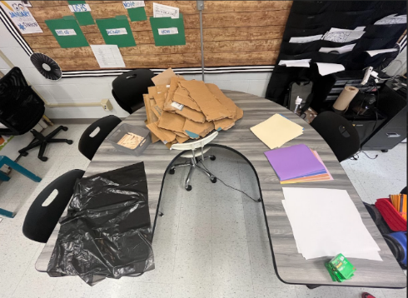Introduce students to the criteria and constraints for this project:

* Use 2 of the provided materials and be able to explain why those materials were chosen.
* Construct a bridge that fits the type of bridge chosen by the class.
* Construct a bridge that can sustain (hold) the weight of a school bus loaded with students.
* Every group will be given a roll of tape in addition to their 2 selected materials.

With the selected class bridge, each group will work together to plan what materials are going to be used and where those will be utilized within the design. Draw and label the design as a group on a sheet of paper. Meet with each group to discuss the final design before gathering materials to begin construction.

Students will now have a chance to work with their groups for 30 minutes to construct a model of their own bridge. During this work time, try to provide minimal guidance to allow students to productively struggle. Once groups are finished, partner groups together to share their bridge design. Encourage groups to ask questions and provide feedback about each other’s design.

**Overall Learning Objective**: Test and refine the bridge design to compare the strengths and weaknesses of how the bridge performs.

**Learning Experience 4: How can we test and refine our bridge design?**

Once engineers have built their design, they need to test their prototype to determine what revisions should be made to ensure that the bridge can successfully sustain the weight of a school bus loaded with students. In preparation for testing the students’ bridges, set two desks 2 feet apart and have an item(s) that will simulate the school bus. Some examples of items you might use are a hardcover chapter book, a small jar of peanut butter, a baseball, a bottle of water or a bundle of 75 pencils. This setup will need to remain for the duration of the activity and will be used multiple times from this point forward.

After the initial design phase, each group will get a chance to test their bridge on the class demonstration setup. Before completing the test of the bridges, have a discussion with students by posing the question, "How are we going to know if the bridge is a successful design or not?” The success of the bridge is based on the ability to sustain the weight of a school bus loaded with students. Students may notice changes in the bridge from the test such as the bridge held together in one piece, pieces may come apart, the bridge may bend, the bridge may break totally in two, the bridge may lean and the objects fall off, the bridge may wobble, or does it stay sturdy, strong, and tightly together.

Students will bring their bridge to the demo setup and fix it to the desks. The bridge should support itself without being touched or held. The teacher will then guide the vehicle across the model bridge.

Ask each group to reflect after their test to help them revise their designs. Each group will need to record their answers to the following reflection questions:

Reflection Questions

* Which parts of the design were most successful?
* Which parts of the design need improvement?
* Out of the materials provided, is there a different material that could improve the design?
* How could you improve your design?

After groups respond to the reflection questions, have each group share one strength and one weakness of their design. Record each group’s response on a class t-chart. Once all groups have had an opportunity to reflect and discuss their design, students return to their initial plan to make revisions. Each group can use one new material in this redesign. Allow groups 20 minutes to make the revisions to their bridge.

Repeat the testing process that was done in the first phase and ask the same reflection questions. Once all groups have been able to test their bridge designs a final time, it is time to reflect on the engineering task. Refer to the driving question, *How can we build a bridge to get safely across a river?*Gather student responses as students share key points from each learning experience. Focus questions can be used to help guide the conversations and remind students how they have grown in their understanding.

Focus Questions

Learning Experience 1: How do engineers solve a problem?

Learning Experience 2: What materials are best suited for making bridges strong?

Learning Experience 3: What type of bridge would be best to solve our problem?

Learning Experience 4: How can we test and refine our bridge design?

Create a chart to collect the class’s reflections. Record students’ reflections and responses to the driving question, How can we build a bridge to get safely across a river? Students must provide evidence from observations of any of the bridges tested in the class.  At the end of the discussion, present each student with a civil engineering certificate.

**Culminating Task:**

Distribute the [Project Build-a-Bridge Assessment](https://docs.google.com/document/d/1UF_1k0NlaZTdKcZh3ejHI1Ii_DYIujC6D5j1SNEroDM/edit?usp=sharing). Allow students time to respond to the prompts independently. Students will draw a model of their bridge design and tell which two materials they chose to use and why these materials were well-suited for building a bridge based on their properties.

*Please note that the following are samples of students’ work and should not be interpreted as exemplars. The student samples below show the students explaining the materials they chose; however, a student may decide they should have selected a different material based on their class findings and explain their reasoning behind the change.*

Part A: Student drew a picture of their bride design.

Part B: The student wrote these were the best materials I used pop sick sticks, tape, cardboard these materials were the best because my bridge made it that it was strong, non-flexible, sturdy, hard, thick. 

## Student Work Samples for Project Build-a-Bridge Assessment

### Student 1:

### 

Part A: Student drew a picture of their bride design.

Part B: The student wrote, cardboard and poster board because our bridge was successful and the cardboard held it.  The reason I used cardboard is because cardboard is strong and if you put tape on cardboard it will still be a little bendy but I used tape and it was successful. 

**Student 2:**