HS Geometry Assignment
This assignment is weakly aligned to the standards.
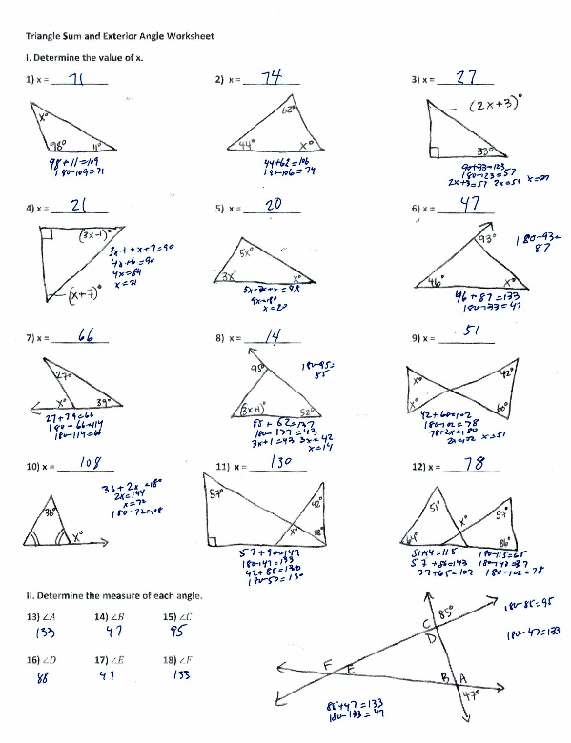

Overview
Students find unknown values of angles using relationships between the angles of a triangle, vertical angles, and linear pairs of angles. The assignment is weakly aligned with high school geometry standards because it involves applying, rather than proving, theorems and is more closely aligned with seventh- and eighth-grade standards.

Related Standards
We looked at how well the assignment aligned to the following standards:
KY.HS.G.6: Apply theorems for lines, angles, triangles, parallelograms.
KY.HS.G.7: Prove theorems about geometric figures.
KY.HS.G.7.a: Construct formal proofs to justify theorems for lines, angles and triangles.

Why is this assignment weakly aligned?
The Kentucky Academic Standard’s Clarifications for KY.HS.G.6 state that “students use previously learned definitions, theorems, postulates and properties of lines, angles, triangles and parallelograms to draw conclusions and to make inferences.” This assignment requires students to repeatedly apply a principle that should have already been established in eighth grade (standard KY.8.G.5): that the interior angles of a triangle add up to 180°. Some problems also ask students to apply concepts about supplementary, complementary, vertical, and adjacent angles, which is more appropriate for seventh grade (standard KY.7.G.5). A high school-level assignment aligned to this content would require students to prove the relationships of angle measures in triangles by writing verbal explanations and naming the mathematical properties that are the basis for solving problems of these types.
High school geometry standards ask students to reason formally about geometric relationships and to apply them in modeling contexts, where geometric principles are applied to authentic real-world scenarios. Students at this grade level should be able to construct careful, mathematically sound proofs and have the chance to connect their mathematical reasoning to authentic contexts. Although it is not unreasonable to access previously learned content in high school assignments, when doing so, students should be asked to reason with the content at a higher level than was required in middle school.
Practice Standards
High school geometry standards about proving theorems lend themselves to Mathematical Practice Standard #3 (“Construct viable arguments and critique the reasoning of others”). The assignment, however, does not ask students to explain their reasoning, nor does it connect to any real-world scenario; instead, it asks students to write and solve equations that are more suited for middle school.

