Kindergarten Learning Experience Example: K.G.KGE.1

Introduction
The following learning experience was developed by the Teach KY Agriculture to demonstrate implementation examples aligned to the Kentucky Academic Standards (KAS) for Social Studies K.G.KGE.1
It is important to note that the assignment(s), indicated throughout these Teacher Notes, and related resource(s) represent one example. This example is not a requirement nor a suggestion for school curriculum. While the Kentucky Department of Education (KDE) is responsible for the development of high-quality academic standards, state law assigns each local district the authority to develop the school’s curriculum and determine appropriate instructional resources based on language found in Kentucky Revised Statute (KRS) 160.345. It is under the discretion of the superintendent to determine the local curriculum, including the evaluation and selection of instructional resources. The KDE does not adopt, select or recommend specific curricula for coursework. Per KRS 160.345(g), “the local superintendent shall determine which curriculum, textbooks, instructional materials, and student support services shall be provided in the school after consulting with the local board of education, the school principal, and the school council and after a reasonable review and response period for stakeholders in accordance with local board of education policy.”

Kentucky Academic Standards (KAS) for Social Studies alignment:
K.G.KGE. 1 Identify physical and environmental characteristics of communities.
Educators may have to engage students with a standard multiple times throughout a year in order to meet the full intent of the standard. As a result, the following assignment example may not encompass the entire scope of the standards identified.

Overview:
Students will investigate the physical and environmental characteristics of their community in Kentucky and learn about the goods that are produced there.

Compelling Question:
What are the physical and environmental characteristics of my community that make it a good place to produce goods?

Teacher Notes
The following vocabulary words will be featured in this lesson:
- Physical Characteristics
- Environmental Characteristics
- Climate
- Weather
- Landforms
- Natural resources

Begin by providing students with a copy of the Agriculture Where I Live worksheet and access to coloring tools available in the classroom, such as crayons, colored pencils or markers. Explain that they will be filling out information on their worksheet throughout the lesson. The bottom of this worksheet is designed for use in Franklin County. Modify the county name and image for the county in which you live.
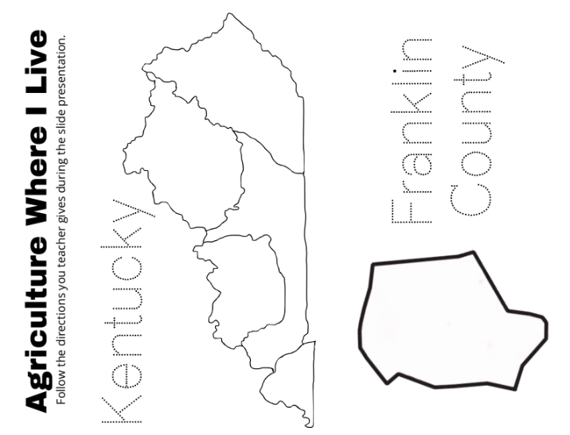

Then, display the How Does My Community Provide for My Needs? slideshow. Introduce the compelling question to students displayed on slide 13: “What are the physical and environmental characteristics of my community that make it a good place to produce goods?” Review vocabulary words on the slides that follow and support students in understanding the question and what they will be investigating today.

Next, introduce the five regions of Kentucky to students using the slide 17 and the links provided within the map. Have students get out one red, blue, yellow, green, and orange crayon, colored pencil or marker. Explain that they will be coloring their map as they learn about each region in Kentucky. Then, point out the region where you are located and have students draw a smiley face in the corresponding region on their map.

Then, discuss climate, water, and land in Kentucky and in their community with slides 18-20. Slides 21-44 contain an image of the land in various places that students can predict whether those places are Kentucky or not based on what they know about the land. Then, discuss natural resources such as energy and forests.

On slide 47, ask students to identify what’s shown in each of the pictures at the bottom of the map. Then click the map to see what types of things are grown or raised in each region.

Remind students that the physical and environmental characteristics of those regions dictate what can be grown or raised there. Prompt them with questions such as:
- What are some things that grow in every Kentucky region?
- What’s something that’s mostly in the EAST?
- What’s something that’s mostly in the WEST?
- Which of these things have you seen being grown or raised in your community?
- Does your family grow or raise any of these things?
- Which animal or crop do you know the MOST about?
- Which animal or crop do you know the LEAST about?

Ask students to attempt to draw or write one thing from each region on their map.

On slide 49, tell students they are going to take a closer look at their own county. First, have students identify all of the different pictures on their worksheet. Remind students of the compelling question, and then click the map at the top of the page to view your county profile. (Use the information provided, or scroll down and click the link for more primary friendly data). Discuss the information on your county profile and have students color or circle the answers on their worksheet.

Then, point out the physical and environmental characteristics of your community that make it a good place for these things to be grown or raised.

Task Aligned to the Compelling Question
This can be done at the end of the lesson, later in the day, or as a check for understanding at the beginning of the next lesson in the unit. Have students complete the task below, using what they have learned about their county. Ask them to circle the things they have, grow and raise, and to place an X over the things they do not have, grow and raise in their county.

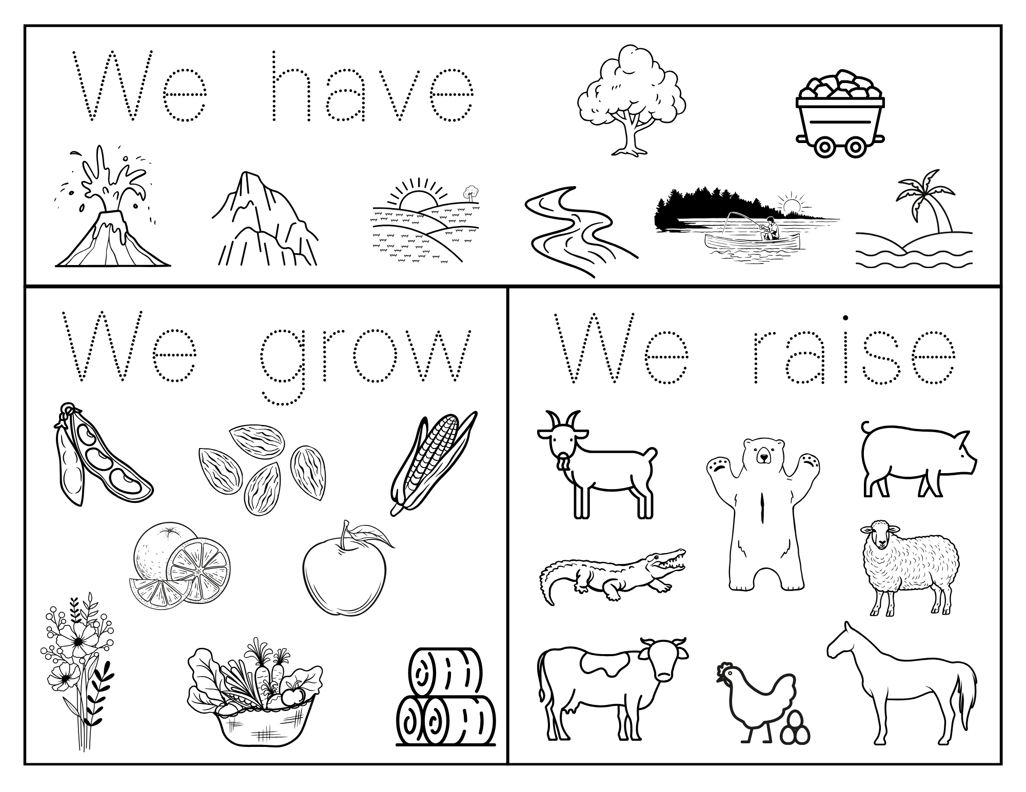

This will serve as an assessment for students’ mastery of K.G.KGE.1 and their ability to answer the compelling question, “What are the physical and environmental characteristics of my community that make it a good place to produce goods?”

