3rd Grade Reading & Writing Assignment
This assignment is weakly aligned to the standards.

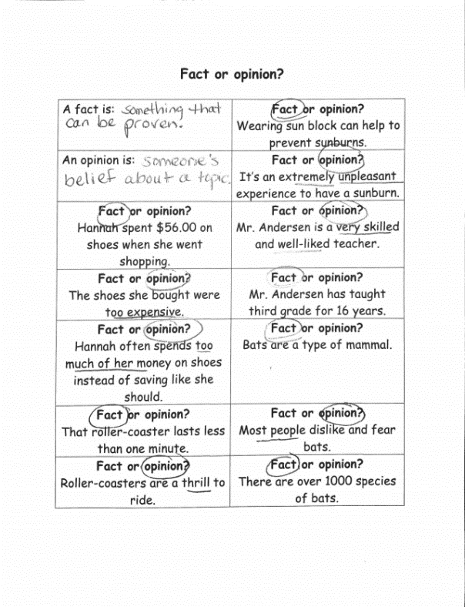
Overview
Third-grade students define the terms “fact” and “opinion” and then determine which term applies to a series of statements. This assignment does not require students to read and make meaning from a worthwhile text.
Related Standards
RI.3.6: Distinguish their own perspective from that of the author of a text, and describe how various perspectives shape the content and style of a text.
The assignment is weakly aligned to this standard. The series of statements in the task do not reflect the point of view of an author. They are commissioned for educational purposes and are not worthy of time and attention.

Why is this assignment weakly aligned?
The assignment is not text-dependent. It asks students to evaluate a series of isolated statements, instead of carefully reading and analyzing a grade-appropriate, worthwhile text.
While students have an opportunity to distinguish fact from opinion, the assignment does not require students to distinguish their own point of view from that of the author of a text.

