HS Algebra Assignment
This assignment is partially aligned to the standards.
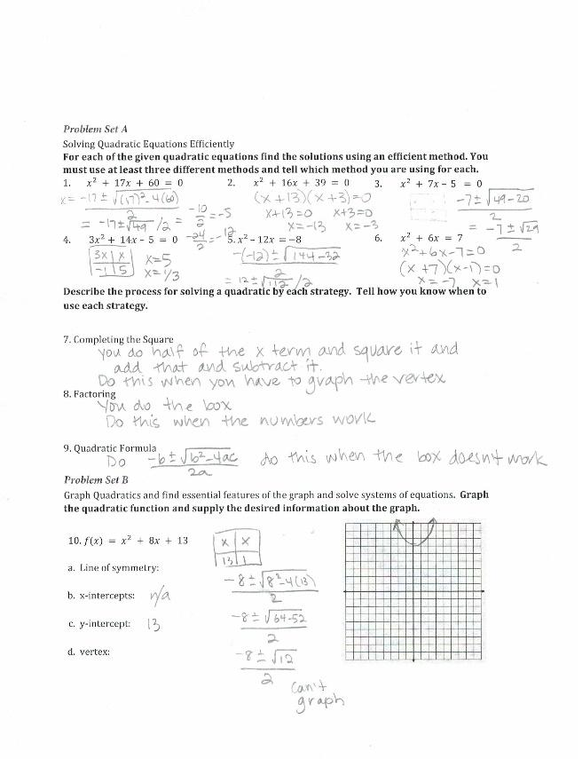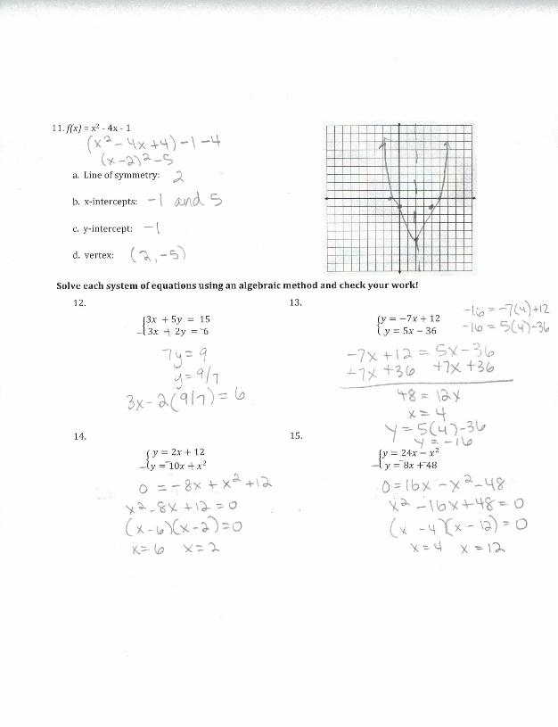

Overview
High school students solve quadratic equations using different methods, graph quadratic functions and identify key features of the graphs and solve systems of linear and quadratic equations. The assignment is partially aligned to the standards. While it requires students to solve and graph some appropriately complex equations, it overemphasizes the use of specific solution methods, doesn’t involve complex solutions, and doesn’t ask students to interpret the key features of the functions they are asked to graph.

Related Standards
We looked at how well the assignment aligned to the following standard:
KY.HS.A.19: Solve quadratic equations in one variable.
- KY.HS.A.19.a: Solve quadratic equations by taking square roots, the quadratic formula and factoring, as appropriate to the initial form of the equation. Recognize when the quadratic formula gives complex solutions and write them as a ± bi for real numbers a and b.
KY.HS.A.21: Solve a simple system consisting of a linear equation and a quadratic equation in two variables algebraically and graphically.
KY.HS.F.1: Understand properties and key features of functions and the different ways functions can be represented.
- KY.HS.F.1.c: For a function that models a relationship between two quantities, interpret key features of graphs and tables in terms of the quantities, and sketch graphs showing key features given a verbal description of the relationship.

Why is this assignment partially aligned?
Standard KY.HS.A.19.a requires students to learn multiple methods for solving quadratic functions (taking square roots, the quadratic formula, and factoring). This assignment gives students a chance to use a variety of those methods. However, the assignment also reinforces the idea that there is a “correct” method for solving certain types of quadratic functions. Although classroom discussions might focus on the type of quadratic function that lends itself easily to each method, the idea of a “correct” method is not a requirement of the standards. In addition, this assignment encourages the use of completing the square as a method. This method is aligned to KY.HS.A.19.c, which is a plus standard. Plus (+) Standards are additional mathematics concepts students should learn in order to take advanced courses such as calculus, advanced statistics or discrete mathematics, but they are not required learning for all students.
Standards KY.HS.A.19.a and KY.HS.A.21 require students to procedurally solve quadratic equations and systems of linear and quadratic equations, and this assignment allows them to do just that. However, there is an expectation that students will solve systems of one linear and one quadratic function (true for only two of the four systems in this assignment). Finally, the problems aligned with KY.HS.F.1.c do ask for some key information about the graph, but do not ask students to interpret these key features, as required by the standard.
Note: Within KY.HS.A.19.a there is an expectation that students will encounter complex solutions when solving, expressing them in the form a + bi (not addressed at all in this assignment). However, recognizing complex solutions is not expected of students in a foundational course. For additional information regarding the alignment of this standard within the content offered within certain high school courses, use the High School Mathematics Matrix Standards by Course 2019-2020.
Practice Standards
The assignment allows students to engage with Mathematical Practice Standard #1 (“Make sense of problems and persevere in solving them”) by solving systems of one linear and one quadratic equation—students must combine their understanding of how systems of equations operate with their understanding of solving for unknown values in a quadratic equation to solve for x and y. Students also have the opportunity to engage with Mathematical Practice Standard #7 (“Look for and make use of structure”) when solving and graphing quadratic equations—students must understand how to find the key features of a quadratic graph from the equation or from an algebraic manipulation of the equation to an equivalent form.

