Seventh Grade Math Assignment
This assignment is partially aligned to the standards.
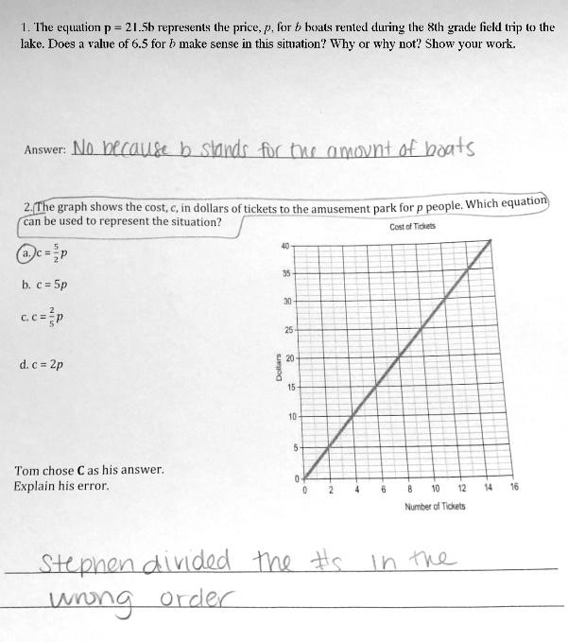

Overview
Seventh-grade students respond to two questions about the proportional relationship between price, number of items or people, and total cost. This assignment is partially aligned with a seventh-grade standard. While both problems appropriately involve equations representing proportional relationships, neither requires students to create the equations themselves.

Related Standards
We looked at how well the assignment aligned to the following standard:
KY.7.RP.2 Recognize and represent proportional relationships between quantities
c. Represent proportional relationships by equations.

Why is this assignment partially aligned?
This assignment is partially aligned with seventh-grade standard KY.7.RP.2.C, which requires students to represent proportional relationships with equations. Both problems involve equations about the proportional relationship between price, number of items or people, and total cost, which follows the example provided in the Clarifications for this standard. However, neither problem requires students to create the equations themselves.
This assignment attempts to build students’ conceptual understanding as required by standard KY.7.RP.2.C, but it only does so superficially. Problem #1 requires students to understand that the value of variables must make sense within a given context, but students were exposed to this type of conceptual understanding of variables in sixth grade. Furthermore, the problem makes no connection to proportional relationships. Problem #2 could require students to draw upon their understanding of proportional relationships, but it’s also possible for students to answer correctly simply by relying on their procedural knowledge of linear equations and slope (for example, slope = rise/run).
Practice Standards
This assignment allows students to engage with Mathematical Practice Standard #3 (“Construct viable arguments and critique the reasoning of others”) because it asks students to explain the error made by another student. However, this would be a stronger opportunity if students had to independently evaluate the response without knowing that it was incorrect.

