# Elementary Science Learning Experience

# Integrated with Reading and Writing Instructional Resource

Grade K Example 2

*This example was adapted from a teacher submission.*

## Science Experience Overview

A hummingbird flying next to a flower. 



Anchoring Phenomenon: Hummingbirds feed on flowers as they fly in slow motion.

Driving Question: Do plants and animals need the exact same things to survive?

Lesson Focus Questions:

1. What do animals need to survive?
2. What do plants need to survive?
3. What does my plant need to grow and how will it change over time?
4. Do plants and animals need the exact same things to survive?

Ted-Ed. (2016, May 23). *How to be happy – by Dan Gilbert* [Video]. YouTube. <https://www.youtube.com/watch?v=J9wRhzGwivw>

Science OER: [Solid Start Science Ever-Changing Environments Unit](https://education.msu.edu/research/projects/solid-start/curriculum/)

*Kentucky Academic Standards (KAS) for Science:*

**K-LS1-1. Use observations to describe patterns of what plants and animals (including humans) need to survive.**

|  |  |  |
| --- | --- | --- |
| **Science and Engineering Practices** | **Disciplinary Core Idea** | **Crosscutting Concepts** |
| Analyzing and Interpreting Data | LS1.C: Organization for Matter and Energy Flow in Organisms | Patterns |

*Educators may have to engage with a standard multiple times throughout a year to meet the full intent of the standard. As a result, the following example may not encompass the entire scope of the standards identified*.

## Reading and Writing Connection

Vibrant student experiences in science differ from those in Reading and Writing. However, intentionally aligning topics enhances learning in both. The following, green-rated High-Quality Instructional Resource (HQIR) is used in Reading and Writing during the same time as this Science learning experience:

HQIR: EL Education

Knowledge-Building Topic: The Secret World of Pollination

Grade-Level Complex Text(s): *From Seed to Plant* by Gail Gibbons; *What is Pollination?* by Bobbie Kalman (pgs. 24-25); *The Little Hummingbird* by Michael Nicoll Yahgulanaas

The following Reading and Writing standards and tasks, along with Interdisciplinary Literacy Practices, play a supporting role and are integrated into this vibrant Science Learning Experience:

Text-Dependent Tasks: Writing to Learn, Writing to Demonstrate Learning

*Kentucky Academic Standards for Reading and Writing*: RI.2.1, RI.2.2, RI.2.3, RI.2.4, C.2.5, C.2.6, L.2.4, L.2.5

*Interdisciplinary Literacy Practices*: 1, 2, 4, 6, 7, 8

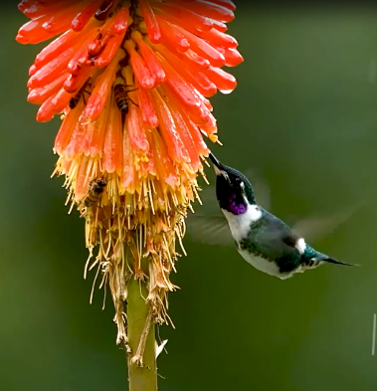At the beginning of the ELA unit the students are introduced to pollinators and pollination. Students have background knowledge that flowers have nectar and pollinators need nectar. Students define nectar as a sweet liquid found in flowers. They have looked at different pollinators such as flies, beetles, bees, wasp and moths. Introduce a new pollinator to the students by showing a [Hummingbird Video](https://www.youtube.com/watch?v=J9wRhzGwivw) of hummingbirds feeding on flowers and flying in slow motion. Hummingbirds are familiar to young students, and they can easily observe the hummingbird feeding on the plant to get food. A time-lapse or regular video of this interaction will emphasize that animals, like hummingbirds, need food (in this case, the plant) to survive. During and after the video, students write down things they notice and things they wonder. Provide a space for students to share their notices and wonderings without indicating which ones are right or wrong. Eliciting students’ ideas allows the students to see that people have different ideas and all student ideas are valued. As students share, capture their thinking on the board or on chart paper in words and pictures. Encourage students to use discussion stems such as:

Ted-Ed. (2016, May 23). *How to be happy – by Dan Gilbert* [Video]. YouTube. <https://www.youtube.com/watch?v=J9wRhzGwivw>

YouTube. (2023, March 6). *Sawfly caterpillar eating leaves (Time Lapse)* [Video]. YouTube. [https://www.youtube.com/watch?v=BzsoFmP7BtM](https://www.youtube.com/watch?v=BzsoFmP7BtM" \t "_new)

**Launching the Anchoring Phenomenon:**

**Driving Question: Do plants and animals need the exact same things to survive?**

* I notice…
* I saw…
* I wonder why…
* How come…

|  |  |
| --- | --- |
| **Notice** | **Wonder** |
| * The hummingbirds are colorful. * The flowers are bright. * The hummingbirds are small. * The hummingbird’s wings move fast. * The hummingbird’s beak is long and pointy. * The hummingbird likes flowers. * The flowers have bees and hummingbirds around it. * The hummingbird sticks its beak in the flower. | * Why does the hummingbird not land on the flower? * What is the hummingbird doing? * Why is the hummingbird’s beak so long? * Where do the hummingbirds live? * Why is the hummingbird going to the flower? * Are the hummingbirds eating the plant? * Is the plant, ok? * Why are the flowers so colorful? |

During the discussion use the following questions to continue eliciting student ideas:

* What are the hummingbirds doing to survive?
* What do you think would happen if the hummingbirds had no flowers to go to?
* Why do you think flowers are important for hummingbirds?
* Do you think the flower will be able to keep growing after the hummingbird visits it? Why or why not?

The notice and wonder chart help to identify students’ current thinking as they try to make sense of this phenomenon. Ask students the driving question, “Do plants and animals need the exact same things to survive?” Make two separate charts to capture initial ideas, one titled “Plants Need…,” and the other “Animals Need….” Include pictures of plants and animals at the top of the chart to support emergent readers.

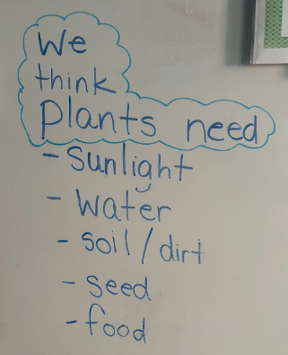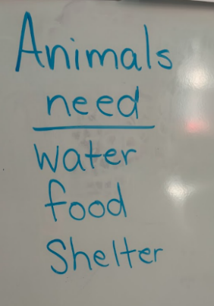Students might say plants/flowers need (water, sunlight) and hummingbirds need (food, shelter). Students can begin to draw connections between plants and animals, particularly how animals depend on plants for survival. It's important to record all student ideas, as these thoughts will serve as a foundation for further investigations. After exploring and investigating, students will have the opportunity to revisit and refine their thinking, deepening their understanding as they gather new evidence.

## Learning Experience #1: What do animals need to survive?

**Learning Objective:** Students make observations of what animals need to survive.

Begin the discussion by reviewing what students already know about animals and what animals need to survive. Explain to students, hummingbirds, like other animals, need certain things to live and grow. Pose the question, “Based on what you already know and what we have read, what do you think the hummingbird needs to survive in their environment?” Using the student suggestions, consider setting up a hummingbird garden outside on the school grounds close to the classroom. The hummingbird garden should consist of a hummingbird feeder, bird bath with water, bright colored flowers and a large bush or small tree. Use the garden for students to make observations of the hummingbird as students identify the needs of hummingbirds.

Students will have a chance to investigate what hummingbirds need to survive through hands-on exploration. During the hands-on exploration, provide materials that represent the basic needs of a hummingbird: food (nectar from flowers), water (for hydration), shelter (trees and nests for rest and safety) and air (symbolized by a fan or open windows).

**FOOD**

Begin by exploring flowers, real or artificial, and ask students, “Why do you think the hummingbird might like this flower?” Show how flowers provide nectar, a sweet liquid that hummingbirds drink for energy. Let students pretend to be a hummingbird by using a straw to “feed” from the flower, helping them understand how the hummingbird collects food.

To do this gather flowers, small cups filled with a mixture of water and a bit of sugar (to mimic nectar), and straws (to simulate a hummingbird’s beak). Consider using brightly colored paper and an arrangement of brightly colored flowers on a table to create a garden for students to visit. Place the small containers of the sugar mixture near or inside the flowers to represent nectar. Provide each student with a straw. Gather students around the garden area. Have students imagine they are the hummingbird looking for food. Identify that the bright colorful garden attracts hummingbirds. Ask students, “What do you think hummingbirds do when they find a flower?” Demonstrate for students how to take the straw and show students how to carefully “sip” the sugar water from the container explaining that hummingbirds use their long beaks to reach into flowers and drink the nectar inside. Ask students what nectar tastes like? How do you think it helps the hummingbird? After everyone has had a turn, gather to discuss what they experience using the following questions:

* Was it easy or hard to get the nectar from the flower?
* Why do you think the hummingbird’s beak is shaped the way it is?
* What do you think would happen if there were no flowers for the hummingbirds to feed on?
* Why do you think hummingbirds might visit brightly colored flowers?

Remind students of the text they read in the reading block, *What is Pollination?* By Bobbie Kalman. This text provides rich information about the process of pollination and the various pollinators. Reread pages 24-25 about bird pollinators. Hummingbirds are specifically mentioned in this text and can be a great source of information for this section on food. Ask the students the following questions to relate back to learning:

* What is the role of a bird's beak in pollination?
* According to the text, what are hummingbirds attracted to?
* Why do you think that is important to the bird’s survival?

Think about the video we watched at the beginning of the hummingbird on the flower. What wonderings can we answer based on the information gathered from the text?

**WATER**

Continue exploring by asking, “Do you think the hummingbird needs water too?” Explain that while hummingbirds get water from nectar, they also use water for other purposes. These little birds also need water to take baths and clean themselves. Sticky pollen and drops of nectar can get on their beaks and feathers. Staying clean helps them fly their best. Show pictures or videos of places where birds, including hummingbirds, might get water such as shallow puddles, birdbaths, or leaves with dew. Allow students to hold small cups of water, simulating how hummingbirds might drink from a puddle or dew on leaves by using a straw. Show videos or pictures of other animals drinking water, such as a dog lapping, a bird scooping with its beak, or a human sipping. Ask, “What do all these animals, including hummingbirds, have in common when it comes to water?” Help students connect their observations to the idea that all animals, no matter how different they are, need water to survive.

Remind students of the text they read, *The Little Hummingbird* by Michael Nicoll Yahgulanaas. Even though this text is a folk tale about a little hummingbird, students can learn information about the environment a hummingbird lives in. Relate the need for water with the text of how the hummingbird knew where to find the water and used the resource to do what it could do.

**SHELTER**

Relating back to the text, *The Little Hummingbird* by Michael Nicoll Yahgulanaas, ask students the following questions for discussion:

* Where does the hummingbird live?
* In the folk tale, what problem were the animals faced with?
* Why would this problem be so frightening to all the animals?

Ask students, “Where do you think the hummingbird goes when it needs to rest or sleep?” After gathering ideas watch [Nature: Hummingbird Nest](https://www.youtube.com/watch?v=6Ll-jinc1_s). Share observations students had from the video. Explain that, like all animals, hummingbirds need a safe place to rest, protect themselves from predators, and take care of their young. Highlight how hummingbird nests are often small and carefully hidden in trees or shrubs to keep them safe. If you have a hummingbird nest, bring it in so students can make up close observations. Go back to the video and pause it for students to take a second look. Encourage students to imagine being in a safe, cozy space like a nest, and ask, “Why do you think a hummingbird might choose to hide its nest in a tree or bush?” This discussion helps students connect the idea of shelter to the survival needs of animals, including finding protection and rest.

**AIR**

Just like you, hummingbirds need food, water and shelter. Ask, “What else do you need to live?” This question should lead to the students responding they need air to breathe. Emphasize that all animals, including hummingbirds, need air to breathe. Explain that air is essential for survival and helps hummingbirds get the energy they need to fly, feed, and stay alive. To make this concept tangible, use a fan or open a window to let students feel the movement of air, encouraging them to imagine how air supports the hummingbird’s rapid wing movements and breathing. Ask, “How do you think air helps a hummingbird stay alive?” or “What might happen if a hummingbird couldn’t get enough air?”

After these explorations, return to students’ initial ideas on what animals need to survive. Allow students to add to or change their thinking based on what they learn. Record these ideas on the chart for students.

**Learning Objective:** Students make observations of what plants need to survive.

Since the hummingbird, like other animals, need plants for food, what do plants need to survive? Show a video of a house plant time lapse. Gather the students together to begin exploring how plants grow. Watch a time-lapse video of a house plant. As the students watch the video, encourage students to record what they notice and wonder. After the video, elicit students’ ideas on what they think the plant needs to grow and add to or revise their initial ideas.

## Learning Experience #2: What do plants need to survive?

Read, *From Seed to Plant* by Gail Gibbons in the Wonders resource. Students continue adding to and/or revising their initial ideas based on the text. Explain to the students that they are going to investigate plants and gather evidence on what plants need.

Share that the class will be looking at different plants and making observations. When we make observations, we are like scientists. We use our eyes and other senses to notice details about the world around us. Pick an object everyone can see such as a plant in the classroom or a picture of a plant. Model how to make detailed observations by saying, “I see this plant has green leaves, I notice that some leaves are bigger than others, and I feel that that soil is dry.” Encourage students to share their observations of the plant. As students are sharing, explain the difference between an observation and an opinion. For example, a student may observe that the plant is tall. Another student may have an opinion that they think the plant is pretty. Help the students focus on sharing their observations, what they see. They can use prompts such as:

* I see…
* I notice…
* I observe that…

Prior to beginning this learning experience, prepare beans in 4 different baggies on a piece of paper towel. Place these baggies in four different conditions: dark with no water, dark with water, light with no water, and light with water. Setting up this investigation in the classroom will help students understand more deeply the conditions the beans are growing in and allow them to view details closer. If you are not able to set up the in-class investigation, use the photos below to make observations and identify patterns in the growth of the bean plants in all four conditions. Explain that these are different photos of bean plants that grew in four different conditions: dark with no water, dark with water, light with no water, and light with water. The following pictures are an example from [Solid Start Curriculum](https://education.msu.edu/research/projects/solid-start/curriculum/) Every-Changing Environment Unit Lesson 6 Slide Deck.

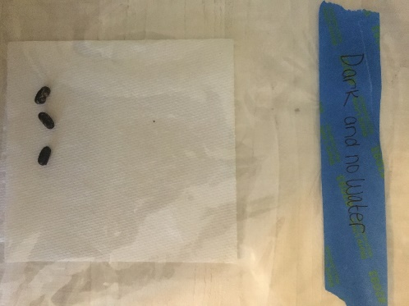 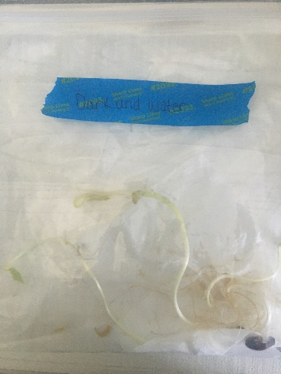 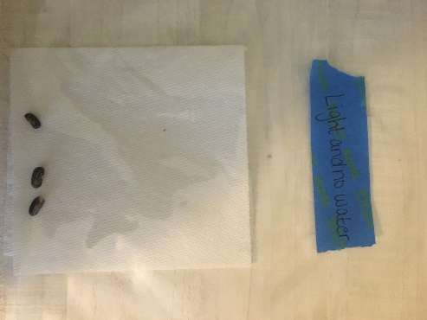 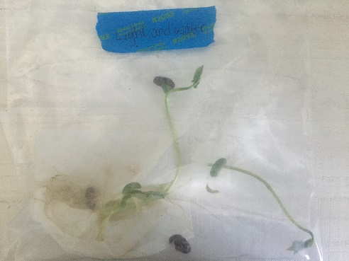

Dark with no water Dark with water Light with no water Light with water

Show the students each picture and clearly explain the condition in which the plant grew. Tell the students they will collaborate with a partner to look at the photos and discuss which plant they think is the healthiest and why. Encourage them to use evidence from the photos to support their answer. As students look at the pictures, remind them to make observations. Explain that they should focus on what is different between the plants, like whether the plants look healthy, how tall they are, or how their leaves look. Set up stations where the baggies or photos are displayed. Allow a few minutes at each station for students to make observations and record their thoughts through drawings and words. As students are making their observations, ask questions such as:

* Why do you think one plant looks healthier than the others?
* Which plants look like they are growing?
* What do you observe about the plant in [location]?
* How tall is the plant in [location]?
* What color is the plant in [location]?
* Do you think the plant [in [location] looks healthy?
* Why do you think the plant is healthy or not healthy?
* How does the plant growing in the light compare to the one growing in the dark?
* What do you notice about the plants that have water versus those that don’t?

Gather students into a scientists’ circle to share their observations and discuss together. Make an anchor chart divided into four sections to organize and record observations:

* Plant in Dark Place and Dry
* Plant in Dark Place and Water
* Plant in Light Place and Dry
* Plant in Light Place and Water

Give students a chance to discuss which plant(s) they think are the healthiest and why. As a class identify patterns in the results. Lead a discussion about the findings to figure out that plants need sunlight and water to survive. Questions to ask to support the discussion:

* What patterns do you notice between the plants that are in the dark?
* What patterns do you notice between the plants that are in the light?
* What does this tell us about what plants need to survive?
* What patterns do you notice between the plants that are dry?
* What pattern do you notice between the plants that received water?
* What does this tell us about what plants need to survive?
* What evidence supports your claim?
* Do other groups agree or disagree? Why?

Revise students’ initial ideas poster to record what students have determined plants need based on evidence. Transition to watching the episode of Hero Elementary titled “[What Plants Need](https://www.youtube.com/watch?v=6VlpGusuQr0).” Before starting, explain, “In this episode, the Sparks’ Crew learns about a special plant. Let’s see what they discover!” As the episode plays, pause at key moments to ask the following questions:

* “Sara worried the plant could take over the city, but then the plant stopped growing. Sara said that the problem was solved. Do you agree with Sara or Lucita, who said the plant is still a problem? Why?”
* “When Mr. Sparks is watering the plant, what does the crew notice?”

After watching the episode, add on to the anchor chart of what students decide plants need together. Continue to add to and revise their initial ideas. Ask questions like:

* “What new ideas did we learn from the video?”
* “Are there any things we missed before?”
* “How do these needs help the plant grow?”

Conclude the lesson by summarizing, “Today, we learned that plants need different things to grow. We saw how important sunlight, water, and care are for plants. In our next lessons, we’ll explore more about how we can help plants grow and thrive!”

**Learning Objective:** Students will use their observations overtime to describe patterns of what plants need to survive.

## Learning Experience #3: What does my plant need to grow and how will it change over time?

Review the anchor chart from the earlier lesson of what students identify that plants need. Have the students explain why each of these things are important for the plant. Tell the students that today they will get to plant their own flowers. Explain that they will take care of their plant and watch it grow over the next several days and weeks. Give each student a small cup, soil and bean seed. Guide students as they plant their seeds.

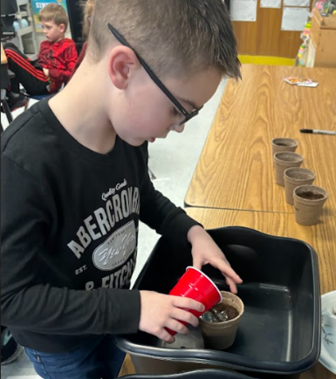

Ask students what they could observe about their plant as it grows. Students may say plant’s height, colors of the leaves, size of the leaves, stem growth, and number of leaves on the plant. As a class decide which of the observations to record regularly and develop an observation chart for students. For example, they might decide to measure the plant’s height in inches and draw pictures on their observation sheet of how their plant looks every week. Plant height may require support on how to use a ruler. Consider taking pictures of the plants during certain time periods to support students in making observations of change over time.

Discuss how they will water their plants regularly and make sure they get enough sunlight. Remind them this will be their responsibility to keep their plant healthy and growing.

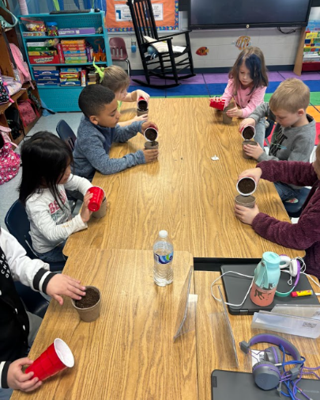

After a few weeks of observations, form a scientist circle and invite students to share their observations from their observation sheets. Ask students what changes they noticed about their plant over time and how did their plant look different from when they first planted it. Support students in thinking about comparing their earlier and later observations. Ask, was your plant bigger or small at the start or did the number of leaves change. After students have had time to think through their observations and discuss, guide students in developing a class claim. A claim is when we use our observations to say something we believe is true and can be supported by evidence. For example, if the students observed their plants growing taller each week and had more leaves their claim might be plants need sunlight and water to grow. Students can use the following sentence stems to support their conversation:

* I think plants need \_\_\_\_\_ because I saw \_\_\_\_\_.
* My plant grew because I \_\_\_\_\_.
* My plant did not grow because of the \_\_\_\_\_\_.
* Plants grow best when they have \_\_\_\_\_.

Record the class claims on an anchor chart. Use icons and pictures alongside the written words on the chart. Invite students to add to the drawings. An additional option support students’ learning at school or at home is the following game called “[Caring for Plants](https://static.pbslearningmedia.org/media/media_files/5b03618f-2c39-4949-b843-d97097e19452/61db601c-8831-46d7-812a-eb56ac7b4ac6.pdf)”. The goal of this game is for each child to collect and trade cards to find the things that keep a plant healthy. They will use evidence to explain what their plants need. They will ask questions about getting water, soil, and sunlight for a healthy plant. In the game, players collect cards that show things plants need to grow. The goal is to be the first player to grow three healthy plants by giving the plants water, soil, and light.

**Learning Objective:** Students will use their observations to describe patterns of what plants and need to survive.

## Learning Experience #4: Do plants and animals need the exact same things to survive?

Revisit the Driving Question, “Do plants and animals need the exact same things to survive?” Have students examine their charts of plants and animal needs. Have the students identify the needs that are present on both charts, circle those needs and connect the two circles. Similarities should include water and air. Ask students, “What, if any, differences do you see in the needs of plants and animals?” Plants need sunlight, space to grow, and soil, while animals need food and shelter. Show the connection between the plants and animals by using the hummingbird and flower phenomenon. Pose the following questions to the students:

* What happens to hummingbirds if flowers don’t get sunlight and water?
* What happens to flowers if hummingbirds don’t visit them?
* Why are both plants and animals important for each other?

Hummingbirds need plants for food, and plants need the hummingbird for pollination. Based on what we know about the needs of flowers (plants) and hummingbirds (animals), what could we do to help both the hummingbirds and the flowers to survive?

As a formative assessment, use the [Data of Living Things](https://drive.google.com/file/d/1Gbxi2e4h9rYH_mMWjjtoJkDtKG-ie1u_/view). After analyzing and interpreting data about what animals and plants need to survive, make a claim about the needs of a given plant or animal, using the patterns in the data as evidence to support your claim. In this assessment, students are asked what plants, animals and humans need to survive. Students will analyze and interpret data, record information, use and share pictures, drawings and/or writing of observations.

## Student Work Samples:

*Please note that the following are samples of students’ work and should not be interpreted as exemplars.*

**Student 1** **Student 2**

**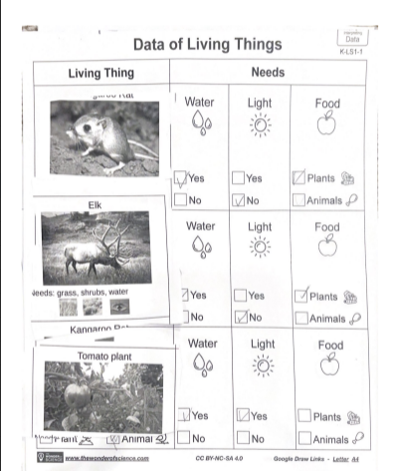**  **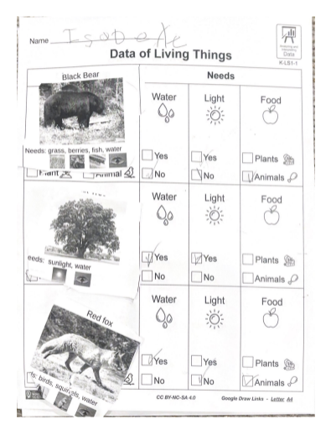**

**Student 3**

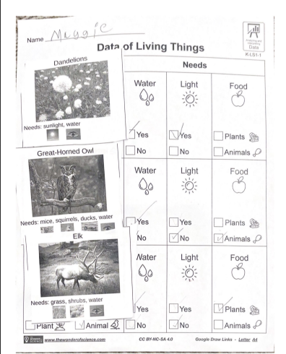

## Transfer Task: Cole’s Chart Through Course Task (TCT)

Assign the Science Assessment System Through Course Task (TCT) as an assessment on the standard taught this week “[Cole’s Chart](https://education.ky.gov/curriculum/conpro/science/Documents/Cole's_Chart_TCT.pdf)” - In this assessment students will be asked what plants, animals and humans need to survive. Students will analyze and interpret data, record information, use and share pictures, drawings and/or writing of observations. Students will use observations to describe patterns and/or relationships in the natural and designed world(s) in order to answer scientific questions and solve problems. (this assessment will need to be given in small groups)

Read the scenario to the students to set the stage for the task and discusses the needs of animals and plants chart. Encourage students to look carefully at each of the columns to identify the type of living things in each column. For instance, when analyzing the food column, students should notice the living things are all animals. When analyzing the water column, students should notice that all the living things are recorded. Consider questions that would prompt students to notice these rather than providing them.