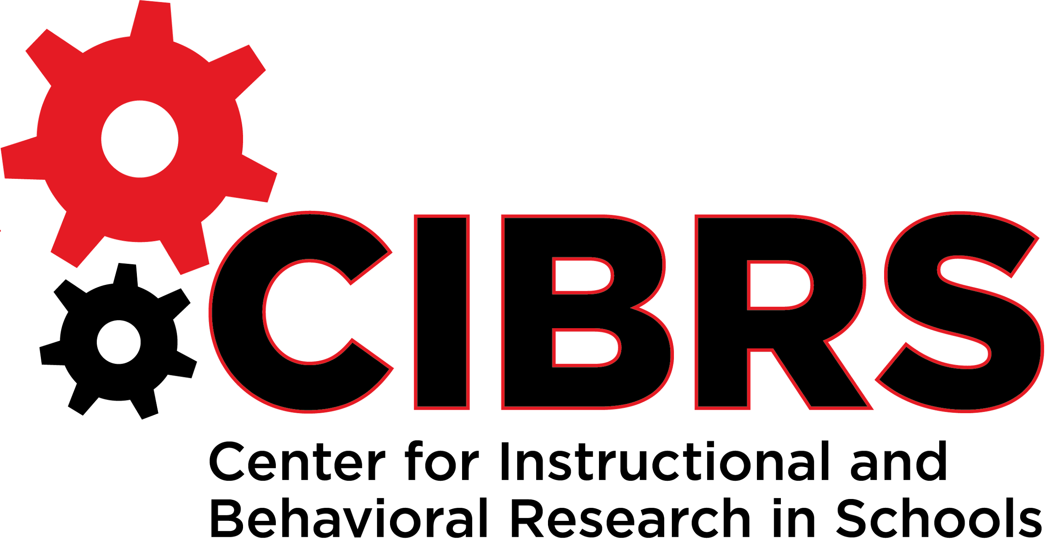

|  |
| --- |
| District/School Name |
| School Year |

**Initiative Inventory**

|  |
| --- |
| *This tool can be used by districts or schools to guide current initiatives and programs in order to assist teams in implementation. It is also used to help teams streamline current mandates, resources, and funding allocations.* |

| **Initiative**  **\*Regulation** | **Leadership of Initiative**  **(leader & team)** | **Target Population** | **Funding Source** | **Start/**  **End Dates** | **Priority or Strategic Plan**  **(yes/no)** | **Data**  **(Outcome or Expected Impact)** | **Evaluation/ Fidelity Measure** | **Communication** |
| --- | --- | --- | --- | --- | --- | --- | --- | --- |
|  |  |  |  |  |  |  |  |  |
|  |  |  |  |  |  |  |  |  |
|  |  |  |  |  |  |  |  |  |
|  |  |  |  |  |  |  |  |  |
|  |  |  |  |  |  |  |  |  |
|  |  |  |  |  |  |  |  |  |
|  |  |  |  |  |  |  |  |  |
|  |  |  |  |  |  |  |  |  |
|  |  |  |  |  |  |  |  |  |
|  |  |  |  |  |  |  |  |  |
|  |  |  |  |  |  |  |  |  |
|  |  |  |  |  |  |  |  |  |
|  |  |  |  |  |  |  |  |  |
|  |  |  |  |  |  |  |  |  |
|  |  |  |  |  |  |  |  |  |
|  |  |  |  |  |  |  |  |  |
|  |  |  |  |  |  |  |  |  |
|  |  |  |  |  |  |  |  |  |