# Elementary Science Learning Experience

# Integrated with a Reading and Writing Instructional Resource

Grade 2 Example 1

*This example was adapted from a teacher submission.*

## Science Experience Overview

## Anchoring Phenomenon:

## All You Need to Know About Vatnajökull National ParkChanges in the largest glacier in Iceland named the Vatnajökull Glacier. Its name means “Water Glacier” due to the large number of rivers and lakes originating from its melting water.

Driving Question:

How did the glacier Vatnajökull form and how did it change?

Lesson Focus Questions:

1. What conditions should exist for a glacier to form?

Campervan Iceland. (2023). *Vatnajökull National Park* [Photograph]. Campervan Iceland. [**https://www.campervaniceland.com/blog/iceland-national-parks/vatnajokull-park**](https://www.campervaniceland.com/blog/iceland-national-parks/vatnajokull-park)

1. How do glaciers continually change?
2. What effects do glaciers have on the environment around them?

*Kentucky Academic Standards (KAS) for Science:*

* 2-ESS2-1 Compare multiple solutions designed to slow or prevent wind or water from changing the shape of the land. *
* 2-ESS1-1 Use information from several sources to provide evidence that Earth events can occur quickly or slowly.
* 2-ESS2-3 Obtain information to identify where water is found on Earth and that it can be solid or liquid.

|  |  |  |
| --- | --- | --- |
| **Science and Engineering Practices** | **Disciplinary Core Idea** | **Crosscutting Concepts** |
| **Constructing Explanations and Designing Solutions**  **Obtaining, Evaluating, and Communicating Information** | **ESS2.A: Earth Materials and Systems**  **ETS1.C: Optimizing the Design Solution**  **ESS1.C: The History of Planet Earth** | **Stability and Change**  **Patterns** |

*Educators may have to engage with a standard multiple times throughout a year to meet the full intent of the standard. As a result, the following example may not encompass the entire scope of the standards identified*.

## Reading and Writing Connection

Vibrant student experiences in Science differ from those in Reading and Writing. However, intentionally aligning the topics enhances learning in both. The following green-rated High-Quality Instructional Resource (HQIR) is used in Reading and Writing during the same time period as this Science learning experience:

* HQIR: Wonders (2023), Grade 2, Unit 4
* Knowledge-Building Topic: Earth Changes
* Grade-Level Complex Text: “Glaciers” by Elizabeth Doering

The following Reading and Writing standards and tasks, along with Interdisciplinary Literacy Practices, play a supporting role and are integrated in this vibrant Science Learning Experience:

* Text-Dependent Tasks: Writing to Learn, Writing to Demonstrate Learning
* *Kentucky Academic Standards for Reading and Writing*: RI.2.1, RI.2.2, RI.2.3, RI.2.4, RI.2.5, RI.2.7, RI.2.9, RI.2.10, C.2.6, L.2.4
* *Interdisciplinary Literacy Practices*: 1, 2, 4, 7, 8

**Overall Learning Objective**: Investigate how glaciers move and affect the environment around them**.**

**Ideal Student Response to the Driving Question:** This is an opportunity to gather students initial ideas and to use maps to help students see that glaciers mostly form near oceans and poles.

Launching the Anchoring Phenomenon:

**Launching the Anchoring Phenomenon**

**Driving Question: How did the glacier Vatnajökull form and how did it change?**

~~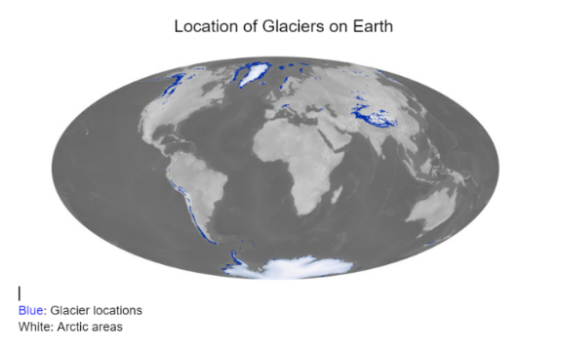~~Present students with an [image](https://docs.google.com/document/d/14JlNcGANMi7bF9wPE5D-MW8vcut9dOO5s-sMi1kI5Ts/edit?usp=sharing) (Figure 1: Location of Glaciers on Earth) from NASA’s website of where glaciers are located. Students will use the map to make predictions about what this map represents. Students will use the [Think-Pair-Share](http://www.pz.harvard.edu/resources/think-pair-share) strategy to answer the question: What does the blue on the map represent?

After students share their initial ideas, read the article, “Kids on the High Seas” by Dave and Jaja Martin about children going to Iceland. This will equip students with more information about what the map represents. Included at the end of the text is a photograph of a big chunk of ice in the ocean. Ask students, “How did these huge ice pieces get in the ocean?” Allow students to share thoughts verbally, on post-its, or on whiteboards and record their thoughts on the board to make their thinking visible. Take the students on a virtual field trip to Iceland just like the kids in the text to make observations.

Figure 1

Simmon, R. (2013). *Map* [Photograph]. *Worldwide Glaciers.* NASA. [Worldwide Glaciers (nasa.gov)](https://visibleearth.nasa.gov/images/81545/worldwide-glaciers)

Draw a notice and wonder t-chart on the board and encourage students to record it in their science notebook or provide students with a copy of the t-chart. Show the students [drone footage](https://youtu.be/5PC6aiH0jsc) on YouTube of the Vatnajökull Glacier in Iceland. During and after the video, students write down things they notice and things they wonder. Provide a space for students to share their notices and wonderings without being told which ones are right or wrong. Eliciting students’ ideas allows the students to see that people have different ideas and all student ideas are valued. As students share, capture their thinking on the board or on chart paper. Their notice and wonder chart can be used to identify students’ current thinking as they attempt to make sense of this phenomenon.

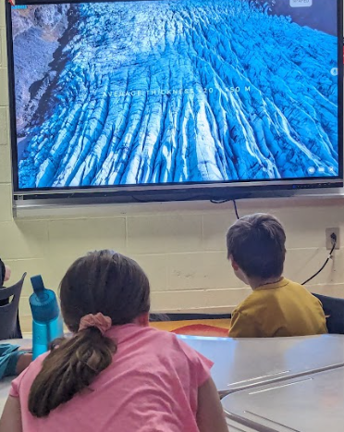

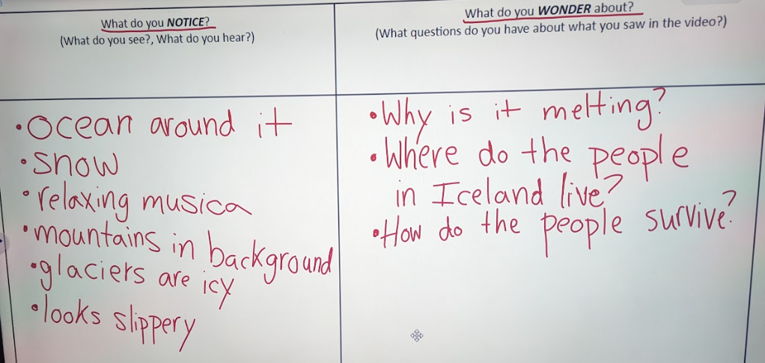

Refer to Figure 1 once again and discuss additional ideas for what the blue on the map represents based off of their observations. Guide the students to determine that blue represents the location of glaciers on the earth. Introduce the driving question, *“*How did the glacier Vatnajökull form and how does it change*?”* Write this on a clean piece of paper to begin creating a driving question board that will be displayed and used throughout this entire learning experience. Invite students to share their initial questions they have about the glacier. As they share their questions, record one question per sticky note and add them to the driving question board. Record at least one question per student. As questions are being recorded, group them by categories and name each category with input from the students once all questions have been gathered.

Throughout the learning experience, revisit the driving question board and check off questions students can answer based on their learning and add new questions they have about the phenomenon. Explain to the students that after engaging in investigations and research, they will be able to answer the driving question and become glacier experts.

**Learning Objective:** Determine the conditions necessary for glacier formation. In their investigation, students will observe the effect of pressure exerted on marshmallows (representing snow) and draw conclusions about pressure exerted on snow.

**Learning Experience #1: What conditions should exist for a glacier to form?**

To investigate the driving question, “How did the glacier Vatnajökull form and how did it change?”, we will first focus on what conditions should exist for a glacier to form. Make the focus question visible for all students in the room. Provide time for students to write and/or draw their initial ideas to answer the focus question. Revisit the NASA map (Figure 1) of where glaciers are located on Earth. Remind students that blue is a symbol for glacier locations. In partners, they should discuss why they think glaciers are present in these locations. What are some commonalities between these locations? Once students have talked with their partners, allow each pair to share out in whole group. Record student ideas on an anchor chart.

After hearing students’ thoughts, conclude based on observations of the map, that more glaciers are found closer to the North and South Poles. Ask students why they think there are more glaciers there. Show them a map of the world temperatures and compare the differences and similarities between the temperature map and the NASA glacier location map. Have the students share what they notice about the temperature where glaciers are found. Students reveal that the Earth is warmer around the equator and colder at the poles. Listen for observations about colder climates being associated with glacier locations. Ask students what happens when water is in a cold environment. Address how water freezes when it gets extremely cold (32 degrees Fahrenheit or 0 degrees Celsius).

Reference the driving questions board. Remind students that the focus question is, “What conditions should exist for a glacier to form?” Allow the students time to go back to their initial ideas and revise their response to see how their ideas changed or grew. Ask students what new questions they have about glaciers after seeing the temperature map. Listen for questions around what glaciers are made of or about snow and ice. Ask students what they think a glacier is made of. If this question is on the driving question board reference that. Gather student initial ideas. Record the questions on individual sticky notes and add them to the driving question board.

Ask the class, what are glaciers made of (snow or ice)? Vote by raising their hands. Hold up a marshmallow and ask them to describe it with adjectives. Tell them we are going to use the marshmallow, representing snow, to help us see how we can change a fluffy, soft, squishy item like snow or a marshmallow into something hard and strong like ice. The purpose behind this investigation is for the students to make the connection that glaciers are formed from snow that is tightly compacted.

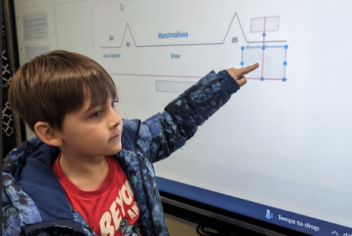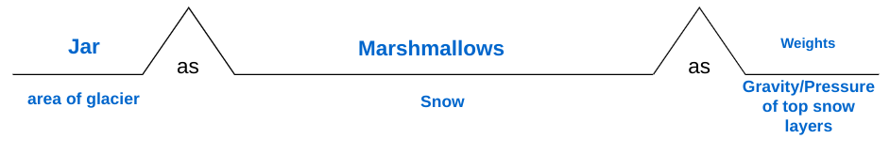When developing and using a model, be explicit about what each component represents. Display or draw the outline of this analogy map on the board without writing the blue words just yet. By describing what you will be doing and through questioning, have them determine what each component of the upcoming learning experience represents in the model.

(i.e., What do you think the jar will represent in this model? ‘Area of the glacier.’ What could represent the snow? ‘Marshmallows’ etc.) Leave the finished analogy map on the board so students keep track of what each material represents in the context of glacier formation.

Students will engage in a modeling experience titled “[Glacier Pressure](https://www.teachervision.com/science/glacial-pressure).” Place students in groups, pass out the materials needed and engage in a discussion around what students observe.

### Materials Needed:

1. A cleaned-out small jar, such as an olive jar for each group
2. 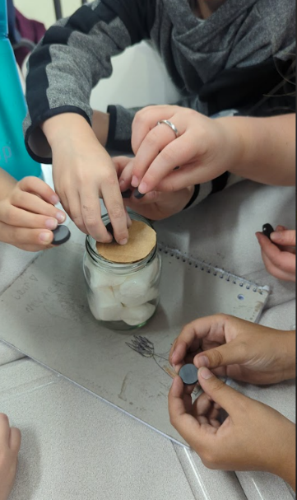Five or six large marshmallows for each group
3. One cardboard disc of slightly smaller diameter than that of the jar for each group
4. Several small, heavy weights or something heavy that will sit on top of a marshmallow and fit inside the jar for each group.

### Steps to Complete:

1. Vertically stack five or six marshmallows inside the jar.
2. Place the cardboard disc on top of the stack.
3. Draw a picture of what this looks like on a piece of paper.
4. Place a weight on top of the disc and observe what happens.
5. Add the rest of the weights one at a time and observe what occurs.
6. Draw a picture of what it looks like after the weights are placed on it.

### Discussion Questions after modeling:

1. What did you notice about the marshmallow when it was compressed?
2. What would have happened if the sides of the jar had not been there to hold the marshmallows within the jar?
3. What do you think this has to do with the formation of glaciers?

Remind students of the focus question. “What conditions should exist for a glacier to form?**”** Direct students to keep the focus question in mind as they watch the video [Can you grow a glacier?](https://thekidshouldseethis.com/post/growing-artificial-glaciers-ted-ed-ice-stupa-video) from the site *The Kids Should See This*. Pause the video and discuss what they notice and wonder along the way. Add thoughts to a new notice and wonder chart. Next, read text, “Glaciers” by Elizabeth Doering. Record additional thoughts and questions to the anchor chart.

### Exit Slip: Have students revisit the answer to the focus question. On the same sheet of paper where they drew the before picture (see step 3 above in ‘Steps to Complete’), they should draw a picture of the outcome. Then they should complete this sentence frame orally or in writing. “Glaciers are formed by _______________.”

**Learning Objective:** Illustrate and describe how glaciers move and change form.

Remind students they are still working toward the understanding of the driving question on the driving question board anchor chart made on the first day when launching the phenomenon: ‘How did the glacier Vatnajökull form and how does it change? As a class, look for any questions that can be answered on the driving question board. We will now explore how glaciers continually change. Post the focus question for all students to view as they record their initial thoughts in word or illustrations.

**Learning Experience #2: How do glaciers continually change?**

Show the students the three materials that we will be using in this learning experience. Have them discuss with a partner what they believe each component of the model represents.

### Materials Needed for the learning experience below:

1. A large ice cube (does not have to be perfectly shaped, but should have at least one flat side)
2. An inclined, smooth surface for the ice cube to slide down (i.e. a cookie sheet or cutting board propped up on one side under books, a small ramp) set up near an electric outlet.
3. A hair dryer

Allow students to share their ideas about what those three things represent whole group. Create the analogy map for this model as done in the previous learning experience. (Ice cube=ice/glacier, inclined surface= hill/mountain, hair dryer=heat/temperature increase).

Ask the students to brainstorm ways that this ice cube/“glacier” could change. Place the “glacier” at the top of the incline. Have students make a prediction about what will happen to our “glacier” if it warms up. Share ideas as a class and observe what happens to the “glacier.” If it is taking a while to melt, use the hair dryer to speed up the process.

While waiting for it to start melting, explore images of mountains on the internet to observe how snow stays on mountain tops year-round. Explain: The higher up the mountain you go, the lower the air pressure. When the air pressure is low so is the temperature. This leads students to realize that oftentimes glaciers form on mountains and on higher land because of the cool temperatures and snow. Vatnajökull is not entirely on mountains because it spreads over such a large area of land, however, Iceland has such a cold climate that it is an ideal place for glaciers to form.

Allow students to write down their observations of the “glacier.” Allow students to discuss what they see happening to the glacier. Watch this [YouTube video](https://www.youtube.com/watch?v=a8JYWU1IDBg) of a compilation of glaciers melting. Have students record their notices and wonderings. Share these out with the class.

Revisit the text, “Glaciers” by Elizabeth Doering focusing on the section that details how glaciers move. Ask the students to reflect on what they learned in the recent “glacier” learning experience and the book pages. Add their new science ideas to the anchor chart with the anchoring phenomenon. Ask students, based on what you learned today about how glaciers form and change over time. Ask how the glacier Vatnajökull formed and how it changes over time.

### Exit Slip:

Have students explain how glaciers change shape and move by using this sentence stem: “Glaciers can change in the following ways: __________________________.” They can draw illustrations or a comic strip to depict each example.

### Different changes they could mention:

1. Glaciers can go downhill due to layers melting.
2. Glaciers become heavy so gravity pulls them downhill.
3. The ice can crack due to different layers melting.
4. Continental glaciers flow towards the coast.
5. Valley glaciers flow down mountains.

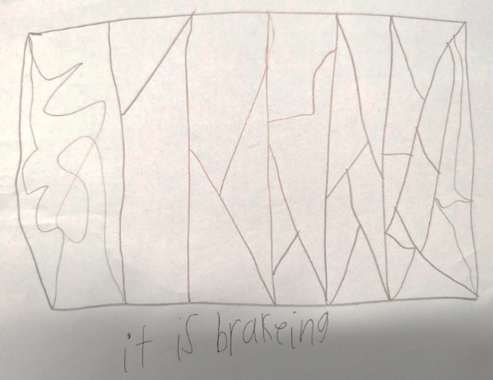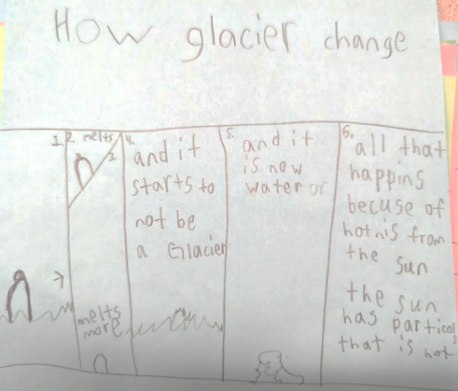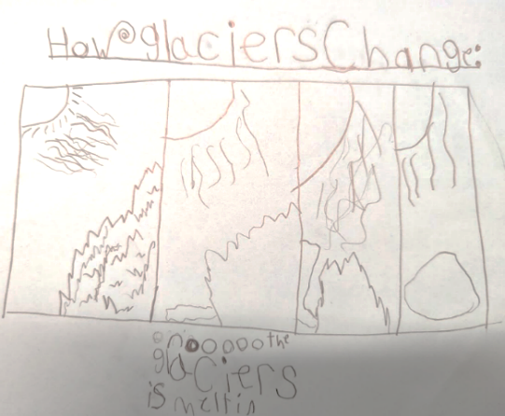Students construct an explanation to respond to the prompt on how glaciers change. This text-dependent task is a form of writing to demonstrate learning.

**Learning Experience #3: What effect do glaciers have on the environment around them?**

Example 1: Student uses images to explain how glaciers change through the process of melting.

Example 2: Student uses text to explain how glaciers change through the process of melting.

Example 3: Student uses images to explain how glaciers change when the ice cracks due to different layers melting.

**Learning Objective:** Compare and contrast the positive and negative effects of glacier changes on the environment.

At this point, students have an understanding that the glacier, Vatnajökull, formed over time from tightly compacted snow at a high altitude. They also know that it changes shape due to temperature fluctuation and that when it melts, chunks of it can float downhill. Since we know how it formed and changed, next students wonder, how does the change in the glaciers affect the environment. Part 3’s purpose is to guide students to understanding that when glaciers melt, they can have the following impacts (which are both positive and negative):

1. Carving and scraping of the land, creating moraines (piles of rocks and soil)
2. Leaving behind soil that can be used for planting.
3. Creating lakes and ponds
4. Increasing water levels
5. Causing wildlife on the glaciers to lose their homes.
6. Less fresh water available

Revisit the driving question board and the student generated questions and call out the question that led to this learning experience. Ask students to vote whether they think it is a good thing for glaciers to melt or a bad thing for glaciers to melt by having those that think it is a positive thing go to one side of the room and those who think it is a negative thing go to the other side. Allow students to discuss in their groups why they think it is a positive or negative thing. Allow students to share their thoughts. Students will investigate to see whether glaciers melting is a positive or a negative thing for the environment around them by modeling some examples.

### Materials Needed for the learning experience below:

1. A large ice cube (does not have to be perfectly shaped, but should have at least one flat side)
2. An inclined, smooth surface for the ice cube to slide down (ie. a cookie sheet or cutting board propped up on one side under books, a small ramp) set up near an electric outlet.
3. A hair dryer
4. Sand or dirt to cover the smooth surface, about an inch deep all over the smooth surface.
5. Little pebbles to place underneath the ice cube.
6. Small objects to represent trees, animals, and buildings that will be placed in the sand or dirt.

In a place where all the students can see, set up the inclined surface with sand or dirt spread along the bottom. Then create one or two craters in the sand or dirt. Next, spread out the pebbles and the small objects that will represent the trees, animals, and buildings. Tell students the ice cube is once again representing our glacier and place it at the top of the inclined surface, with some pebbles underneath it. While waiting for the glacier to melt, do think-pair-share for students to predict what they think will happen to the soil, craters, pebbles, living things, and buildings when the glacier starts to melt. Use the hair dryer to speed up the process if necessary. The ice cube should begin to slide down and the following should occur:

* Pebbles, living things and homes should shift location.
* Pebbles on top of the glacier should fall.
* Pebbles underneath the glacier should drag in the sand/soil (this might take some intervention on the part of the teacher).
* The craters may collect some of the melted water from the ice.

As students observe these models, have them record their observations for each model by drawing a before and after picture of the landscape and write captions for each, explaining the differences before and after the glacier melted. Ask students to share their observations about how the landscape has changed aloud. Have students review the text “Glaciers” by Elizabeth Doering a third time. Have students pull evidence from the text to support the claim that when glaciers move, they can cause changes to the environment. To see that melting glaciers are not always a negative event, watch [Climate 101: Glaciers | National Geographic](https://education.nationalgeographic.org/resource/climate-101-glaciers/) to learn more about how global warming impacts glaciers and how communities depend on glaciers for their economy. Have students work in groups to fill out a [t-chart](https://docs.google.com/document/d/1ewKh9kL4wxmIQ0DpFXBh1d9EkqP6EvEYvTS-XHDiq9w/edit?usp=sharing) of positive and negative effects of glacier melting. Go back to the driving questions board and see if students can now answer their own questions aloud. Write down the students’ thoughts on the anchor chart and be sure to include the following impacts of melting glaciers:

1. 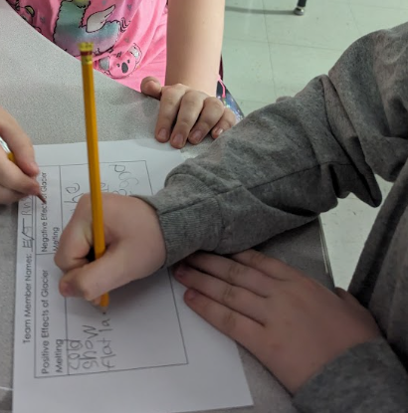Carving and scraping of the land, creating moraines (piles of rocks and soil)
2. Leaving behind soil that can be used for planting.
3. Creating lakes and ponds
4. Increasing water levels
5. Causing wildlife on the glaciers to lose their homes.
6. Less fresh water available

In [Google Maps](https://www.google.com/maps/d/viewer?mid=1YtJsjj3Y27nk4hfp8P_RTgwZzA4&hl=en_US&ll=64.77922283173318%2C-20.17429300000001&z=7) locate Iceland to show students just how large of an area that Vatnajökull takes up on the island. Use the Pegman feature (the yellow stick man in the right-hand corner on Google Maps) for the students to see it up close. You can do this in a few locations to show them just how vast the landscape is. Thinking about the investigation on the soil and the melting ice cube, along with students learned from the *Mighty Glaciers* book, ask the students to write a prediction about what will happen if the glacier Vatnajökull melts. A sentence starter for this could be “If Vatnajökull melts, I think Iceland would change because…”.

## Transfer Task: How can we design a solution to slow or prevent the glacier, Skaftafellsjokull, from melting and increasing the sea level?

Present this scenario: Iceland’s government has asked for your help to design a solution to slow or prevent the glacier, Skaftafellsjökull, from melting and increasing the sea level. Skaftafellsjökull is a part of the Vatnajökull ice cap; in other words, Vatnajökull is a massive glacier and Skaftafellsjökull is a section of it. The website [Vatnajökulsþjóðgarður](https://www.vatnajokulsthjodgardur.is/en/melting-glaciers/loftlagsbreytingar-og-joklar) provides an image that compares what the glacier looked like in 1989 to what it looked like in 2020.

Students can choose one of the following formats to demonstrate their solution: diagram, a scientific model, poster, Flipgrid (or another video format), picture book/comic or slideshow. Students can compare one another’s solutions, determining which ones would be the most effective at reducing the environmental change of a glacier.

*Please note that the following are samples of students’ work and should not be interpreted as exemplars.*

## Student Work Samples:

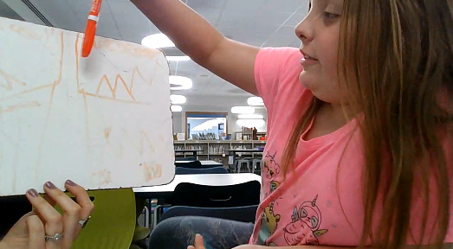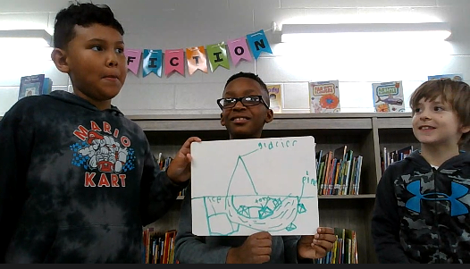

Sample 1: [A group of students describe their design of using fans to keep the air cool.](https://youtu.be/vUmpdZ8bTCw)

Sample 2: [A student describes her design of creating a cover to block the sunlight.](https://youtu.be/w2-I1mHcoEU)