Elementary Social Studies Learning Experience
Integrated with a Reading and Writing Instructional Resource
Kindergarten Civics Example 1
This example was adapted from a teacher submission.

Reading and Writing Connection
Knowledge-Building Topic: Change
Grade-Level Complex Text(s): Let Me Help Her by Lili Henderson, Peter's Chair by Ezra Jack Keats
Text-Dependent Tasks: Writing to Demonstrate Learning, Writing to Publish
Kentucky Academic Standards for Reading and Writing: RI.K.1, RI.K.3, RI.K.8, RI.K.9, RI.K.10, C.K.1, C.K.4, C.K.6
Interdisciplinary Literacy Practices: 1, 2, 4, 6, 7, 8

Social Studies Experience Overview
Students will learn about ways to be a good citizen in a variety of settings, including at home, school, and in their community. They will explore who a citizen is, why being a good citizen is important and different opportunities in their community to display good citizenship.

KAS for Social Studies alignment:
- K.I.Q.1 Ask compelling questions about their community.
- K.C.RR.1 Identify roles and responsibilities of self and others at home, in school and neighborhood settings.
- K.I.CC.3 Identify ways to civically engage at school.

Educators may have to engage with a standard multiple times throughout a year in order to meet the full intent of the standard. As a result, the following assignment example may not encompass the entire scope of the standards identified.

Setting the Stage: Compelling Question

K.I.Q.1 Ask compelling questions about their community.

Compelling Question: How can I be a good citizen?

Compelling questions are open-ended, enduring and center on significant unresolved issues. For more information on compelling questions, visit Section B: “What are Compelling Questions and how do students ask them?” from the Inquiry Practices of the KAS for Social Studies module.
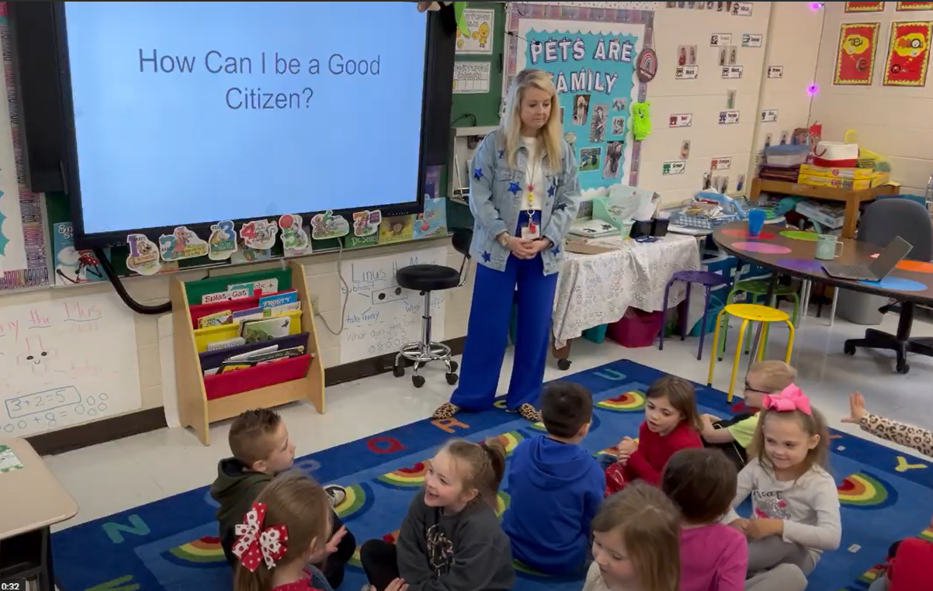
Introduce the compelling question to students. Display and read the question. Discuss the meaning of “citizen”, explaining to students that a citizen is someone who lives in a particular place. For example, their city/town, neighborhood and school are places they live and where they are considered a citizen. Explain to students that it is very important to be a good citizen, and that they will be exploring how they can be a good citizen in their local community.

Investigation 1: Being a good citizen at home
K.C.RR.1 Identify roles and responsibilities of self and others at home, in school and neighborhood settings.

Now that students understand what a citizen is, explain that they will be investigating how they can be a good citizen at home. Show the following video:

PBS Learning Media. (n.d.). Little Helper: Daniel Tiger’s Neighborhood. ket.pbslearningmedia.org/resource/01204ad9-bbaf-4275-a35e-691d441e2eea/little-helper-daniel-tigers-neighborhood/

As they watch, ask students to pay close attention to the different ways the children in the video show responsibility and help out in their home. Afterward, ask students:

- What were some different ways children were helping out at home?
- Why is it important to be a good citizen in your home?

Discuss these questions as a class, ensuring students are able to correctly identify ways to help at home and why it is important for them to contribute in their homes. Next, ask students to think about their roles and responsibilities in their own homes. Have students Turn and Talk to a partner to discuss their ideas about the following question:

How can I be a good citizen at home?

After they have had time to brainstorm together, work as a class to create a list of ways to be a good citizen in their home. Record students’ responses on chart paper that is visible for the class to reference. Then, ask students to create their own checklist of ways they will help out in their homes, using the ideas from the video and also from their discussions. Invite students to take these home and share their ideas with the family so they can implement their plan at home.

Investigation 2: Being a good citizen at school
K.C.RR.1 Identify roles and responsibilities of self and others at home, in school and neighborhood settings.

Next, explain to students that they are going to investigate how to be a good citizen in their school community. Show the following video:

PBS Learning Media. (n,d,). Get Up & Go Play! Being a Good Citizen. https://ket.pbslearningmedia.org/resource/80c95968-e6fa-4648-911f-3b9b795a26b1/get-up-go-play-being-a-good-citizen-young-explorers

As they watch, ask students to consider the following question:

What are some ways to show good citizenship in school?

After the video, discuss this question as a class, using what they learned from the video. Record students’ responses on chart paper that is visible for the class to reference.

Then, ask students to brainstorm different ways students in your classroom can be good citizens of their school. As students share, record their ideas on chart paper for students to reference. Once you have a sufficient list generated with a variety of different ideas relevant to different parts of the school building, assign students a partner. Ask students to select one of the ideas generated during the class discussion (or they can come up with a new one) and create a poster that explains this action students can take throughout the school to be good citizens, using both words and drawing. Support students as needed while they work. An example from a Kentucky student is below:
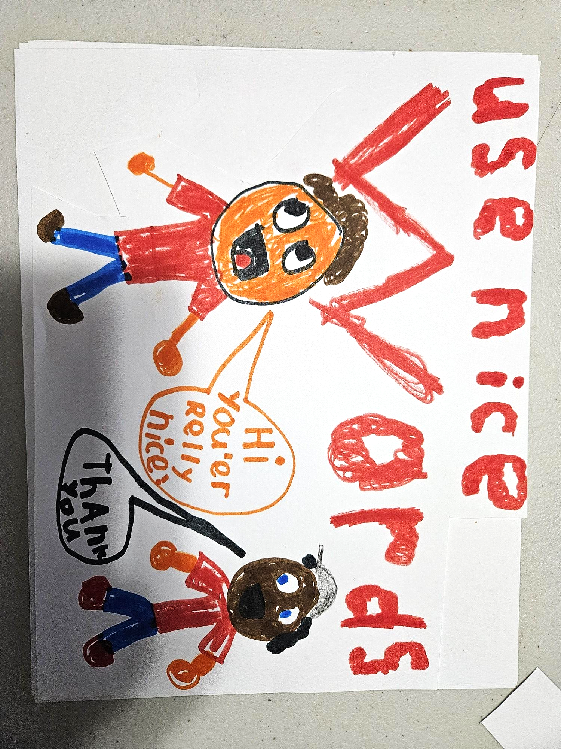
When they finish, allow them to display their poster in the part of the school to which it applies. This will allow other students to learn these ideas and contribute to being a good citizen of their school community.
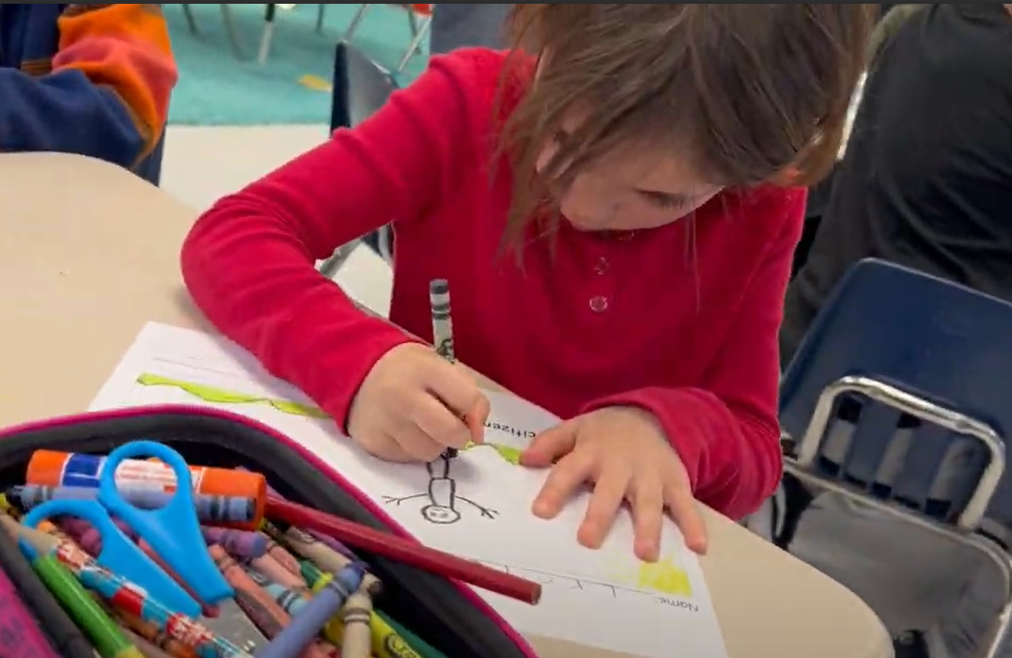

Investigation 3: Being a good citizen in the community
K.C.RR.1 Identify roles and responsibilities of self and others at home, in school and neighborhood settings.

Now that students have explored good citizenship in their home and school, explain that they will now consider their larger community. This may include their neighborhood, town or city. Show students the following video:

PBS Learning Media. (n.d.). What is Citizenship? Young Explorers. ket.pbslearningmedia.org/resource/b238d167-cf88-4a09-8f6f-f03993236943/what-is-citizenship-young-explorers

Ask them to pay attention to different ways they can be citizens in their community. Notice that this video will also share some ideas for their home and school. After the video, ask students to discuss the following question:

What are some ways to show good citizenship in the community?

Record students’ responses on chart paper visible for the class to reference. Ask students to first consider the different ways that they learned from the video. Then, ask them to brainstorm additional ways from their own knowledge and experiences.

Then, explain to students that good citizens in the community often do whatever they can to help others in their community in need. Show students real world examples of good citizens in their community helping others. You can search for videos and/or articles from your local news channel or newspaper. This will provide students with real examples from their community that will show relevance to their lives.

Here are some examples of a variety of different ways people are helping their community, from different parts of the state:
- Adkins, Rachel. (2024, July 21). Kentucky Changers: A mission project helping communities across the state. https://www.kentuckytoday.com/baptist_life/kentucky-changers-a-mission-project-helping-communities-across-the-state/article_8f4f5792-45f6-11ef-96d2-0f8790906dfe.html
- Metcalf, Sabriel. (2024, May 12). Volunteers, community members work to keep Frankfort shelter open. https://spectrumnews1.com/ky/louisville/news/2024/05/10/community-helping-access-frankfort
- O’Neill, Tyler. (2024, April 7). Habitat for Humanity helps repair 6 homes in Portland neighborhood. https://spectrumnews1.com/ky/louisville/news/2024/04/06/habitat-for-humanity-love-your-neighborhood
- Battle, William. (2024, March 5). Spayed and Aid of Kentucky continues helping the pets of Logan County. https://www.wbko.com/2024/03/05/spayed-aid-kentucky-continues-helping-pets-logan-county/
- Six, Taylor. (2022, August 5). https://www.kentucky.com/news/state/kentucky/article264136721.html

After exploring some examples, pose the following questions to students during a class discussion:

- What were some of the problems facing our community that were addressed in these news stories?
- In what ways did people in our community (or state) address these problems to help others in need?
- How did their actions improve the community?

During this discussion, explain to students that helping to solve problems facing our community is an important way of showing good citizenship. After the discussion, add these ways of helping the community to the list you have generated. Then, explain to students that they can help their community, too! There are ways they can make a difference and show good citizenship in their community. Have students Turn and Talk to a partner to discuss their ideas about the following question:

How can we be good citizens in our community?

Allow pairs to share their ideas and add them to the list for students to reference. Challenge students to select one or two things they would like to commit to doing either as individuals or as a class to improve their community. This can be as simple as committing to picking up any trash they encounter in their community to taking up collections of used toys and clothes to donate to a local shelter. Some different ideas can be found here: 20 Ways Kids Can Help The Community.

Task Aligned to the Compelling Question
- K.I.Q.1 Ask compelling questions about their community.
- K.C.RR.1 Identify roles and responsibilities of self and others at home, in school and neighborhood settings.
- K.I.CC.3 Identify ways to civically engage at school.

Review citizenship and discuss what they learned about being a good citizen in their community. Explain to students that they will create a brochure to share with another class about ways to be a good citizen at home, school and in their community, using the prompt below:

Task:

Create a brochure to share with another class that answers the compelling question, “How can I be a good citizen?” In your brochure, include both words and images, explaining ways to be a good citizen at home, school and in your community.

Students may work with a partner or in small groups, at your discretion. Explain to students that the brochures they create will be shared with students from another class to help teach them about good citizenship. Provide a rubric for their brochure and review with students to ensure they understand the criteria. An example is below:

 | 1 | 2 | 3
Knowledge of Content | Student does not show knowledge of content required in the standards. | Student shows some knowledge of content required in the standards. | Student shows knowledge of content required in the standards.
Illustrations | Student illustrations are not finished or are not clear. | Student illustrations are somewhat clear of topic. | Student illustrations are clear and understood.
Sharing | Student did not present or share their brochure with others. | Student presented or shared some of their brochure with others. | Student shared or presented all of their brochure with others.
Totals:

Provide students with a template or structure for the brochure. For example, it can be divided into three columns for explaining good citizenship at home, school and their community. Provide support to students as needed, and remind them to check and make sure they are following the expected criteria. After brochures are completed, pair students with another class to teach the new students about being a good citizen.

Student Work Samples
Below are two excerpts from student work samples in Kentucky classrooms:
