Academic Vocabulary Facilitator’s Guide, Grades 6-8

Session 11

OVERVIEW
Grade Band/ Content Area | - ELA 6-8
Essential Questions | - Why is vocabulary instruction critical for equity in literacy?  - Which words do I teach and how?
Enduring Understandings | - Students who know fewer vocabulary words struggle with comprehension, and often get fewer experiences to read grade level text with rich vocabulary as a result. Often, attempts to differentiate for struggling readers mean that those readers end up reading less challenging passages vs. getting supported opportunities to engage with challenging text and learn new vocabulary.  - We must focus instruction on academic vocabulary (Tier 2 words) and domain-specific vocabulary (Tier 3 words).  - We must spend the most time on words needed to fully comprehend the text, words likely to appear in future texts from any discipline, and words that are part of a word family or semantic network.  - To support students in both a breadth and depth of vocabulary knowledge, we must teach vocabulary
Key Components of Cycle | The Learning Cycle includes the following components to support shifts in instruction:  - Shared Learning: Learning sessions where teachers learn new knowledge and skills aligned to the topic of the content cycle. This could look a variety of ways, including reading and discussing an article, studying a classroom video, or doing some group practice of a particular planning skill.  - Planning & Practice: Opportunities for teachers to apply the content they are learning. This could include analyzing units/lessons, creating lessons, rehearsing lessons, watching and reflecting on videos of their classroom practice, etc.  - Student Progress Monitoring: This is an opportunity for teachers to examine student progress aligned to the topic of the cycle. This can include formative student work analysis, end of unit assessments, culminating tasks, etc.  Over the course of this learning cycle, teachers will build an understanding of why vocabulary instruction is critical for our students and how to align their planning and practice research-based principles for implicit vocabulary instruction, explicit vocabulary instruction, text sets, and for reinforcing and extending vocabulary. In this cycle, teachers will have opportunities to experience vocabulary instruction through the lens of students and consider the impact.

TEACHER AND STUDENT GOALS
Teacher Planning & Practice Look-Fors  NOTE: The Practice and Look Fors below come from Leading Educators’ Program Standards. Teams should feel welcome to tailor these to align with district tools as needed. | Example Student Goal(s)  NOTE: These goals are intended to be a starting place for team goal setting. Teams should feel welcome to tailor or add to these based on context, curriculum, and district/school tools.
Practice: Analyzes and adapts questions and tasks to focus on the vocabulary words that are most critical for developing students’ literacy, comprehending the text, and understanding the key ideas of the unit  Look Fors:  - Questions and tasks focus on academic or domain-specific words that are most likely to be encountered again in the future or are most critical for comprehending the text  - Lessons broaden students’ word knowledge through instructional strategies (e.g., text-dependent questions, drop-in definitions, glossary, etc.) that teach words that can be understood quickly during reading  - Weekly lessons deepen students’ word knowledge by explicitly defining, modeling, and giving students active practice with 6-10 vocabulary words  - Over the course of the unit, students have opportunities to maintain and extend vocabulary through additional practice with words previously taught | Possible goals:  - In-class observation of specific student actions that correlate with the learning connected to this content cycle  - Achievement or growth on a unit/domain assessment  - Achievement or growth on a prioritized unit/domain writing task (see rubric guidance below)

CYCLE-AT-A-GLANCE
NOTE: Each row is intended to represent one 90-minute session, but schools can adjust the pacing of learning based on their context and teacher needs.

Session | Type of Learning | Objective(s) | Assessment of Learning
Session 11  Reinforcing Vocabulary Across Lessons/Texts | Student Progress Monitoring | Identify strengths and gaps in student outcomes for all students  Prioritize instructional next steps to accelerate learning for all students | Student Work Analysis/Next Steps

Preparation:
Participant should be given access to the following documents to engage in the learning for this session:
- PowerPoint Slides
- Participant Handout

Session 11: Student Progress
Pre-Work | - Teachers prepare and bring an exemplar response to the student assignment that will be analyzed.  - Teachers bring a copy of the learning task.  - Teachers organize the student work they will analyze by subgroup.  - Teachers identify the rubric or checklist they will use to examine the student work for proficiency.
PPT | Session 11 PowerPoint Slides  *Times listed in the presenter’s notes on slides are approximate, and may be adjusted to meet the needs and schedule of the individual PLC.
Printing/Digital Handouts | Participant Handout
Agenda | Facilitation Guidance
- Opening  - Examining Student Work  - Enduring Understandings  - Closing | Overview: During this session, teachers will engage in student work analysis to identify evidence of student progress toward goals and to suggest instructional next steps. Following the analysis, teachers will share feedback in order to prepare for individual or co-teaching team planning. Finally, teachers will have the opportunity to plan strategically in response to the analyzed data to ensure that all students demonstrate progress toward the overall intended learning.

Facilitator’s Notes | Accompanying Slide
Slide 1:  Session Summary: During this final session, teachers will engage in student work analysis to identify evidence of student progress toward goals and to suggest instructional next steps. Following the analysis, teachers will share feedback in order to prepare for individual or co-teaching team planning. Finally, teachers will have the opportunity to plan strategically in response to the analyzed data to ensure that all students demonstrate progress toward the overall intended learning.  Session Length: 90 minutes | 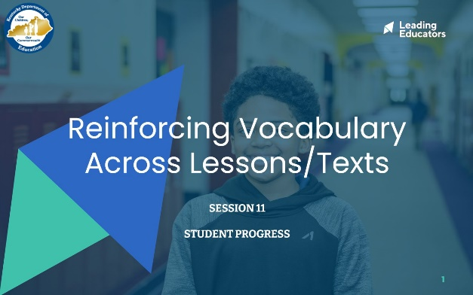
Slide 2:  Do Now (3 minutes):  - “Think of one success you have had in reinforcing vocabulary in your instruction. What was it? Why was it successful?”  - 1 minute: Jot reflection on handout  - 2 minutes: Share with partner | 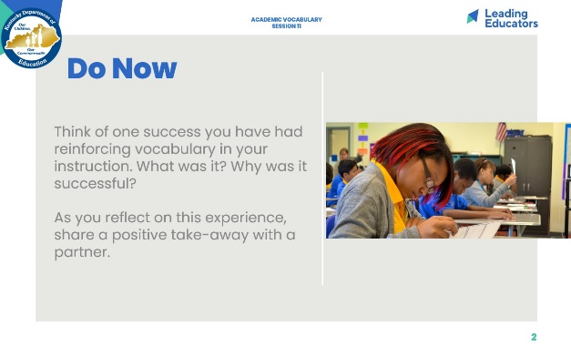
Slide 3:  Cycle Overview (1 minute)  - It is our final session. Review the concepts covered in previous sessions. | 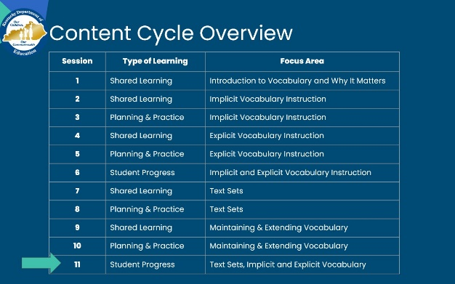
Slide 4:  Session Objectives and Agenda (1 minute)  Framing (1 minute) “This final week, we’ll explore connections between our learning about how to effectively approach vocabulary instruction and our students’ growth. To do this, we will conduct student work analysis to analyze our instructional effectiveness through the lens of student outcomes on a learning task. As we uncover trends of growth and need, we’ll plan for instructional next steps that will support students in achieving learning targets.” | 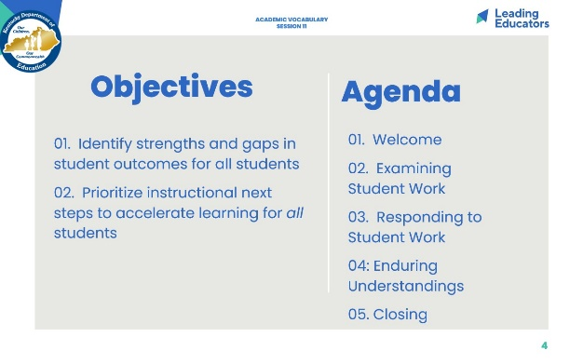
Slide 5:  Preparing for the Protocol (5 minutes)  Framing: “As we prepare for our student work analysis protocol today, take a moment to assemble the following materials:  - The exemplar student response you completed for pre-work  - The learning task and intended student outcome for the student work  - Sub-group student work samples  - The rubric/checklist you will use to examine the student work for proficiency.  - Teachers should locate a partner, ideally one who teaches the same grade. Other possible configurations: vertical grade partners, co-teachers, etc. | 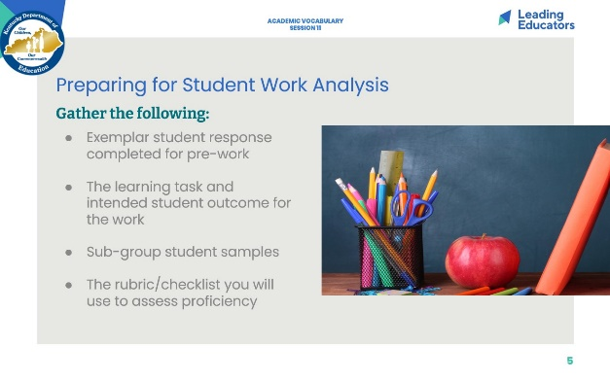
Slide 6:  Examining Student Work (30 minutes total; 15 minutes/partner)  - For the following steps, assign one partner as the first presenter and then repeat the steps with the second partner presenting.  - Intended Outcome & Exemplar Student Response: The presenting partner will share the intended outcome and exemplar student response for the learning task that was completed for pre-work.  - Examine Student work (Sub-Group): Together, teachers will examine, and annotate the student work.  - Identify Evidence and Instructional Next Steps: Teachers will identify evidence of students’ ability to meet the identified learning outcome aligned to the rubric/checklist and individual student goals, jotting evidence of strengths, areas of growth, and instructional next steps on a Capture Sheet.  *After 15 minutes, repeat process with other partner’s student work. | 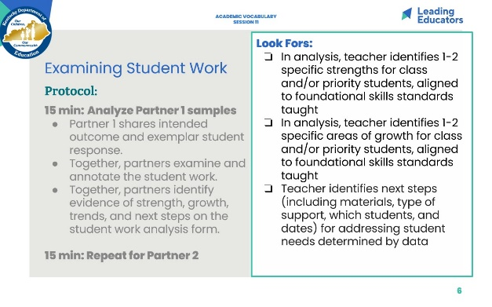
Slide 7:  Considering Implications (5 minutes)  - Reflect Individually: Consider the following questions:  - Overall, what strengths and gaps did you observe in your students’ work?  - Considering our content cycle look-fors, how might planning and practice have contributed to the strengths and areas for growth?  - Where are the tracks of your vocabulary instruction most evident?  - How can you transfer what you learned from your sub-group of students to the larger class? | 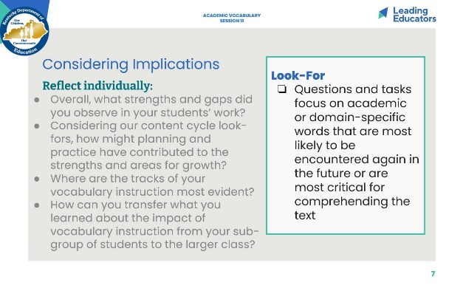
Slide 8:  Reflecting on the Entire Content Cycle (18 minutes)  [Have charts with headings prepared]  - 2 minutes: Framing: In our final session, it is time to think about the impact of all that we have learned together. For each of the five areas we explored--selecting words, implicit instruction, explicit instruction, text sets, and reinforcing vocabulary--share one takeaway that will continue to inform your practice. What is it that you will ultimately hold on to with each concept?  - To share our thoughts, we will add takeaways to the five charts around the room in a modified Write Around protocol.  - 7 minutes: Round 1: Find a chart at which to start. Make sure you have a marker. Jot your takeaway and move clockwise around the room.  - [When everyone has had a chance to respond to all 5--about 7 min--shift to Round 2.]  - 7 minutes: Now, return to the charts and read what your colleagues have shared. You may respond in a variety of ways -- adding more, agreeing, disagreeing, reinforcing, connecting, etc. The idea is to have a conversation in writing.  - 2 minutes: Final walk: Read any comments you have not yet seen. | 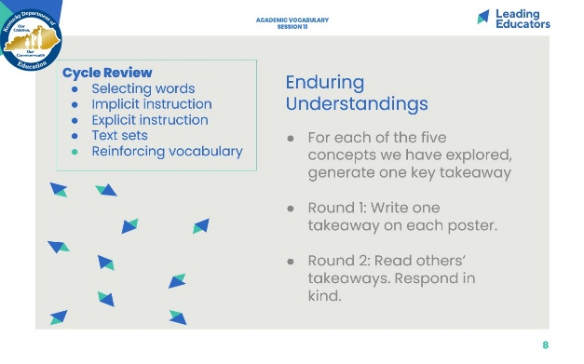
Slide 9:  Final Reflection (10 minutes)  - Ask participants to close the cycle by reflecting on how vocabulary propels student achievement.  - Using the “I used to...but now I…” frame, conduct a whip share to hear from all participants.  - Thank participants for their work and commitment to students. | 