Academic Vocabulary Facilitator’s Guide, Grades 6-8

Session 2

OVERVIEW
Grade Band/ Content Area | - ELA 6-8
Essential Questions | - Why is vocabulary instruction critical for equity in literacy?  - Which words do I teach and how?
Enduring Understandings | - Students who know fewer vocabulary words struggle with comprehension, and often get fewer experiences to read grade level text with rich vocabulary as a result. Often, attempts to differentiate for struggling readers mean that those readers end up reading less challenging passages vs. getting supported opportunities to engage with challenging text and learn new vocabulary.  - We must focus instruction on academic vocabulary (Tier 2 words) and domain-specific vocabulary (Tier 3 words).  - We must spend the most time on words needed to fully comprehend the text, words likely to appear in future texts from any discipline, and words that are part of a word family or semantic network.  - To support students in both a breadth and depth of vocabulary knowledge, we must teach vocabulary
Key Components of Cycle | The Learning Cycle includes the following components to support shifts in instruction:  - Shared Learning: Learning sessions where teachers learn new knowledge and skills aligned to the topic of the content cycle. This could look a variety of ways, including reading and discussing an article, studying a classroom video, or doing some group practice of a particular planning skill.  - Planning & Practice: Opportunities for teachers to apply the content they are learning. This could include analyzing units/lessons, creating lessons, rehearsing lessons, watching and reflecting on videos of their classroom practice, etc.  - Student Progress Monitoring: This is an opportunity for teachers to examine student progress aligned to the topic of the cycle. This can include formative student work analysis, end of unit assessments, culminating tasks, etc.  Over the course of this learning cycle, teachers will build an understanding of why vocabulary instruction is critical for our students and how to align their planning and practice research-based principles for implicit vocabulary instruction, explicit vocabulary instruction, text sets, and for reinforcing and extending vocabulary. In this cycle, teachers will have opportunities to experience vocabulary instruction through the lens of students and consider the impact.

TEACHER AND STUDENT GOALS
Teacher Planning & Practice Look-Fors  NOTE: The Practice and Look Fors below come from Leading Educators’ Program Standards. Teams should feel welcome to tailor these to align with district tools as needed. | Example Student Goal(s)  NOTE: These goals are intended to be a starting place for team goal setting. Teams should feel welcome to tailor or add to these based on context, curriculum, and district/school tools.
Practice: Analyzes and adapts questions and tasks to focus on the vocabulary words that are most critical for developing students’ literacy, comprehending the text, and understanding the key ideas of the unit  Look Fors:  - Questions and tasks focus on academic or domain-specific words that are most likely to be encountered again in the future or are most critical for comprehending the text  - Lessons broaden students’ word knowledge through instructional strategies (e.g., text-dependent questions, drop-in definitions, glossary, etc.) that teach words that can be understood quickly during reading  - Weekly lessons deepen students’ word knowledge by explicitly defining, modeling, and giving students active practice with 6-10 vocabulary words  - Over the course of the unit, students have opportunities to maintain and extend vocabulary through additional practice with words previously taught | Possible goals:  - In-class observation of specific student actions that correlate with the learning connected to this content cycle  - Achievement or growth on a unit/domain assessment  - Achievement or growth on a prioritized unit/domain writing task (see rubric guidance below)

CYCLE-AT-A-GLANCE
NOTE: Each row is intended to represent one 90 minute session, but schools can adjust the pacing of learning based on their context and teacher needs.

Session | Type of Learning | Objective(s) | Assessment of Learning
Session 2  Implicit Vocabulary Instruction | Shared Learning | Explain implicit vocabulary instruction and why it matters  Apply and analyze implicit vocabulary instruction | - “Advertisement” for Implicit Vocabulary Instruction (group posters)  - Identify implicit vocabulary instruction strategies that could be used to support a text  - Shared analysis of a lesson from sample curriculum identifying implicit vocabulary instruction strategies and potential adaptations

Preparation:
Participants should be given access to the following documents to engage in the learning for this session:
- PowerPoint Slides
- Participant Handout
- Prework: Implicit Instruction

Session 2: Shared Learning: Implicit Vocabulary Instruction
Pre-Work | - [30 min]: Participants read “Implicit Instruction: Building Vocabulary During Reading” (p. 270-281) from Reading Reconsidered and capture thinking in response to the following questions:  - What is implicit vocabulary instruction?  - How do we determine which words to implicitly teach?  - What are some strategies for implicit vocabulary instruction?
PPT | Session 2 PowerPoint  *Times listed in the presenter’s notes on slides are approximate, and may be adjusted to meet the needs and schedule of the individual PLC.
Printing or Sharing/Materials | - “Implicit Instruction: Building Vocabulary During Reading”  - Participant Handout  - In advance, the facilitator should put up two posters with the headings, “Sample Lesson: Noticings” and “Sample Lesson: Adjustments.”
Agenda | Facilitation Guidance
- Opening  - Principles of Implicit Vocabulary Instruction  - Practice  - Reflection | Overview: In this session, participants will have the opportunity to explore implicit vocabulary instruction. They begin by considering the why, what, and how of implicit vocabulary instruction. Then they have the opportunity to examine a text and practice applying the principles of implicit vocabulary instruction. Finally, teachers practice looking at a curriculum lesson plan to identify how implicit vocabulary instruction is incorporated and what adjustments they would make, based on the needs of students and the demands/meaning of the text.

Facilitator’s Notes | Accompanying Slide
Slide 1:  1 minute  Frame: “Welcome to our second sub-topic in our vocabulary content cycle. Today’s session will serve as an introduction to implicit vocabulary instruction and its role in supporting literacy. We’ll start today’s session using what we know about Tier 2 and Tier 3 words to determine which words to teach.”  Session Length: 90 minutes | 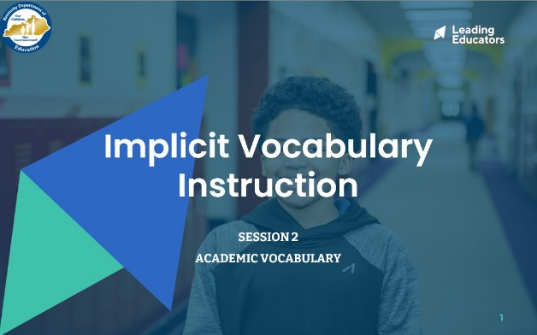
Slide 2:  15 minutes  Directions/Framing:  - 3 minutes: Read short text from Narrative of the Life of Frederick Douglass from EL Education activity (in handout)  - 10 minutes: Participants work in partners to:  - Identify two examples of Tier 2 Words and two examples of Tier 3 Words  - Identify which words you would spend more or less time on teaching and why  - This is just some quick practice to get us into the work! Don’t worry about being perfect here!  - Thank you all for digging into that practice! Today, we are going to extend our learning beyond identifying which words to teach and which ones we would spend more time on. We are going to consider some strategies for teaching. Specifically, we will be focused on “implicit vocabulary instruction.”  Look or Listen Fors/Evidence of Mastery:  - Participants identify two examples of Tier 2 and Tier 3 words.  - Participants reflect on which words they would teach considering which ones matter most to the text and would be likely seen in future texts. | 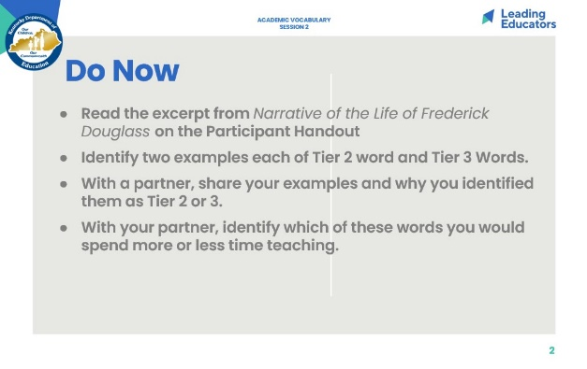
Slide 3:  Cycle Overview (1 minute)  - Share 11-week path of the cycle, explaining how the professional learning includes opportunities for shared learning, planning and practice, and studying student progress. | 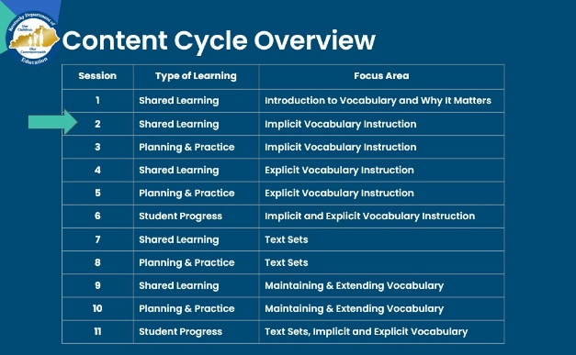
Slide 4:  2 minutes  Directions/Framing/Key Points:  - Here are the objectives for the session. May I have two volunteers read them aloud?  - Here is our path for learning (read agenda)  Look or Listen Fors/Evidence of Mastery:  NA | 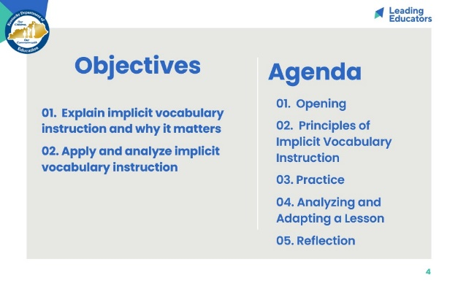
Slide 5:  Norms (1 minute)  - Ask volunteers to popcorn read norms. | 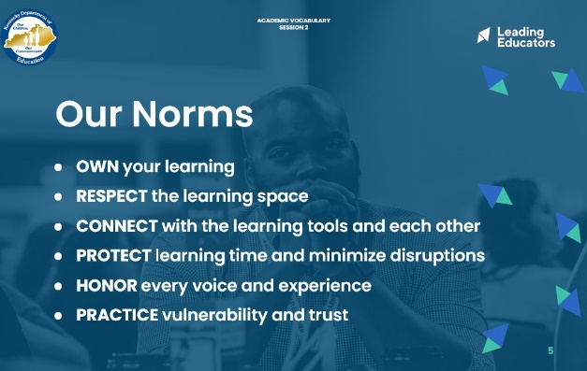
Slide 6:  12 minutes  Directions/Framing:  “Let’s begin by returning to our pre-work reading to make sure that we understand the key points around implicit vocabulary instruction.”  - 2 minutes: Participants take out and review notes from pre-work.  - 10 minutes: We are going to imagine we are creating a one-page flyer/advertisement for “implicit vocabulary” instruction, in order to clearly communicate the key points to others. Please form teams of 2-3. In your groups, use a poster to create your advertisement. Feel free to use words or pictures, but be sure to answer all three questions. You have 10 minutes. You should bring with you: Pre-work reading and notes, and your creative spirit. | 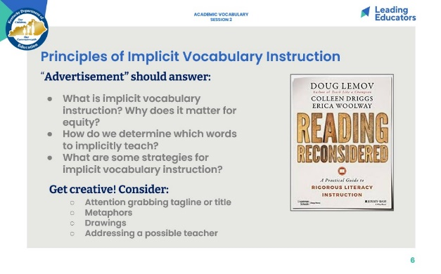
Slide 7:  Key Takeaways: Principles of Implicit Vocabulary Instruction (5 minutes)  Directions/Framing/Key Points:  - 4 minutes: Gallery Walk of ads: Ask teachers to review the key points on the slide, and look for them in the posters as they do a gallery walk of the ads.  - 1 minute: After Gallery Walk: “Thank you all for engaging! Really exciting to see the way you have named the important key points about implicit vocabulary instruction. We’ll now build upon this learning as we move into practice.” | 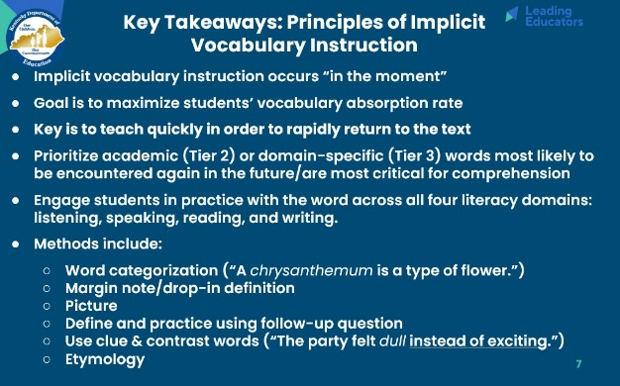
Slide 8:  Frame (1 minute):  “Here are the look fors that we are working toward in our planning and practice. Take a moment to read them. As you can see, we are working toward ensuring that our questions and tasks are focused on the most important words (like we talked about last week) and also that we are leveraging implicit vocabulary instruction to broaden students’ word knowledge as they read.” | 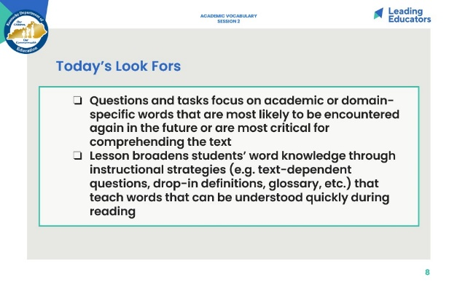
Slide 9:  17 minutes  Directions/Framing:  - 2 minutes: Now that you have had a chance to reflect on principles of implicit vocabulary instruction, let’s jump into some practice! We will return to the excerpt we read in our Do Now, Narrative of the Life of Frederick Douglass.  - We will work in teams of 2-3 to apply our learning about implicit vocabulary instruction to this text. Take a moment to read the directions on the slide. Any clarifying questions before we begin?  - 15 minutes: Participants work in teams to identify 2 words they would implicitly teach and prepare their 2-minute classroom skit of instruction.  Look or Listen Fors/Evidence of Mastery:  - Participants prioritize vocabulary words that:  - Support key ideas in the text or could be distracting/confusing to students if not defined  - Are Tier 2 words that students are likely to see again  - Are Tier 3 words that are unlikely to be encountered again outside of context of text  - Able to be taught quickly in order to return to text  - Participants leverage implicit vocabulary strategies that allow words to be taught efficiently. | 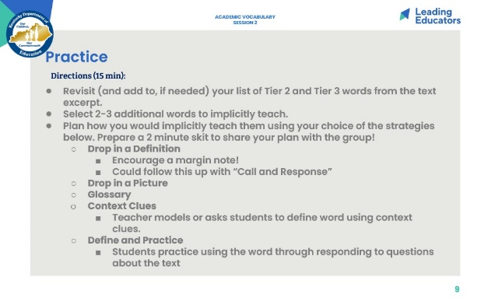
Slide 10:  15 minutes  Directions/Framing/Key Points:  - Now, we will have the chance to share our skits!  - Facilitator asks for groups to volunteer to present their skits. As the rest of the group is watching the skit, they should consider the reflection questions on the slide.  - Each group has 2 minutes to present. Afterwards, the facilitator can solicit 1-2 volunteers from the group to celebrate one thing that was effective about the example (this is so valuable for culture building on the team!)  - NOTE: Facilitator should determine how much time to allocate for celebrations (or questions) from the group depending on the size of the group and how many skits there are.  - At end: Thank you all for your thoughtful and energetic skits! It is powerful the way we can learn from each other, and it is exciting to see this learning put into practice so quickly.  Look or Listen Fors/Evidence of Mastery:  - Participants prioritize vocabulary words that:  - Support key ideas in the text or could be distracting/confusing to students if not defined  - Are Tier 2 words that students are likely to see again  - Are Tier 3 words that are unlikely to be encountered again outside of context of text  - Able to be taught quickly in order to return to text  - Participants leverage implicit vocabulary strategies that allow words to be taught efficiently. | 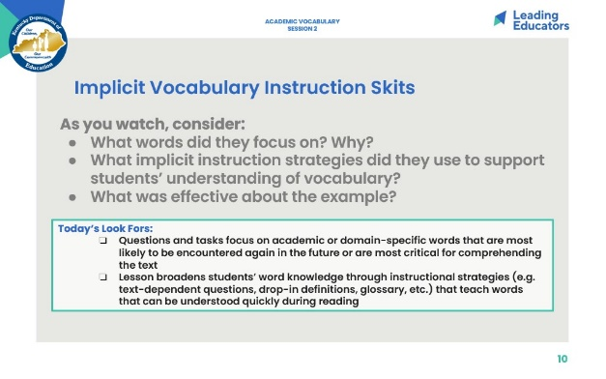
Slide 11:  4 minutes  Reflection:  - Finally, let’s conclude with a reflection on why this matters and where we go next! Take 1 minute to reflect.  - Consider one student in your classroom who is currently struggling with grade-level complex texts due to vocabulary. How can implicit vocabulary instruction help to ensure that this student has equitable opportunities in literacy?  - What is one next step you can take in your classroom tomorrow?  - 3 minutes: Stand up, find someone you have not talked with yet today, and share out your reflections.  Look or Listen Fors/Evidence of Mastery:  - Participants reflect on a specific student and next step.  1 minute  Directions/Framing:  - Before we close out, I want to take a minute to preview the learning that we will engage in next week. We will have an opportunity to review an upcoming text and lesson and analyze it against our look fors. We will also get to practice delivering implicit instruction. [Note: If teachers do not have a curricular resource that includes strong vocabulary instruction, direct them to prep an upcoming read aloud by identifying Tier 2 and 3 words and planning ways to teach some of those words implicitly]  - Thank you all for your engagement in today’s learning! | 