Academic Vocabulary Facilitator’s Guide, Grades 6-8

Session 3

OVERVIEW
Grade Band/ Content Area | - ELA 6-8
Essential Questions | - Why is vocabulary instruction critical for equity in literacy?  - Which words do I teach and how?
Enduring Understandings | - Students who know fewer vocabulary words struggle with comprehension, and often get fewer experiences to read grade level text with rich vocabulary as a result. Often, attempts to differentiate for struggling readers mean that those readers end up reading less challenging passages vs. getting supported opportunities to engage with challenging text and learn new vocabulary.  - We must focus instruction on academic vocabulary (Tier 2 words) and domain-specific vocabulary (Tier 3 words).  - We must spend the most time on words needed to fully comprehend the text, words likely to appear in future texts from any discipline, and words that are part of a word family or semantic network.  - To support students in both a breadth and depth of vocabulary knowledge, we must teach vocabulary
Key Components of Cycle | The Learning Cycle includes the following components to support shifts in instruction:  - Shared Learning: Learning sessions where teachers learn new knowledge and skills aligned to the topic of the content cycle. This could look a variety of ways, including reading and discussing an article, studying a classroom video, or doing some group practice of a particular planning skill.  - Planning & Practice: Opportunities for teachers to apply the content they are learning. This could include analyzing units/lessons, creating lessons, rehearsing lessons, watching and reflecting on videos of their classroom practice, etc.  - Student Progress Monitoring: This is an opportunity for teachers to examine student progress aligned to the topic of the cycle. This can include formative student work analysis, end of unit assessments, culminating tasks, etc.  Over the course of this learning cycle, teachers will build an understanding of why vocabulary instruction is critical for our students and how to align their planning and practice research-based principles for implicit vocabulary instruction, explicit vocabulary instruction, text sets, and for reinforcing and extending vocabulary. In this cycle, teachers will have opportunities to experience vocabulary instruction through the lens of students and consider the impact.

TEACHER AND STUDENT GOALS
Teacher Planning & Practice Look-Fors  NOTE: The Practice and Look Fors below come from Leading Educators’ Program Standards. Teams should feel welcome to tailor these to align with district tools as needed. | Example Student Goal(s)  NOTE: These goals are intended to be a starting place for team goal setting. Teams should feel welcome to tailor or add to these based on context, curriculum, and district/school tools.
Practice: Analyzes and adapts questions and tasks to focus on the vocabulary words that are most critical for developing students’ literacy, comprehending the text, and understanding the key ideas of the unit  Look Fors:  - Questions and tasks focus on academic or domain-specific words that are most likely to be encountered again in the future or are most critical for comprehending the text  - Lessons broaden students’ word knowledge through instructional strategies (e.g., text-dependent questions, drop-in definitions, glossary, etc.) that teach words that can be understood quickly during reading  - Weekly lessons deepen students’ word knowledge by explicitly defining, modeling, and giving students active practice with 6-10 vocabulary words  - Over the course of the unit, students have opportunities to maintain and extend vocabulary through additional practice with words previously taught | Possible goals:  - In-class observation of specific student actions that correlate with the learning connected to this content cycle  - Achievement or growth on a unit/domain assessment  - Achievement or growth on a prioritized unit/domain writing task (see rubric guidance below)

CYCLE-AT-A-GLANCE
NOTE: Each row is intended to represent one 90-minute session, but schools can adjust the pacing of learning based on their context and teacher needs.

Session | Type of Learning | Objective(s) | Assessment of Learning
Session 3  Implicit Vocabulary Instruction | Planning & Practice | Apply knowledge of implicit vocabulary instruction to curricular planning and practice  Give and receive feedback from colleagues in order to revise plans and refine practices | Analyze and annotate lesson from curriculum for implicit vocabulary instruction and potential adjustments.

Preparation:
Participant should be given access to the following documents to engage in the learning for this session:
- PowerPoint Slides
- Participant Handout
- Goal Setting Document

Session 3: Planning and Practice
Pre-Work | Teachers gather and bring:  - Goal-Setting Document for the current content cycle  - A read aloud/vocabulary lesson plan for upcoming week
PPT | Session 3 PowerPoint  *Times listed in the presenter’s notes on slides are approximate, and may be adjusted to meet the needs and schedule of the individual PLC.
Printing | Participant Handout
Agenda | Facilitation Guidance
- Opening  - Plan  - Practice  - Revise  - Closing | Overview: In this planning and practice session, teachers will apply what they have learned about implicit vocabulary instruction. As teachers plan for an upcoming read aloud/vocabulary lesson, they will focus on the Planning and Instructional Look-Fors that will support them in meeting goals set in the previous session. Teachers will practice with a colleague, eliciting specific feedback to aid in effective instructional implementation. After collaborating with colleagues and giving/receiving feedback, teachers will modify their approach and complete or refine their instructional plans.

Facilitator’s Notes | Accompanying Slide
Slide 1:  Session Summary In this planning and practice session, teachers will apply learning of the instructional practice studied in the previous new learning session. As teachers plan, they will focus on the Planning and Instructional Look-Fors that will support them in meeting goals set in the previous session. Teachers will practice with a colleague, eliciting specific feedback to aid in effective instructional implementation. After collaborating with colleagues and giving/receiving feedback, teachers will modify their approach and complete or refine their instructional plans.  Session Length: 90 minutes | 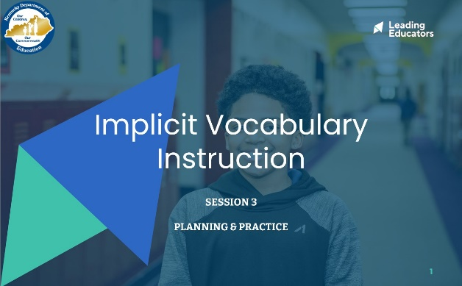
Slide 2:  Do Now (2 minutes): “Please take out the goal-setting document you completed during the first week of this content cycle. Take a couple of minutes to reflect on the progress you have seen in your practice and in your students over the past week. What are some ways you want to continue to grow?” | 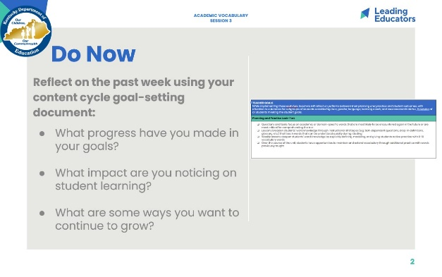
Slide 3:  Cycle Overview (1 minute)  - Share path of the cycle, explaining how the professional learning includes opportunities for shared learning, planning and practice, and studying student progress. | 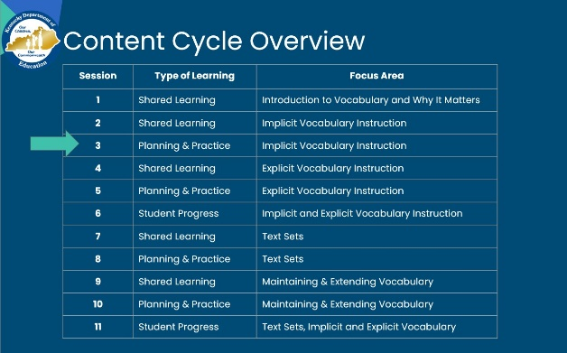
Slide 4:  (3 minutes)  Framing (1 minute): “This week, we’ll return to a planning protocol in which we plan and receive feedback on strategic ways that we can leverage our learning from last week as we work toward the goals and look-fors of this cycle. Just like musicians rehearsing, we are tuning and refining our practice off-stage before performing for our audience of students!”  Team Building (2 minutes): “Before we dig in, take a moment to share with a partner the reflections you noted during the Do Now. Additionally, discuss the instructional evidence you intend to include in your plan today that will reflect the growth identified in your goals. Revisiting our goals prior to planning will help to narrow our focus on the portions of our curriculum that we want to receive feedback on today.” | 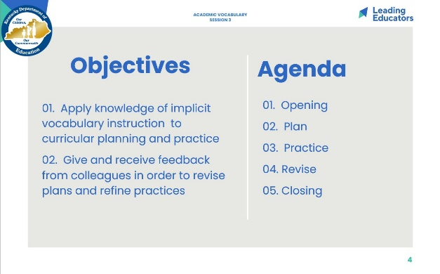
Slide 5:  Norms (1 minute)  - Review norms | 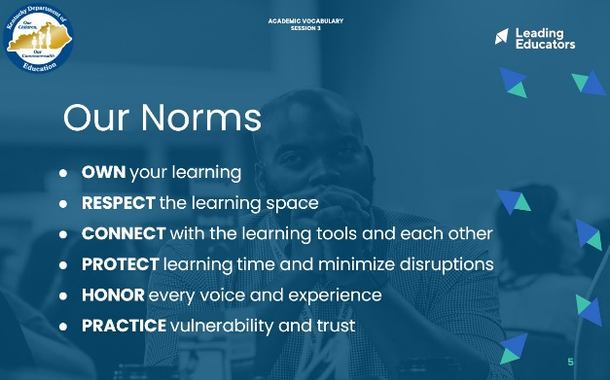
Slide 6:  Preparing for the Protocol (2 minutes):  “In our previous sessions, we’ve discussed the importance of teaching vocabulary and we dove into the implicit approach to vocabulary instruction. Today, we are going to plan and practice implementing our shared learning. Please make sure you have the following materials pulled up: your goal-setting document and an upcoming read aloud/lesson plan. (If there is no formal lesson plan, that is okay -- the text is the most important part) | 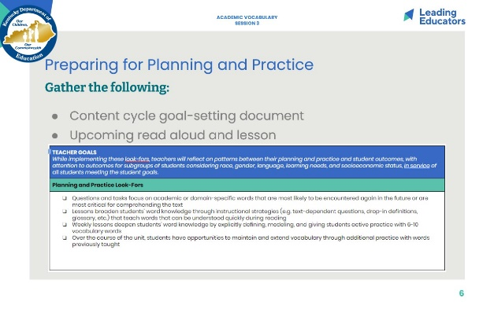
Slide 7:  Planning (30 minutes total)  Intended Student Learning (8 minutes)  - Framing (1 minute): “As we prepare to plan, identify a partner to work with. With that partner, discuss the intended student learning for the Lesson plan you will be analyzing today. Internalizing student outcomes for this part of the curriculum is essential so that you can provide each other with specific and targeted feedback during our practice today.”  - Partners (7 minutes): Discuss student outcomes for the targeted curricular resource and alignment to the goals for the content cycle.  Analyze and Adapt Curriculum (22 minutes)  - Framing (2 minutes): As a reminder... “In the planning and practice phase, we will be working like musicians who annotate their scores and shape the dynamics of even the most famous musical works before they perform these masterpieces on stage. Even when we use curriculum that is a high-quality resource, it is our analysis and adaptation of the materials that will allow us to implement them masterfully with our students. In our first phase of planning today, we will hone in on vocabulary in our read aloud. Based on our shared learning from the past two weeks, we will be prioritizing Tier 2 and Tier 3 words that we think our students might struggle with. Then we will plan to teach those words using what we have learned about implicit vocabulary instruction.  - Individually or in Co-teaching teams (20 minutes): Teachers analyze and adapt a portion of their curriculum that will elevate achievement for all students. If resource does not include implicit instruction, this is a place for adaptation, Teachers will also plan for effective implementation (i.e., oral instructions, visuals, relevant routines, etc.) of the instructional approach. When planning, teachers should consider how implementation aligns to the intended student learning and how it will impact and support the diverse needs of students.  If teachers do not have a high-quality curricular resource that addresses vocabulary, use the next slide. (Unhide it.) | 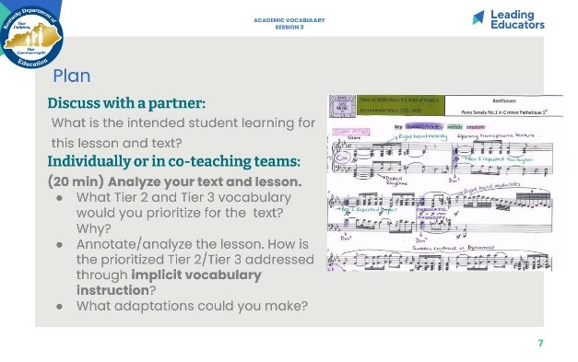
Slide 8:  ALTERNATIVE VERSION TO SUPPORT LESSON CREATION -- UNHIDE SLIDE  Planning (30 minutes total)  Intended Student Learning (8 minutes)  - Framing (1 minute): “As we prepare to plan, identify a partner to work with. With that partner, discuss the text you will be reading and the intended student learning? What should they be able to know and do by the end of the read aloud?”  - Partners (7 minutes): Discuss student outcomes for the text. These can include big ideas and understandings from the text (message, main idea) as well as practice with specific KAS.  Plan the read aloud (22 minutes)  - Framing (2 minutes): As a reminder... “In the planning and practice phase, we will be working like musicians who annotate their scores and shape the dynamics of even the most famous musical works before they perform these masterpieces on stage. In our first phase of planning today, we will hone in on vocabulary in our read aloud. Based on our shared learning from the past two weeks, we will be prioritizing Tier 2 and Tier 3 words that we think our students might struggle with. Then we will plan to teach those words using what we have learned about implicit vocabulary instruction.  - Individually or in Co-teaching teams (20 minutes): Teachers first identify words to teach and select 3-4 to address using what they have learned about implicit vocabulary instruction. | 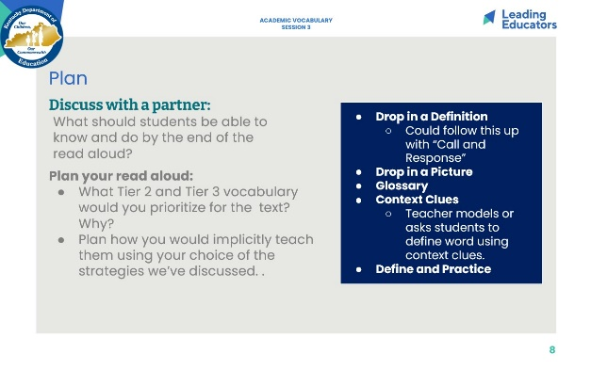
Slide 9:  Framing for Practice (3 minutes): “Before we begin our “off-stage practice” let’s reflect: Why is lesson rehearsal important? How does it connect to equity? We will be practicing how we will teach 1-2 of the prioritized vocabulary words we identified during our planning.”  Look/Listen for:  - Lesson rehearsal allows us to “work out the kinks” in our practice off-stage before we are in front of students.  - Many professions practice: Musicians rehearse, doctors practice surgical procedures before they do them on living people, athletes go to practice. Teachers have one of the highest stakes audiences of all - and we can practice, too!  - Lesson rehearsal is connected to equity for students, because it helps teachers refine their instruction before bringing it to students. This way all kids get their teacher’s very best.  - Lesson rehearsal is connected to equity for teachers because we all vary in terms of our current knowledge and experience. Practice gives us a chance to prepare for our students in an environment where can get feedback and support from others. | 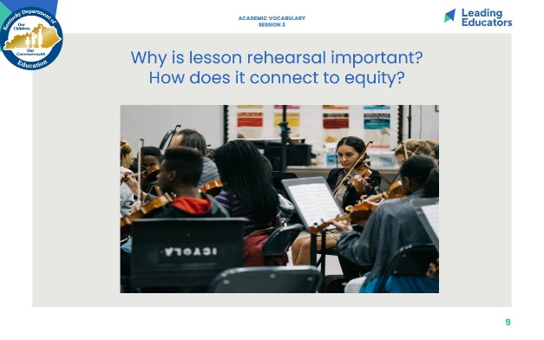
Slide 10:  Practice (18 minutes)  Practice/Feedback Loop Round 1 (7 minutes): Partner 1 practices instructional plan and records partner feedback aligned to relevant Planning and Practice Look-Fors. Partners may consider the following questions when providing feedback to consider:  - Does the vocabulary instruction in this read aloud lesson work?  - What modification would strengthen this lesson component for all students?  - Does this lesson component/instructional approach align to and/or support the intended student learning?  Practice/Feedback Loop Round 2 (7 minutes): Partner 2 practices instructional plan and records partner feedback aligned to relevant Planning and Instructional Look-Fors.  Individual Reflection (4 minutes): “As we prepare for revising, take a minute to jot down implications from your partner’s feedback, for your next steps with planning. A question to consider in your reflection is: What are my next steps, based on feedback received, that would ensure effective implementation for all learners?” | 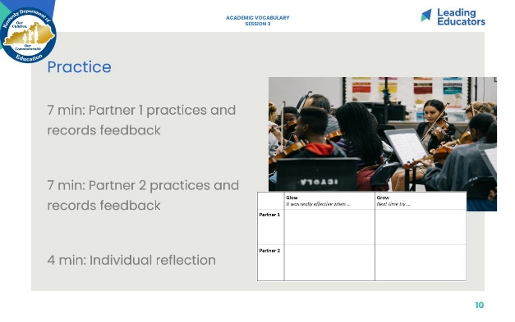
Slide 11:  Revising (20 minutes)  - “Now is the time for you to reflect on the rehearsal experience and to think about the feedback you received from your partner.”  - Using the feedback provided, teachers will revise their instructional approach and continue planning. | 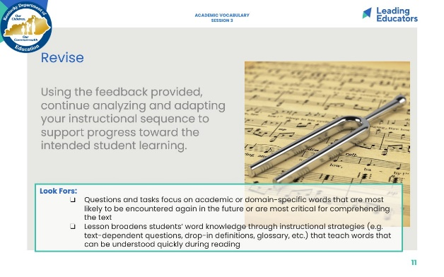
Slide 12:  7 minutes  Closing the Protocol (7 minutes total)  Partner Debrief (3 minutes): Teachers return to their original partner and share instructional plans and modifications/adaptations made in response to the feedback received. A guiding question to facilitate this discussion might be: How did you apply your partner’s practice feedback into your revised lesson?  Whole Group Debrief (2 minutes):  - What did you learn from engaging in the Practice and Feedback loop with your colleague?  - How has this process increased my intentional support for the diverse needs of students in my class?  Upload Planning Artifacts (2 minutes): Teachers upload their planning artifacts. | 