Academic Vocabulary Facilitator’s Guide, Grades 6-8

Session 9

OVERVIEW
Grade Band/ Content Area | - ELA 6-8
Essential Questions | - Why is vocabulary instruction critical for equity in literacy?  - Which words do I teach and how?
Enduring Understandings | - Students who know fewer vocabulary words struggle with comprehension, and often get fewer experiences to read grade level text with rich vocabulary as a result. Often, attempts to differentiate for struggling readers mean that those readers end up reading less challenging passages vs. getting supported opportunities to engage with challenging text and learn new vocabulary.  - We must focus instruction on academic vocabulary (Tier 2 words) and domain-specific vocabulary (Tier 3 words).  - We must spend the most time on words needed to fully comprehend the text, words likely to appear in future texts from any discipline, and words that are part of a word family or semantic network.  - To support students in both a breadth and depth of vocabulary knowledge, we must teach vocabulary
Key Components of Cycle | The Learning Cycle includes the following components to support shifts in instruction:  - Shared Learning: Learning sessions where teachers learn new knowledge and skills aligned to the topic of the content cycle. This could look a variety of ways, including reading and discussing an article, studying a classroom video, or doing some group practice of a particular planning skill.  - Planning & Practice: Opportunities for teachers to apply the content they are learning. This could include analyzing units/lessons, creating lessons, rehearsing lessons, watching and reflecting on videos of their classroom practice, etc.  - Student Progress Monitoring: This is an opportunity for teachers to examine student progress aligned to the topic of the cycle. This can include formative student work analysis, end of unit assessments, culminating tasks, etc.  Over the course of this learning cycle, teachers will build an understanding of why vocabulary instruction is critical for our students and how to align their planning and practice research-based principles for implicit vocabulary instruction, explicit vocabulary instruction, text sets, and for reinforcing and extending vocabulary. In this cycle, teachers will have opportunities to experience vocabulary instruction through the lens of students and consider the impact.

TEACHER AND STUDENT GOALS
Teacher Planning & Practice Look-Fors  NOTE: The Practice and Look Fors below come from Leading Educators’ Program Standards. Teams should feel welcome to tailor these to align with district tools as needed. | Example Student Goal(s)  NOTE: These goals are intended to be a starting place for team goal setting. Teams should feel welcome to tailor or add to these based on context, curriculum, and district/school tools.
Practice: Analyzes and adapts questions and tasks to focus on the vocabulary words that are most critical for developing students’ literacy, comprehending the text, and understanding the key ideas of the unit  Look Fors:  - Questions and tasks focus on academic or domain-specific words that are most likely to be encountered again in the future or are most critical for comprehending the text  - Lessons broaden students’ word knowledge through instructional strategies (e.g., text-dependent questions, drop-in definitions, glossary, etc.) that teach words that can be understood quickly during reading  - Weekly lessons deepen students’ word knowledge by explicitly defining, modeling, and giving students active practice with 6-10 vocabulary words  - Over the course of the unit, students have opportunities to maintain and extend vocabulary through additional practice with words previously taught | Possible goals:  - In-class observation of specific student actions that correlate with the learning connected to this content cycle  - Achievement or growth on a unit/domain assessment  - Achievement or growth on a prioritized unit/domain writing task (see rubric guidance below)

CYCLE-AT-A-GLANCE
NOTE: Each row is intended to represent one 90-minute session, but schools can adjust the pacing of learning based on their context and teacher needs.

Session | Type of Learning | Objective(s) | Assessment of Learning
Session 9  Reinforcing Vocabulary Across Lessons/Texts | Shared Learning | Reinforce prioritized vocabulary across lessons/texts | Analyze and adapt a lesson from the curriculum, identifying opportunities to reinforce vocabulary from previous lessons

Preparation:
Participant should be given access to the following documents to engage in the learning for this session:
- PowerPoint Slides
- Participant Handout
- Prework: Maintenance and Extension

Session 9: Shared Learning: Reinforcing and Extending Vocabulary Instruction
Pre-Work | 30 min: Participants read “Maintenance and Extension” (p.281-285) from Reading Reconsidered and capture thinking in response to the following questions:  - Why is it important that teachers are thoughtful and intentional about creating and using systems for students to meaningfully revisit words?  - What are some strategies for maintaining and extending students’ vocabulary?  - How does this compare to your current practice?
PPT | Session 9 PowerPoint  *Times listed in the presenter’s notes on slides are approximate, and may be adjusted to meet the needs and schedule of the individual PLC.
Printing/Digital handouts | - Participant Handout  - “Maintenance and Extension”
Agenda | Facilitation Guidance
- Opening  - Why This Matters  - Strategies for Maintaining and Extending Vocabulary  - Practice with a Lesson  - Reflection | Overview: In this session, participants will explore how to maintain and extend vocabulary across lessons. They will first learn about several different strategies for the classroom through videos, experiences, and resources. They will then apply their learning to a lesson from the curriculum.

Facilitator’s Notes | Accompanying Slide
Slide 1:  1 minute  Frame: 1 minute  “Welcome to our final shared learning session in this content cycle. In today’s session, we will delve into how we can support students to continue to maintain and extend their understanding of vocabulary beyond the first lesson where it is taught. Just as athletes engage in ball-handling drills and other exercises to refine their skills, so too do our students need to continue to work with the vocabulary they have learned so that they can build a deeper understanding of more words, which will help them to become stronger communicators and readers.” | 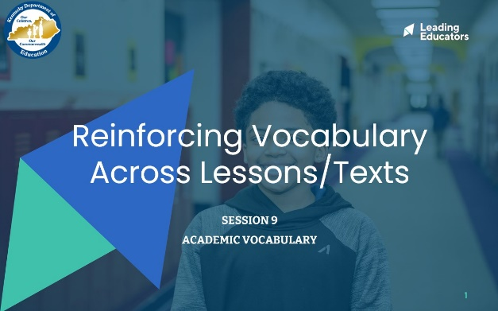
Slide 2:  5 minutes:  Directions/Framing:  Facilitator shares the quote, “The limits of my language mean the limits of my world” by Ludwig Wittgenstein. Participants reflect on the following questions:  - What does this quote mean to you?  - How has this been true in your classroom?  - 1 minute: Reflect independently.  - 3 minutes: Share reflections with a partner.  - Thank you all for sharing! As I heard many of you reflect, language is critical to students’ having access to texts, conversations, and understanding new content. Vocabulary can expand our horizons and cultivate joy and interest for students. Today we will explore additional strategies for supporting students in strengthening their vocabularies so there are no limits.  Look or Listen Fors/Evidence of Mastery:  - The world reflects opportunities, open doors, possibilities.  - Without a strong vocabulary, there is a limit to opportunities.  - We all have the capacity to improve our limits. | 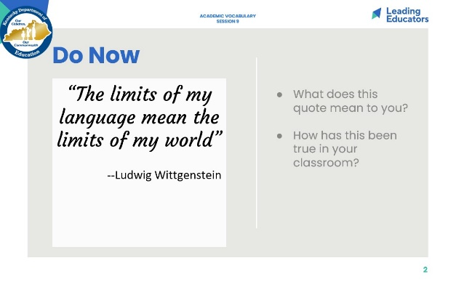
Slide 3:  Cycle Overview (1 minute)  - Share 11-week path of the cycle, reminding teachers how the professional learning includes opportunities for shared learning, planning and practice, and studying student progress. | 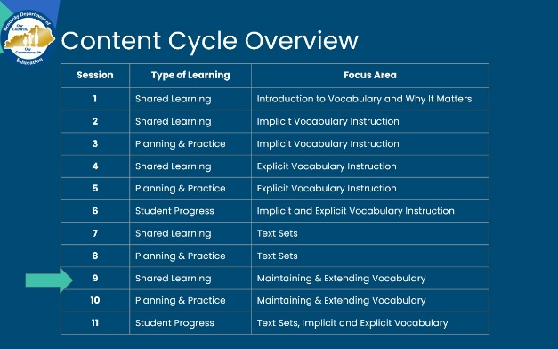
Slide 4:  2 minutes  Directions/Framing/Key Points:  - Here are the objectives for the session. May I have two volunteers read them aloud?  - Here is our path for learning.  Look or Listen Fors/Evidence of Mastery:  NA | 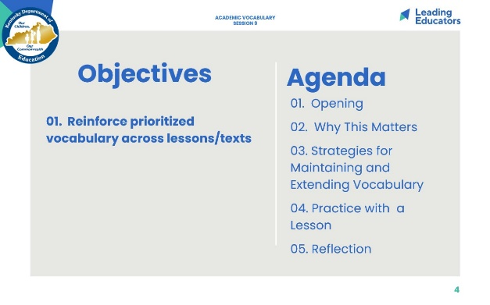
Slide 5:  10 minutes  Directions/Framing:  “Let’s begin by returning to our pre-work reading to make sure that we understand the key points around systems and routines for supporting students in maintaining and extending their vocabularies.”  - 5 minutes: In partners, participants return to their notes from the pre-work article, and share their answers to the following questions:  - Why is it important that teachers are thoughtful and intentional about creating and using systems for students to meaningfully revisit words?  - What are some strategies for maintaining and extending students’ vocabulary?  - How does this compare to your current practice?  - What do you want to learn?  - 5 minutes: Whole group share out, with the facilitator soliciting and reinforcing the key takeaways.  Look or Listen Fors/Evidence of Mastery:  - The end goal is for students to retain vocabulary for later use in reading writing and speaking  - In order to solidify student understanding of vocabulary words, students must use them  - Spiraling back involves revisiting words you have already taught, giving students the kind of practice that can lead to mastery.  - Many different approaches to reinforcing and maintaining previously taught vocabulary.  - Engaging in wordplay  - Reviewing several words at once  - Active practice questions - Useful in providing an additional prompt for rigorously applying a word - Helps with spiraling back on previously taught vocab  - Choose between two words - which is best for _______  - Pose questions that force students to think about relationships between words: Could a ___ be a ____ Why? Why not?  - Prompting students to upgrade word choice in discussion and writing  - Applying words to reading / Connecting to Text  - Utilizing the classroom environment--Word Walls | 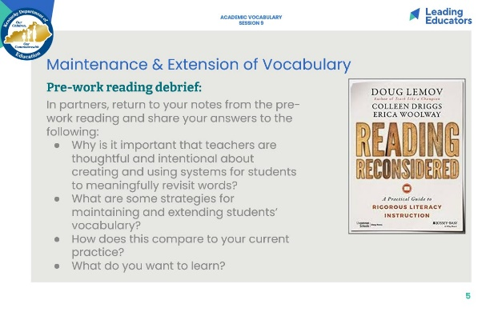
Slide 6:  Key Takeaways: Reinforcing Vocabulary Across Lessons & Texts (3 min)  Directions/Framing/Key Points:  - 1 minute: “Here are some key takeaways about reinforcing vocabulary, many of which you have surfaced.”  - 2 minutes: Provide time for teachers to review the slide and ask clarifying questions, as needed.  Look and/or Listen For:  - The end goal of vocabulary instruction is for students to retain vocabulary for later use in reading comprehension, writing, and speaking.  - Research show that students need at least six repetitions with a word before they can master it.  - Students need to hear, say, write, think deeply about words in order to begin to use them in their regular speech and writing and understand them well in reading.  - Spiraling back involves revisiting words you have already taught, giving students the kind of practice that can lead to mastery.  - There are many different approaches to reinforcing and maintaining previously taught vocabulary. Some include:  - Engaging in wordplay to review  - Prompting students to upgrade word choice in discussion and writing  - Applying words to reading / Connecting to Text  - Utilizing the classroom environment - Word Walls | 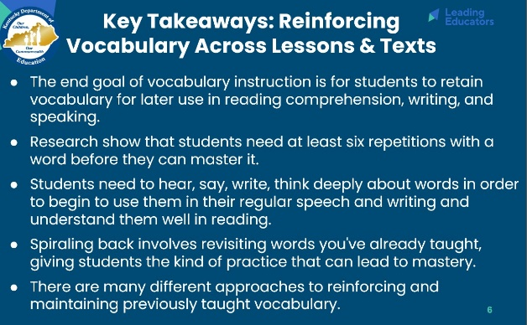
Slide 7:  6 minutes: https://vimeo.com/84900192  Directions/Framing:  - We will now have the opportunity to take a look at some example protocols for maintaining and extending vocabulary.  - As we explore each strategy, please use your handout to capture thinking about each one.  - First, let’s take a look at the “Interactive Word Wall” strategy. This is a Grade 8 ELA classroom working on a unit with texts focused on war.  - 2 minutes: Watch video and capture notes.  - 3 minutes: Give participants time to add any additional thinking into their handout. Facilitator can also invite participants to share with a partner.  Look or Listen Fors/Evidence of Mastery:  - Students have opportunities to make and explain connections between words, challenging them to more deeply consider the meaning and nuances of words.  - This strategy can get students using and hearing multiple vocabulary words during a short period of time.  - This could also be adjusted so that students are writing their responses using a word wall that is on a wall. It could also be adjusted so that each table or pair of students has their own interactive word wall so that there is more cognitive demand on more students. The teacher could include a writing prompt at the end of the lesson that asks students to write a paragraph explaining the connections between 2-3 words. | 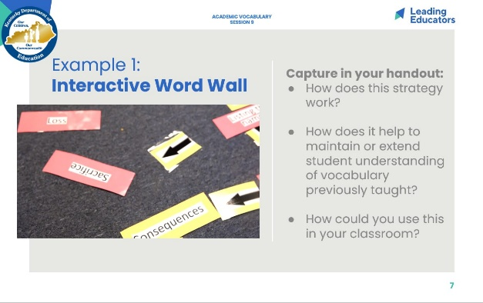
Slide 8:  7 minutes  Directions/Framing:  - Let’s take a look at another example. This protocol is called “Quiz Quiz Trade.”  - The video we are going to see is of a fourth grade classroom, but is one of the best available videos of this strategy; it showcases the ways that students are engaging with the words as a result of the protocol. In our classrooms with older students, the protocol would look the same but just with different words.  - 2 minutes: Watch video and capture notes.  - 3 minutes: Give participants time to add any additional thinking into their handout. Facilitator can also invite participants to share with a partner.  Look or Listen Fors/Evidence of Mastery:  - Students each have a card with a word, and then they take turns quizzing their partner, then trading cards with their partner. Then they find a new partner, and repeat the process. This gives students exposure to many vocabulary words. It challenges students to understand the meaning of the words, say them, and read them. | 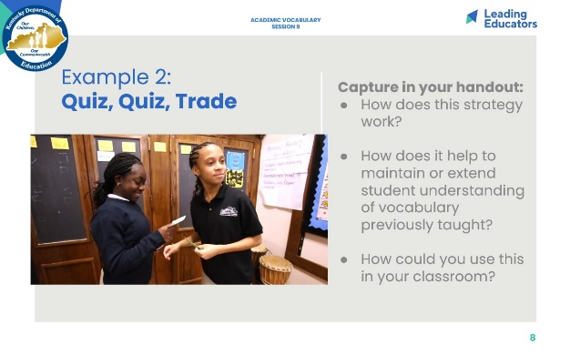
Slide 9:  6 minutes  Directions/Framing:  - Let’s see another example, only this time we are going to sit in the seats of students!  - The article we read as pre-work mentioned the power of ‘word play questions.’ These can be questions that are part of the Do Now, homework, or some other regular classroom routine. The idea is that they are questions that challenge students to think more deeply about the meaning of multiple vocabulary words, and then students have opportunities to talk or write about those words.  - Let’s try this example. The vocabulary words in this example were taken from an EngageNY Module focused on ethics and equity in the medical field. Can I get a volunteer to read our task and vocabulary words?  - 2 minutes: Jot down your story! *students may use phones or dictionaries to look up any unfamiliar words  - 3 minutes: Share with a partner.  Look or Listen Fors/Evidence of Mastery:  - Participants are talking about the picture using the vocabulary words. | 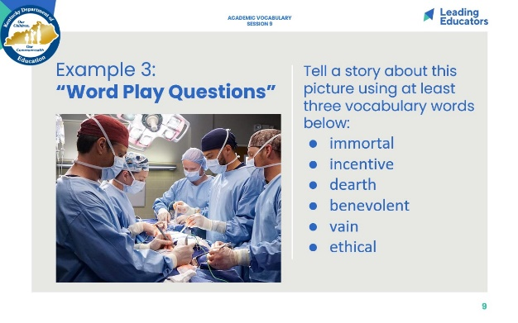
Slide 10:  3 minutes  Directions/Framing:  - 3 minutes: Give participants time to add any additional thinking into their handout. Facilitator can also invite participants to share with a partner.  Look or Listen Fors/Evidence of Mastery:  - This strategy could be used during Do Nows, homework, or other regular classroom routines. | 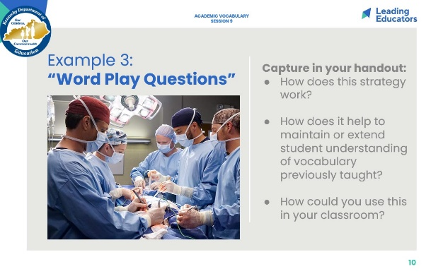
Slide 11:  7 minutes  Directions/Framing:  - Let’s take a look at one last classroom example. This protocol is called “Give One, Get One, Move On,” or GOGOMO. We used this strategy in our last shared learning session!  - This video is of an eighth grade classroom studying the word “metamorphosis.” Again, this is the best video for this strategy and something that could be tailored to intermediate grade students.  - 2 minutes: Watch video and capture notes.  - 3 minutes: Give participants time to add any additional thinking into their handout. Facilitator can also invite participants to share with a partner.  Look or Listen Fors/Evidence of Mastery:  - This strategy could be used to review an entire unit or topic (so could include many vocabulary words); it could also be used to study a single word, with students writing examples, non-examples, or other characteristics in each of the boxes. This strategy can get students to write and talk about many unit vocabulary words at once, or it can support students in building a deeper understanding of a single vocabulary word that has more depth and nuance. | 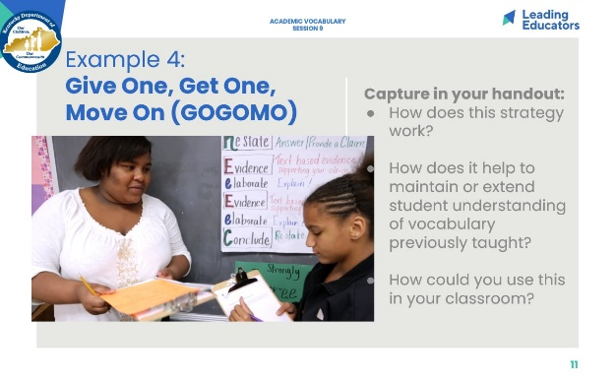
Slide 12:  25 minutes  Directions/Framing:  - “Let’s take a look at a lesson from your unit of study where students read informational text to support their thinking. As you review this lesson, you will determine ways these lessons support previously taught vocabulary and how you might incorporate one vocabulary strategy to reinforce the vocabulary from your lesson.”  - Today when we practice, we are going to take a look at one lesson from your curriculum. We will consider 3-5 vocabulary words that you will teach. Then we will consider one task or strategy we could add or adjust in this lesson in order to also review some of the previously learned vocabulary. Please capture your thinking in your handout.  - 20 minutes: Work Time (independently or in groups)  - 5 minutes: whole group share out  Look or Listen Fors/Evidence of Mastery:  - Selection of 3-5 vocabulary words from lesson  - Selection/Adaptation of vocabulary strategy from today’s session  - Discussion of how to implement | 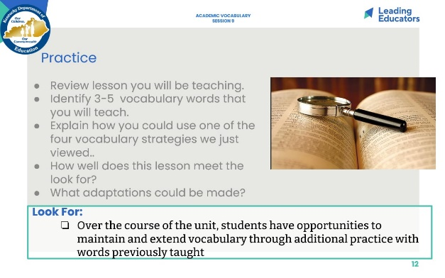
Slide 13:  5 minutes  Directions/Framing:  - Our reflection for today goes back to our first session during which we discussed the relationship between vocabulary instruction and equity.  - Why is vocabulary instruction critical for equity in literacy for all students, including (and especially) English Language Learners, students who are struggling readers, or students with special needs? What is one next step you can take in your classroom to support students in maintaining or extending vocabulary?  - 1 min: Participants reflect.  - 4 min: Whole group whip-around with each participant sharing one key takeaway in response to one of the questions.  Look or Listen Fors/Evidence of Mastery:  - Strong understanding of vocabulary is essential for reading comprehension, and in particular for accessing grade-level complex texts  - English Language Learners and students who are struggling readers often have lower comprehension because they do not know as many vocabulary words  - Vocabulary instruction can help to create access to texts for all students | 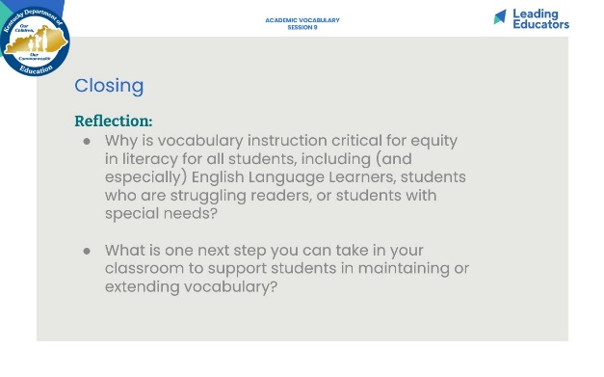
Slide 14:  1 minute  Directions/Framing:  - Before we close out, I want to take a minute to preview the learning that we will engage in next week. We will have an opportunity to review an upcoming text and lesson and analyze it against our look fors.  - Thank you all for your engagement in today’s learning!  Look or Listen Fors/Evidence of Mastery:  NA | 