Academic Vocabulary Facilitator’s Guide, Grades 9-12

Session 10
OVERVIEW

Grade Band/ Content Area | - ELA 9-12
Essential Questions | - Why is vocabulary instruction critical for equity in literacy?  - Which words do I teach and how?
Enduring Understandings | - Students who know fewer vocabulary words struggle with comprehension, and often get fewer experiences to read grade level text with rich vocabulary as a result. Often, attempts to differentiate for struggling readers mean that those readers end up reading less challenging passages vs. getting supported opportunities to engage with challenging text and learn new vocabulary.  - We must focus instruction on academic vocabulary (Tier 2 words) and domain-specific vocabulary (Tier 3 words).  - We must spend the most time on words needed to fully comprehend the text, words likely to appear in future texts from any discipline, and words that are part of a word family or semantic network.  - To support students in both a breadth and depth of vocabulary knowledge, we must teach vocabulary
Key Components of Cycle | The Learning Cycle includes the following components to support shifts in instruction:  - Shared Learning: Learning sessions where teachers learn new knowledge and skills aligned to the topic of the content cycle. This could look a variety of ways, including reading and discussing an article, studying a classroom video, or doing some group practice of a particular planning skill.  - Planning & Practice: Opportunities for teachers to apply the content they are learning. This could include analyzing units/lessons, creating lessons, rehearsing lessons, watching and reflecting on videos of their classroom practice, etc.  - Student Progress Monitoring: This is an opportunity for teachers to examine student progress aligned to the topic of the cycle. This can include formative student work analysis, end of unit assessments, culminating tasks, etc.  Over the course of this learning cycle, teachers will build an understanding of why vocabulary instruction is critical for our students and how to align their planning and practice research-based principles for implicit vocabulary instruction, explicit vocabulary instruction, text sets, and for reinforcing and extending vocabulary. In this cycle, teachers will have opportunities to experience vocabulary instruction through the lens of students and consider the impact.

TEACHER AND STUDENT GOALS

Teacher Planning & Practice Look-Fors  NOTE: The Practice and Look Fors below come from Leading Educators’ Program Standards. Teams should feel welcome to tailor these to align with district tools as needed. | Example Student Goal(s)  NOTE: These goals are intended to be a starting place for team goal setting. Teams should feel welcome to tailor or add to these based on context, curriculum, and district/school tools.
Practice: Analyzes and adapts questions and tasks to focus on the vocabulary words that are most critical for developing students’ literacy, comprehending the text, and understanding the key ideas of the unit  Look Fors:  - Questions and tasks focus on academic or domain-specific words that are most likely to be encountered again in the future or are most critical for comprehending the text.  - Lessons broaden students’ word knowledge through instructional strategies (e.g., text-dependent questions, drop-in definitions, glossary, etc.) that teach words that can be understood quickly during reading.  - Weekly lessons deepen students’ word knowledge by explicitly defining, modeling, and giving students active practice with 6-10 vocabulary words.  - Over the course of the unit, students have opportunities to maintain and extend vocabulary through additional practice with words previously taught. | Possible goals:  - In-class observation of specific student actions that correlate with the learning connected to this content cycle  - Achievement or growth on a unit/domain assessment  - Achievement or growth on a prioritized unit/domain writing task (see rubric guidance below)

CYCLE-AT-A-GLANCE
NOTE: Each row is intended to represent one 90-minute session, but schools can adjust the pacing of learning based on their context and teacher needs.

Session | Type of Learning | Objective(s) | Assessment of Learning
Session 10  Reinforcing Vocabulary Across Lessons/Texts | Planning & Practice | Apply learning to curricular planning and practice  Give and receive feedback from colleagues in order to revise plans and refine practices | Analyze and annotate unit/lesson, identifying opportunities to use and reinforce vocabulary from the unit.

Preparation:
Participant should be given access to the following documents to engage in the learning for this session:
- PowerPoint Slides
- Participant Handout
- Goal Setting Document

Session 10: Planning and Practice

Pre-Work | Teachers gather and bring:  - Goal-Setting Document for the current content cycle  - Curricular Documents
PPT | Session 10 PowerPoint  *Times listed in the presenter’s notes on slides are approximate, and may be adjusted to meet the needs and schedule of the individual PLC.
Printing/ Digital handouts | Participant Handout

Agenda | Facilitation Guidance
- Opening  - Plan  - Practice  - Revise  - Closing | Overview: In this planning and practice session, teachers will apply learning of the instructional practice studied in the previous new learning session. As teachers plan, they will focus on the Planning and Instructional Look-Fors that will support them in meeting goals set in the previous session. Teachers will practice with a colleague, eliciting specific feedback to aid in effective instructional implementation. After collaborating with colleagues and giving/receiving feedback, teachers will modify their approach and complete or refine their instructional plans.

Facilitator’s Notes | Accompanying Slide
Slide 1:  Session Summary In this planning and practice session, teachers will apply learning of the instructional practice studied in the previous new learning session. As teachers plan, they will focus on the Planning and Instructional Look-Fors that will support them in meeting goals set in the previous session. Teachers will practice with a colleague, eliciting specific feedback to aid in effective instructional implementation. After collaborating with colleagues and giving/receiving feedback, teachers will modify their approach and complete or refine their instructional plans.  Session Length: 90 minutes | 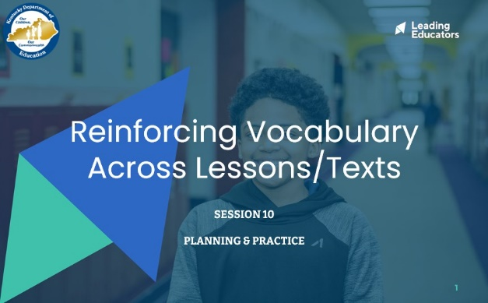
Slide 2:  Do Now (2 minutes): “Please take out the goal-setting document you completed during the first week of this content cycle. Take a couple of minutes to reflect on the progress you have seen in your practice and in your students over the past week. What are some ways you want to continue to grow?” | 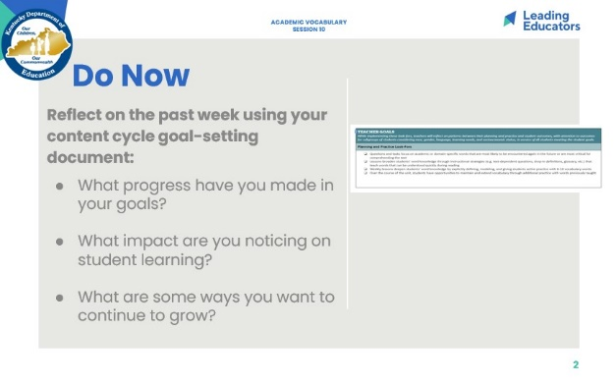
Slide 3:  (3 minutes)  Framing (1 minute): “This week, we’ll engage in a planning protocol in which we plan and receive feedback on strategic ways that we can leverage our learning from last week as we work toward the goals and look-fors of this cycle. Just like musicians rehearsing, we are tuning and refining our practice off-stage before performing for our audience of students.”  Team Building (2 minutes): “Before we dig in, take a moment to share with a partner the reflections you noted during the Do Now. Additionally, discuss the instructional evidence you intend to include in your plan today that will reflect the growth identified in your goals. Revisiting our goals prior to planning will help to narrow our focus on the portions of our curriculum that we want to receive feedback on today.” | 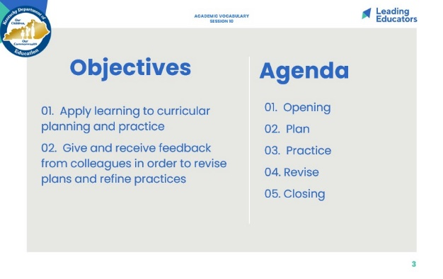
Slide 4:  Norms (1 minute)  - Review norms | 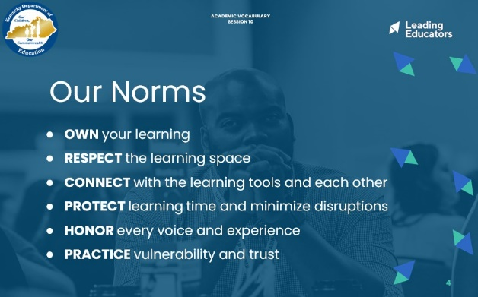
Slide 5:  Cycle Overview (1 minute)  - Share 11-week path of the cycle, reminding teachers how the professional learning includes opportunities for shared learning, planning and practice, and studying student progress. | 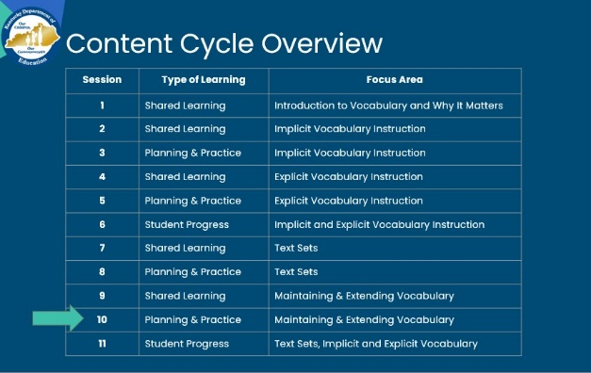
Slide 6:  Preparing for the Protocol (2 minutes): “In our previous session, we discussed the importance of vocabulary instruction and why it matters for our students, especially as it relates to equity. Today, we are going to plan and practice implementing our shared learning. | 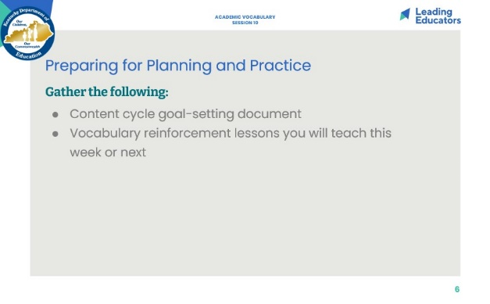
Slide 7:  Planning (30 minutes total)  Analyze and Adapt Curriculum (30 minutes)  - Framing (2 minutes): “In this final session, we have the opportunity to  - Individually or in Co-teaching teams (20 minutes): Teachers analyze and adapt a portion of their curriculum that will provide students with opportunities to maintain and extend vocabulary acquisition.  - Teachers who do not have a curricular resource that outlines these activities can use the time to plan activities using learning from the previous session. | 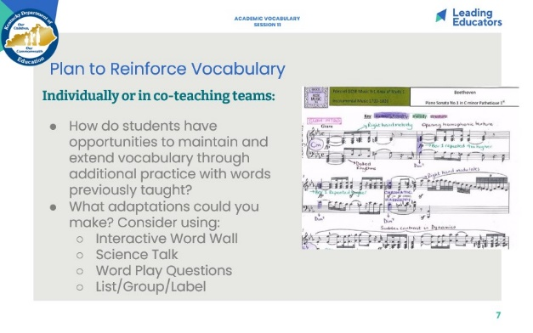
Slide 8:  Practice (18 minutes)  - In this practice scenario, explain that teachers may opt to teach a specific activity (as they have done in previous practice sessions) or share/talk through an extension activity that does not lend itself to rehearsal (e.g., Interactive Word Wall).  - Practice/Feedback Loop Round 1 (7 minutes): Partner 1 practices instructional plan and records partner feedback aligned to relevant Planning and Practice Look-Fors. Partners may consider the following questions when providing feedback to consider:  - Does the vocabulary instruction in this read aloud lesson work?  - What modification would strengthen this lesson component for all students?  - Does this lesson component/instructional approach align to and/or support the intended student learning?  - Practice/Feedback Loop Round 2 (7 minutes): Partner 2 practices instructional plan and records partner feedback aligned to relevant Planning and Instructional Look-Fors.  - Individual Reflection (4 minutes): “As we prepare for revising, take a minute to jot down implications from your partner’s feedback, for your next steps with planning. A question to consider in your reflection is: What are my next steps, based on feedback received, that would ensure effective implementation for all learners?” | 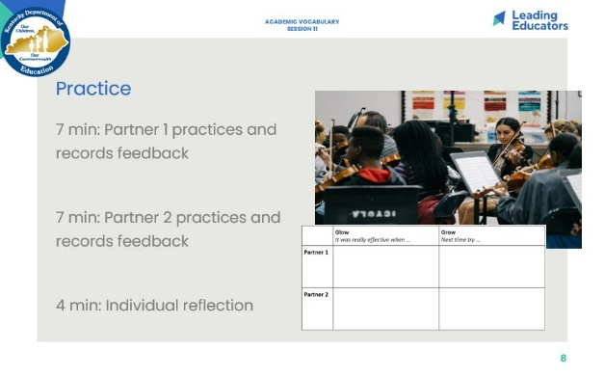
Slide 9:  Revise (20 minutes)  - Using the feedback provided, teachers will revise their instructional approach and continue planning. | 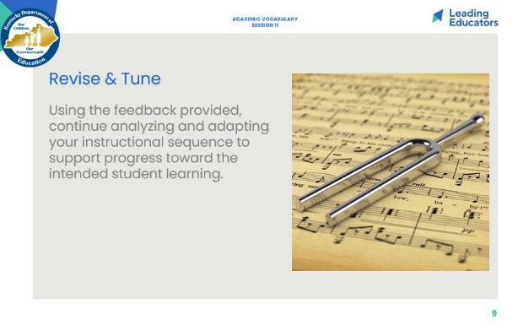
Slide 10:  10 minutes  Closing the Protocol (7 minutes total)  - Partner Debrief (2 minutes): Teachers return to their original partner and share instructional plans and modifications/adaptations made in response to the feedback received. A guiding question to facilitate this discussion might be: How did you apply your partner’s practice feedback into your revised lesson?  - Whole Group Share (4 minutes):  - What is one commitment you can make to your students and/or yourself in regards to reinforcing vocabulary instruction?  Identify Next Steps (3 minutes): The Teacher Leader will provide guidance regarding the collection of student work for the following session.  - Pre-Work: Teachers should do the following:  - Create and bring an exemplar response to the assignment that will be analyzed (written task, similar to what was prepared for Session 6)  - Bring a rubric/checklist to support analysis. Checklists for this analysis can be grounded in the Student Look-Fors from the Goal-Setting doc.  - Collect identified task for sub-group of students (identified during the first week of the cycle) to be analyzed to determine students’ growth toward the intended learning outcomes. Teachers may also choose to bring an entire class set of work, if teams discuss further analysis of student learning. | 