Academic Vocabulary Facilitator’s Guide, Grades 9-12

Session 1
OVERVIEW
Grade Band/ Content Area | - ELA 9-12
Essential Questions | - Why is vocabulary instruction critical for equity in literacy?  - Which words do I teach and how?
Enduring Understandings | - Students who know fewer vocabulary words struggle with comprehension, and often get fewer experiences to read grade level text with rich vocabulary as a result. Often, attempts to differentiate for struggling readers mean that those readers end up reading less challenging passages vs. getting supported opportunities to engage with challenging text and learn new vocabulary.  - We must focus instruction on academic vocabulary (Tier 2 words) and domain-specific vocabulary (Tier 3 words).  - We must spend the most time on words needed to fully comprehend the text, words likely to appear in future texts from any discipline, and words that are part of a word family or semantic network.  - To support students in both a breadth and depth of vocabulary knowledge, we must teach vocabulary
Key Components of Cycle | The Learning Cycle includes the following components to support shifts in instruction:  - Shared Learning: Learning sessions where teachers learn new knowledge and skills aligned to the topic of the content cycle. This could look a variety of ways, including reading and discussing an article, studying a classroom video, or doing some group practice of a particular planning skill.  - Planning & Practice: Opportunities for teachers to apply the content they are learning. This could include analyzing units/lessons, creating lessons, rehearsing lessons, watching and reflecting on videos of their classroom practice, etc.  - Student Progress Monitoring: This is an opportunity for teachers to examine student progress aligned to the topic of the cycle. This can include formative student work analysis, end of unit assessments, culminating tasks, etc.  Over the course of this learning cycle, teachers will build an understanding of why vocabulary instruction is critical for our students and how to align their planning and practice research-based principles for implicit vocabulary instruction, explicit vocabulary instruction, text sets, and for reinforcing and extending vocabulary. In this cycle, teachers will have opportunities to experience vocabulary instruction through the lens of students and consider the impact.

TEACHER AND STUDENT GOALS
Teacher Planning & Practice Look-Fors  NOTE: The Practice and Look Fors below come from Leading Educators’ Program Standards. Teams should feel welcome to tailor these to align with district tools as needed. | Example Student Goal(s)  NOTE: These goals are intended to be a starting place for team goal setting. Teams should feel welcome to tailor or add to these based on context, curriculum, and district/school tools.
Practice: Analyzes and adapts questions and tasks to focus on the vocabulary words that are most critical for developing students’ literacy, comprehending the text, and understanding the key ideas of the unit  Look Fors:  - Questions and tasks focus on academic or domain-specific words that are most likely to be encountered again in the future or are most critical for comprehending the text.  - Lessons broaden students’ word knowledge through instructional strategies (e.g., text-dependent questions, drop-in definitions, glossary, etc.) that teach words that can be understood quickly during reading.  - Weekly lessons deepen students’ word knowledge by explicitly defining, modeling, and giving students active practice with 6-10 vocabulary words.  - Over the course of the unit, students have opportunities to maintain and extend vocabulary through additional practice with words previously taught. | Possible goals:  - In-class observation of specific student actions that correlate with the learning connected to this content cycle  - Achievement or growth on a unit/domain assessment  - Achievement or growth on a prioritized unit/domain writing task (see rubric guidance below)

CYCLE-AT-A-GLANCE
NOTE: Each row is intended to represent one 90-minute session, but schools can adjust the pacing of learning based on their context and teacher needs.
Session | Type of Learning | Objective(s) | Assessment of Learning
Session 1  Introduction to Vocabulary Instruction and Why it Matters | Shared Learning | Explain why vocabulary instruction matters for equity  Identify which words to teach and why  Create personal planning and practice goals to accelerate learning for all students | - Explain the relationship between vocabulary instruction and equity.  - Shared analysis of text to determine which words are Tier 2/Tier 3 and which words should be prioritized.  - Vocabulary Instruction: Goal Setting for Planning and Instruction Document

Preparation:
Participant should be given access to the following documents to engage in the learning for this session:
- PowerPoint Slides
- Participant Handout
- Goal Setting Document
- Facilitator’s Handout: Sample Evidence

Session 1: Shared Learning: Introduction to Vocabulary Instruction and Why It Matters
Pre-Work | (20 min) Participants read through “Choosing Words to Teach” https://www.readingrockets.org/article/choosing-words-teach and capture thinking in response to the following questions:  - Why is vocabulary instruction critical for literacy instruction for all students, including (and especially) English Language Learners, students who are struggling readers, or students with special needs?  - What does vocabulary instruction currently look like in your classroom? What is the impact?  - What do you want to learn?  - Bring a copy of a couple of pages of a complex text you teach to the PLC meeting.
PPT | Session 1 PowerPoint  *Times listed in the presenter’s notes on slides are approximate, and may be adjusted to meet the needs and schedule of the individual PLC.
Printing or Sharing/Materials | - Vocabulary Instruction: Goal Setting for Planning and Instruction Document  - 9-12 Participant Handout
Agenda | Facilitation Guidance
- Welcome  - The WHY  - Word Selection  - Practice  - Goal Setting | Overview: In this session, participants will explore why vocabulary instruction matters for students as well as which words to teach and how. They will reflect together on what the research says about the importance of vocabulary, connect vocabulary instruction to the Kentucky Academic Standards, engage in an experience to understand the student perspective, and practice prioritizing vocabulary to teach with a text in their grade band.

Facilitator’s Notes | Accompanying Slide
Slide 1:

Framing (1 minute):
Welcome to the first session in our content cycle! Today’s session will serve as both an introduction to and foundation in vocabulary in literacy. We will dive into the ‘why’ behind this work and the role it plays in growing students, addressing equity in the classroom, and helping our instructional practice evolve to meet the needs of our kids. Over the next 11 weeks, we will explore how to put this into practice. Some of our beliefs may be challenged and reflection will be a key part of our work. By the end of today’s session, you will be able to use that reflection to create personal planning and practice goals. To that end, let’s start with a reflection on an essential question that we will explore throughout our learning. We will continue to reflect more and more in depth on this question throughout the cycle, but it is critical to ground our learning here.

Slide 2:  Do Now (10 minutes total):  Let’s begin by reflecting on the pre-work article and our own practice. Take a moment to read our reflection questions. These are the same reflection questions from our pre-work:  - Why is vocabulary instruction critical for equity in literacy for all students, including (and especially) English Language Learners, students who are struggling readers, or students with special needs?  - What does vocabulary instruction currently look like in your classroom?  - What is the impact?  - What do you want to learn?  1 minute: Considering notes from the pre-work article, reflect independently.  7 minutes: Group in triads and share your reflections grounding your responses in evidence from the text.  2 minutes: Share whole group.  Key Takeaways:  - Strong understanding of vocabulary is essential for reading comprehension, and in particular for accessing grade-level complex texts.  - English Language Learners and students who are struggling readers often have lower comprehension because they do not know as many vocabulary words.  - Vocabulary instruction can help to create access to texts for all students. | 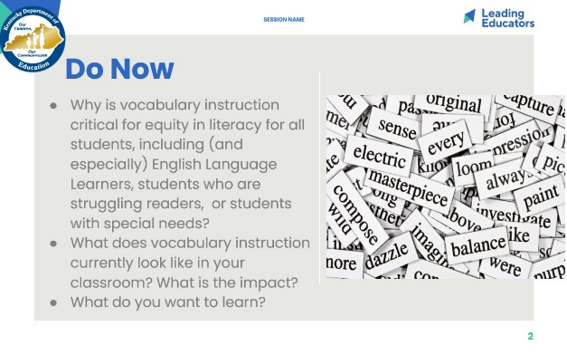
Cycle Overview  (4 minutes)  - 1 minute: Share 11-week path of learning for this cycle (on slide), explaining how the learning builds over the course of the cycle. Our 11-week cycle includes time for Shared Learning, planning and practice, and looking at student work to determine progress. We will front-load some shared learning experiences so that we are fully prepared to plan, practice, and analyze student work based on what we have learned together.  - 1 minute: Reflect Independently. How will the learning in this cycle support your own development and your students’ learning?  - 2 minutes: Share out whole group. | 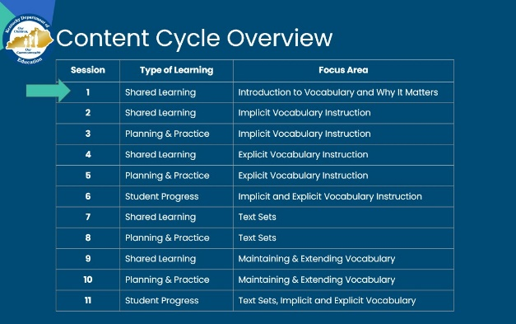
Slide 4:  Session Objectives and Agenda (1 minute)  - Share the objectives and agenda for this session, connecting to the overarching goal of the cycle. | 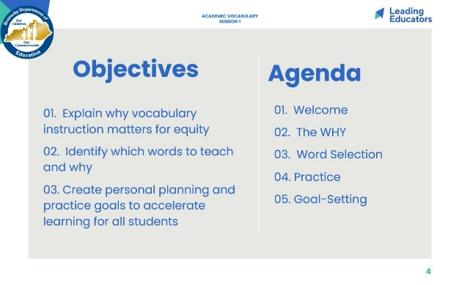
Slide 5:  Norms (2 minutes) *Can replace with school norms*  - Participants choose one norm that they would like to focus on for the session and/or day.  - Then, participants turn-talk with an elbow partner who can hold them accountable.  - Just want to remind you of our norms and call them back into the room. A few other norms to remember:  - There will be lots of opportunities for partner/table conversation. Look for my hand when it is time to come back together.  - Use tech as a tool not a distraction. If you need to send a text or answer a call, please step in the hall, and come back when you are ready to rejoin the session.  Look or Listen Fors/Evidence of Mastery:  - Listen for evidence in conversations. | 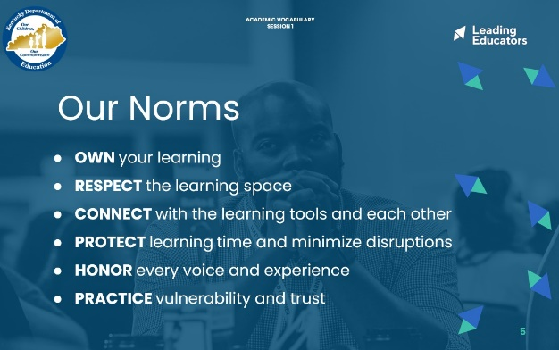
Slide 6:  Frame (1 minute): “Let’s take a minute to experience first-hand how knowledge of vocabulary is critical for reading comprehension, and step into the shoes of a student.” | 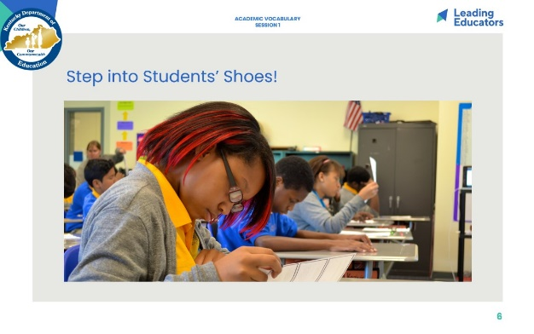
Slide 7:  Experience the Learning (3 minutes)  - 2 minutes: Participants review the excerpt. “May I have a volunteer read this passage aloud for the group?”  - 1 minute: Participants jot down notes of their summary of the passage. Facilitator can frame that if participants are not sure about the meaning of the word, they can just use the context clues.  (NOTE: Of course, given the number of words missing from the passage, participants cannot actually use context clues to figure out the words! However, this is something we as teachers commonly say to students and it is helpful to simulate that same experience recognizing how hard it can be to use that strategy if too many words are unknown.) | 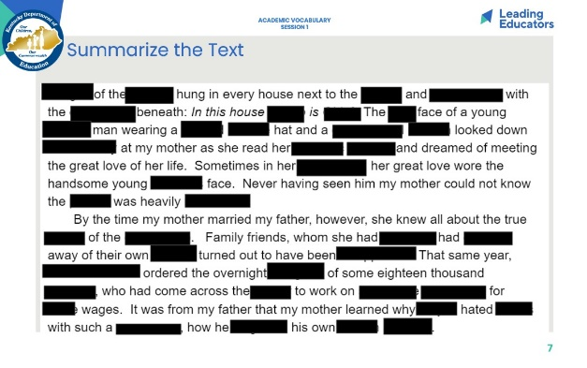
Slide 8:  Reflection (5 minutes)  2 minutes: Reflect on the following with a partner:  - How well were you able to summarize the passage? Why?  - Why didn’t you just use context clues to figure out the words that were blacked out?  - How did this experience feel for you?  3 minutes: Share reflections whole group  Key Takeaways:  - We could not understand the passage and answer the questions because there were too many words unknown.  - We cannot use context clues to develop an understanding of unknown words because we know too few words to get the context.  - This is frustrating and it is not clear how to make meaning without knowing more words. | 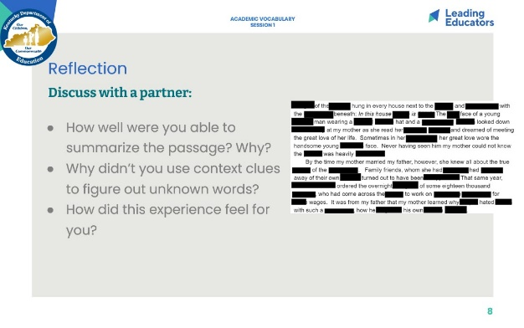
Slide 9:  Matthew Effect (2 minutes):  Explain graph. “There’s research that shows that one of the major reasons the gap between struggling readers is maintained over time – and in fact grows over time – is due to challenges with vocabulary, and something called the Matthew Effect.” This works like a compound interest curve. The idea of the rich getting richer while the poor get poorer can be extrapolated to reading. Students who know fewer vocabulary words struggle with comprehension, and often get fewer experiences to read grade level text with rich vocabulary as a result. Often, attempts to differentiate for struggling readers mean that those readers end up reading less challenging passages vs. getting supported opportunities to engage with challenging text and learn new vocabulary.  Vocabulary instruction is critical to instructional equity. | 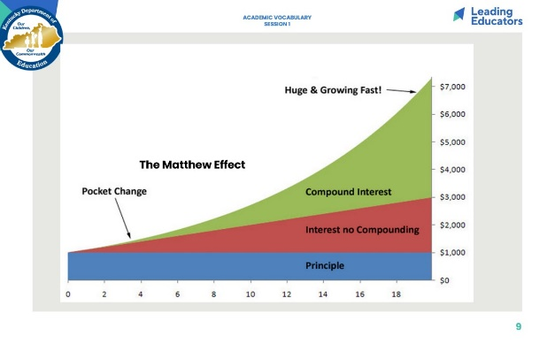
Slide 10:  Connect to the KAS (2 minutes)  - Ask participants to read excerpt from KAS introduction to Reading Literature and Informational Text.  - Say: “The standards put vocabulary at the front and center of reading literature and informational text. While the Guiding Principle for Reading Standard 4 specifically addresses vocabulary, the overview makes it clear that vocabulary is a throughline for knowledge and comprehension in literary and informational texts.”  - Ask volunteer to read the Guiding Principle for Reading Craft & Structure Standard 4 aloud. | 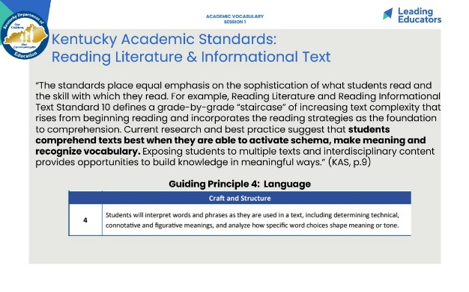
Slide 11:  Connect to the KAS (3 minutes)  - Ask volunteer to read excerpt from p. 9 of KAS, Language Section  - Say: “The standards recognize the essential role of vocabulary in our students’ comprehension. Word knowledge leads students to better comprehension. While we see attention to vocabulary woven throughout the standards, let us now focus our attention on Language Standard 4: Vocabulary Acquisition and Use.”  - Ask volunteer to read the Guiding Principle for Standard 4 aloud  - Say: “Again, the Kentucky standards make clear that vocabulary is an essential component of literacy instruction. Not only do students need to use strategies to figure out the meanings of unknown words they may encounter in their reading, students also need to acquire a range of words. The standards show us that we need to teach words in ways that allow students to own and hold on to them.” | 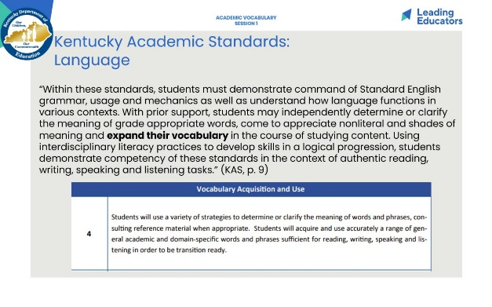
Slide 12:  Check for Understanding (5 minutes):  - Say: Let’s bring together our knowledge of vocabulary instruction, standards, and equity. We are going to take 3 minutes to jot down responses to this prompt: Explain the relationship between vocabulary instruction and equity.  - Give 3 minutes for responses. Circulate to check for understanding using the sample evidence below.  - 1 minute: Ask for 2 volunteers to share responses.  Look or Listen Fors/Evidence of Mastery:  - Sample Evidence: Facilitator’s Handout | 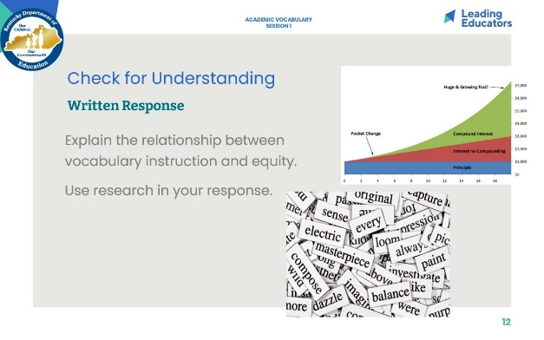
Slide 13:  Key Takeaways: Why Vocabulary Instruction is Important (2 minutes)  Directions/Framing/Key Points:  - 1 minute: “Here are some key takeaways that you may have captured in your written reflection.”  - 1 minute: Provide a minute for teachers to review and discuss the key takeaways. | 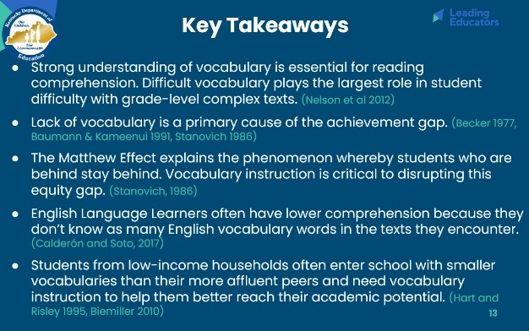
Slide 14:  Word selection (10 minutes) Share link to Prework: “Choosing Words to Teach”  Frame: “We know that vocabulary is critical to reading comprehension. How does a teacher know which words to teach? Let’s return to our pre-work, “Choosing Words to Teach”” to review which words to specifically teach.”  - 5 minutes: In partners, participants return to their notes from the pre-work article, and share their answers to the following questions:  - Define and give examples of Tier 1, Tier 2, and Tier 3 words.  - How do we know which words to spend the most time on?  - 5 min: Whole group share out, with the facilitator soliciting and reinforcing the key takeaways.  Key Takeaways:  - Tier 1 words  - Words of everyday speech  - Important to early learning since these Tier 1 words are used to explain more unusual words  - Tier 2 words  - Words that are not specific to a single content  - Not commonly used in everyday conversation  - Vital to comprehension  - Referred to as academic language  - Examples: obstacle, accumulate, adjust, cautious, broad, relative, determine, vary, etc.  - Tier 3 words  - Words that are domain specific  - More common in informational text than in literary text  - Often defined within the text using contextual clues  - Usually not encountered in everyday conversations  - Which words should we spend the most time on?  - Words needed to fully comprehend the text,  - Words likely to appear in future texts from any discipline, and  - Words that are part of a word family or semantic network | 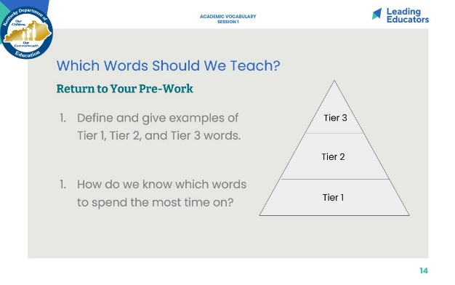
Slide 15:  Frame (1 minute): Read slide: “Today’s ‘Look For’ - questions and tasks focus on academic or domain-specific words that are most likely to be encountered again in the future or are most critical for comprehending the text.” | 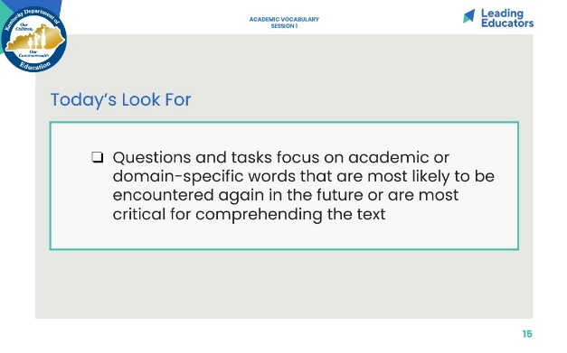
Slide 16:  Teacher Goals (5 minutes)  - Teacher Look-Fors Analysis (3 minutes): “Before we reflect on our own instructional practice, let’s take some time to internalize these look-fors using the following guiding questions: How are these look fors connected to the focus for our learning this cycle? Are there planning or practice look-fors that you would add to this list?” Teachers read teacher look-fors and annotate.  - Share Out (2 minutes): Team discusses reactions to the list and any additions that may apply to their class/school needs. | 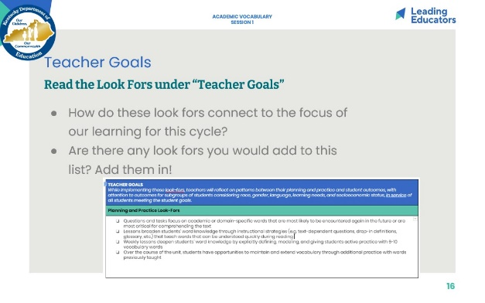
Slide 17:  Practice (25 minutes) [Participants need two different colored highlighters or markers]  Frame (1 minutes): “Now that you know what Tier 2 and Tier 3 words are and we’ve analyzed which of these words need to be specifically taught, let’s practice with a text from your own class.”  Practice identifying Tier 2 and 3 Words to teach  - 12 minutes: Participants will read Tier I and Tier II sections from the prework. With a partner or independently, they will highlight Tier 2 words in yellow and highlight Tier 3 words in blue from a text they are using in class. If text cannot be highlighted, teachers may also chart words on a sheet of paper. List highlighted words from text on table at the bottom of the text to indicate if the words require more time and attention or less time and attention. Participants note possible reasons for their thinking.  - 8 minutes: Participants work with partners in discussion the questions in the Your Turn section of “Choosing Which Words to Teach”.  - 3 minutes: Facilitate whole group share. Which tier of words was more challenging to identify? What tools did you use to support your analysis of the vocabulary in the text? Share out possible words. Emphasize that Tier 3 words may need to be taught, but will need less time.  Key Takeaways:  - In the prework article “Choosing Which Words to Teach”, participants can identify Tier 2 and Tier 3 words and can determine which of these words need more instructional time and attention or less instructional time and attention and can justify their thinking.  - The vocabulary we prioritize depends on the needs of our students. In addition, while there are general guidelines for which words to spend more and less time on, if students are really struggling with the vocabulary and meaning of the text, the teacher will have to address more of the vocabulary and offer additional support. | 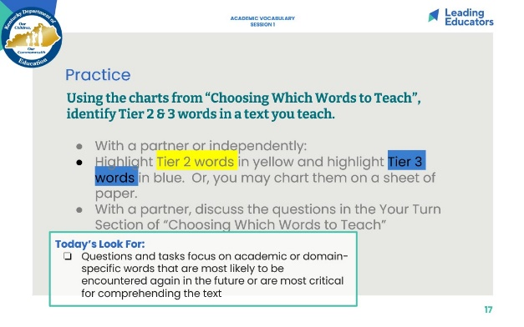
Slide 18:  Self-Reflection (7 minutes)  - Framing (1 minute): “Now take a few minutes to reflect on how often you currently implement the look fors we’re focusing on during this content cycle. Then, select one or two look-fors that you want to focus on most deeply during the upcoming weeks with an accountability partner. Determine what data you’ll collect to measure progress toward your goal.”  - Individual Self-Reflection (4 minutes): Teachers complete self-reflection and determine a personal goal.  - Partner Share (2 minutes): In partnerships, teachers will share their goals. | 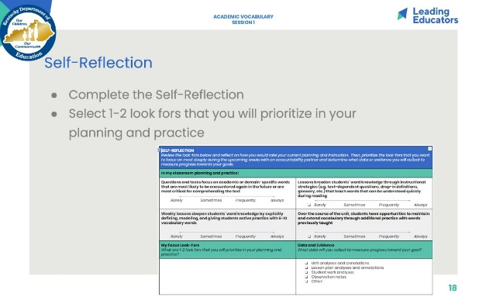
Slide 19:  Student Goals (7 minutes)  Directions/Framing/Key Points:  - 1 minute: “Finally, let’s take some time to internalize the Student Goals for this content cycle. At various points during the content cycle, we will reflect on student data. This will help us connect the dots between our instructional practice and student learning, with an eye toward identifying any inequities that might exist in outcomes for subgroups of students. We know that every one of us wants all of our students to succeed, and we also know that inequities exist. Surfacing them will help us deepen our ability to adjust our practice in ways that meet the needs of all students. Take a few minutes to read the student goals. Then, select 6 students you will prioritize for progress monitoring throughout this content cycle. Make sure that this group of students is reflective of your overall class demographics, considering race, gender, language, learning needs, and socioeconomic status.”  - 4 minutes: Teachers read student goals and determine 6 students they will monitor throughout this content cycle.  - 2 minutes: With a partner, teachers share their list of students and how they selected them. | 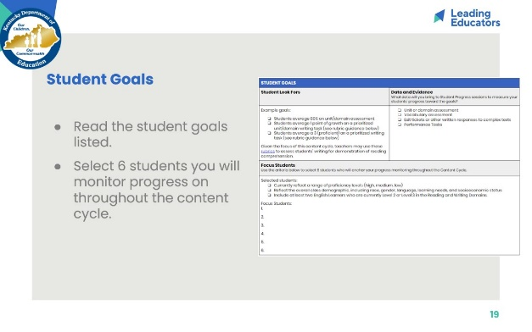
Slide 20:  Next Steps (3 minutes)  “Thank you for a wonderful start to our content cycle. To prepare for our next session, you will dive into an excerpt from Reading Reconsidered on implicit vocabulary instruction.” | 