Academic Vocabulary Facilitator’s Guide, Grades 9-12

Session 4
OVERVIEW

Grade Band/ Content Area | - ELA 9-12
Essential Questions | - Why is vocabulary instruction critical for equity in literacy?  - Which words do I teach and how?
Enduring Understandings | - Students who know fewer vocabulary words struggle with comprehension, and often get fewer experiences to read grade level text with rich vocabulary as a result. Often, attempts to differentiate for struggling readers mean that those readers end up reading less challenging passages vs. getting supported opportunities to engage with challenging text and learn new vocabulary.  - We must focus instruction on academic vocabulary (Tier 2 words) and domain-specific vocabulary (Tier 3 words).  - We must spend the most time on words needed to fully comprehend the text, words likely to appear in future texts from any discipline, and words that are part of a word family or semantic network.  - To support students in both a breadth and depth of vocabulary knowledge, we must teach vocabulary
Key Components of Cycle | The Learning Cycle includes the following components to support shifts in instruction:  - Shared Learning: Learning sessions where teachers learn new knowledge and skills aligned to the topic of the content cycle. This could look a variety of ways, including reading and discussing an article, studying a classroom video, or doing some group practice of a particular planning skill.  - Planning & Practice: Opportunities for teachers to apply the content they are learning. This could include analyzing units/lessons, creating lessons, rehearsing lessons, watching and reflecting on videos of their classroom practice, etc.  - Student Progress Monitoring: This is an opportunity for teachers to examine student progress aligned to the topic of the cycle. This can include formative student work analysis, end of unit assessments, culminating tasks, etc.  Over the course of this learning cycle, teachers will build an understanding of why vocabulary instruction is critical for our students and how to align their planning and practice research-based principles for implicit vocabulary instruction, explicit vocabulary instruction, text sets, and for reinforcing and extending vocabulary. In this cycle, teachers will have opportunities to experience vocabulary instruction through the lens of students and consider the impact.

TEACHER AND STUDENT GOALS

Teacher Planning & Practice Look-Fors  NOTE: The Practice and Look Fors below come from Leading Educators’ Program Standards. Teams should feel welcome to tailor these to align with district tools as needed. | Example Student Goal(s)  NOTE: These goals are intended to be a starting place for team goal setting. Teams should feel welcome to tailor or add to these based on context, curriculum, and district/school tools.
Practice: Analyzes and adapts questions and tasks to focus on the vocabulary words that are most critical for developing students’ literacy, comprehending the text, and understanding the key ideas of the unit  Look Fors:  - Questions and tasks focus on academic or domain-specific words that are most likely to be encountered again in the future or are most critical for comprehending the text.  - Lessons broaden students’ word knowledge through instructional strategies (e.g., text-dependent questions, drop-in definitions, glossary, etc.) that teach words that can be understood quickly during reading.  - Weekly lessons deepen students’ word knowledge by explicitly defining, modeling, and giving students active practice with 6-10 vocabulary words.  - Over the course of the unit, students have opportunities to maintain and extend vocabulary through additional practice with words previously taught. | Possible goals:  - In-class observation of specific student actions that correlate with the learning connected to this content cycle  - Achievement or growth on a unit/domain assessment  - Achievement or growth on a prioritized unit/domain writing task (see rubric guidance below)

CYCLE-AT-A-GLANCE
NOTE: Each row is intended to represent one 90-minute session, but schools can adjust the pacing of learning based on their context and teacher needs.

Session | Type of Learning | Objective(s) | Assessment of Learning
Session 4  Explicit Vocabulary Instruction | Shared Learning | Explain explicit vocabulary instruction and why it matters  Apply and analyze explicit vocabulary instruction | - Reflection: 1) What is explicit vocabulary instruction and why does it matter for students? 2) How do we determine which words to explicitly teach? 3) What are some strategies for explicit vocabulary instruction?  - Shared analysis of a lesson from sample curriculum identifying explicit vocabulary instruction strategies and potential adaptations.

Preparation:
Participant should be given access to the following documents to engage in the learning for this session:
- PowerPoint Slides
- Participant Handout
- Prework: “Explicit Vocabulary Instruction: The Daily Word Rollout to Achieve Deep Word Knowledge”
- Explicit Vocabulary Instruction: Facilitator’s Examples

Session 4: Shared Learning: Explicit Vocabulary

Pre-Work | 30 min: Participants read “Explicit Vocabulary Instruction: The Daily Word Rollout to Achieve Deep Word Knowledge” (p.256-270) from Reading Reconsidered and capture thinking in response to the following questions:  - What is explicit vocabulary instruction and why does it matter for students?  - How do we determine which words to explicitly teach?  - What are some strategies for explicit vocabulary instruction?
PPT | - Session 4 PowerPoint  - In advance, facilitator should put up two posters with the headings, “Sample Lesson: Noticings” and “Sample Lesson: Adjustments.”  *Times listed in the presenter’s notes on slides are approximate, and may be adjusted to meet the needs and schedule of the individual PLC.
Printing | - “Explicit Vocabulary Instruction: The Daily Word Rollout to Achieve Deep Word Knowledge”  - Participant Handout

Agenda
- Opening  - Principles of Explicit Vocabulary Instruction  - The Student Experience  - Analyzing and Adapting a Lesson  - Reflection | Overview: In this session, participants will have the opportunity to explore explicit vocabulary instruction. They begin by considering the why, what, and how of explicit vocabulary instruction. Then they have the opportunity to look at an example classroom and consider the explicit instruction strategies used and their impact on student understanding. Finally, teachers practice looking at a curriculum lesson plan to identify how explicit vocabulary instruction is incorporated and what adjustments they would make, based on the needs of students and the demands/meaning of the text.

Facilitator’s Notes | Accompanying Slide
Slide 1:  1 minute [Facilitator: Prepare 2 posters “Noticings” and “Adjustments”]  Frame: “Welcome to our third sub-topic in our vocabulary content cycle! Today’s session will serve as an introduction to explicit vocabulary instruction and its role in supporting literacy. Just as athletes become better at their sport simply by playing it, so too our students build their vocabulary simply through the act of reading! However, just as athletes also benefit from the intentional support of coaches, so too do our students benefit from direct support with vocabulary through explicit instruction.”  Session Length: 90 minutes | 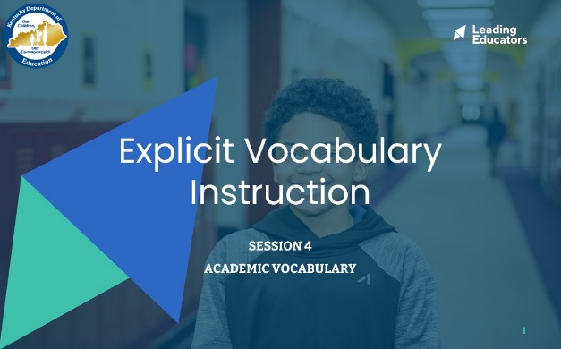
Slide 2:  5 minutes  Directions/Framing:  Let’s begin by considering our students.  Reflect: Consider one of your priority students who is struggling with complex texts due to vocabulary. What is one example of progress they have made in the last week due to implicit vocabulary instruction? What student misunderstandings could result if we solely relied on implicit vocabulary instruction?  - 1 minute: Reflect independently.  - 4 minutes: Stand-pair-share.  Thank you all for sharing! There are so many words that students can learn just through reading and some intentional teacher support along the way. You all are making so much meaningful progress with your students! However, as I heard many of you share with each other just now, there are some words that are more nuanced, abstract, and essential for students to understand, and for those words there are benefits to giving students more explicit practice. In particular, this can be important for our ELL students. That is what we will explore today as we examine explicit vocabulary instruction.  Look or Listen Fors/Evidence of Mastery:  - Participants share about a particular student and the potential limits of implicit vocabulary instruction. | 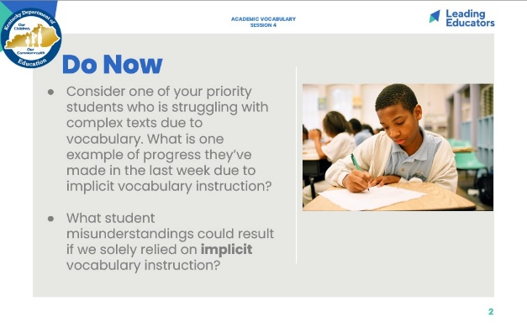
Slide 3:  1 minute  Cycle Overview  - Share 11-week path of the cycle, explaining how the professional learning includes opportunities for shared learning, planning and practice, and studying student progress. | 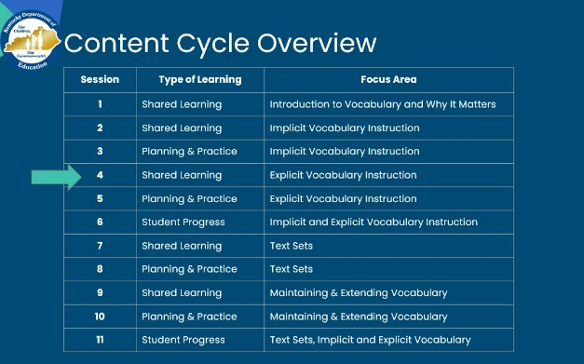
Slide 4:  2 minutes  Directions/Framing/Key Points:  - Here are the objectives for the session. May I have two volunteers read them aloud?  - Here is our path for learning.  Look or Listen Fors/Evidence of Mastery:  NA | 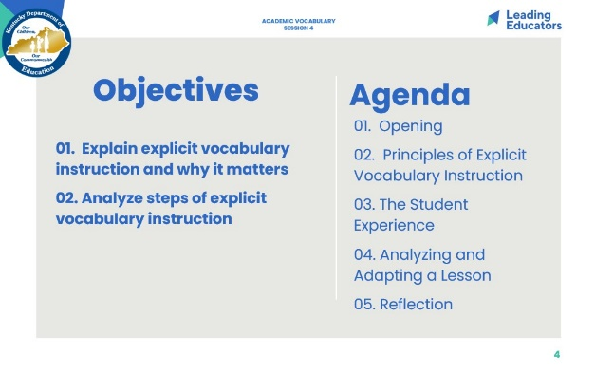
Slide 5:  12 minutes  Directions/Framing:  - Let’s begin by returning to our pre-work reading to make sure that we understand the key points around explicit vocabulary instruction.  - 1 minute: Participants take out notes from pre-work.  - 2 minutes: Facilitator Frame. In order to review and deepen our understanding, we are going to leverage a strategy called “Give One, Get One, Move On!” AKA “GOGOMO”. This is a strategy that can be used to deepen understanding of concepts or vocabulary words. Has anyone used this strategy before? Can you explain how it works?  - There are a number of different versions of this protocol. Here is how we will use it today. You will see in your handout you have a 3x3 grid.  - The first thing you will do is fill in 3-5 of the boxes in that grid with key points about Explicit Vocabulary Instruction, considering the reflection questions on the slide.  - The second thing we will do then is “mingle” around as a group, with you all exchanging information with each other about Explicit Vocabulary Instruction, in order to fill in the entire grid with 9 distinct pieces of information that connect to the reflection questions.  - 4 minutes: Participants fill in 3-5 pieces of information about Explicit Vocabulary Instruction into their grid.  - 5 minutes: Participants mingle around the room, pairing with each other in order to “give one” and “get one,” filling up their grid with information about explicit vocabulary instruction.  - Thank you all for engaging! It is really exciting to see the way you have named the important key points about explicit vocabulary instruction.  Look or Listen Fors/Evidence of Mastery:  - Facilitators, see the Facilitator Handout: Explicit Vocabulary Instruction: Facilitator’s Examples | 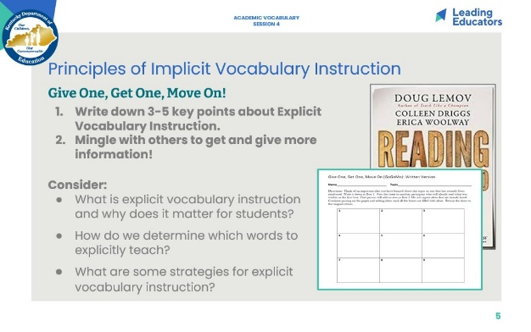
Slide 6:  10 min  Directions/Framing:  - 5 min: As a check for understanding, participants synthesize their key takeaways to the three questions on a notecard.  - 5 min: Facilitator can address or capture new questions that are surfacing about explicit vocabulary instruction.  Look or Listen Fors/Evidence of Mastery:  Facilitators, see the Facilitators’ Explicit Vocabulary Instruction Handout for examples | 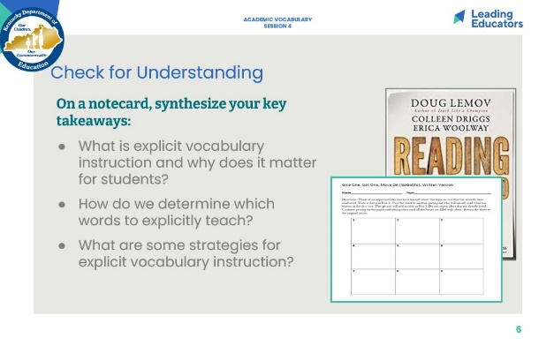
Slide 7:  Key Takeaways: Principles of Explicit Vocabulary Instruction (3 min)  Directions/Framing/Key Points:  - 1 min: “Here are some key takeaways about Explicit Vocabulary Instruction, many of which you have surfaced.”  - 2 min: Provide time for teachers to review the slide and ask clarifying questions, as needed.  Look and/or Listen For:  - Steps for explicit vocabulary instruction are: 1) Word selection; 2) Accurate and student-friendly definition; 3) Parameters of use; 4) Active practice  - Word Selection:  - Typically focus on Tier 2 words  - Words that appear in a text students are reading that is critical to comprehension and that students may not know  - Words that relate to the content being taught and would be helpful when discussing a text (even if the word does not appear in the text itself)  - Words that can help students develop awareness of and practice shades of meaning (e.g., gaze vs. glance) or upgrade their word choice (e.g., good vs. acceptable, favorable, or satisfactory)  - Accurate & Student Friendly Definition  - Provide students with the definition of the front-end of the explicit vocabulary instruction so they can spend most of their time practicing the word vs. figuring out what it means  - Create definitions that do not use jargon  - Try to keep the definition brief, but avoid oversimplifying the definition  - Make sure the definition uses words students already know  - Make sure the definition matches the word’s part of speech  - When providing the definition, model its use in a sentence and consider ways to “make it stick” like showing a visual or using a gesture  - Parameters of Use  - Tell students how the word is commonly used and how it is not commonly used (e.g., tame is used to describe animals not people)  - Tell students about any word partners that apply (e.g., “foist” is almost always followed by the word “upon”)  - Provide practice exploring the way the word can be changed into different parts of speech, or adjusted with prefixes and suffixes  - Help students discern shades of meaning by explaining how the word is similar to and different from other words (e.g., glum and dejected are both sad feelings, but glum is not as strong as dejected)  - Active Practice  - Ask students when a word would (and would not apply): “Would it be accurate to say Aunt Alexandra is acting like a tyrant in this scene? Explain.”  - Ask students to combine new words. “Could a tyrant ever be humble? Why or why not?”  - Ask students to narrate the story. “Can a group ever exert tyranny over another group? How? Explain how a group of people in To Kill a Mockingbird make decisions that are tyrannical.”  - Ask students to define a change: “How is it different to state that Aunt Alexandra is being tyrannical as opposed to, say, bossy?”  - Ask students to change the form of the word and use it in a different part of speech.  - Make sure students say the word in their practice and that their use is detailed enough to demonstrate understanding of the word.  - Correct when students use the word incorrectly or imprecisely. | 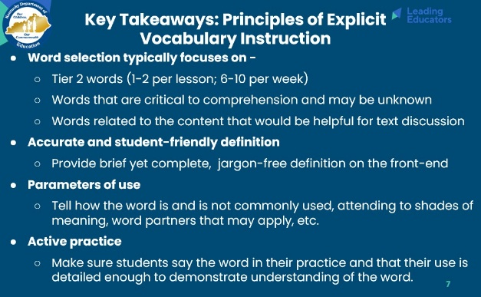
Slide 8:  30 min. | 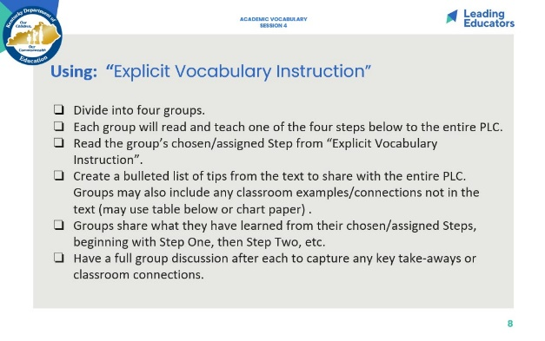
Slide 9:  6 min  Directions/Framing:  - Finally, let’s conclude with a reflection on why this matters and where we go next! Take 2 minutes to reflect.  - 3 min: Stand up, find someone you have not talked with yet today, and share out your reflections.  Look or Listen Fors/Evidence of Mastery:  - Participants reflect on a specific student and next step. | 