Academic Vocabulary Facilitator’s Guide, Grades 9-12

Session 5
OVERVIEW

Grade Band/ Content Area | - ELA 9-12
Essential Questions | - Why is vocabulary instruction critical for equity in literacy?  - Which words do I teach and how?
Enduring Understandings | - Students who know fewer vocabulary words struggle with comprehension, and often get fewer experiences to read grade level text with rich vocabulary as a result. Often, attempts to differentiate for struggling readers mean that those readers end up reading less challenging passages vs. getting supported opportunities to engage with challenging text and learn new vocabulary.  - We must focus instruction on academic vocabulary (Tier 2 words) and domain-specific vocabulary (Tier 3 words).  - We must spend the most time on words needed to fully comprehend the text, words likely to appear in future texts from any discipline, and words that are part of a word family or semantic network.  - To support students in both a breadth and depth of vocabulary knowledge, we must teach vocabulary
Key Components of Cycle | The Learning Cycle includes the following components to support shifts in instruction:  - Shared Learning: Learning sessions where teachers learn new knowledge and skills aligned to the topic of the content cycle. This could look a variety of ways, including reading and discussing an article, studying a classroom video, or doing some group practice of a particular planning skill.  - Planning & Practice: Opportunities for teachers to apply the content they are learning. This could include analyzing units/lessons, creating lessons, rehearsing lessons, watching and reflecting on videos of their classroom practice, etc.  - Student Progress Monitoring: This is an opportunity for teachers to examine student progress aligned to the topic of the cycle. This can include formative student work analysis, end of unit assessments, culminating tasks, etc.  Over the course of this learning cycle, teachers will build an understanding of why vocabulary instruction is critical for our students and how to align their planning and practice research-based principles for implicit vocabulary instruction, explicit vocabulary instruction, text sets, and for reinforcing and extending vocabulary. In this cycle, teachers will have opportunities to experience vocabulary instruction through the lens of students and consider the impact.

TEACHER AND STUDENT GOALS

Teacher Planning & Practice Look-Fors  NOTE: The Practice and Look Fors below come from Leading Educators’ Program Standards. Teams should feel welcome to tailor these to align with district tools as needed. | Example Student Goal(s)  NOTE: These goals are intended to be a starting place for team goal setting. Teams should feel welcome to tailor or add to these based on context, curriculum, and district/school tools.
Practice: Analyzes and adapts questions and tasks to focus on the vocabulary words that are most critical for developing students’ literacy, comprehending the text, and understanding the key ideas of the unit  Look Fors:  - Questions and tasks focus on academic or domain-specific words that are most likely to be encountered again in the future or are most critical for comprehending the text.  - Lessons broaden students’ word knowledge through instructional strategies (e.g., text-dependent questions, drop-in definitions, glossary, etc.) that teach words that can be understood quickly during reading.  - Weekly lessons deepen students’ word knowledge by explicitly defining, modeling, and giving students active practice with 6-10 vocabulary words.  - Over the course of the unit, students have opportunities to maintain and extend vocabulary through additional practice with words previously taught. | Possible goals:  - In-class observation of specific student actions that correlate with the learning connected to this content cycle  - Achievement or growth on a unit/domain assessment  - Achievement or growth on a prioritized unit/domain writing task (see rubric guidance below)

CYCLE-AT-A-GLANCE
NOTE: Each row is intended to represent one 90-minute session, but schools can adjust the pacing of learning based on their context and teacher needs.

Session | Type of Learning | Objective(s) | Assessment of Learning
Session 5  Explicit Vocabulary Instruction | Planning & Practice | Apply knowledge of explicit vocabulary instruction to curricular planning and practice  Give and receive feedback from colleagues in order to revise plans and refine practices | Analyze and annotate lesson from curriculum for explicit vocabulary instruction and potential adjustments.

Preparation:
Participant should be given access to the following documents to engage in the learning for this session:
- PowerPoint Slides
- Participant Handout
- Goal Setting Document

Session 5: Planning and Practice

Pre-Work | Teachers gather and bring:  - Goal-Setting Document for the current content cycle  - Curricular Documents
PPT | Session 5 PowerPoint  *Times listed in the presenter’s notes on slides are approximate, and may be adjusted to meet the needs and schedule of the individual PLC.
Printing/ Digital Handouts | Participant Handout

Agenda
- Opening  - Plan  - Practice  - Student Goals  - Closing | Overview: In this planning and practice session, teachers will apply learning of the instructional practices studied in the previous shared learning sessions. As teachers plan, they will focus on the Planning and Instructional Look-Fors that will support them in meeting goals set in the previous session. Teachers will practice with a colleague, eliciting specific feedback to aid in effective instructional implementation. After incorporating feedback into upcoming plans, teachers will prepare the student progress task for the next session.

Facilitator’s Notes | Accompanying Slide
Slide 1:  Session Summary In this planning and practice session, teachers will apply learning of the instructional practice studied in the previous new learning session. As teachers plan, they will focus on the Planning and Instructional Look-Fors that will support them in meeting goals set in the previous session. Teachers will practice with a colleague, eliciting specific feedback to aid in effective instructional implementation. After collaborating with colleagues and giving/receiving feedback, teachers will modify their approach and complete or refine their instructional plans.  Session Length: 90 minutes | 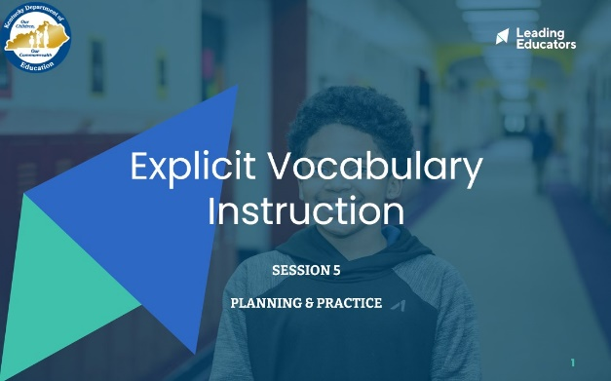
Slide 2:  Do Now (2 minutes): “Please take out the goal-setting document you completed during the first week of this content cycle. Take a couple of minutes to reflect on the progress you have seen in your practice and in your students over the past week. What are some ways you want to continue to grow?” | 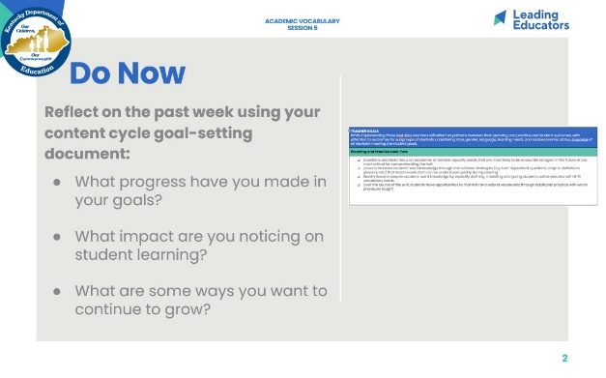
Slide 3:  Cycle Overview (1 minute)  - Review 11-week path of the cycle, explaining how the professional learning includes opportunities for shared learning, planning and practice, and studying student progress. | 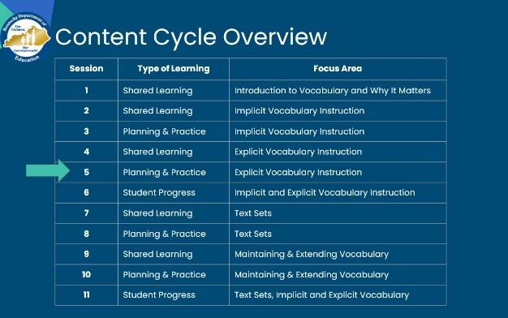
Slide 4:  (3 minutes)  Framing (1 minute): “This week, we’ll return to a planning protocol in which we plan and receive feedback on strategic ways that we can leverage our learning from last week as we work toward the goals and look-fors of this cycle. Just like musicians rehearsing, we are tuning and refining our practice off-stage before performing for our audience of students!”  Team Building (2 minutes): “Before we dig in, take a moment to share with a partner the reflections you noted during the Do Now. Additionally, discuss the instructional evidence you intend to include in your plan today that will reflect the growth identified in your goals. Revisiting our goals prior to planning will help to narrow our focus on the portions of our curriculum that we want to receive feedback on today.” | 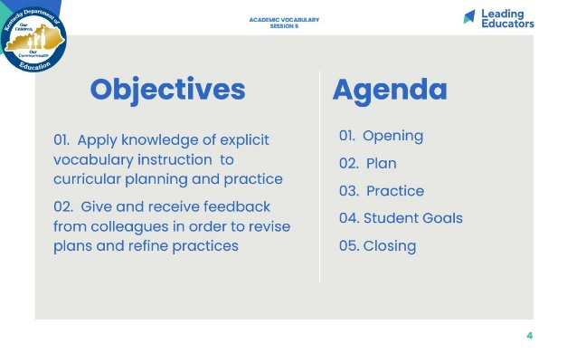
Slide 5:  Norms (1 minute) <Insert school/team norms as applicable.>  - Review norms | 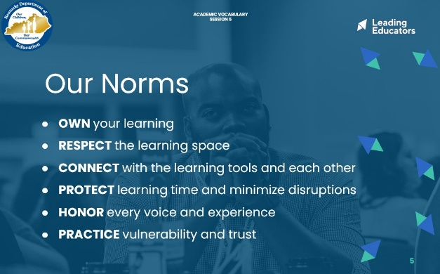
Slide 6:  Preparing for the Protocol (2 minutes):  “In our previous sessions, we’ve discussed the importance of teaching vocabulary and the roles of implicit and explicit vocabulary instruction. Today, we are going to plan and practice implementing our shared learning. Please make sure you have the following materials pulled up: your goal-setting document and an upcoming read aloud/lesson plan.” (If there is no lesson plan from a curricular resource, that is okay -- the text is the most important part) | 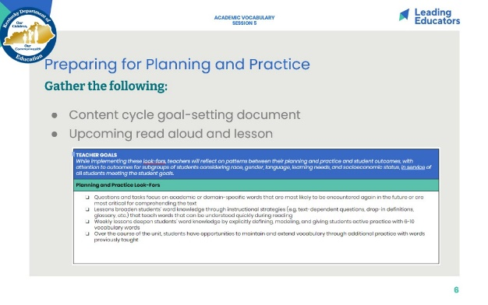
Slide 7:  Planning (28 minutes total)  Intended Student Learning (6 minutes)  - Framing (1 minute): “As we prepare to plan, identify a partner to work with. With that partner, discuss the intended student learning for the Lesson plan you will be analyzing today. Internalizing student outcomes for this part of the curriculum is essential so that you can provide each other with specific and targeted feedback during our practice today.”  - Partners (5 minutes): Discuss student outcomes for the targeted curricular resource and alignment to the goals for the content cycle. (Both partners should have time to share.)  Analyze and Adapt Curriculum (22 minutes)  - Framing (2 minutes): As a reminder... “Even when we use curriculum that is a high-quality resource, it’s our analysis and adaptation of the materials that will allow us to implement them masterfully with our students. In our first phase of planning today, we will hone in on vocabulary in our read aloud. Based on our shared learning from the past two weeks, we will be prioritizing Tier 2 and Tier 3 words that we think our students might struggle with. Then we will plan to teach those words using what we have learned about implicit vocabulary instruction.  - Individually or in Co-teaching teams (20 minutes):  Teachers analyze and adapt a portion of their curriculum that will elevate achievement for all students. If resource does not include explicit vocabulary instruction, this is a place for adaptation. Teachers can use the roll-out script outlined in Reading Considered as a support.  Teachers will also plan for effective implementation (i.e., oral instructions, visuals, relevant routines, etc.) of the instructional approach. When planning, teachers should consider how implementation aligns to the intended student learning and how it will impact and support the diverse needs of students.  If teachers do not have a high-quality curricular resource that addresses vocabulary, use the next slide. (Unhide it.) | 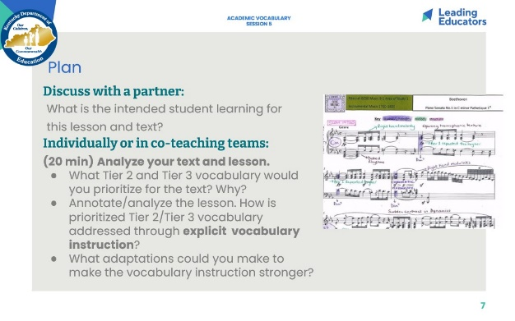
Slide 8:  ALTERNATIVE VERSION TO SUPPORT LESSON CREATION -- UNHIDE SLIDE  Planning (28 minutes total)  Intended Student Learning (6 minutes)  - Framing (1 minute): “As we prepare to plan, identify a partner to work with. With that partner, discuss the text you will be reading and the intended student learning? What should they be able to know and do by the end of the read aloud? Knowing the central ideas or messages helps determine which words to prioritize for explicit instruction.”  - Partners (5 minutes): Discuss student outcomes for the text. These can include big ideas and understandings from the text (message, main idea) as well as practice with specific KAS.  Plan the explicit instruction to accompany the read aloud (22 minutes)  - Framing (2 minutes): As a reminder... “in the planning and practice phase, we will be working like musicians who annotate their scores and shape the dynamics of even the most famous musical works before they perform these masterpieces on stage. In our first phase of planning today, we will hone in on vocabulary in our read aloud. Based on our shared learning from the past two weeks, we will be prioritizing Tier 2 and Tier 3 words that we think our students might struggle with. Then we will plan to teach those words using what we have learned about explicit vocabulary instruction.  - Individually or in Co-teaching teams (20 minutes): Teachers first identify words to teach and select 2 words to address using what they have learned about explicit vocabulary instruction. Use the suggested roll-out from Reading Reconsidered as a guide. | 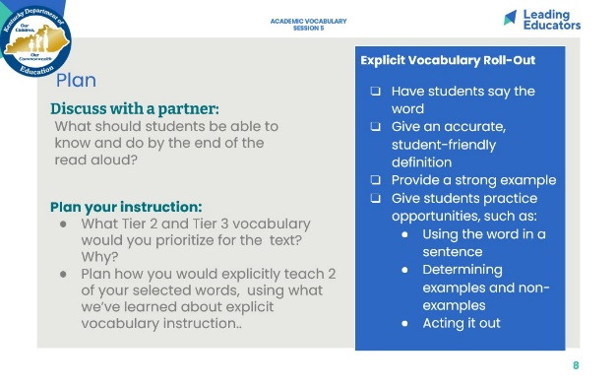
Slide 9:  Practice (18 minutes)  - Practice/Feedback Loop Round 1 (7 minutes): Partner 1 practices instructional plan and records partner feedback aligned to relevant Planning and Practice Look-Fors. Partners may consider the following questions when providing feedback to consider:  - Does the vocabulary instruction in this read aloud lesson work?  - What modification would strengthen this lesson component for all students?  - Does this lesson component/instructional approach align to and/or support the intended student learning?  - Practice/Feedback Loop Round 2 (7 minutes): Partner 2 practices instructional plan and records partner feedback aligned to relevant Planning and Instructional Look-Fors.  - Individual Reflection (4 minutes): “Now let’s take a few minutes to jot down implications from your partner’s feedback, for your next steps with planning. A question to consider in your reflection is: What are my next steps, based on feedback received, that would ensure effective implementation for all learners?” | 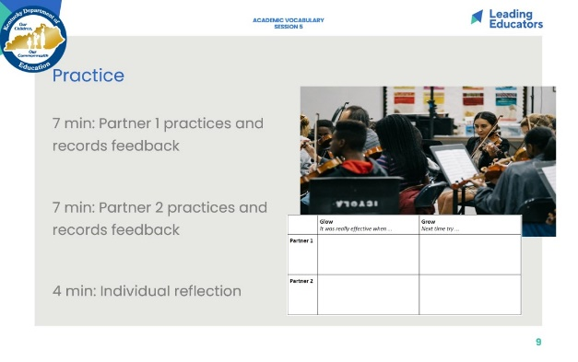
Slide 10:  Preparing the Student Progress Task (24 minutes)  Framing (2 minutes):  - “In our first session, we identified 6 students to progress monitor throughout this content cycle. Next week, we will have the opportunity to look at work samples from those students to reflect on their progress and analyze the impacts of vocabulary instruction on reading comprehension. In our shared learning sessions thus far, we have explored how to identify Tier 2 and Tier 3 words, and how to use both implicit and explicit vocabulary instruction in our teaching.”  - “To prepare for this student progress session, we are going to identify or create the task that will assess students’ progress with reading comprehension. Then we will write exemplar responses to the task and identify or create the rubric that will help assess students’ proficiency.”  Individually or in Co-Teaching Teams (22 minutes):  - If team does not have assessments/tasks embedded in curriculum, you may guide teachers to use written response to text rubrics and to plan a written task based on the current topic/theme. Leverage language from KAS to craft tasks.  - RL.9- 10.2 Determine a theme or central idea of a text, and analyze in detail its development over the course of the text, including how it emerges and is shaped and refined by specific details.  - RL.11- 12.2 Determine two or more themes or central ideas of a text and analyze their development over the course of the text, including how they interact and build on one another to produce a complex account.  - Teams may also choose to develop vocabulary assessments that push students to use the target words in a variety of scenarios. (Ex: To assess the word resilient: Which character can be described as resilient? Why? Give one example of his or her resilience...)  - If team has curriculum with strong assessments/tasks, they can identify an assessment/task that can be administered before the next session. Teachers can write an exemplar response and identify (or create) an accompanying rubric. Encourage teachers to review existing tasks to identify how they are aligned to the KAS. | 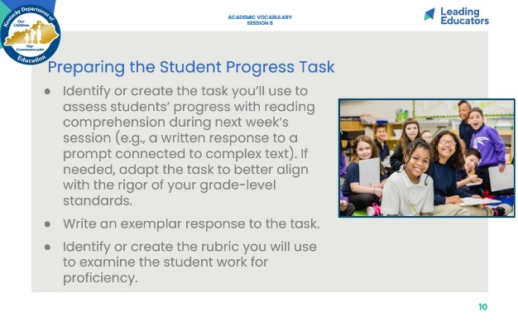
Slide 11:  1 minute  Say: “As a recap: Students need deep word knowledge, taught by explicitly teaching one word at a time. Students also need to acquire an incredible amount of words throughout their schooling, and can learn words through implicit instruction during read aloud. When we tackle vocabulary from both of these angles, we hit our goal. The two work in synergy; we need to know when to do them and how to do them. “ | 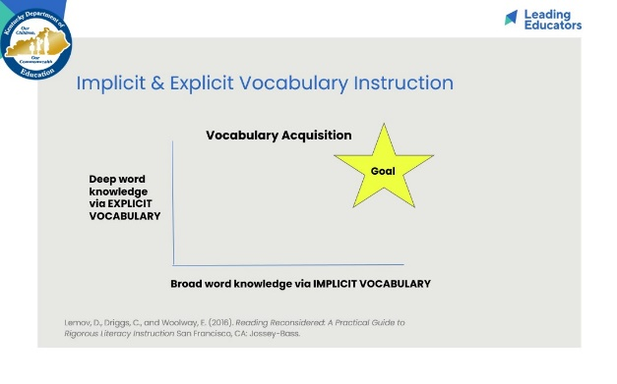
Slide 12:  7 minutes  Closing the Protocol (7 minutes total)  - Partner Debrief (2 minutes): Teachers return to their original partner and share instructional plans and modifications/adaptations made in response to the feedback received. A guiding question to facilitate this discussion might be: How did you apply your partner’s practice feedback into your revised lesson?  - Whole Group Debrief (2 minutes):  - What did you learn from engaging in the Practice and Feedback loop with your colleague?  - How has this process increased my intentional support for the diverse needs of students in my class?  - Prep for Next Session (1 minute)  - Next week, we will devote our time to studying student work samples from the tasks we just identified/created. This will give us an opportunity to reflect on the impact of our vocabulary instruction and to identify next steps. Please bring with you samples from the students you identified in your sub-group, as well as your exemplar response and rubric. | 