Academic Vocabulary Facilitator’s Guide, Grades 9-12

Session 7
OVERVIEW

Grade Band/ Content Area | - ELA 9-12
Essential Questions | - Why is vocabulary instruction critical for equity in literacy?  - Which words do I teach and how?
Enduring Understandings | - Students who know fewer vocabulary words struggle with comprehension, and often get fewer experiences to read grade level text with rich vocabulary as a result. Often, attempts to differentiate for struggling readers mean that those readers end up reading less challenging passages vs. getting supported opportunities to engage with challenging text and learn new vocabulary.  - We must focus instruction on academic vocabulary (Tier 2 words) and domain-specific vocabulary (Tier 3 words).  - We must spend the most time on words needed to fully comprehend the text, words likely to appear in future texts from any discipline, and words that are part of a word family or semantic network.  - To support students in both a breadth and depth of vocabulary knowledge, we must teach vocabulary
Key Components of Cycle | The Learning Cycle includes the following components to support shifts in instruction:  - Shared Learning: Learning sessions where teachers learn new knowledge and skills aligned to the topic of the content cycle. This could look a variety of ways, including reading and discussing an article, studying a classroom video, or doing some group practice of a particular planning skill.  - Planning & Practice: Opportunities for teachers to apply the content they are learning. This could include analyzing units/lessons, creating lessons, rehearsing lessons, watching and reflecting on videos of their classroom practice, etc.  - Student Progress Monitoring: This is an opportunity for teachers to examine student progress aligned to the topic of the cycle. This can include formative student work analysis, end of unit assessments, culminating tasks, etc.  Over the course of this learning cycle, teachers will build an understanding of why vocabulary instruction is critical for our students and how to align their planning and practice research-based principles for implicit vocabulary instruction, explicit vocabulary instruction, text sets, and for reinforcing and extending vocabulary. In this cycle, teachers will have opportunities to experience vocabulary instruction through the lens of students and consider the impact.

TEACHER AND STUDENT GOALS

Teacher Planning & Practice Look-Fors  NOTE: The Practice and Look Fors below come from Leading Educators’ Program Standards. Teams should feel welcome to tailor these to align with district tools as needed. | Example Student Goal(s)  NOTE: These goals are intended to be a starting place for team goal setting. Teams should feel welcome to tailor or add to these based on context, curriculum, and district/school tools.
Practice: Analyzes and adapts questions and tasks to focus on the vocabulary words that are most critical for developing students’ literacy, comprehending the text, and understanding the key ideas of the unit  Look Fors:  - Questions and tasks focus on academic or domain-specific words that are most likely to be encountered again in the future or are most critical for comprehending the text.  - Lessons broaden students’ word knowledge through instructional strategies (e.g., text-dependent questions, drop-in definitions, glossary, etc.) that teach words that can be understood quickly during reading.  - Weekly lessons deepen students’ word knowledge by explicitly defining, modeling, and giving students active practice with 6-10 vocabulary words.  - Over the course of the unit, students have opportunities to maintain and extend vocabulary through additional practice with words previously taught. | Possible goals:  - In-class observation of specific student actions that correlate with the learning connected to this content cycle  - Achievement or growth on a unit/domain assessment  - Achievement or growth on a prioritized unit/domain writing task (see rubric guidance below)

CYCLE-AT-A-GLANCE
NOTE: Each row is intended to represent one 90-minute session, but schools can adjust the pacing of learning based on their context and teacher needs.

Session | Type of Learning | Objective(s) | Assessment of Learning
Session 7  Text Sets | Shared Learning | Explain what text sets are and why they matter.  Analyze a text set. | - Reflection: 1.) What are the criteria of a strong text set? 2) Why are text sets important for students?  - Shared analysis of a sample text set identifying strengths and potential adaptations.

Preparation:
Participant should be given access to the following documents to engage in the learning for this session:
- PowerPoint Slides
- Participant Handout
- Prework: It’s Time for a Reading Reset

Session 7: Shared Learning: Text Sets

Pre-Work  https://iowareadingresearch.org/blog/text-sets-background-knowledge | 30 min: Participants read It’s Time for a Reading Reset (Knowledge Matters Campaign) and capture thinking in response to the following questions:  - How does background knowledge connect to equity?  - What are some ways to build students’ background knowledge?  - How does vocabulary relate to background knowledge?  - How do you address background knowledge in your current practice?
PPT | Session 7 PowerPoint  *Times listed in the presenter’s notes on slides are approximate, and may be adjusted to meet the needs and schedule of the individual PLC.
Printing/Digital Handouts | - Participant Handout

Agenda | Facilitation Guidance
- Opening  - Why This Matters  - Components of Text Sets  - Analyzing and Adapting Text Sets  - Reflection | Overview: In this session, teachers will explore how to leverage text sets to build knowledge and vocabulary simultaneously. Participants discuss the importance of background knowledge to students’ reading success and the implications for equity. Teachers use the Kentucky Academic Standards and exemplar text sets to unpack what makes a strong text set. From there, the session includes time to analyze existing text sets to identify strengths and possible adaptations.

Facilitator’s Notes | Accompanying Slide
Slide 1:  1 minute  Frame: “Welcome to our fourth shared learning in this content cycle on academic vocabulary. Today’s session will serve as an introduction to text sets and their role in supporting literacy. While we have discussed specific strategies for teaching vocabulary words explicitly and implicitly, we also need to talk about how to provide students with multiple exposures to words, and to explore the connections between background knowledge and vocabulary development.”  Session Length: 90 minutes | 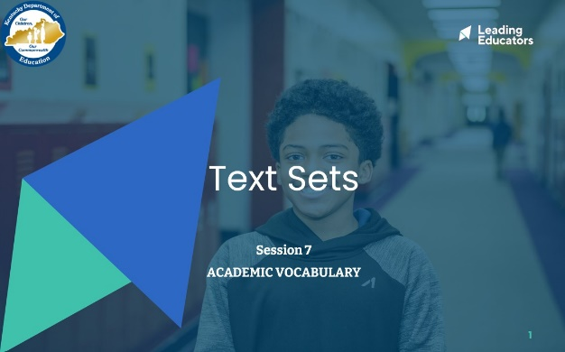
Slide 2:  4 minutes  Directions/Framing/Key Points:  - 1 minute: To begin our work, let’s start by reflecting on the ultimate purpose of reading, and the joy that comes with reading. Can I have a volunteer read our prompt?  - 1 minute: Reflect independently.  - 2 minutes: Share with a partner.  It was so powerful to hear so many different stories about students who have learned so much about so many different topics through reading. (Facilitator should name some topics overheard.) This is the ultimate purpose of reading - to learn about different places, people, perspectives, subjects, ourselves. The purpose of reading, ultimately, is to build knowledge.  Look or Listen Fors/Evidence of Mastery:  - Participants are sharing a story about a student who was excited about a particular topic. Participants share out about what the student would read, how they would talk about the topic, etc.  - Facilitators should listen to be sure that participants are talking about a topic (e.g., sharks, sea mammals, hurricanes, etc.) and not a series or author (Harry Potter, etc.) | 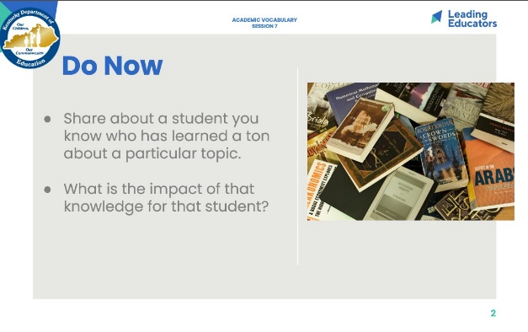
Slide 3:  Cycle Overview (1 minute)  - Review the cycle. | 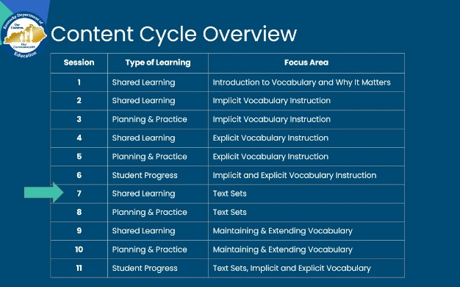
Slide 4:  1 minute  Directions/Framing/Key Points:  - Here are the objectives for the session. May I have two volunteers read them aloud?  - Here is our path for learning.  Look or Listen Fors/Evidence of Mastery:  N/A | 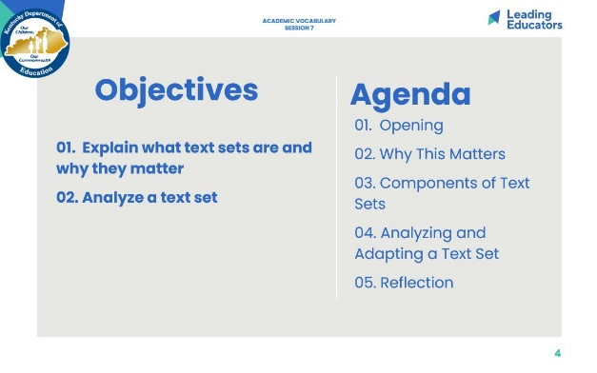
Slide 5:  4 minutes: KAS  Directions/Framing:  - Please read the excerpt from the Kentucky Academic Standards and highlight words that communicate the importance of text sets in reading comprehension.  - 2 minutes: Participants highlight  - 2 minutes: Whole group share: What are the key messages we want to hold onto?  Look/Listen For:  - Using text sets is essential to meeting the standards  - Text sets should include high-quality texts, can be print and non-print  - Text sets should be organized so that students start with less rigorous text and move to more rigorous text  - Text sets allow students to build background knowledge -- which includes vocabulary knowledge | 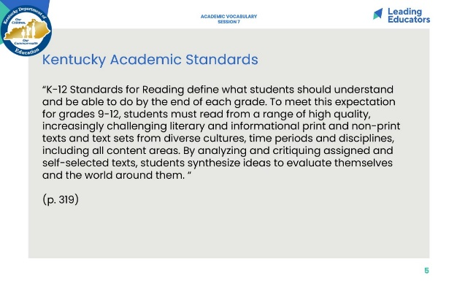
Slide 6:  14 minutes  Directions/Framing:  - Let’s begin by returning to our pre-work reading to make sure that we understand the key points around background knowledge and how text sets support the construction of background knowledge.  - 1 minute: Participants take out notes from pre-work and “It’s Time for a Reading Reset!”  - 2 minutes: Facilitator Frame. In order to review and deepen our understanding, we are going to leverage a quick 3-2-1 protocol.  - As you reflect on the pre-reading, distill your thinking into:  - 3 take-aways -- what stuck with you? What did you learn? What key understandings were reinforced for you?  - 2 wonderings -- what questions do you have about the case for background knowledge? What questions do you have about how it impacts your instruction?  - 1 connection to current practice around teaching to build background knowledge-- what is something you might shift? What is something you are already doing that connects to research?  - 3 minutes: Participants complete 3-2-1 in handout  - 3 minutes: Participants stand up and find partner to share 3-2-1  - 3 minutes: Facilitate small group or table share: Why is background knowledge an equity issue?  - 2 minutes: Facilitate whole group share: What is the role of text sets in building background knowledge?  Look or Listen Fors/Evidence of Mastery:  - Background knowledge and equity:  - Knowledge begets knowledge.  - Our most vulnerable students must have opportunities to build background knowledge at school.  - Many programs currently focus on skills and strategies without intentionally building background knowledge.  - The role of text sets  - Text sets focus on a topic vs. a skill (like main idea).  - Through reading different texts, students build content knowledge.  - Students have multiple exposures to words and concepts. | 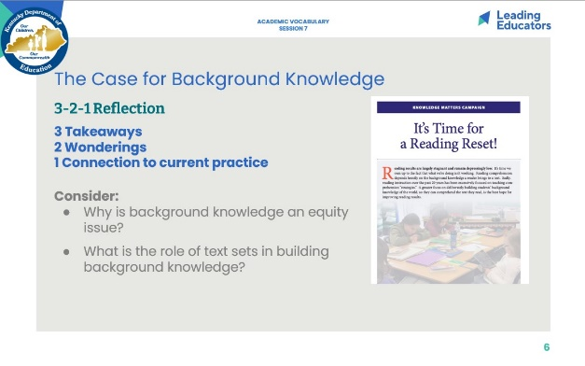
Slide 7:  15 minutes Text Set Exploration  - Divide participants into small groups of 3-4  - Direct participants to page 3 in the handout, which has an excerpt from the Iowa Reading Research Center. The featured text set is designed to support a 7th grade unit on immigration.  - 1 minute: Frame: Let’s explore an example of a strong text set from a secondary unit. First, you have time to independently explore/click on links to the texts shared here. Then, with your group, you will discuss the following questions:  - How are the texts connected?  - What will students learn?  - What do you notice about the kinds of texts?  - 5 minutes: individual exploration  - 7 minutes: group work to record thinking  - 4 minutes: share out whole group -- 1-2 responses for each of the three questions  Look or Listen fors:  - How are the texts connected? Texts build coherent knowledge around factors that influence immigration.  - What will students learn? From unit description: Immigration patterns of various groups in United States history (e.g., Irish, Chinese, Syrians), previous immigration policies and related reforms, previous push-pull factors, personal experiences of immigrants, current events that influence push-pull factors (e.g., gang violence in El Salvador).  - Kinds of texts: Fiction, informational types -- articles, interviews, cartoons | 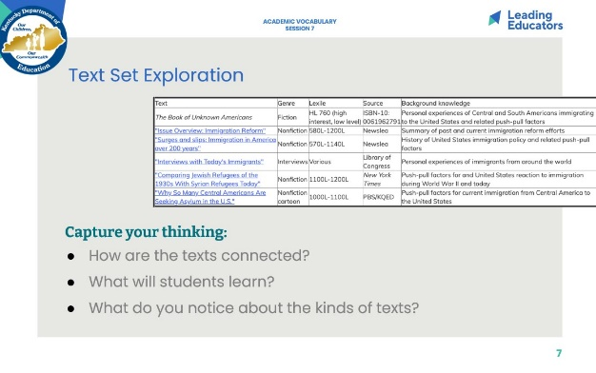
Slide 8:  2 minutes: KAS Connection  Framing/Directions:  - We just saw an example of a text set that includes a variety of text genres.  - This graphic of the Interdisciplinary Practices in the KAS shows the emphasis on multi-media -- anything that communicates a message is a text!  - Consider your classroom: When and how have you used non print texts? Briefly share with a partner. | 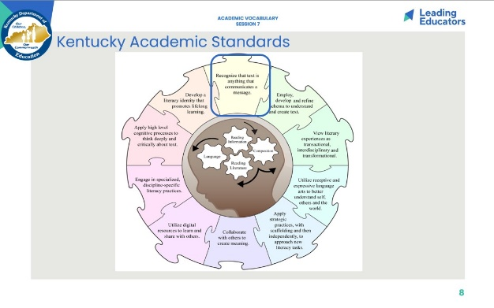
Slide 9:  4 minutes: Research connections  Framing/Directions:  - Let’s connect our learning and the KAS back to research.  - May I have two volunteers to read these two points from research?  - By “conceptually coherent,” Cervetti means texts that are focused around a narrow topic, such as the Dickens text set that we read earlier. In conceptually coherent text sets, the knowledge and vocabulary demands overlap, just like we explored earlier.  - 1 minute: Why would these findings be true? Take a moment to process with a partner.  - 3 minutes: Whole group share out  Additional probe if it does not come out explicitly: What are implications for teaching?  Look or Listen Fors/Evidence of Mastery:  - When organizing texts by topic, students acquire vocabulary in two ways: 1) There is overlap of content-specific words across the texts on that topic, and 2) As they build knowledge about the topic, they have stronger context through which to make inferences about the meaning of unknown words. (Share dolphin examples from marine animals text set.)  - When we read topic aligned texts as we did this morning, we get repeated exposure to similar vocabulary.  - With greater background knowledge about a topic, we also are able to make meaning of previously unknown words more quickly.  - We often have to use context clues to figure out the meaning of words. What are the context clues? The other words! So often, our background knowledge can help us more easily make sense of what we are reading, which allows us to more easily determine the meaning of unknown words.  - As teachers, we should create opportunities for students to engage in conceptually coherent text sets, through whole group instruction, small group reading, independent reading, or some combination. | 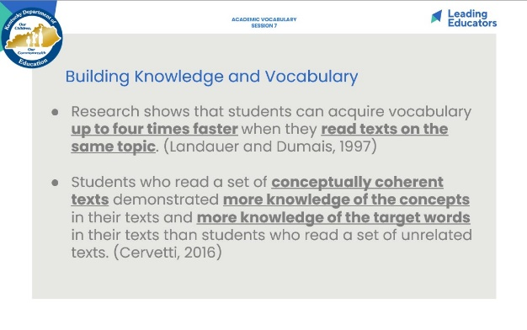
Slide 10:  2 minutes  Framing:  - When we look at text sets through the lens of the KAS, we can consider a few guiding criteria: text sets need to clearly build knowledge (vs. focusing on a skill like determining central idea or theme), stay focused and coherent, align to a task, include a variety of text types (print and non-print), and may be ordered from less rigorous to more rigorous, depending on the topic. | 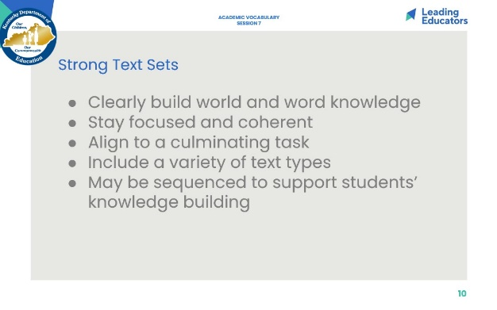
Slide 11:  4 minutes  Framing:  - While there is no set way to create a text set, it is helpful for us to have some steps in mind as we think about the process.  - 1 minute: May I have a volunteer read the steps on the slide?  - 2 minutes: How is this similar to or different from your current practice? Partners share.  - 1 minute: Whole group share. | 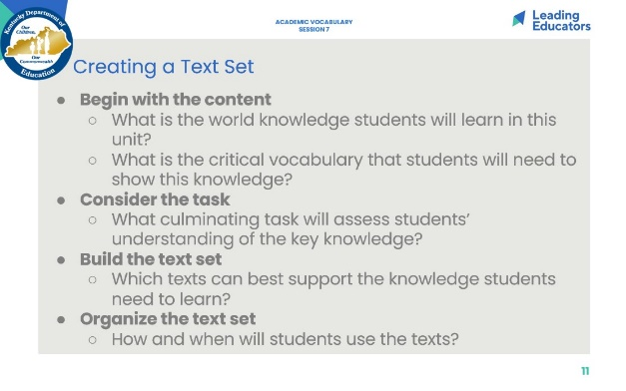
Slide 12:  10 minutes: Practice Analyzing a Text Set (*Some sites require setting up a free account.)  Directions/Framing:  - 1 minute: Let’s take a look at a text set example from an open-source curriculum sites.  - 10 minutes: First, find and review a text set.  - 4 minutes: Next, with a partner, talk through the texts. What are the strengths and what could be adjusted?  - 2 minutes: Facilitate brief group share.  Look or Listen Fors/Evidence of Mastery:  - Strengths: Coherence, clearly aligned to intended standards/content.  - Adaptations: | 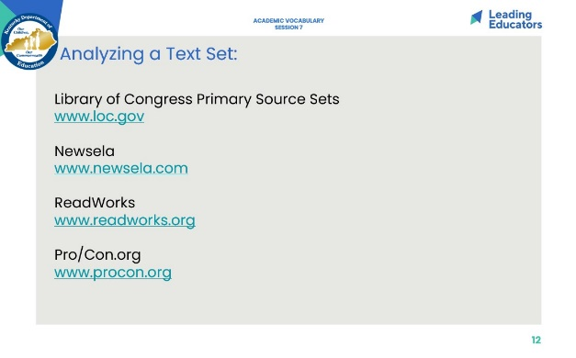
Slide 13:  15 minutes: Analyzing and Adapting a Text Set  Direct participants to select a text set.  Directions/Framing:  - 1 minute: Let’s continue to practice looking at strong text sets and considering how they align to the KAS. We are going to work in partnerships to explore a text set from the Kentucky Text Sets site.  - 10 minutes: In partnerships, examine the text set “Creature Features” and jot down strengths and possible adaptations on your handout. Keep in mind what we have discussed as criteria for strong text sets.  - 4 minutes: Group share: What are strengths? What adaptations could you make?  Look or Listen Fors/Evidence of Mastery:  - Strengths: Diversity of text (types, print/non print), clearly aligned to task, suggested sequence of texts, repeated vocabulary (these strengths apply to most of the text sets, but responses will depend on what participants select)  - Possible adaptations: | 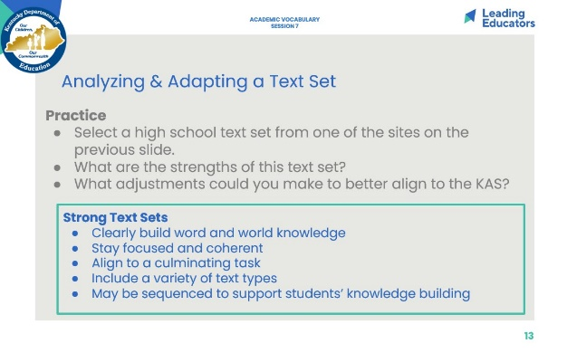
Slide 14:  10 minutes  Directions/Framing:  - 5 minutes: As a check for understanding, participants synthesize their key takeaways to the two questions on a notecard.  - 5 minutes: Ask participants to share responses. Facilitator can address or capture new questions that are surfacing about text sets. [Collect notecards to review understandings from group]  Look or Listen Fors/Evidence of Mastery:  - Text sets are groups of texts (print and non-print) that support knowledge building around a specific topic or concept.  - Text sets allow students to build coherence, to have repeated access to critical vocabulary and background knowledge. Background knowledge is critical to equity.  - Strong text sets connect to a topic/concept, align to a task, include a variety of text, and may be sequenced from less to more rigorous. | 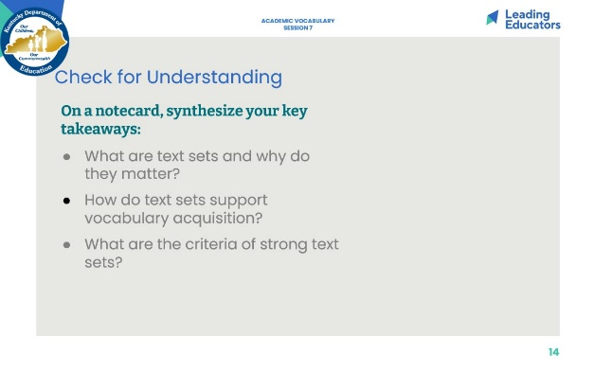
Slide 15:  6 minutes  Directions/Framing:  - Finally, let’s conclude with a reflection on why this matters and where we go next. Take 2 minutes to reflect.  - 3 minutes: Stand up, find someone you have not talked with yet today, and share out your reflections.  Look or Listen Fors/Evidence of Mastery:  - Participants reflect on a specific student and next step.  For next session:  Remind participants to bring an existing text set or to bring a topic and some possible resources. Share with participants kentuckytextsets.weebly.com - a state-specific site with text set ideas. | 