Academic Vocabulary Facilitator’s Guide, Grades 9-12

Session 8
OVERVIEW

Grade Band/ Content Area | - ELA 9-12
Essential Questions | - Why is vocabulary instruction critical for equity in literacy?  - Which words do I teach and how?
Enduring Understandings | - Students who know fewer vocabulary words struggle with comprehension, and often get fewer experiences to read grade level text with rich vocabulary as a result. Often, attempts to differentiate for struggling readers mean that those readers end up reading less challenging passages vs. getting supported opportunities to engage with challenging text and learn new vocabulary.  - We must focus instruction on academic vocabulary (Tier 2 words) and domain-specific vocabulary (Tier 3 words).  - We must spend the most time on words needed to fully comprehend the text, words likely to appear in future texts from any discipline, and words that are part of a word family or semantic network.  - To support students in both a breadth and depth of vocabulary knowledge, we must teach vocabulary
Key Components of Cycle | The Learning Cycle includes the following components to support shifts in instruction:  - Shared Learning: Learning sessions where teachers learn new knowledge and skills aligned to the topic of the content cycle. This could look a variety of ways, including reading and discussing an article, studying a classroom video, or doing some group practice of a particular planning skill.  - Planning & Practice: Opportunities for teachers to apply the content they are learning. This could include analyzing units/lessons, creating lessons, rehearsing lessons, watching and reflecting on videos of their classroom practice, etc.  - Student Progress Monitoring: This is an opportunity for teachers to examine student progress aligned to the topic of the cycle. This can include formative student work analysis, end of unit assessments, culminating tasks, etc.  Over the course of this learning cycle, teachers will build an understanding of why vocabulary instruction is critical for our students and how to align their planning and practice research-based principles for implicit vocabulary instruction, explicit vocabulary instruction, text sets, and for reinforcing and extending vocabulary. In this cycle, teachers will have opportunities to experience vocabulary instruction through the lens of students and consider the impact.

TEACHER AND STUDENT GOALS

Teacher Planning & Practice Look-Fors  NOTE: The Practice and Look Fors below come from Leading Educators’ Program Standards. Teams should feel welcome to tailor these to align with district tools as needed. | Example Student Goal(s)  NOTE: These goals are intended to be a starting place for team goal setting. Teams should feel welcome to tailor or add to these based on context, curriculum, and district/school tools.
Practice: Analyzes and adapts questions and tasks to focus on the vocabulary words that are most critical for developing students’ literacy, comprehending the text, and understanding the key ideas of the unit  Look Fors:  - Questions and tasks focus on academic or domain-specific words that are most likely to be encountered again in the future or are most critical for comprehending the text.  - Lessons broaden students’ word knowledge through instructional strategies (e.g., text-dependent questions, drop-in definitions, glossary, etc.) that teach words that can be understood quickly during reading.  - Weekly lessons deepen students’ word knowledge by explicitly defining, modeling, and giving students active practice with 6-10 vocabulary words.  - Over the course of the unit, students have opportunities to maintain and extend vocabulary through additional practice with words previously taught. | Possible goals:  - In-class observation of specific student actions that correlate with the learning connected to this content cycle  - Achievement or growth on a unit/domain assessment  - Achievement or growth on a prioritized unit/domain writing task (see rubric guidance below)

CYCLE-AT-A-GLANCE
NOTE: Each row is intended to represent one 90-minute session, but schools can adjust the pacing of learning based on their context and teacher needs.

Session | Type of Learning | Objective(s) | Assessment of Learning
Session 8  Text Sets | Planning & Practice | Apply knowledge of text set creation to curricular planning and practice  Give and receive feedback from colleagues in order to revise plans and refine practices | Analyze or create a text set, identifying opportunities to better align to the KAS

Preparation:
Participant should be given access to the following documents to engage in the learning for this session:
- PowerPoint Slides
- Participant Handout
- Goal Setting Document

Session 8: Planning and Practice

Pre-Work | Teachers gather and bring:  - Goal-Setting Document for the current content cycle  - An existing text set within the curriculum OR a topic and possible text resources to support
PPT | Session 8 PowerPoint  *Times listed in the presenter’s notes on slides are approximate, and may be adjusted to meet the needs and schedule of the individual PLC.
Printing/ Digital handouts | Participant Handout

Agenda | Facilitation Guidance
- Opening  - Review  - Planning  - Practice  - Closing | Overview: In this planning and practice session, teachers will apply learning of the instructional practice studied in the previous new learning session. As teachers plan, they will focus on the Planning and Instructional Look-Fors that will support them in meeting goals set in the previous session. Teachers will practice with a colleague, eliciting specific feedback to aid in effective instructional implementation. After collaborating with colleagues and giving/receiving feedback, teachers will modify their approach and complete or refine their instructional plans.

Facilitator’s Notes | Accompanying Slide
Slide 1:  Session Summary In this planning and practice session, teachers will apply learning of the instructional practice studied in the previous new learning session (text sets). As teachers plan, they will focus on the Planning and Instructional Look-Fors that will support them in meeting goals set in the previous session. Teachers will practice with a colleague, eliciting specific feedback to aid in effective instructional implementation. After collaborating with colleagues and giving/receiving feedback, teachers will modify their approach and complete or refine their instructional plans.  Session Length: 90 minutes | 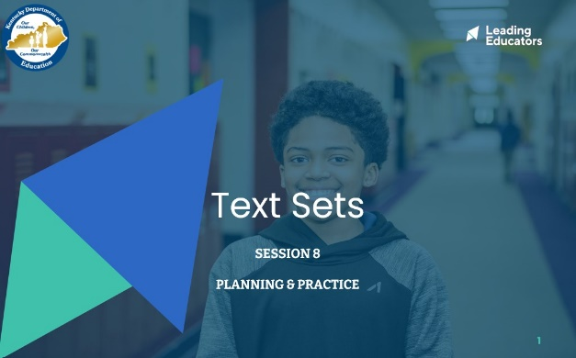
Slide 2:  Do Now (4 minute): “Please take out the goal-setting document you completed during the first week of this content cycle. Take a couple of minutes to reflect on the progress you have seen in your practice and in your students over the past week. What are some ways you want to continue to grow?” | 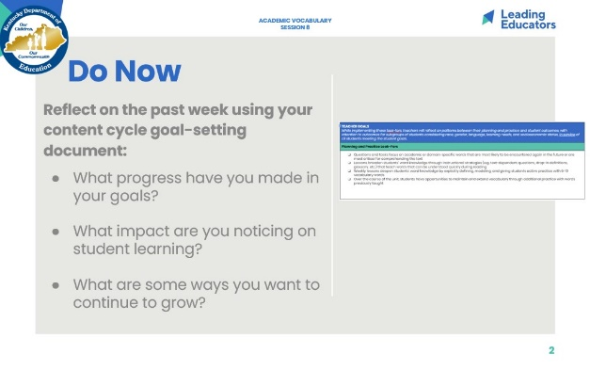
Slide 3:  Cycle Overview (1 minute)  - Share path of the cycle, explaining how the professional learning includes opportunities for shared learning, planning and practice, and studying student progress. | 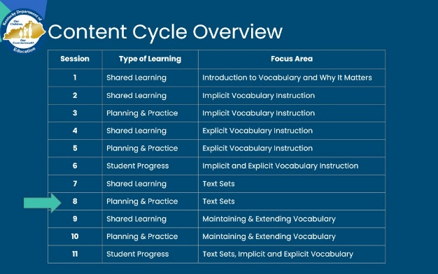
Slide 4:  2 minutes  Share objectives and agenda. | 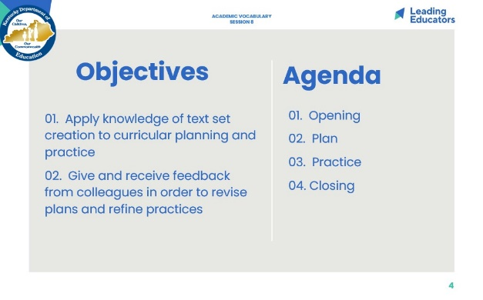
Slide 5:  Norms (1 minute)  - Review norms. | 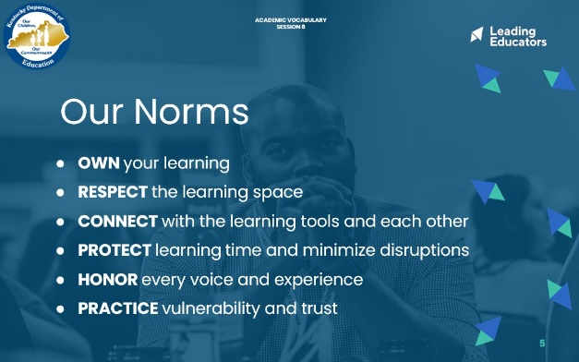
Slide 6:  10 minutes: Review Text Sets  Framing/Directions:  - 2 minutes: Before we dive into our text set planning and practice, let’s pause to reflect on what we learned in our last session. To do this, we have two quotes that represent some common misconceptions. Our job is going to be to explain to the “speaker” how to consider what we know about research and standards.  In partnerships, assign yourselves an A and a B. If you are A, you will read the A quote to your partner and your partner will respond. Make it a role play back and forth. Then you will switch, and partner B will read the B quote while partner A responds.  - 4 minutes: Partners role play  - 4 minutes: Ask for volunteers to share talking points for A and B. Surface any questions or misunderstandings and guide teachers to talking points below.  Look or Listen Fors/Evidence of Mastery:  - Responses include at least one key idea to clarify the misconception  - Responses explain at least one piece of research  Key Idea(s)  In Response to Quote A  - A single text may anchor a unit, but in order to build conceptual coherence, students should read additional (short) texts that connect to the concepts within the anchor text. This will allow for practice and deep knowledge of words and concepts.  - The Cervetti study shows that when students read texts on the same topic, they actually learned more knowledge and vocabulary than students who read the same amount of texts but on all different topics.  In Response to Quote B  - Historically, students have spent time on skills and have not had intentional knowledge building -- this hurts our most vulnerable students who need more time building background knowledge.  - Knowledge begets knowledge -- the more you know, the more you learn about a topic/idea.  - Students can use strategies like finding the main idea, but in service of making meaning from text. The skill does not stand alone! | 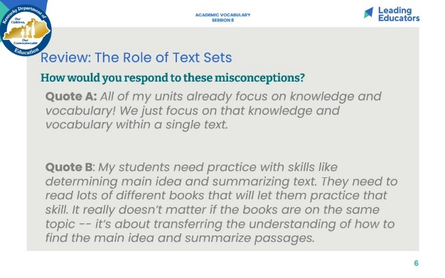
Slide 7:  Planning (40 minutes total) This slide is for teams that have existing text sets outlined within curriculum.  Intended Student Learning (8 minutes)  - Framing (1 minute): “As we prepare to plan, identify a partner to work with. With that partner, discuss the intended student learning for the unit and text set you will be analyzing today. Internalizing student outcomes for this part of the curriculum is essential so that you can provide each other with specific and targeted feedback during our practice today.”  - Partners (7 minutes): Discuss student outcomes for the targeted curricular resource and alignment to the goals for the content cycle.  Analyze and Adapt Curriculum (32 minutes)  - Framing (2 minutes): Our planning time today will look a little different than in previous sessions. Instead of looking at a particular lesson, we will look at a unit/text set as a whole. You will have the opportunity to consider how your text set builds knowledge and vocabulary understandings, and you will be able to make adaptations and adjustments based on the KAS.  - Individually or in Co-teaching teams (30 minutes): Teachers analyze and adapt an existing text set that will elevate achievement for all students using the questions on the slide as guidance.  If teachers do not have a curricular resource that leverages text sets, use the next slide! (Unhide it.) | 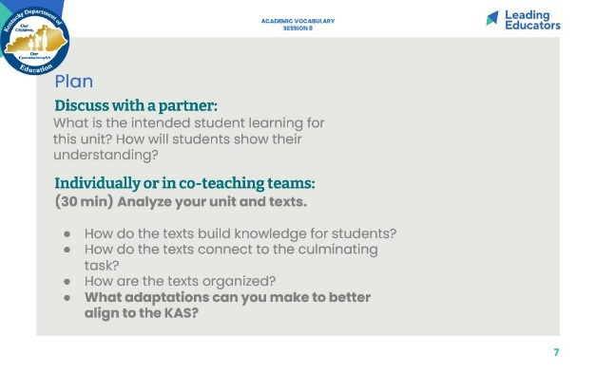
Slide 8:  Planning (40 minutes total) This slide is for teams that DO NOT have existing text sets outlined within curriculum.  Intended Student Learning (10 minutes)  - Framing (1 minute): “As we prepare to plan, identify a partner to work with. With that partner, discuss the intended student learning for the topic and text set you will be creating today. Internalizing student outcomes for this part of the curriculum is essential so that you can provide each other with specific and targeted feedback during our practice today.”  - Partners (9 minutes): Discuss topic and student knowledge outcomes. Draft culminating task that assesses the key knowledge for the unit.  - Create Curriculum (30 minutes)  - Framing (1 minute): Our planning time today will look a little different than in previous sessions. Instead of looking at a particular lesson, we will consider a unit/text set as a whole. You will have the opportunity to create a text set that aligns to your culminating task. Your text set will reflect what we know about the KAS and what goes into strong text sets.  - Individually or in Co-teaching teams (29 minutes): Teachers create a text set that will elevate achievement for all students using the questions on the slide as guidance. | 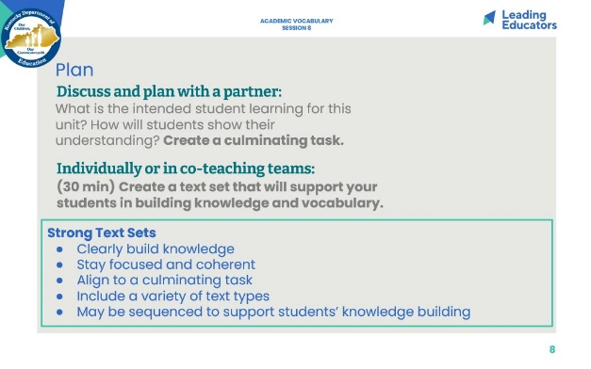
Slide 9:  Practice (18 minutes)  - Frame: Since it is tricky to “practice” text sets, we are going to use this time to share and talk through the planning we just did.  - Practice/Feedback Loop Round 1 (7 minutes): Partner 1 shares text set (newly created or adapted) and records partner feedback aligned to relevant Planning and Practice Look-Fors. Partners may consider the following questions when providing feedback to consider:  - Does the text set meet our criteria for strong text sets?  - What additional revisions can be made to support students and to align to the KAS?  - Practice/Feedback Loop Round 2 (7 minutes): Partner 2 shares text set and records partner feedback.  - Individual Reflection (4 minutes): “As we prepare for revising, take a minute to jot down implications from your partner’s feedback, for your next steps with planning. A question to consider in your reflection is: What are my next steps, based on feedback received, that would ensure effective implementation for all learners?” | 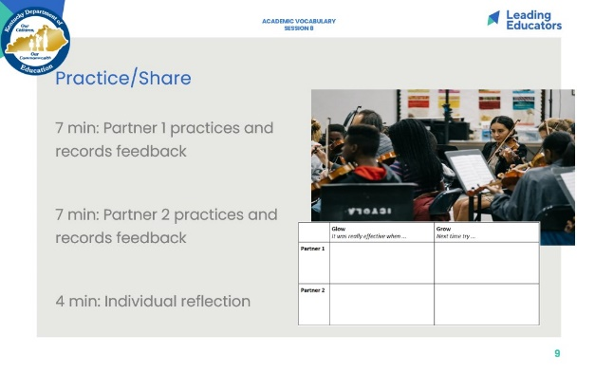
Slide 10:  10 min  Closing the Protocol (10 minutes total)  - Partner Debrief (3 minutes): Teachers return to their original partner and share text set plans and modifications/adaptations made in response to the feedback received. A guiding question to facilitate this discussion might be: How did you apply your partner’s practice feedback into your revised lesson?  - Whole Group Debrief (2 minutes):  - What did you learn from engaging in the Practice and Feedback loop with your colleague?  - Whip Share (5 minutes): What is one new understanding you have about creating or adjusting text sets for your students? (Everyone shares one sentence; repeats are fine.) | 