11th-12th Grade Reading and Writing Assignment
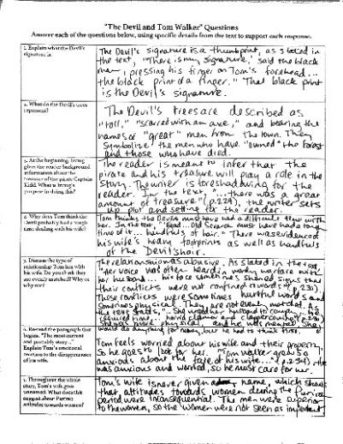
This assignment is strongly aligned to the standards.
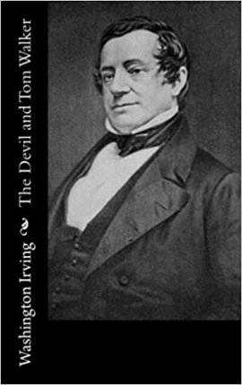
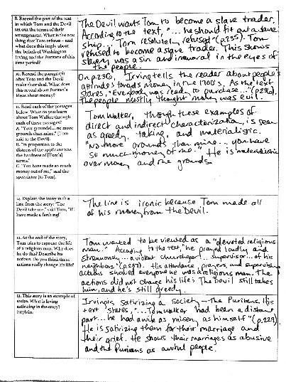
Overview
Eleventh-grade students read “The Devil and Tom Walker,” a grade-appropriate text by Washington Irving, then respond to a series of text-specific questions. This assignment exposes students to a noteworthy literary text that builds historical knowledge, and the questions require students to focus on key details and progressively build their understanding of the text. Students are expected to defend their responses with specific evidence from the text.
About the Text

Title and Author | “The Devil and Tom Walker” by Washington Irving
What is the Lexile Level of this text? | 1120
Based on Lexile, which grades is this text intended for? | 9-10
Is the text qualitatively complex enough for the grade? | Yes
Is this text fiction or non-fiction? | Fiction
Is this text authentic or was it written for educational purposes? | Authentic
Does the text provide sufficient detail to build knowledge of a worthwhile topic and/or is it worth reading closely and re-reading? | Yes

Related Standards
RL.11-12.1: Cite relevant and thorough textual evidence to support analysis of the text says explicitly as well as inferences drawn from the text.
The assignment is strongly aligned to this standard. Task directions stipulate that students must use specific evidence from the text to substantiate their responses. Questions are nuanced and demand that students make significant inferences.

RL.11-12.2: Determine two or more themes or central ideas of a text and analyze their development over the course of the text, including how they interact and build on one another to produce a complex account.
The assignment is strongly aligned to this standard. Multiple questions require students to analyze and explain the text’s major themes of religion, money, and gender relations.

RL.11-12.3: Analyze the impact of the author’s choices over the course of a text regarding how to develop and relate elements of a story or drama.
The assignment is strongly aligned to this standard. Question 11, for example, asks students to analyze the author’s development of the main character.

RL.11-12.5: Analyze how an author’s choices concerning how to structure specific parts of a text contribute to its overall structure and meaning as well as its aesthetic impact.
The assignment is strongly aligned to this standard. Question 5, for example, requires students to analyze the author’s choice to begin the story with a seemingly unrelated detail.

RL.11-12.6: Analyze how point of view and perspective are used to manipulate the reader for a specific purpose or effect, including but not limited to satire, sarcasm, irony and understatement.
The assignment is strongly aligned to this standard. Questions 13 and 14 guide students to explain the author’s deployment of irony and satire.

RL.11-12.9: Demonstrate knowledge of various time periods to analyze how two or more texts from the same period treat similar themes or topics.
The assignment is strongly aligned to this standard. The text was published in the nineteenth century and depicts an eighteenth century Puritan society; it explores a social/religious history and set of themes that are critical to early American literature.

L.11-12.2: When writing: a. Demonstrate command of the conventions of standard English capitalization, punctuation and spelling when writing.
Why is this assignment strongly aligned to this standard?
The assignment is strongly aligned to this standard. Students have opportunity to demonstrate their command of 11th grade-level language conventions in their responses (this is implicit rather than explicit in task directions).
Why is this assignment Strongly aligned?
This assignment is strong because it has a strong text and strong questions:
The assignment exposes students to engage with a worthwhile text. The text exhibits exceptional literary craft, making extensive use of symbolism, religious imagery, and allusion. It also demands sophisticated understanding of irony and satire.
The assignment requires students to read carefully and focus on the key details of the text. The questions point students back to specific passages that build their understanding. Questions become increasingly more complex (from “Explain what the Devil’s signature is” to “What is Irving satirizing in the story?”). The purposeful sequencing of questions helps students arrive at a cumulative understanding of the story.
Students are required to articulate their ideas about the text in writing. The questions ask students to support those ideas with specific, relevant details from the story.
Students practice formal, academic writing. In their written responses, they are expected to demonstrate command of advanced language conventions.

