11th-12th Grade Reading and Writing Assignment
This assignment is weakly aligned to the standards.

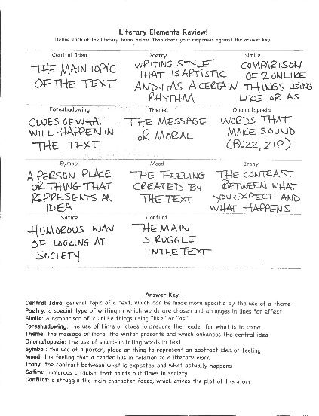
Overview
Eleventh-grade students fill out a chart defining a series of literary terms. This task is not connected to any meaningful reading or writing. Students define terms in isolation, without applying them to text.
Related Standards
RL.11-12.3: Analyze the impact of the author’s choices over the course of a text regarding how to develop and relate elements of a story or drama.
The assignment is weakly aligned to this standard. The task is tenuously connected to this standard, as it does concern story elements. But without any relationship to text, the task does not approach this standard’s depth.

L.11-12.4: Determine the meaning of words and phrases as they are used in the text,

including figurative and connotative meanings; analyze the cumulative impact of specific word choices on meaning and tone and on the text as a whole.

The assignment is weakly aligned to this standard because the task requires students to define words, but not in the context of 11-12 reading and content.

Why is this assignment weakly aligned?
The assignment includes no reading. Students are presented with a series of arbitrary literary terms and asked to define them in isolation.
The assignment includes no writing. Students jot down brief definitions for each literary term. They have no opportunity to engage in more substantive, analytical writing.
Students are not asked to build any meaningful content or cultural knowledge, and the questions do not provide opportunity to practice grade-appropriate reading or writing skills in context. Therefore, the assignment does not align to the intent of the grade-level standards.

