Grade 1 Assignment
This assignment is strongly aligned to the Kentucky Academic Standards (KAS) for Social Studies
Teacher Notes

Introduction
This Teacher Notes document provides instructional support for implementing the strongly aligned assignments to the KAS for Social Studies. To examine why this assignment is strongly aligned to the KAS for Social Studies, engage with the Grade 1 Assignment Review Protocol for this assignment.
It is important to note that the assignment(s), indicated throughout the Teacher Notes, and related resource(s) represent one example. It is not a requirement nor a suggestion for school curriculum. While the Kentucky Department of Education (KDE) is responsible for the development of high-quality academic standards, state law assigns each local district the authority to develop the school’s curriculum and determine appropriate instructional resources based on language found in Kentucky Revised Statute (KRS) 160.345. It is under the discretion of the superintendent to determine the local curriculum, including the evaluation and selection of instructional resources. The KDE does not adopt, select or recommend specific curricula for coursework. Per KRS 160.345(g), “the local superintendent shall determine which curriculum, textbooks, instructional materials, and student support services shall be provided in the school after consulting with the local board of education, the school principal, and the school council and after a reasonable review and response period for stakeholders in accordance with local board of education policy.”

Kentucky Academic Standards (KAS) for Social Studies alignment:
- 1.I.Q.1 Ask compelling questions about communities in Kentucky.
- 1.I.Q.2 Identify supporting questions to investigate compelling questions about communities in Kentucky.
- 1.C.PR.1 Investigate rules and laws in Kentucky to understand their purpose.
- 1.E.MA.1 Describe how different jobs, as well as public and private institutions, help people in the community.
- 1.I.UE.2 Construct responses to compelling and supporting questions about communities in Kentucky.
- 1.I.CC.2 Construct an argument with reasons to address how to improve the local community and Kentucky.

Educators may have to engage with a standard multiple times throughout a year in order to meet the full intent of the standard. As a result, the following example may not encompass the entire scope of the standards identified.

Overview:
Students will describe and investigate the purpose of rules and laws in Kentucky. Students will describe how different jobs, as well as public and private institutions, help people in the community. Students will use this knowledge to construct an argument with reasons to address how to improve the local community and Kentucky. In this assignment, students engage with the KAS for Social Studies to build knowledge that will enable them to construct an argument to answer the compelling question: “What makes a community healthy?” Through these investigations, students build knowledge to answer the compelling question by investigating supporting questions.

Setting the Stage: Compelling Question

1.I.Q.1 Ask compelling questions about communities in Kentucky.

Compelling Question:
“What makes a community healthy?”

Compelling questions are open-ended, enduring and center on significant unresolved issues. This assignment provides a compelling question to demonstrate alignment because Grade 1 students are not required to ask compelling questions without teacher support. Therefore, teachers may provide the compelling questions that students engage with as it is not the expectation of the standard that students ask the compelling questions on their own. For more information on compelling questions, visit Section B: “What are Compelling Questions and how do students ask them?” from the Inquiry Practices of the KAS for Social Studies module.

In a whole group discussion, pose the compelling question to students: “What makes a community healthy?” Visit Leading Discussions for more information on how to conduct whole group discussions. As students engage with the compelling question, have them explain what being healthy means and provide examples. You may consider creating a Mind Map together as a class as students brainstorm the meaning and examples of being healthy. For more information on Mind Mapping, the video Mind Mapping may be helpful. Students may respond that being physically healthy means eating vegetables, exercising, avoiding junk food and not being sick. Prompt them to go beyond what makes a body healthy to what makes other places or things healthy. For example, pose the question: “What makes a healthy classroom?” Student responses may include, but are not limited to, being respectful to one another, following directions and being safe. Then, ask students what makes an unhealthy classroom. Responses may include, but are not limited to not respecting one another, not following instructions and not using classroom materials appropriately. This will help students get an idea of how something other than the body may be considered healthy or unhealthy.

Next, reread the compelling question together. Explain to students that they are going to be investigating what makes a community healthy. Ensure that students understand what is meant by “community”. The KAS for Social Studies Glossary of Terms defines community as “ a group of people who have common interests and goals and typically share a space, culture, heritage or government.” Students may recall from Kindergarten that communities apply to their local and school community and may include their school, friends, family, neighborhood and town.

Inform students that they will be investigating the compelling question, “What makes a community healthy?” by exploring three supporting questions.

Supporting Questions

1.I.Q.2 Identify supporting questions to investigate compelling questions about communities in Kentucky.

Supporting Questions:
- What is the purpose of rules and laws in Kentucky?
- How do different jobs help people in the community?
- How do public and private institutions help people in the community?

Supporting Questions:
Supporting questions are aligned to the compelling question and can be answered through using the concepts and practices of each social studies discipline. In grade 1, students are expected to identify supporting questions to investigate compelling questions. Strategies, such as What Makes You Say That?, may be implemented to inspire students when identifying additional, more discipline specific, questions they have about the compelling question. For more information on generating supporting questions, visit “Section C: What are Supporting Questions, and how do students ask them?” from the Inquiry Practices of the KAS for Social Studies module.

Investigation: Part 1
1.C.PR.1 Investigate rules and laws in Kentucky to understand their purpose.

Supporting question: What is the purpose of rules and laws in Kentucky?

To investigate Kentucky laws, the following sources may be utilized:
- Driving Laws. (n.d.). Red Light and Stop Sign Tickets in Kentucky. https://www.drivinglaws.org/resources/kentucky-red-light-stop-sign-tickets.html.
- FindLaw. (2016). Kentucky Compulsory Education Laws. https://statelaws.findlaw.com/kentucky-law/kentucky-compulsory-education-laws.html.
- Kentucky Department of Education. (2020). Student Health Services: Health Forms. https://education.ky.gov/districts/SHS/Pages/Health-Forms.aspx.
- Kentucky Transportation Cabinet. (n.d.). Child Passenger Safety Information. https://transportation.ky.gov/HighwaySafety/Pages/ChildPassengerSafetyInformation.aspx.
- VItale, Kali. (2021, June 23). Why Do We Have Rules and Laws? [video]. https://www.youtube.com/watch?v=flSjeLJkFMo.

Explain to students that they will be exploring the supporting question, “What is the purpose of rules and laws in Kentucky?” in this investigation. Begin by showing the video Why Do We Have Rules and Laws? to students. During and after viewing this video of this book, some comprehension questions to pose to students may include:

- What are rules?
- Why are rules important?
- What are some examples of rules in the classroom and what is their purpose?
- What are some examples of rules in the community and what is their purpose?
- What is a law?
- Why do we have laws?

Next, have students explore rules in their community. Place students in small groups to work together to complete the graphic organizer below. They should work together to brainstorm a list of rules, identify which type of rule it is and explain its purpose. Consider completing the first row of the organizer together as a class to help with gradual release for students completing the rest in their small groups.

Rule | Is this a classroom rule, school rule, or community rule? | What is the purpose of this rule?

Provide time for groups to complete the graphic organizers, and then ask groups to share the information from their graphic organizer with the class about one of the rules they discussed.

Then, conduct a Turn and Talk, asking students to discuss their responses to the following question with a peer:

What is the purpose of rules in Kentucky? Cite evidence from your own life.

After students have had time to discuss this question, allow some students to share their responses with the class. Ensure that students have an understanding of what rules are and their purpose and are able to provide examples from their lives.

Next, inform students that they will now be investigating the purpose of laws in Kentucky. Remind students that they learned the following from the book Why do we need rules and laws?

- “Communities have rules called laws that everyone must follow.”
- “A law is a rule made by government.”
- “A government is a group of people who run a country, province, state, or community.”

Remind students of the compelling question, “What makes a community healthy” and inform them that they will be exploring laws that help contribute to a healthy community. Explain to students that, like rules, laws can make the community healthier.

Discuss several Kentucky laws with students, such as, but not limited to, the following:
- Seat belt and car seat law
- Children required to attend school
- Dental, physical and immunization requirements when entering school
- Red light and stop light laws

Note that these are written above an elementary student’s reading level and should be adapted for students to comprehend. For more information on adapting primary sources for elementary students, visit Adapting Primary Sources So All Students Benefit. Discuss each law together and ask students to explain its purpose and how it makes the community healthier. Record this information on the graphic organizer below, making it visible for students.

What is the Kentucky law? | What is the purpose of this law? | How did this law make the community healthier?

As you discuss each law, its purpose and impact, provide support and clarity for students as needed. An example of how the chart may be completed is below:

What is the Kentucky law? | What is the purpose of this law? | How did this law make the community healthier?
Seat belts required | to ensure that people wear seat belts at all times. | It makes traveling within the community safer by protecting drivers and passengers.
children must attend school | to provide students with knowledge and skills for the future; for support socially, emotionally and physically. | It helps children in the community build the knowledge and skills to contribute to the community. For example, school teaches students that they need to follow the rules of the community, etc.
drivers must stop at stop signs | to make sure drivers take turns at intersections. | It makes traveling within the community safer by providing rules that drivers must follow when they come to intersections.
Immunizations required | to ensure that all students are protected against harmful diseases. | It makes the community healthier because it prevents people from getting dangerous diseases and protects others in the community who might have compromised immune systems.

Here is a sample from a grade 1 classroom:
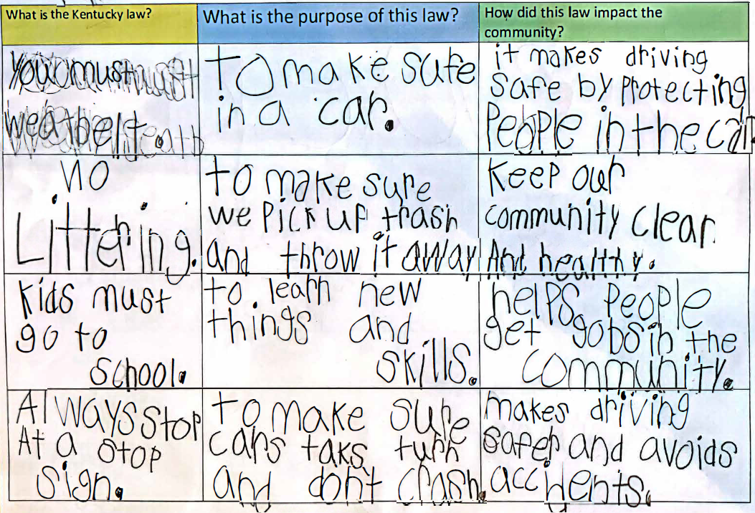
Completing this chart together as a class will provide evidence and information that will be helpful to students as they investigate the supporting question. Students will be able to use these examples in their responses.

To promote further student thinking on the purpose of rules and laws and their impact on the community, consider a read aloud of What if Everybody Did That?. This book explains how an act of breaking a rule may seem small, but if everyone broke the rule, how big the consequences would be. This can help students think about what the consequences might be if everyone broke these laws, which may help them when considering the purpose of the laws and their impact on the community.

Now that students have investigated a variety of Kentucky laws and their purpose, pose the supporting question to students:

What is the purpose of rules and laws in Kentucky?

Explain to students that they are considering the overall purpose of all laws in Kentucky. Conduct a Think, Pair, Share with students, asking them to discuss this question. Once pairs have had time to share their thoughts with each other, facilitate a class discussion about the purpose of rules and laws in Kentucky. Visit Leading Discussions for more information on how to conduct whole group discussions. As students share their ideas, record them on chart paper that is visible for students. Once you have compiled a list, discuss the similarities among these ideas. Ensure that students understand the purpose of laws in Kentucky before moving on to the supporting question task that follows.

Task Aligned to the Supporting Question:

KAS for Social Studies alignment:
- 1.I.Q.2 Identify supporting questions to investigate compelling questions about communities in Kentucky.
- 1.C.PR.1 Investigate rules and laws in Kentucky to understand their purpose.
- 1.I.UE.2 Construct responses to compelling and supporting questions about communities in Kentucky.

Task Aligned to the Supporting Question:
Respond to the supporting question: “What is the purpose of rules and laws in Kentucky?”
In your response, explain the purpose of at least TWO rules or laws in Kentucky. You may use writing and drawing in your explanation.

To support students with this task, read the prompt together and discuss the expectations with students. Explain that they must answer the supporting question by explaining the purposes of at least two of the rules and laws they have discussed during this investigation. First, allow students to access the graphic organizers and the list of generated ideas of the purposes of rules and laws in Kentucky from this investigation to assist them. You may present students with a graphic organizer with sentence starters, such as the one below, to plan their responses:

The purpose of rules and laws in Kentucky is to…
One rule or law in Kentucky is… | The purpose of this rule or law is…
Another rule or law in Kentucky is… | The purpose of this rule or law is…

Read the sentence starters to students, explaining that students will complete the sentence with information they have learned. Ask students to first explain the purpose of rules and laws in Kentucky in the first box. Explain to students that this statement is about the purpose of all rules and laws in Kentucky and is a generalization about why they exist. Then, explain that they will now choose two different rules or laws from the graphic organizers they completed earlier and list those in the corresponding boxes with the sentence starters. Ask them to then complete the sentences in the remaining two boxes that explain the purpose of each of the rules or laws they chose.

Allow students time to provide peer to peer feedback. Ask students to share their graphic organizers with a partner and read their responses to each sentence starter. Some questions for partners to consider as they read and listen to their peer’s responses are:

- Did my partner explain the overall purpose of rules and laws in Kentucky?
- Did my partner list two rules or laws in Kentucky?
- Did my partner explain the purpose of both rules and laws?

Explain to students that they may provide feedback that will help their partner effectively complete their graphic organizers. For more information on feedback in the social studies classroom, visit KDE’s Evidence-Based Instructional Practices 6: Social Studies. Then, ask students to complete the task aligned to the supporting question. They may copy the sentences they created in the graphic organizers with the sentence starters. They may also draw pictures to support their explanations. Because text is anything that communicates a message and grade 1 students are still learning to communicate effectively through written text, it is appropriate that they are also provided the opportunity to demonstrate their learning through images and drawings.

Student Work Samples:
Below are student work samples from Kentucky classrooms of the Task Aligned to the Supporting Question.

Strongly Aligned Example
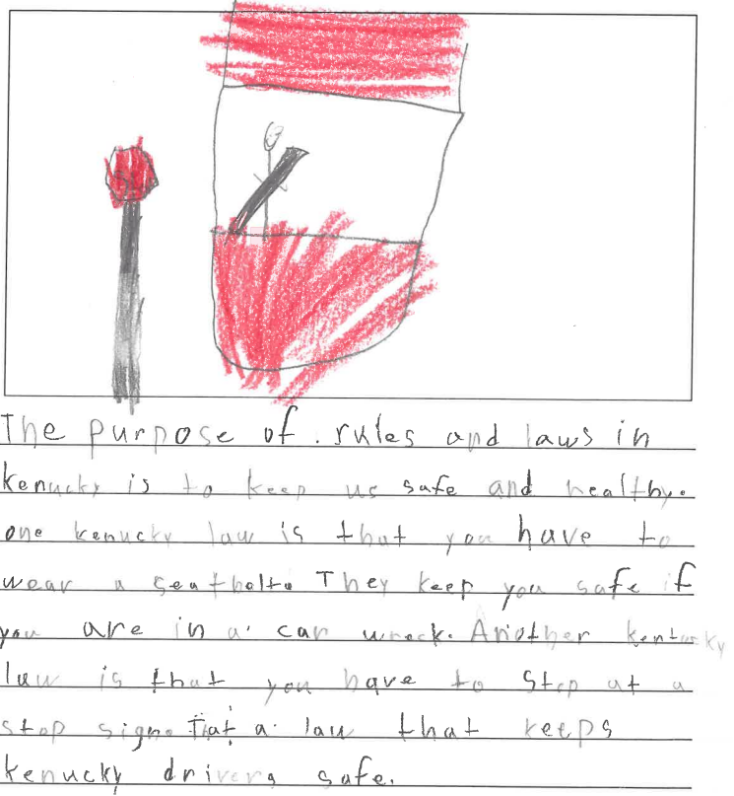

Partially Aligned Example
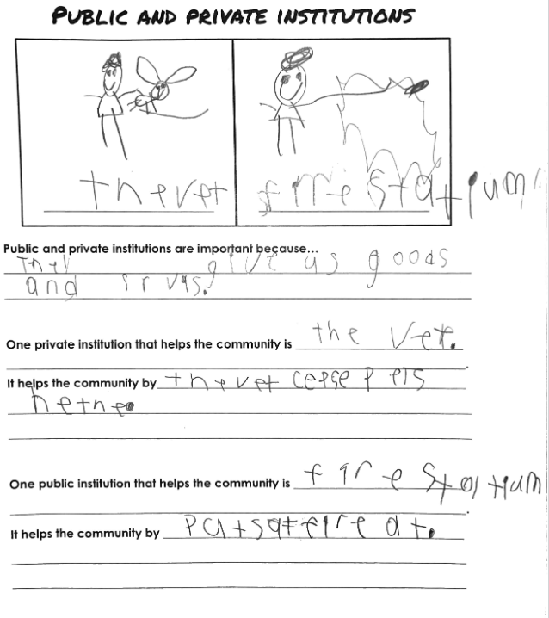
Weakly Aligned Example
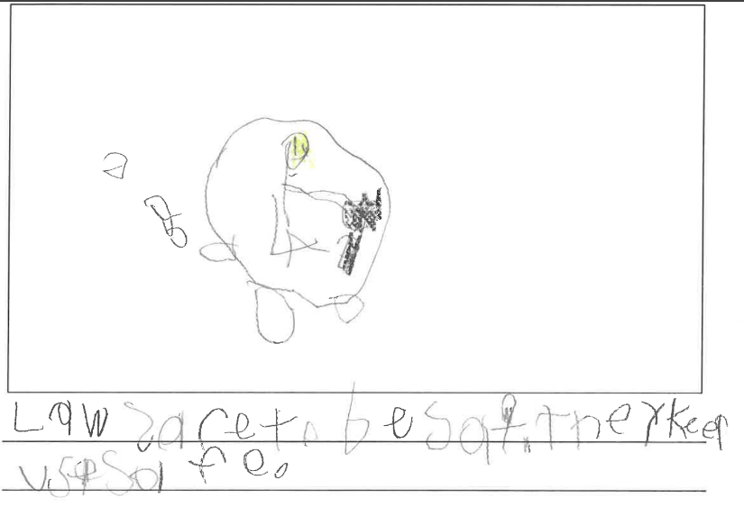

Investigation: Part 2
1.E.MA.1 Describe how different jobs, as well as public and private institutions, help people in the community.

Supporting Question: How do different jobs help people in the community?

Explain that by living in communities, people can enjoy the benefit of the various skills and talents of others. People often do a job they are good at, or gain specialized skills from working at a specific job. Distribute pictures/names of various jobs in the community that provide services that help to improve the community, and the pictures/names that describe their role. Examples are shown below:
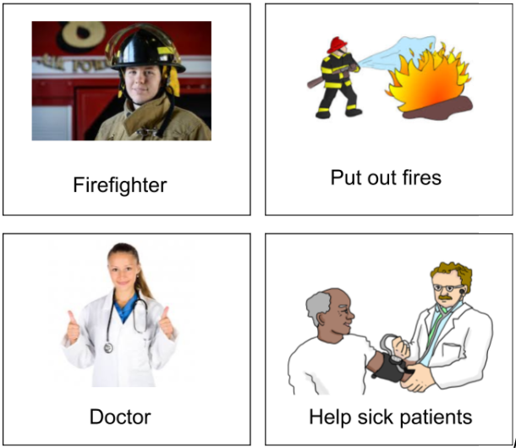

Each student should receive one card, either a job or role. Explain to students that they have been given various jobs and roles that benefit the community, and that they will need to seek the job or role that corresponds to their card. Students can travel around the room and talk to their peers to search for their match. Once they have found their match, the students will become partners. Have the pairs discuss the following question:

How does this job benefit the community?

Once pairs have had time to discuss this question with their partner, have them share with the class to allow all students to hear the community roles and how they benefit the community. Then, pose the supporting question to the class:

How do different jobs help people in the community?
Explain to students that they are considering how all of the different jobs they have discussed help people in the community. Conduct a Think, Pair, Share with students, asking them to discuss this question. Once pairs have had time to share their thoughts with each other, facilitate a class discussion about the benefits of different jobs in the community. Visit Leading Discussions for more information on how to conduct whole group discussions. As you discuss, ensure students understand that different roles provide different benefits that together contribute to a healthier community. Then, ask students to complete the Task Aligned to the Supporting Question, below.

Task Aligned to the Supporting Question:

KAS for Social Studies alignment:
- 1.I.Q.2 Identify supporting questions to investigate compelling questions about communities in Kentucky.
- 1.E.MA.1 Describe how different jobs, as well as public and private institutions, help people in the community.
- 1.I.UE.2 Construct responses to compelling and supporting questions about communities in Kentucky.

Task Aligned to the Supporting Question:
Answer the supporting question: “How do different jobs help people in the community?”
In your response, provide at least TWO examples of jobs in the community. You may use drawing and writing in your explanation.

To prepare students for this task, first read and discuss the prompt together. Explain to students that they will be answering the supporting question, “How do different jobs help people in the community?” and will identify and explain at least two examples in their response. You may provide a graphic organizer with sentence starters for students to prepare their responses, such as the one below:

Different jobs help the community by…
One job is… | This job helps the community by…
Another job is… | This job helps the community by…

Explain to students that they will be completing these sentences to form their responses. Go over this graphic organizer with them, explaining each sentence starter they will need to complete. Their first response should be a generalization about how different jobs help the community. Remind students that they are not referring to specific jobs here, but a general statement about how all of the different jobs in our community collectively help our community be successful. It may help to ask students, “What if everyone wanted to have the same job in our community? How would that impact us? How does having a variety of different jobs help our community?”, since this may help them think more collectively about the benefit of jobs in their community.
Then, students may identify two different jobs from the activity they completed during this investigation and explain how each job helps the community. Consider allowing students to work in small groups to complete the graphic organizer together. You may enlarge this chart or reproduce it on chart paper and students in each group can work together to complete it. Check students’ graphic organizers for accuracy as they work.

After groups have had time to complete the sentences in the graphic organizers, allow students to provide peer to peer feedback. Assign a partner group to each group and ask them to read their responses to each other and provide feedback. Some questions for partners to consider as they read and listen to their peer’s responses are:

- Did my partner explain how different jobs help the community?
- Did my partner list two examples of jobs?
- Did my partner explain how each of these jobs helps the community?

Explain to students that they may provide feedback that will help their classmates effectively complete their graphic organizers. For more information on feedback in the social studies classroom, visit KDE’s Evidence-Based Instructional Practices 6: Social Studies. Then, ask students to complete the task aligned to the supporting question. They may copy the sentences they created in the graphic organizers with the sentence starters. They may also draw pictures to support their explanations. Because text is anything that communicates a message and Grade 1 students are still learning to communicate effectively through written text, it is appropriate that they are also provided the opportunity to demonstrate their learning through images and drawings.

Student Work Samples:
Below are student work samples from Kentucky classrooms of the Task Aligned to the Supporting Question.

Strongly Aligned Example
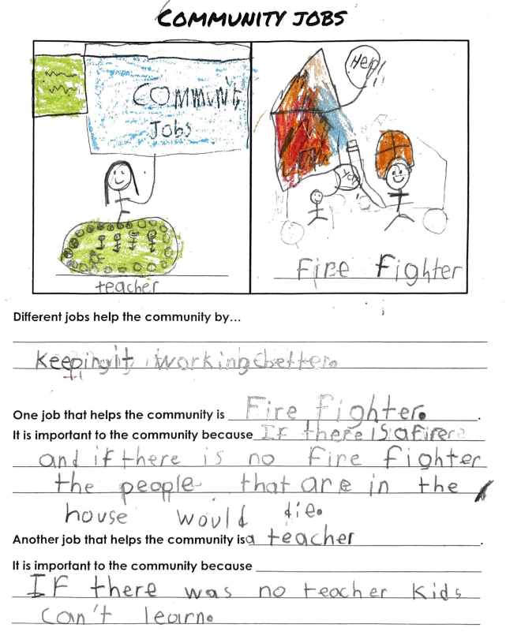

Partially Aligned Example
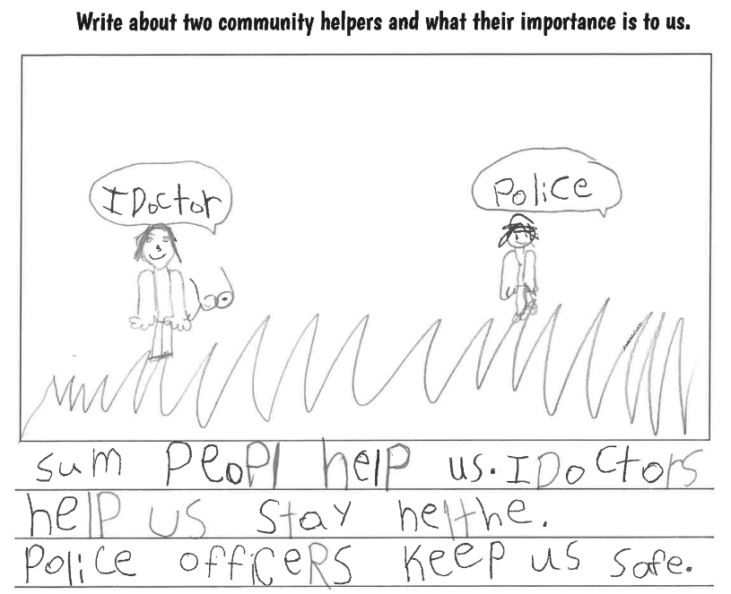

Weakly Aligned Example
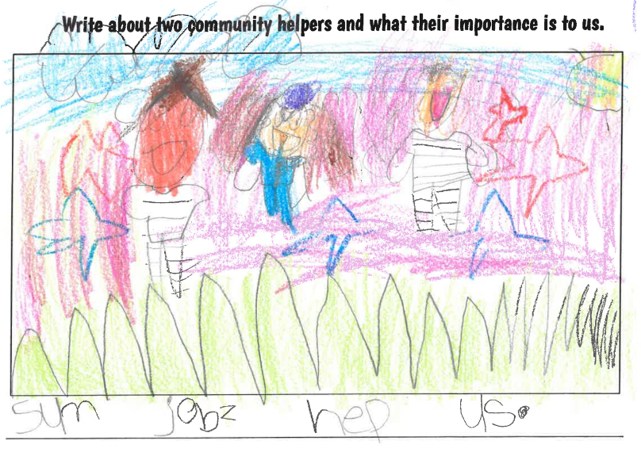

Investigation: Part 3
1.E.MA.1 Describe how different jobs, as well as public and private institutions, help people in the community.

Supporting Question: How do public and private institutions help people in the community?

Now that students have discussed a variety of different jobs and how they benefit the community, this investigation will focus on how different institutions help people in the community. Begin by reviewing the terms “goods” and “services”. Students should be familiar with these terms from Kindergarten, but revisiting them will ensure an understanding before moving on to institutions. For your reference, the KAS for Social Studies Glossary of Terms provides the following definitions:

- goods - possessions or personal property; items of value used for trade or sale.
- services - to supply help to someone; systems to meet public needs, such as utilities and transportation.

Ask students to recall the meaning of “goods” and “services” and define them in their own words. Work together as a class to develop student-generated definitions for students to reference. An example is below:

- goods: things people can buy or trade.
- services: something someone does for you that you pay for.

Display the student-generated definitions and ask students to brainstorm examples of goods and services. Some examples students may identify include, but are not limited to:

- goods: books, food, computers, clothing, toys
- services: haircuts, car repair, healthcare, education

List several examples of each for students to reference. Then, discuss with students the meaning of “institution”. First, read the word and ask students to pronounce the word with you. Provide a student friendly definition, such as “an institution is any type of organization or business.” Provide support for students to understand what an organization or business is, and discuss examples with students. Then, ask students to Turn and Talk with a partner and use “institution” in a sentence. Allow pairs to share their sentences with the class, checking for students’ understanding. Explain that many institutions in the community provide goods or services to people in the community.

Explain to students that they will be discussing how both public and private institutions help the community. To do this, students must understand the difference between public and private institutions. Conduct a whole group discussion where you explicitly teach the similarities and differences of public and private institutions. As you and your students are discussing public and private institutions, provide examples from your community that are real life examples of each type of institution. Provide a Venn Diagram, such as the one below, to record responses and to support students during your discussion. As you are conducting your whole group discussion about the differences between public and private institution, use the Explanation Game Thinking Strategy to encourage students to explain why an institution is public or private. The routine focuses first on identifying something interesting about an object or idea. First, have students identify what they notice:
- I notice that...
Second, have students follow that observation with the question:
- Why is it that way? or Why did it happen that way?

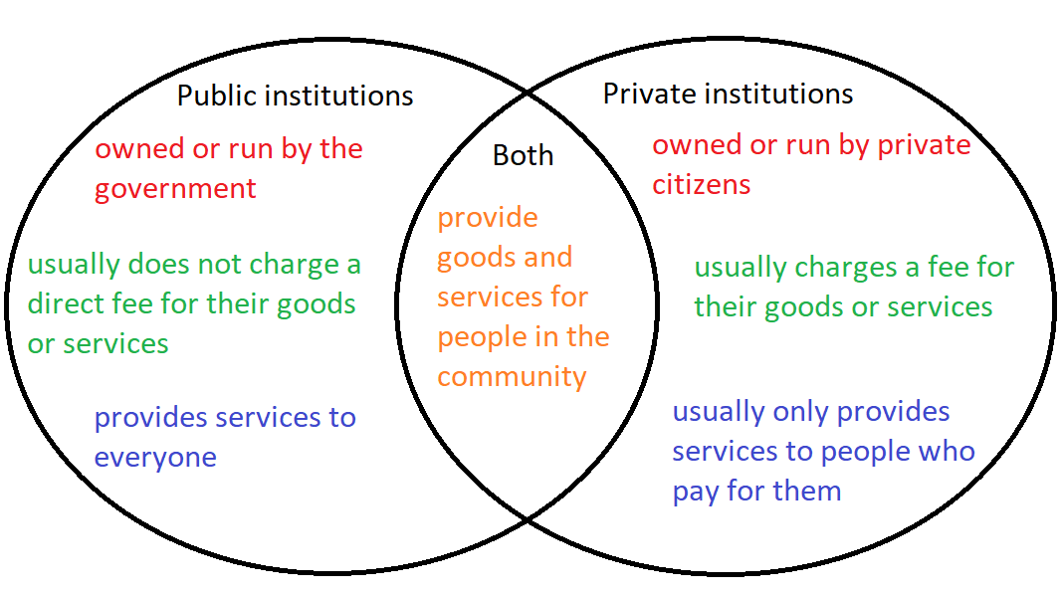
Once students have learned about the characteristics of public and private institutions, provide students with cards containing generic images of different types of community institutions to formatively assess whether or not they can apply what they have learned, such as the ones below:

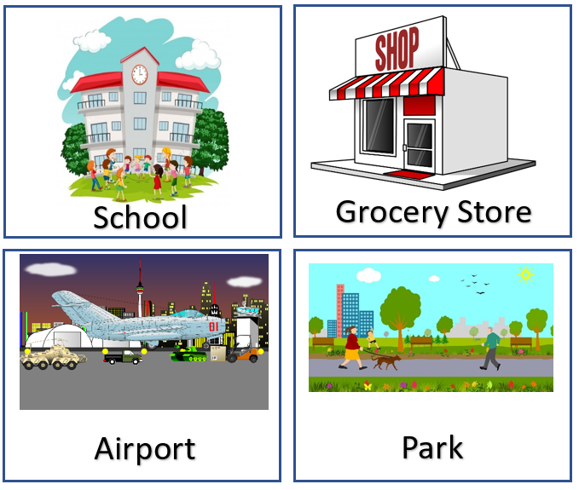
Independently, ask students to sort these institutions, determining whether they are public or private. Ask students to provide justification for their classification in a whole group setting to check for understanding and clear up misconceptions during this task.

Next, have students take a virtual walking tour of their community via Google Earth as a whole group. Taking a virtual tour of the community will enable students to apply what they have learned about public and private institutions and apply them to examples from their daily life. If Google Earth does not provide clear pictures of the institutions in your community, you may look up public and private institutions in your community that students know and present their webpages to students during this exercise. Utilize the following graphic organizer to display and complete together as a class:

Name of Institution | What goods or services does it provide? | Is it private or public? Why? | How does this institution help people in the community?

Begin with your school and travel virtually around the community, identifying institutions and recording information on the graphic organizer. For each institution you identify, ask students to determine the goods or services the institution provides for the community. Next, ask students whether it is private or public using the Venn Diagram as a resource, clarifying and providing support as needed. Then, have students determine how this institution helps people in the community.

Below is an example of how this chart may be completed:

Name of Institution | What goods or services does it provide? | Is it private or public? Why? | How does this institution help people in the community?
Our school | an education for young people in the community | public; the government owns the building | It provides the opportunity for young people in the community to learn.
the gas station | gas for cars in the community | private; it is owned by an individual person or a private company | It provides a place for people to put gas in their cars so they can travel where they need to go.
the fire station | puts out fires in the community | public; the government pays for the building and salary of the firefighters | The fire station will put out fires in the community and help with emergencies.
the grocery store | food for the community | private; owned by private companies | It provides a place for people in the community to buy the food they need.

Next, provide a digital slideshow that shows different institutions in the community. Include several institutions with a combination of both private and public institutions. Some examples to include in the digital slideshow include, but are not limited to: the library, post office, pet store, police station, restaurants, etc. For each slide, ask students to write a sentence about how this institution helps the community. Consider providing a sentence starter, such as: “This institution helps the community by _________.”

Then, present the supporting question to students:

How do public and private institutions help people in the community?

Explain to students that they are considering how all of the different types of institutions they have discussed help people in the community. Conduct a Think, Pair, Share with students, asking them to discuss this question. Once pairs have had time to share their thoughts with each other, facilitate a class discussion about this question. Visit Leading Discussions for more information on how to conduct whole group discussions. Together as a class, develop a consensus statement that responds to the question. Below is an example from a Grade 1 classroom in Kentucky:

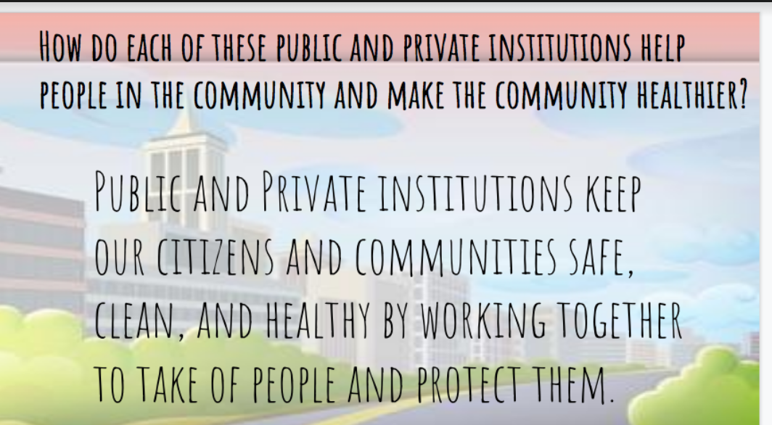

Now that students are familiar with different public and private institutions and how they help the community, have them complete the Task Aligned to the Supporting Question, below.

Task Aligned to the Supporting Question:

KAS for Social Studies alignment:
- 1.I.Q.2 Identify supporting questions to investigate compelling questions about communities in Kentucky.
- 1.E.MA.1 Describe how different jobs, as well as public and private institutions, help people in the community.
- 1.I.UE.2 Construct responses to compelling and supporting questions about communities in Kentucky.

Task Aligned to the Supporting Question:
Answer the supporting question: “How do public and private institutions help people in the community?”
In your response, provide at least ONE example of a public institution and ONE example of a private institution and how it helps people in the community.

To prepare students for this task, first read and discuss the prompt together. Explain to students that they will be answering the supporting question, “How do public and private institutions help people in the community?” When students are answering the supporting question, remind them that they will identify and explain at least two examples in their response. You may provide a graphic organizer with sentence starters for students to prepare their responses, such as the one below:

Public and private institutions help the community by…
One public institution is… | It helps the community by…
One private institution is… | It helps the community by…

Explain to students that they will be completing these sentences to form their responses. Go over this graphic organizer with them, explaining each sentence starter they will need to complete. Their first response should be an overall statement about how public and private institutions help the community. Allow students to revisit the class statement they created to help them with this task. Then, students may identify a public and private institution from their activity during this investigation and explain how that job helps the community.

After students have had time to complete the sentences in the graphic organizers, allow students to provide peer to peer feedback. Assign students a partner and ask them to read their responses to each other and provide feedback. Some questions for partners to consider as they read and listen to their peer’s responses are:

- Did my partner explain how public and private institutions help the community?
- Did my partner list one example of a public institution?
- Did my partner list one example of a private institution?
- Did my partner explain how each of the institutions helps the community?

Explain to students that they may provide feedback that will help their partner effectively complete their graphic organizers. For more information on feedback in the social studies classroom, visit KDE’s Evidence-Based Instructional Practices 6: Social Studies. Then, ask students to complete the task aligned to the supporting question. They may copy the sentences they created in the graphic organizers with the sentence starters. They may also draw pictures to support their explanations. Because text is anything that communicates a message and grade 1 students are still learning to communicate effectively through written text, it is appropriate that they are also provided the opportunity to demonstrate their learning through images and drawings.

Students have now investigated three supporting questions that will help them answer the compelling question, “What makes a community healthy?” Below is a task aligned to the compelling question.

Student Work Samples:
Below are student work samples from Kentucky classrooms of the Task Aligned to the Supporting Question.

Strongly Aligned Example
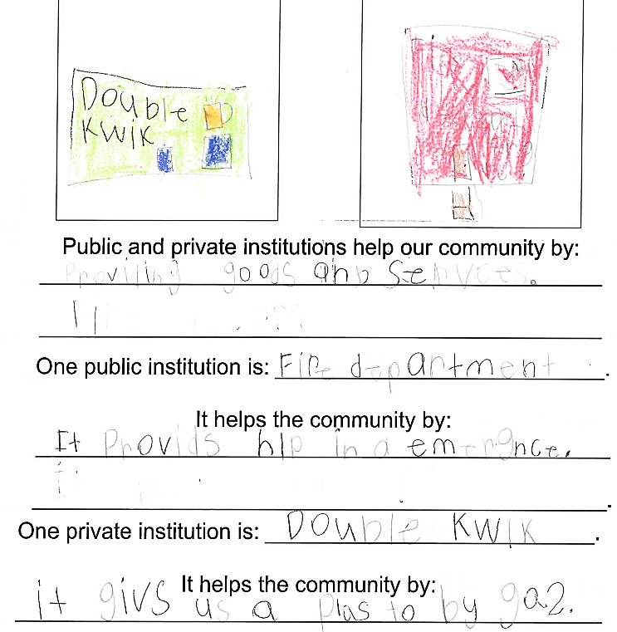

Partially Aligned Example
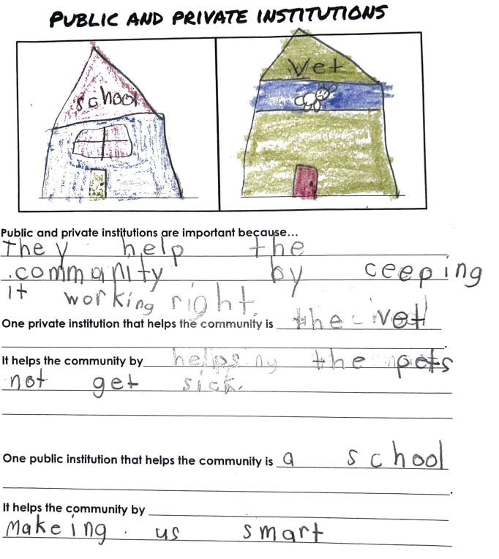

Weakly Aligned Example
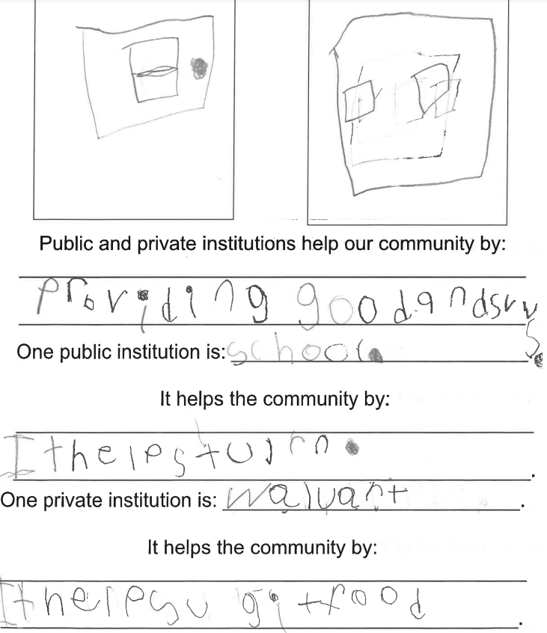

Task Aligned to the Compelling Question:
KAS for Social Studies alignment:
- 1.I.Q.1 Ask compelling questions about communities in Kentucky.
- 1.I.UE.2 Construct responses to compelling and supporting questions about communities in Kentucky.
- 1.I.CC.2 Construct an argument with reasons to address how to improve the local community and Kentucky.

Task Aligned to the Compelling Question:
Part One: Create a poster to respond to the compelling question: What makes a community healthy? On your poster, include how different jobs, public and private institutions, and Kentucky laws help make the community healthy.

Part Two: Construct an argument, with reasons, on how to improve the local community and Kentucky based on your understanding of what makes a community healthy. In your response, provide at least TWO examples.

To prepare students to complete this task, begin by reading and discussing the prompt together as a class. Focus first on only Part One. Explain that students will answer the compelling question, “What makes a community healthy?” by making a poster. In their response for Part One, they will demonstrate their knowledge of the standards addressed throughout the three investigations by explaining how different jobs, public and private institutions and Kentucky laws contribute to a healthy community.

Consider providing a graphic organizer with sentence starters, such as the one below, to support students as they plan for their posters:

What makes a community healthy is…

Kentucky laws make the community healthy by…

Different jobs make the community healthy by…

Public and private institutions make the community healthy by…

To support students in completing their graphic organizers, conduct Conver-Stations to provide time for students to discuss each component. Before you begin, encourage students to use any materials and tasks from each of the previous investigations to help them complete their graphic organizer. Have students use their graphic organizers to support them in this work. Then, place students in groups of 4. Each round, some students will be rotating to a new group, so consider assigning numbers to each student in the group. For the first round, ask students to discuss the first sentence starter on their graphic organizer. After they finish discussing, provide time for them to individually record their responses on the graphic organizer. Then, ask one or two students to rotate to another group (you may do this by calling one or two assigned numbers) and ask students to repeat the process with the second sentence starter. Repeat this process until students have had an opportunity to discuss each sentence stem with a small group and record their responses. Provide support as needed to ensure understanding and accuracy.

When students have completed their graphic organizers with their group, they will work individually to create a poster that represents this information. You may consider having students divide the poster into 4 sections to represent each section of their graphic organizers. Students may reproduce their sentences on the poster, add any supporting information they wish to include and draw and color pictures that represent each statement. As students work, provide support as needed and check their work for accuracy, providing immediate feedback when errors or misconceptions arise.

When students have successfully completed their posters, you may conduct a Gallery Walk for students to view and read their peers’ work. Provide students with some tasks, such as the ones below, to guide them during this exercise. Read the questions with students prior to beginning the activity so students are comfortable and understand what to look for in their peers’ work. Allow students to respond in both text and images.

Find THREE posters that contain information that is different from yours. What information did they include?

Find TWO posters that allow you to make connections to your own work. What connections can you make?

Find ONE poster that inspires you. What about their work inspires you?

After students have had time to view the work of their peers and consider these questions, facilitate a class discussion that provides the opportunity for students to share about each one. Then, explain to students that they are going to use this information about what makes a community healthy to help them with Part Two of the task aligned to the compelling question.

Explain to students that they will now construct an argument, with reasons, on how to improve the local community and Kentucky based on their understanding of what makes a community healthy. Note that this task will require students to construct an argument. Beginning in kindergarten, students are asked to communicate their opinions according to the KAS for Reading and Writing. Communicating an opinion is a building block to writing effective arguments. The KAS for Social Studies requires students to construct arguments beginning in Kindergarten. Explain to students that they will be expressing their opinion and attempting to convince others as they develop their argument. To help students prepare for this task, first pose the question below, asking students to Turn and Talk to a partner to share their ideas:

How can we make the local community healthier?

Remind students to consider their responses from Part One about what makes a community healthy as they consider how to improve their local community and make it healthier. After students have had time to formulate and share their thoughts with a peer, create a Word Cloud as a class to showcase students’ responses to this question. Ask each student to respond to this question with short answers and input their answers into the Word Cloud. The resulting word cloud will display students’ responses and show the most frequent words in larger font. After the Word Cloud is complete, discuss the results with students. Some questions to pose may include:

- What are some of the responses that had the most entries? Why were these ideas popular?
- What are some of the responses that had fewer entries? Out of these less common entries, which ones are interesting ideas that you did not think of before?

Allow students to continue accessing or viewing the Word Cloud as they prepare their responses for Part Two. It is important to note that responses can take on forms other than written paragraphs. You may consider having students record a video to share their responses for Part Two. Students may prepare their response using a graphic organizer with sentence starters, such as the one below:

Ways to improve the local community | Reasoning (explain why this would improve the local community)
One way to improve the local community is… | This would help the community by…
Another way to improve the local community is… | This would help the community by…

Provide support for students as they work and prompt them to add supporting details when appropriate. Students can use this graphic organizer to formulate their responses. If they are creating videos or written responses, allow students to create drawings or gather and print images that can help support their responses.

Students’ videos or visual representations they create can be shared in a variety of ways. One example is displaying their work for other students to view and determine the top three actions they can take as young students that can help their local community. Another example is that the products from this task could become a resource for Kindergarten students as they are learning about their local community and ways to be responsible. K.C.RR.1 states: “Identify roles and responsibilities of self and others at home, in school and neighborhood settings.” Kindergarten students could view videos or visual representations created by Grade 1 students about improving their communities. Kindergarten students could then identify their roles and responsibilities to improve their local communities based on ideas presented by the Grade 1 students.

