First Grade Math Assignment
This assignment is strongly aligned to the standards.
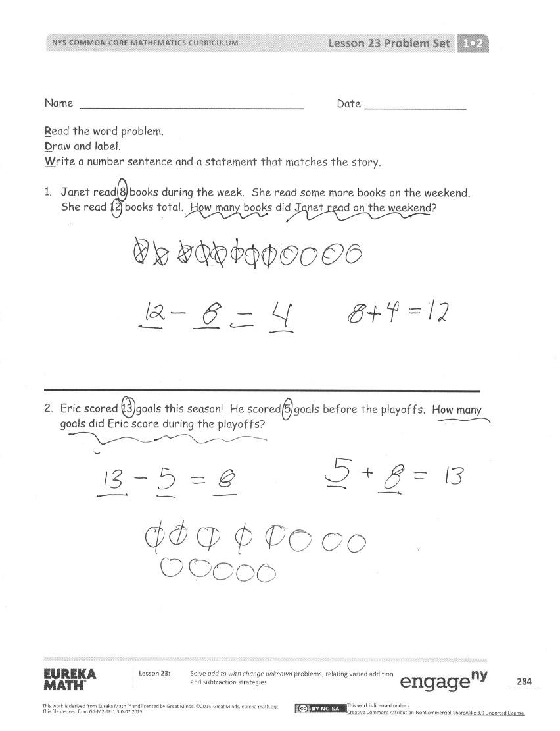

Overview
First-grade students create drawings and equations to solve addition and subtraction word problems, and discuss their work with a partner. This assignment is strong because it requires students to interpret what each word problem is asking them to do and mathematically represent real-world situations in multiple ways.

Related Standards
We looked at how well the assignment aligned to the following standard:
KY.1.OA.1: Use addition and subtraction within 20 to solve word problems involving situations of adding to, taking from, putting together, taking apart and comparing, with unknowns in all positions.

Why is this assignment strongly aligned?
This assignment is well-aligned with first-grade standard KY.1.OA.1. All four problems involve adding or subtracting within 20, as the standard requires. The standard also requires students to solve problems involving addition and subtraction situations with unknowns in all positions. All four problems in this assignment involve a “change unknown” situation, where students are given an initial and final amount and need to find how many things were added or subtracted to get from the initial to the final amount (for example: There were 8 ladybugs on a branch. Some more came. Then there were 15 ladybugs on the branch. How many ladybugs came?). This type of situation is appropriate for first grade, as kindergarten standard KY.K.OA.A.2 only tasks students with solving “result or total unknown” addition and subtraction problems (for example: There were 6 ladybugs on a branch. 3 more ladybugs came. How many ladybugs are on the branch now?). According to the standard, students should also represent addition and subtraction situations in different ways (drawings, objects, and equations). This assignment directs students to create drawings and “number sentences” (equations) for each problem. For additional information regarding the four problem types that should be addressed, see Table 1 in Appendix A within the KAS for Mathematics.
This assignment builds students’ application skills, as outlined in standard KY.1.OA.1. The standard calls for students to add and subtract in the context of word problems, and all four problems in this assignment are word problems that involve real-world situations. The standard also indirectly targets conceptual understanding since it requires students to represent addition and subtraction visually (drawings), physically (objects), and symbolically (equations). This assignment builds students’ conceptual understanding by requiring them to represent the situations with drawings and equations, as well as verbally during their partner discussions.
Practice Standards
This assignment allows students to engage meaningfully with three mathematical practice standards and superficially with a fourth practice standard. Representing real-world topics—like the number of books—visually with drawings and symbolically with equations gives students the chance to engage with Mathematical Practice Standard #4 ("Model with mathematics"). Having students discuss their work with a partner gives them the chance to use mathematical language to explain how their visual representation matches the word problem, and thus engage with Mathematical Practice Standard #3 (“Construct viable arguments and critique the reasoning of others”) and Mathematical Practice Standard #6 (“Attend to precision”). Interpreting what the word problems are asking them to do gives students the chance to engage with Mathematical Practice Standard #1 ("Make sense of problems and persevere in solving them"). However, this is a superficial opportunity because every word problem involves the same structure and “change unknown” situation; once students have interpreted the first problem, they know how to solve the remaining three problems.

