First Grade Math Assignment
This assignment is partially aligned to the standards.
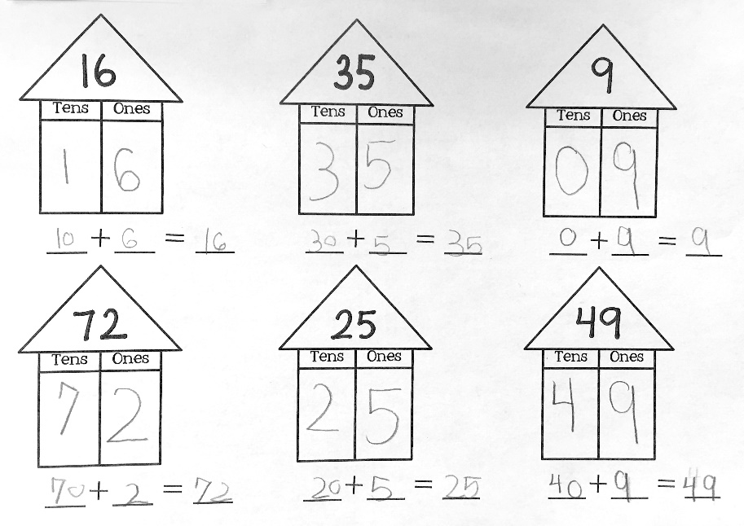

Overview
First-grade students decompose two-digit numbers into tens and ones and represent each number with an addition equation. This assignment is aligned with a first-grade standard but does not give students an adequate opportunity to build conceptual understanding.
Related Standards
We looked at how well the assignment aligned to the following standard:
KY.1.NBT.2: Understand that the two digits of a two-digit number represent amounts of tens and ones. Understand the following as special cases:
a. 10 can be thought of as a bundle of ten ones—called a "ten."
b. The numbers from 11 to 19 are composed of a ten and one, two, three, four, five, six, seven, eight, or nine ones.
c. The numbers 10, 20, 30, 40, 50, 60, 70, 80, 90 refer to one, two, three, four, five, six, seven, eight, or nine tens (and 0 ones).

Why is this assignment partially aligned?
The content of this assignment is aligned with first-grade standard KY.1.NBT.2, which requires students to work with two-digit numbers, especially those between 20-99 (since students have already been introduced to 11-19 in Kindergarten through standard KY.K.NBT.1). Five of the six problems in this assignment appropriately involve two-digit numbers, with four of those between 20-99. The standard also requires students to represent two-digit numbers as equivalent amounts of tens and ones, and this assignment prompts students to identify the place value of both digits in the given numbers (for example, 72 is 7 tens and 2 ones) and decompose them into tens and ones in the form of an addition equation (such as 70 + 2 = 72).
This assignment attempts to build students’ conceptual understanding, but it does so in a superficial way. Understanding that two-digit numbers are made up of some number of tens and ones provides the conceptual groundwork for students to develop an understanding of addition and subtraction within the base-ten system—a major focus of first-grade math instruction. However, to build this understanding, students should have been asked to flexibly represent the tens and ones in two-digit numbers in multiple ways, such as drawings, base-ten blocks, or addition expressions. This assignment requires students to represent two-digit numbers symbolically with an addition equation, which is an appropriate representation, but because students are asked to represent each number exactly the same way, it’s hard to tell if students truly understand place value or if they are just following a rote procedure.
Practice Standards
This assignment allows students to superficially engage with two mathematical practice standards. Using a place value chart (in the form of a house) gives students the chance to superficially engage with Mathematical Practice Standard #5 ("Use appropriate tools strategically"). This would be stronger if students were allowed to choose which tool they wanted to use for the assignment, whether a place value chart or something else like linking cubes. Decomposing a two-digit number into the equivalent number of tens and ones also gives students the chance to superficially engage with Mathematical Practice Standard #7("Look for and make use of structure"), but decomposing all of the numbers exactly the same way doesn’t allow students to meaningfully explore the structure of the base-ten system.

