1st Grade Reading & Writing Assignment
This assignment is partially aligned to the standards.

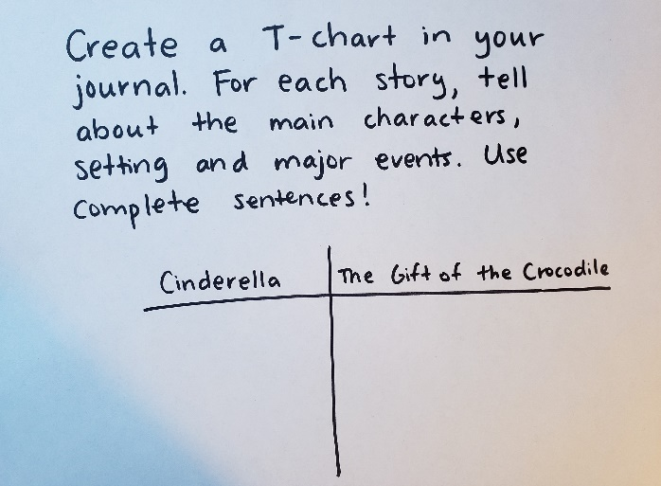
Overview
First-grade students listen to a read-aloud of two versions of the Cinderella story from different cultures, then retell the main characters, setting and events from each. The assignment is partially aligned to the standards because the texts are appropriate for a read-aloud in the first grade, but the task only partially aligns to first grade standards.

About the Text

Title and Author | “Cinderella” by Roberto Piumini; “The Gift of the Crocodile: A Cinderella Story” by Judy Sierra
What is the Lexile Level of this text? | 600AD; 720L
Based on Lexile, which grades is this text intended for? | 2-3
Is the text qualitatively complex enough for the grade? | Yes
Is this text fiction or non-fiction? | Fiction
Is this text authentic or was it written for educational purposes? | Authentic
Does the text provide sufficient detail to build knowledge of a worthwhile topic and/or is it worth reading closely and re-reading? | Yes

Related Standards
RL.1.3: Describe characters, settings, and major events in a story, using key details in order to make meaning of the story development.
This assignment is partially aligned to the standard. Students are prompted to describe the characters, settings and major events from each Cinderella story, but they are not given the opportunity to demonstrate that they have made meaning of the story development.
RL.1.9: Compare and contrast the adventures and experiences of characters in stories.
This assignment is weakly aligned to the standard. Students retell the characters, setting and events of two stories side-by-side, but they are not given the opportunity to compare the adventures and experiences of the characters in those two stories.
RL.1.10: With prompting and support, flexibly use a variety of comprehension strategies (i.e., questioning, monitoring, visualizing, inferencing, summarizing, using prior knowledge, determining importance) to make sense of grade-level appropriate, complex literary texts.
The assignment is strongly aligned to this standard because the task requires students to listen carefully and demonstrate a clear understanding of the texts. The texts are appropriately complex for grade 1.
L.1.2: Demonstrate command of the conventions of standard English capitalization, punctuation, and spelling when writing.
The assignment is strongly aligned to this standard because the task provides an opportunity for students to consistently capitalize the first word in a sentence, correctly use end punctuation, use conventional spelling for words with common patterns and frequently occurring irregular words (e.g., the, by, what) and spell untaught words phonetically (e.g., mader, rong).

Why is this assignment PARTIALLy aligned?
This assignment is partially aligned because although the texts are strong, but the task missed opportunities to more fully align to grade level standards:
The texts are grade-appropriate. The task is based on a read-aloud of two versions of the Cinderella story. Read-aloud texts should be 2-3 grade levels above students expected independent reading level; both Cinderella texts fall in the 2-3 grade band making them appropriate for read-aloud in the 1st grade. The vocabulary and sentence structure of each text are appropriately challenging and reading the same story from different cultures provides an opportunity to analyze meaning and build students’ cultural knowledge.
The task does not require grade-level text analysis. The prompt asks students to describe the main characters, setting and events in the story. While this superficially aligns to standard RL.1.3, the standard requires students to describe those characters, settings and events in order to make meaning of the story development. The task also superficially aligns to standard RL.1.9 because students read multiple stories and retell the characters and experiences, but don’t compare them. However, they are demonstrating their understanding of appropriately complex text for the grade level.
The task allows students to apply their developing language skills to their writing. Practicing the correct use of grammar and spelling is important for improving both reading and writing skills. (In this assignment, however, this opportunity appears to be incidental rather than intentional, as the directions do not include clear expectations for use of grammatical conventions beyond writing in complete sentences.)

