First Grade Math Assignment
This assignment is weakly aligned to the standards.
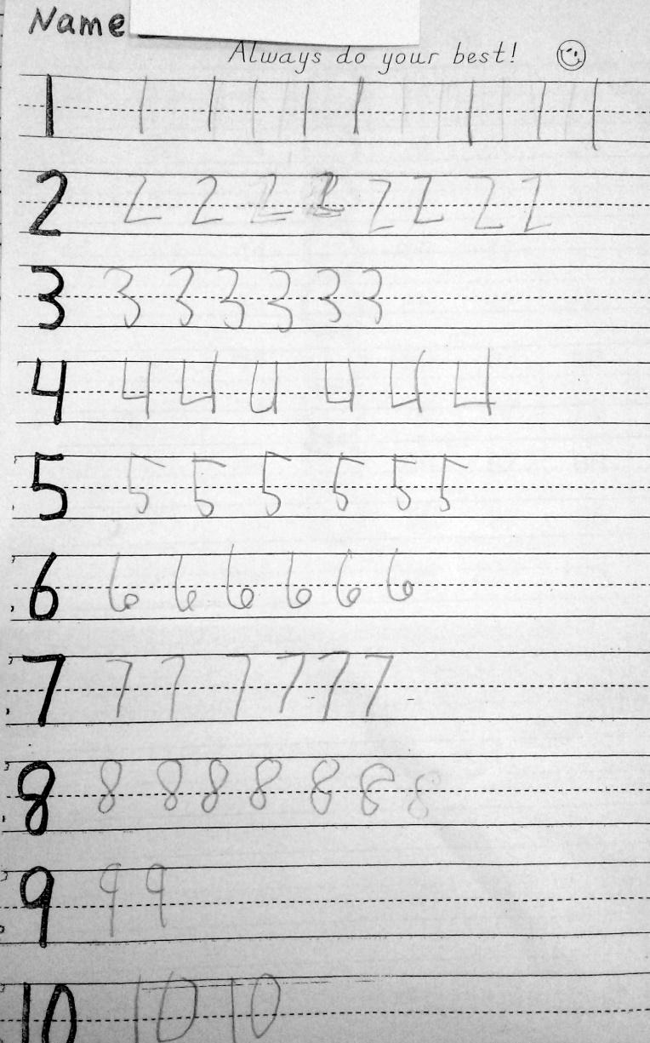

Overview
First-grade students write the numerals 1-20 several times. This assignment is weak for first grade because it is aligned with a kindergarten standard. First-grade students should be writing numerals up to 120.

Related Standards
KY.1.NBT.1: a. Count forward to and backward from 120, starting at any number less than 120. b. In this range, read and write numerals and represent a number of objects with a written numeral.

Why is this assignment weakly aligned?
This assignment is aligned to kindergarten standard KY.K.CC.3, which requires students to write numerals 1-20. In first grade, students should be building on what they learned in kindergarten and writing numerals up to 120. Young students need lots of practice writing numerals, and it could be appropriate to assign more practice to individual first-graders still struggling to write the numerals 1-20 correctly. However, this is not an appropriate assignment for an entire first-grade class.
First-grade standard KY.1.NBT.1 targets both procedural skill (counting, reading, and writing numbers) and conceptual understanding (representing a number of objects with a written numeral), but this assignment only gives students a chance to build a below-grade level procedural skill. There is no connection between the numerals students are writing and the concept that those numerals can represent a number of objects.

