First Grade Reading & Writing Assignment
This assignment is weakly aligned to the standards.

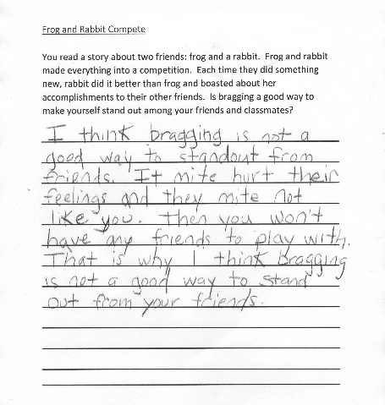
Overview
First-grade students read a story, then respond to a prompt in writing. The text, which is about a frog and a rabbit in competition, is not adequately complex or worthwhile, and the writing prompt is not text-dependent. While the task references a story, it does not require students to read carefully and answer a question based on the text.
About the Text
Title and Author | "Frog and Rabbit Compete"
What is the Lexile Level of this text? | 500L
Based on Lexile, which grades is this text intended for? | 2-3
Is the text qualitatively complex enough for the grade? | No
Is this text fiction or non-fiction? | Fiction
Is this text authentic or was it written for educational purposes? | Written for educational purposes
Does the text provide sufficient detail to build knowledge of a worthwhile topic and/or is it worth reading closely and re-reading? | No

Related Standards

RL.1.1: With prompting and support, ask and answer explicit questions about key ideas and details, and make and support logical inferences to construct meaning from the text.
The assignment is weakly aligned to this standard. The writing prompt does not focus students on key details in the text. Instead, it asks students to cite a personal opinion and support this opinion with their personal experiences.

RL.1.2: With prompting and support, recognize key details from a summary to demonstrate understanding of the author’s message, lesson learned and/or moral.
The assignment is weakly aligned to this standard. While the central message of the referenced text may be about boasting/bragging, the writing prompt does not require students to determine the author’s message and demonstrate their understanding in their writing. Instead, it asks students to cite a personal opinion and support this opinion with their personal experiences.

RL.1.10: With prompting and support, flexibly use a variety of comprehension strategies (i.e., questioning, monitoring, visualizing, inferencing, summarizing, using prior knowledge, determining importance) to make sense of grade-level appropriate, complex literary texts.

The assignment is weakly aligned to this standard because there is no evidence that students are making meaning of the text through the assignment given and therefore no application of reading strategies as called out in this standard.

C.1.1C: Compose opinion pieces, using a combination of drawing, dictating, writing and digital resources,

to state the topic and an opinion. C. Provide reasons with details to support the opinion.

The assignment is weakly aligned to this standard because the writing task calls for students to state an opinion about boasting/bragging but does not require that they support that opinion with details from the text.

L.1.2: When writing: a. Capitalize proper nouns, including but not limited to dates and names of people; b. Demonstrate appropriate use of end punctuation; c. With prompting and support, produce and write commas in dates and to separate single words in a series. d. Use conventional spelling for words with common spelling patterns and for frequently occurring irregular words. e. Spell untaught words phonetically, drawing on phonemic awareness and spelling conventions.
The assignment is strongly aligned to this standard. Students have an opportunity to demonstrate their command of Grade 1 conventions, including capitalizing the first word in a sentence and the pronoun I; correctly using end punctuation; using conventional spelling for words with common patterns and frequently occurring irregular verbs; and using phonetic spelling for untaught words.

Why is this assignment weakly aligned?
This assignment is weak because it does not require that students read carefully or answer questions based on the text:
The writing prompt is not text-dependent. While the task references a story, it does not require students to read carefully and use key details from the text to answer questions. In fact, students could answer this question having never read the text at all.
The task does not require students to determine the central message of a text. Students are not asked to analyze the moral of the story or determine key messages using evidence from the text. Instead, it asks students to offer an opinion and support their opinion with details from their personal experience.
The task allows students to apply their developing language skills to their writing. Practicing the correct use of grammar and spelling is important for improving both reading and writing skills. (In this task, however, this opportunity appears to be incidental rather than intentional, as the directions do not include clear expectations for use of grammatical conventions beyond writing in complete sentences.)

