Grade 2 Assignment
This assignment is strongly aligned to the standards.
Teacher Notes

Introduction
The Teacher Notes documents provide instructional support for implementing the assignments that are strongly aligned to the KAS for Social Studies, located in the Social Studies Student Assignment Library. To examine why this assignment is strongly aligned to the KAS for Social Studies, engage with the Grade 2 Assignment Review Protocol for this assignment.
It is important to note that the assignment(s), indicated throughout these Teacher Notes, and related resource(s) represent one example. This example is not a requirement nor a suggestion for school curriculum. While the Kentucky Department of Education (KDE) is responsible for the development of high-quality academic standards, state law assigns each local district the authority to develop the school’s curriculum and determine appropriate instructional resources based on language found in Kentucky Revised Statute (KRS) 160.345. It is under the discretion of the superintendent to determine the local curriculum, including the evaluation and selection of instructional resources. The KDE does not adopt or select specific curricula for coursework. Per KRS 160.345(g), “the local superintendent shall determine which curriculum, textbooks, instructional materials, and student support services shall be provided in the school after consulting with the local board of education, the school principal, and the school council and after a reasonable review and response period for stakeholders in accordance with local board of education policy.”
Kentucky Academic Standards (KAS) for Social Studies alignment:
- 2.I.Q.1 Ask compelling questions about communities found in North America.
- 2.I.Q.2 Identify supporting questions that help answer compelling questions about communities found in North America.
- 2.G.HI.1 Compare the ways various cultural groups connect and interact within North America.
- 2.H.CH.1 Identify and compare the diverse North American cultural groups of the past and today.
- 2.I.UE.4 Construct responses to compelling and supporting questions, using reasoning, examples and details, about the diversity of communities in North America.
- 2.I.CC.1 Construct an explanation, using correct sequence and relevant information, to provide information on a community in North America.

Educators may have to engage students with a standard multiple times throughout a year in order to meet the full intent of the standard. As a result, the following assignment example may not encompass the entire scope of the standards identified.

Overview:
Students will examine ancient and modern Mexico using a variety of texts, photos and videos to examine how various diverse cultural groups from the past and today influence the culture of Mexico.

Setting the Stage: Compelling Question

2.I.Q.1 Ask compelling questions about communities found in North America.

Compelling Question: “How does culture shape communities?”

Compelling Questions
Compelling questions are open-ended, enduring and center on significant unresolved issues. In this sample assignment the compelling question is provided because Grade 2 students are not required to ask compelling questions without teacher support. Therefore, providing students with the compelling question does demonstrate standard alignment since the standard does not require students to develop the compelling question(s) on their own. For more information on compelling questions, visit Section B: “What are Compelling Questions and how do students ask them?” from the Inquiry Practices of the KAS for Social Studies module.

Introduce the compelling question, “How does culture shape communities?”, by reviewing the meaning of “culture” with students. According to the KAS for Social Studies, students should have been engaging with and demonstrating their knowledge of culture since Kindergarten. In the KAS for Social Studies Glossary of Terms, culture is defined as “a social institution created within the learned behavior of people, including but not limited to their specific norms, values, belief systems, language(s), knowledge, social relations, technologies, institutions and organizations.” Share a student-friendly definition, such as the following from Britannica Kids: “Culture is a pattern of behavior shared by a society, or group of people. Many different things make up a society’s culture. These things include food, language, clothing, tools, music, arts, customs, beliefs, and religion.” Facilitate a discussion around students’ understanding of culture by asking them to:

Define culture in your own words.

Address misconceptions and support students in understanding the meaning of culture as you discuss its meaning. Then, show students this short video and ask them to pay attention to examples of one’s culture:
- Participate Learning. (2021, 13 November). What is Culture?. https://www.youtube.com/watch?v=QbVyWjuyiTA.

After watching, conduct a whole group discussion about how some characteristics of culture are invisible and some are visible. Some questions to pose to students are the following:

- What does it mean for a characteristic of culture to be “visible”?
- What does it mean for a characteristic of culture to be “invisible”?
- What are some examples of characteristics of one’s culture that are visible to us?
- What are some examples of characteristics of one’s culture that are invisible to us?

Once the discussion is complete, provide each student with a graphic organizer, such as the one below, that provides some characteristics of culture:

Characteristics of Culture
Food
Fashion
Holidays/Celebrations
Flags
Music
Language

Give students an opportunity to make personal connections between what they have learned about culture and their own lives. Ask them to identify characteristics of their own culture for each of the characteristics on the graphic organizer, providing support as needed. When they are finished, ask students to create a poster that represents their culture. You may also consider labeling each poster with a cultural characteristic and ask students to travel around the room and add information about their culture. Students may use a combination of images, drawings and text to create their visual representation.

When students are finished with their posters, conduct a Gallery Walk for students to learn about each other’s culture. As students view their peers’ work, encourage them to notice:

- What cultural characteristics did some of your classmates have in common with you?
- What cultural characteristics were different among you and your classmates?

Here is an example from a Gallery Walk from a Kentucky classroom:
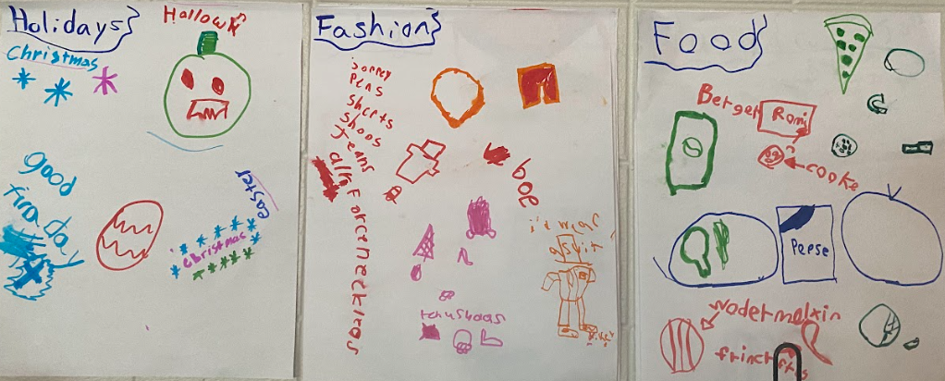

After students have finished the Gallery Walk, ask students to Turn and Talk to a peer and share their responses to these questions. Provide students with the sentence stems below to focus their discussion time.

- I noticed ________ (insert name(s) or an adjective like some, many, most, a couple, none, all of my classmates) and I have the cultural characteristic of _______ in common.
- I noticed ________ (insert name(s) or an adjective like some, many, most, a couple or none, all of my classmates) and I are different when it comes to the cultural characteristic of _______ in common.

*Teach students how to make the statements indicate more than one characteristic when needed. Example: I noticed no classmates and I have the cultural characteristics of music and language in common.

This will provide the opportunity for all students to share their findings. Then, explain to students that they have had the opportunity to learn about the culture of their classmates, and that the many similarities and differences they observed among them demonstrate the diversity in their classroom. Ensure that students understand that our personal identities are shaped by our culture, which includes our lifestyles, customs and traditions; our culture makes us who we are.

Explain to students that in addition to shaping people, culture shapes places. To help students understand what it means for something to “shape” something else, explain: “Something that shapes you helps make you who you are. Your culture has a lot to do with who you are and what you are like. Therefore, culture shapes people. The culture of the people within a place shapes that particular community”. Together as a class, brainstorm and record what comes to mind when they think of the culture of their elementary school. Students may mention their school mascot and colors, their school song or motto, special celebrations, incentives and activities that are unique to their school, the sports and games they play, etc. Explain to students that the culture within the school is what shapes and defines the school. Inform students that they will be exploring and comparing cultural groups in one of the countries found in North America: Mexico. As you introduce the students' first investigation, show students a map of North America and highlight the location of Mexico. To provide students additional context, you may consider showing students where Mexico is in relation to Kentucky.

Supporting Questions

2.I.Q.2 Identify supporting questions that help answer compelling questions about communities found in North America.

Supporting Questions:
- How did cultural groups in Mexico connect and interact in the past?
- How do cultural groups in Mexico interact today?
- How have cultural groups in the past and today shaped Mexico?

Supporting questions are aligned to the compelling question and meant to build students' content knowledge while also preparing them to respond to the compelling question. These questions can be answered through using the concepts and practices of each social studies discipline. In Grade 2, students are expected to identify supporting questions. Strategies such as Question Starts may be used to support students in this work. For more information on supporting questions, visit “Section C: What are Supporting Questions, and how do students ask them?” from the Inquiry Practices of the KAS for Social Studies module.

Considerations for Prior Learning
By this point, students should have some background knowledge on American Indians and indigenous groups from Kentucky. Activate their background knowledge about these cultural groups and how they connected and interacted in the past. Then, explain to students that just like the United States, Mexico contains many diverse indigenous groups that inhabited each region in the past and continue to live there today. Inform them that they will be investigating several supporting questions to learn about how these indigenous cultural groups in Mexico connected and interacted in the past and today. In addition, students will explore how some indigenous groups of Mexico have helped shape Mexican culture today.

The following resource may be utilized with students to introduce culture from Mexico’s past and present: Tonatiuh, D. (2011). Diego Rivera: His World and Ours. New York, NY: Abrams Books for Young Children.

This work is included here to support students in understanding historical context and change over time, which will support them in the investigations that follow. This picture book explains how Diego Rivera learned about Mexico’s past and painted murals that featured important parts of Mexican history and culture. He wanted Mexicans to celebrate and be proud of their heritage. As you read this book aloud to students, pause to discuss the illustrations on each page. Some questions to pose to students are:

- What does this illustration depict?
- Is this from Mexico’s past or modern-day? What clues from the illustration helped you determine this?

Discuss how things change over time from the distant past to the present. Toward the end of the book, there are illustrations depicting events from Mexico’s past in contrast to a similar event today. For example, a big modern day city in Mexico vs. the ancient city of Tenochtitlan, students at their desk today vs. factory workers on a production line, a shopping mall vs. street vendors selling flowers, and luchadores vs. Aztec warriors fighting the conquistadors. For each of these comparisons, discuss with students how and why these places, people and events have changed over time.

Now that students have a general understanding of the ways in which Mexico has changed from the past and today, explain that they will take a closer look at two different cultural groups in Mexico and how they connected and interacted in the past.

Investigation: Part 1
2.H.CH.1 Identify and compare the diverse North American cultural groups of the past and today.

Supporting Question: How did cultural groups in Mexico connect and interact in the past?

To investigate Mexican cultural groups of the past, the following resources may be utilized:
- Britannica, T. Editors of Encyclopaedia. (2017, July 20). Seri. Encyclopedia Britannica. https://www.britannica.com/topic/Seri.
- Encyclopedia.com. (n.d.). Seri. https://www.encyclopedia.com/humanities/encyclopedias-almanacs-transcripts-and-maps/seri.
- National Geographic. (2018). Ancient Maya 101 [video]. https://www.youtube.com/watch?v=Q6eBJjdca14.
- NoticiasMVS. (n.d.). Pueblos Indígenas en México [infographic]. http://noticiasmvsfotos.blob.core.windows.net/media/infografias/8a206f5d5c58f9e85b3774ff6fd05a2b.jpg.
- Smithsonian National Museum of the American Indian. (2012). The Maya People [video]. https://maya.nmai.si.edu/the-maya/maya-people.
- Torres, Núria López. (2022, May 16). An Intimate Look at Mexico’s Indigenous Seri People. The New York Times. https://www.nytimes.com/2022/05/16/travel/comcaac-seri-people-mexico.html.

To begin this investigation, read and discuss the supporting question, “How did cultural groups in Mexico connect and interact in the past?” with students. Ensure that students understand the meaning of connecting and interacting. Explain that the people within a cultural group connect by doing things together and living in the same community and interact by sharing thoughts and ideas. Also, different cultural groups can connect and interact with each other. They may also connect by living or working in the same area or community and they may interact by sharing thoughts and ideas with each other. Inform students that they will be exploring two cultural groups from Mexico’s past and will be responding to this question later by describing and comparing some of these groups.

View the infographic map with students. The goal of viewing this infographic map is for students to have a glimpse at the diversity of Mexico and the number of different cultural groups that have inhabited this country. To support students in understanding the diversity of Mexico, have students engage in a See, Think, Wonder Thinking Strategy by asking the following questions:

- What do you see?
- What do you think about that?
- What does it make you wonder?

Once they have completed the See, Think, Wonder strategy, ask students to identify the many different regions shown on the map. Next, have students identify indigenous groups found within each region. Explain to students that these groups spoke different languages, and a total of 364 different languages were spoken in Mexico.

Inform students that one of the largest groups found in the Yucatan peninsula was the Maya and identify where they were located on the infographic map. Explain that they were an ancient indigenous group who lived a very long time ago, and their ancestors still live there today. Show students two video clips: Ancient Maya 101, which discusses what artifacts show about Maya lifestyle and culture, and Maya People, which provides more information about Maya culture and how it is still seen among the descendants of Maya people today. Share the following questions to students before watching the videos so they can be looking for this information as they watch:

- What types of structures did the Maya build?
- What did we learn about their religion and traditions?
- How did they obtain their food and what foods did they commonly eat?
- What are some of the developments and accomplishments made by the early Maya?
- What else did we learn about Maya culture?
After watching the video, conduct a whole group discussion where students answer these questions. As students are answering these questions, have them cite information from the videos to support their answers. Record students’ responses so they are visible and students can refer to them throughout this investigation and the investigations that follow.

Next, place students in small groups and ask them to create a graffiti board representing Maya culture. Each group can use a poster, chart paper, or whiteboard and collectively write words, phrases and sentences and draw pictures that represent Maya culture. The graffiti board strategy allows students to organize the information they learn from the sources about the Maya culture in text and images, allowing students to process their learning through both linguistic and non-linguistic means. As students work, remind them of the different aspects of culture reviewed at the beginning of the lesson. Some examples of characteristics students may write about or draw include, but are not limited to corn, woven clothing, bright colors and designs, pyramid temples, calendar, agriculture and hieroglyphics.

Here is an example of a graffiti board created by students in a Kentucky classroom:
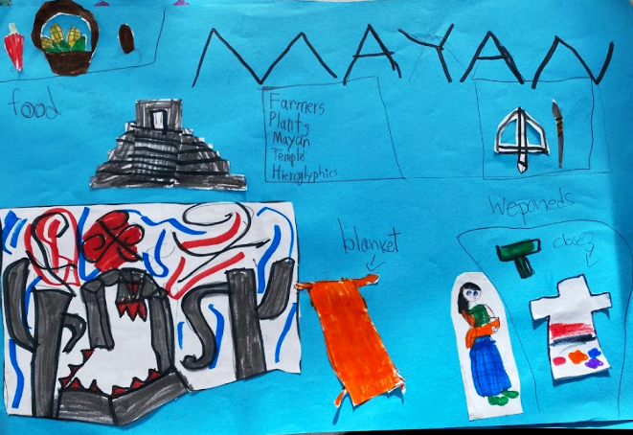

Once students have completed their graffiti board on the Maya, inform students that they will now learn more about the culture of another indigenous group from Mexico, the Seri.

Using the infographic map, point out where the Seri were located in Mexico in the Sonora area. Read the following excerpt from Seri as a class while students follow along to learn more about this cultural group. Reading aloud is appropriate because this source is above Grade 2 reading level. Additional teacher supports while reading aloud may be necessary to ensure students’ understanding. Some strategies for supporting students include, but are not limited to: clarifying challenging vocabulary, asking questions to students as you read to check for understanding and adapting or modifying the source to meet students’ needs. For more information on adapting sources, visit Adapting Primary Sources So All Students Benefit. Ask students to underline information about Seri culture, including, but not limited to their food, fashion, holidays/celebrations, music and language as they read along. Inform students that they will use this information later when creating another graffiti board on the Seri.

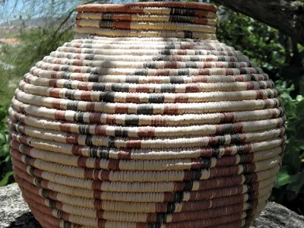
Seri pot basket

Seri, a tribe of Mesoamerican Indians who live on Tiburón Island in the Gulf of California and on the adjacent mainland in Sonora. Their language seems to be related to the Yuman languages, and both are commonly assigned to the hypothetical Hokan super-stock.

Although the Seri now engage in commercial fishing and farm labour, traditionally they lived by gathering, hunting, and fishing for such edibles as shellfish, turtles, pelicans, and cactus fruit. Their simple cane spears, hunting bows, pebble tools, and dwellings of poles and cacti earned them a reputation as being among the most primitive aboriginal groups of North America. They did, however, produce pottery, basketry, and boat-shaped rush rafts.

The Seri lived in mobile bands of not more than 50 individuals. There were no formal band leaders and no social units larger than the band. Shamans, or medicine men, whose powers derived from dreams and visions, were important.

After an unsuccessful missionization attempt in the 18th century, the Seri were little influenced by Spanish colonizers. Although their population has declined, they retain most of their aboriginal social and religious customs.

Facilitate a class discussion about this article. Ask students to identify some of the words they underlined and explain what this tells us about Seri culture in the past. Record this information and display it for students so they may reference this information later.

Then, read aloud the following excerpt about Seri housing. This source is also written above a Grade 2 level and may be challenging for students. As you read aloud, clarify challenging vocabulary and check for students’ understanding. You may also consider adapting the source to meet students’ needs. As you read, ask students to underline information about Seri culture, including, but not limited to, where and how they live.

Settlements
Aboriginally, the Seri were nomadic. Their movements reflected both seasonal and fortuitous changes in the food supply and in the most critical commodity, fresh water. People moved among temporary camps as resources shifted. Camps were occupied for up to several weeks and might be composed of a single nuclear family or as many as fifteen families

Most activities were conducted outdoors, and shelters served primarily as windbreaks and for storage. Houses were fabricated of ocotillo branches and resembled a Quonset hut or a simple rectangular box. They were covered with brush, seaweed, or anything handy. Housing today in the two villages is more substantial.

Again, facilitate a class discussion about this article. Ask students to identify some of the words they underlined and explain what this tells us about Seri culture. As before, record this information so it is visible to students and they can access it throughout this investigation and the investigations that follow.

Next, show students the images and captions below that are featured in An Intimate Look at Mexico’s Indigenous Seri People. Discuss each image and caption as a class using the Photo Analysis Tool. This tool will guide students to analyze the photo by observing its parts, trying to make sense of it and using it as historical evidence. Provide time for students to view the images and make observations about its characteristics and then work together as a class to complete the tool.

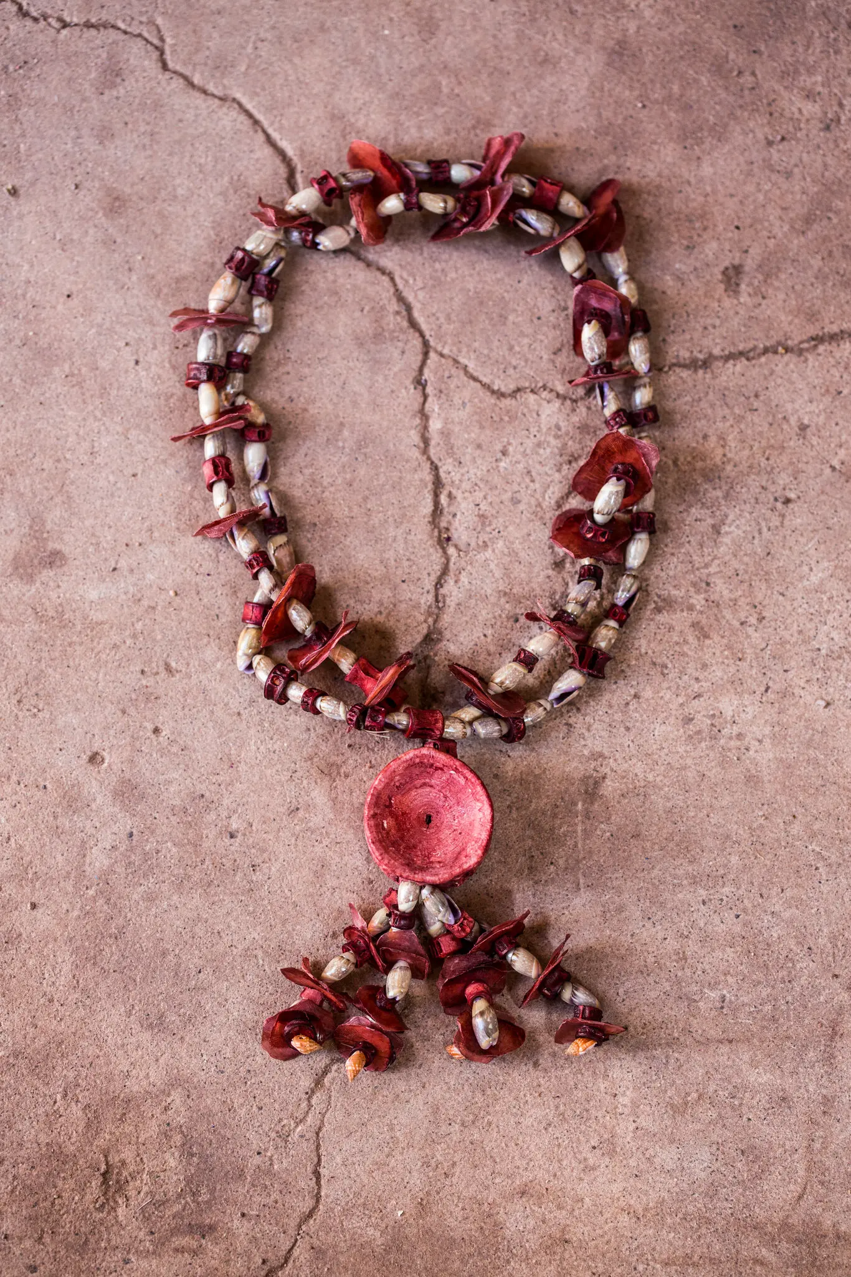
A necklace made with shells and other sea objects.

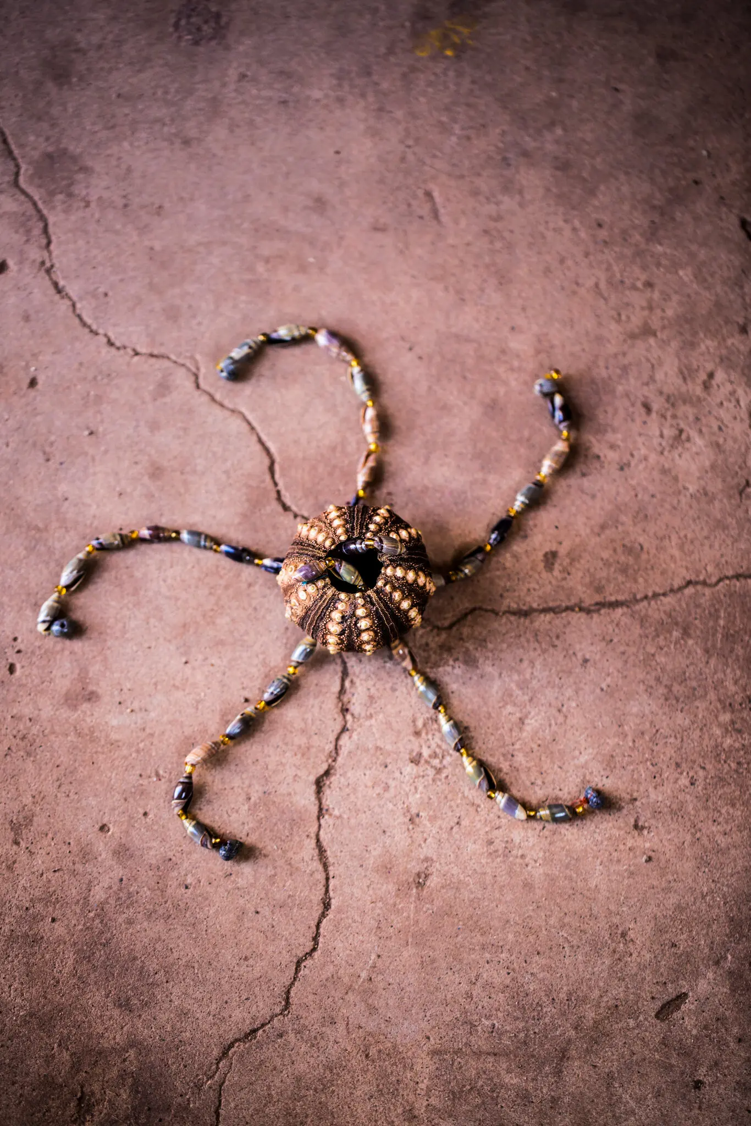
A craft made from a sea urchin.

After analyzing each photo, facilitate a class discussion about what these images tell us about how the Seri connected and interacted in the past. Some questions to pose are below:

- What types of structures did the Seri build?
- What did we learn about their religion and traditions?
- How did they obtain their food and what foods did they commonly eat?
- What are some of the developments and accomplishments made by the early Seri?
- What else did we learn about Seri culture?

As before, record student responses so they are visible and can be referenced for future tasks. Then, place students in small groups to create a graffiti board representing the Seri, just as they did previously with the Maya. Next, place students in small groups and ask them to create a graffiti board representing Seri culture, just as they did previously with the Maya. Each group can use a poster, chart paper, or whiteboard and collectively write words, phrases and sentences and draw pictures that represent Seri culture. The graffiti board strategy allows students to organize the information they learn from the sources about the Seri culture in text and images, allowing students to process their learning through both linguistic and non-linguistic means. As students work, remind them of the different aspects of culture reviewed at the beginning of the lesson. Some examples of characteristics students may write about, or draw include, but are not limited to food, clothing, religion and homes. Here is an example of a graffiti board created by students in a Kentucky classroom:

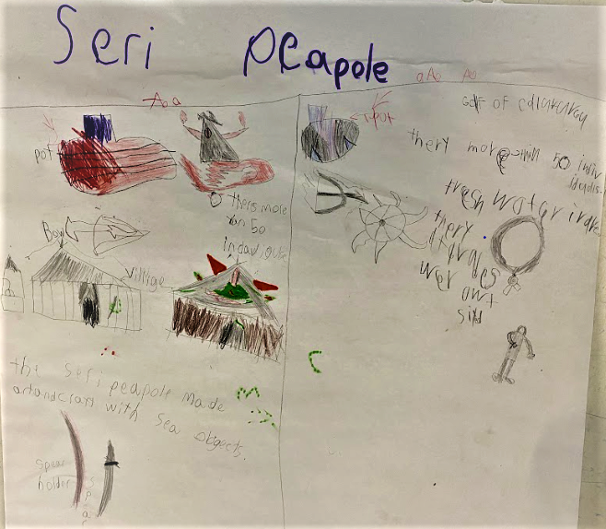

Next, place students in small groups and explain that they will be comparing the Maya and Seri. Provide students with a Venn Diagram that is set up for them to compare the culture of two different groups, such as the one below:

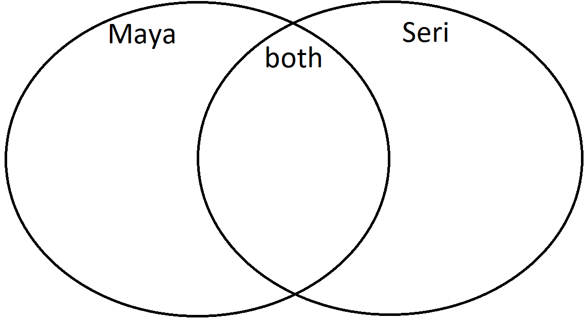

Ask students to work in their groups to revisit their graffiti boards and any sources or notes used during this investigation to compare the two cultural groups. Students may find specific details that differ between the two, such as the types of homes they had and the food they ate. They may find that the similarities between them are more general. For example, both groups had special traditions, both were farmers, etc. Students may write words and draw pictures in the Venn Diagram. As students are working, provide meaningful feedback to ensure students are acquiring the knowledge needed to meet the success criteria of this investigation, which is being able to identify and compare the diverse North American cultural groups of the past. Some questions teachers may consider when providing feedback include, but are not limited to, the following:
- How well are the students comparing the culture of the Maya and Seri?
- Are students adding evidence to their Venn Diagrams correctly or incorrectly?
- What did the student do well?
- How can the student improve??

Then, facilitate a class discussion comparing the groups. Display a Venn Diagram visible for the class and record their responses during the class discussion. Ensure that students understand that while these two groups were from the same country and had many similarities, they also had characteristics that were unique to them.

Explain to students that they are going to use what they have learned about diverse cultural groups from Mexico’s past to complete the task aligned to the supporting question.

Task Aligned to the Supporting Question:
KAS for Social Studies alignment:
- 2.I.Q.2 Identify supporting questions that help answer compelling questions about communities found in North America.
- 2.H.CH.1 Identify and compare the diverse North American cultural groups of the past and today.
- 2.I.UE.4 Construct responses to compelling and supporting questions, using reasoning, examples and details, about the diversity of communities in North America.

In these assignments, students are required to synthesize information learned through engaging with the disciplinary strand standards to answer a supporting question.

Task Aligned to the Supporting Question:
Create a(n) ___________________ (insert form of writing) that answers the supporting question, “How did cultural groups in Mexico connect and interact in the past?” Be sure to include Parts 1 and 2 in your response.

- Part One: Identify and describe two diverse cultural groups from Mexico’s past.

- Part Two: Compare and contrast how these two cultural groups connected and interacted in the past, using reasoning, examples and details.

Before assigning this task, determine the form students will use to respond. Consider a variety of response formats such as posters that use a combination of images and text to convey a message, digital slides, short paragraphs, videos, mind maps or voice recordings. Think about what, if any, instruction students will need in order to be successful composers of that form. If needed, reserve class time to teach students the assigned writing form .

To prepare students for completing this task, read the prompt together and discuss each part, clarifying challenging vocabulary. Provide students with the graphic organizer below to plan their responses.

One cultural group from Mexico’s past is the _________.  Three facts about the _________are: | Another group from Mexico’s past is the _________.  Three facts about the _________ are:
One way the Maya and Seri are different is… | Another way the Maya and Seri are different is…
One way the Maya and Seri are similar is… | Another way the Maya and Seri are similar is…

To address Part One of the prompt, ask students to identify two cultural groups from Mexico’s past and describe them with at least three facts. Encourage students to revisit any sources or materials from this investigation, including information recorded from the sources on the Maya and Seri and the graffiti boards they created. Ask them to complete the first row of the graphic organizer, providing support as needed.

For Part Two, explain to students that they are going to compare these two cultural groups by completing the sentence starters in each box of the graphic organizer. Allow students to refer to their Venn Diagrams they created independently as well as the class created one for this part of the task. To support students, work as a class to discuss and complete the boxes in the graphic organizer that require students to describe one way the Maya and Seri are different and similar. As a reminder, the similarities between the two cultural groups may be very general and the differences may be more specific. Then, have students work independently to complete the boxes that ask for an additional way they are different and similar, providing support as needed. As students work, check their graphic organizers to ensure accuracy. Prompt them to correct any mistakes or misconceptions and to include examples and supporting details.

The information from the completed graphic organizers can be used to create the final product. For example, if students are asked to create a poster, this information can be displayed on the poster with accompanying visuals and other information the student wishes to add. If the teacher wishes for students to develop explanatory informational paragraphs, this graphic organizer can be utilized to help plan and structure their paragraphs.

Student Work Samples:
Below are student work samples from Kentucky classrooms of the Task Aligned to the Supporting Question.

Strongly Aligned Example
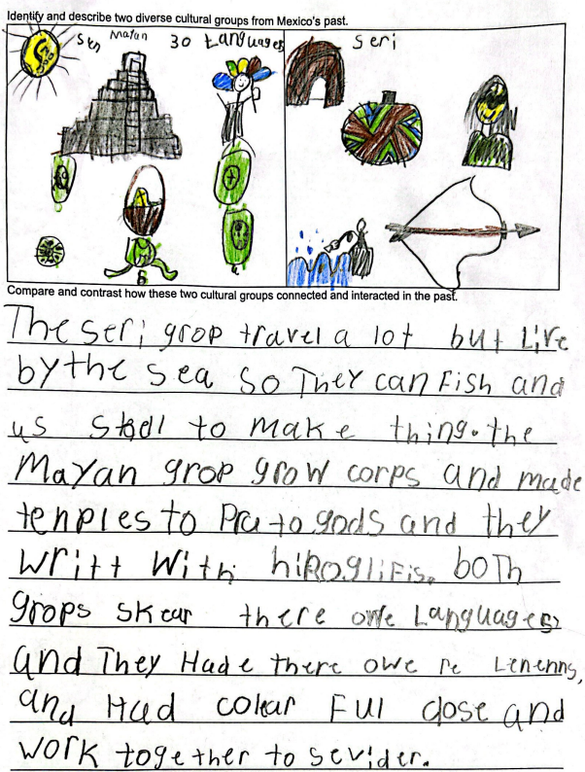

Partially Aligned Example
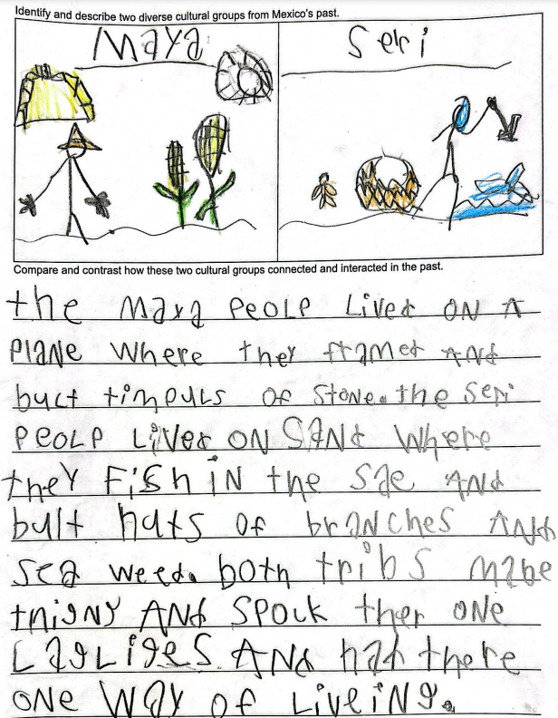

Weakly Aligned Example
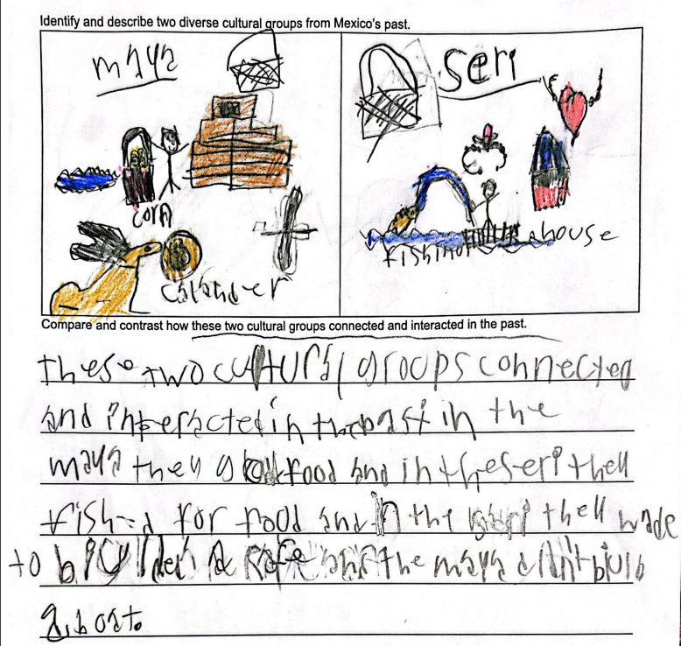

Now that students have examined cultural groups from Mexico’s past, they will move on to investigate the Maya and the Seri in Mexico today.

Investigation: Part 2
2.G.HI.1 Compare the ways various cultural groups connect and interact within North America.

Supporting Question: How do cultural groups in Mexico interact today?

The following sources may be utilized to investigate cultural groups in Mexico today:
- Canadian Museum of History. (n.d.). Maya Civilization. https://www.historymuseum.ca/cmc/exhibitions/civil/maya/mmc08eng.html#:~:text=The%20Maya%20today%20number%20about,and%20the%20Tzeltal%20(80%2C000).
- Central Intelligence Agency. (2022, August 16). The World Factbook. https://www.cia.gov/the-world-factbook/countries/mexico/.
- Editors of Encyclopedia Britannica. (n.d.). Seri. Encyclopedia Britannica. https://www.britannica.com/topic/Seri.
- Encyclopedia Britannica. (n.d.) Mexico: Ethnic composition. Encyclopedia Britannica. https://www.britannica.com/place/Mexico/Ethnic-groups#/media/1/379167/222306.
- LiveScience. (2017, November 6). Mexican Culture: Customs & Traditions. https://www.youtube.com/watch?v=MXmo1yf6or4.
- National Geographic. (2022, May 22). Modern Day Maya. https://education.nationalgeographic.org/resource/modern-day-maya.
- National Geographic Kids. (n.d.). Day of the Dead. https://kids.nationalgeographic.com/celebrations/article/day-of-the-dead.
- Seftel, Briana, (n.d.). Spice Up Your Life: Discover Mexico's 7 Culinary Regions. https://www.greatvaluevacations.com/travel-inspiration/discover-mexico-culinary-regions.
- TRT World. (2019, June 2). Ancient Ball Game: Indigenous game Ulama is being practiced again. https://www.youtube.com/watch?v=Jp0709-CnkY.
- WFMT. (2017, April 27). KAIA Kids Around the World - The Music of Mexico. https://www.youtube.com/watch?v=IKEDd9AQUns.

Explain to students that they are now going to investigate how cultural groups in Mexico interact today. To provide context for students to shift from thinking about Mexico in the past to now investigating the modern day, conduct a Read Aloud using the following resource:

Tonatiuh, Duncan. (2010). Dear Primo: A Letter to My Cousin. Abrams Books for Young Readers.

A video reading this book aloud can be accessed at Dear Primo read-aloud. Explain to students that this book explores the lives and cultures of two different children in the modern day: Charlie and Carlitos. Ensure that students understand that this literary text and a fictional story between two cousins, one of whom lives in rural Mexico and the other in urban America. It is critical that students understand that this book highlights one example within these countries; this book does not include all of the different experiences of all the people of Mexico or of America. Discuss with students how America has both urban areas with big cities and very rural areas with small populations, and everything in between. Explain to students that Mexico is the same way; Mexico has very large cities with skyscrapers and dense populations in addition to the small rural town that will be described in the story. As you read aloud, you may complete a T-chart together with students to keep track of the cultural differences the two cousins experience. A completed example is below:

Carlitos (rural Mexico) | Charlie (urban America)
- Lives on a farm and grows maize (corn)  - Rides bicicleta (bicycle) to school  - Plays futbol (soccer)  - Favorite meal is quesadillas  - Plays trompo (top spinner), canicas (marbles) and papalote (kites)  - Swims in a rio (river)  - Shops at a mercado (open air market)  - Fiestas (parties) with cohetes (fireworks) and mariachis (bands)  - Performers do tricks with animals and lassos  - Celebrates dia de los muertos (Day of the Dead) and with piñatas at parties | - Lives in a city with skyscrapers  - Rides a subway train to school  - Plays basketball  - Favorite meal is pizza  - Plays jump rope, hop scotch and video games  - Splashes in a fire hydrant when it is opened up  - Shops at a supermarket  - Parades with marching bands and people in costumes  - Performers do breakdances  - Celebrates Thanksgiving with a feast and Halloween with trick or treating

After reading, ask students to Turn and Talk to pose the following question:

- What similarities are there between you and Carlitos?
- What similarities are there between you and Charlie?

Then, allow some students to share with the class. Explain to students that people in Mexico and the United States today have much in common, and also unique characteristics due to their location and culture. Now that they have switched gears from the past to thinking about the modern day, explain to students that they will now investigate how cultural groups in Mexico interact today.

To help students understand the composition of Mexico today, show students the following pie chart from Mexico: Ethnic composition:

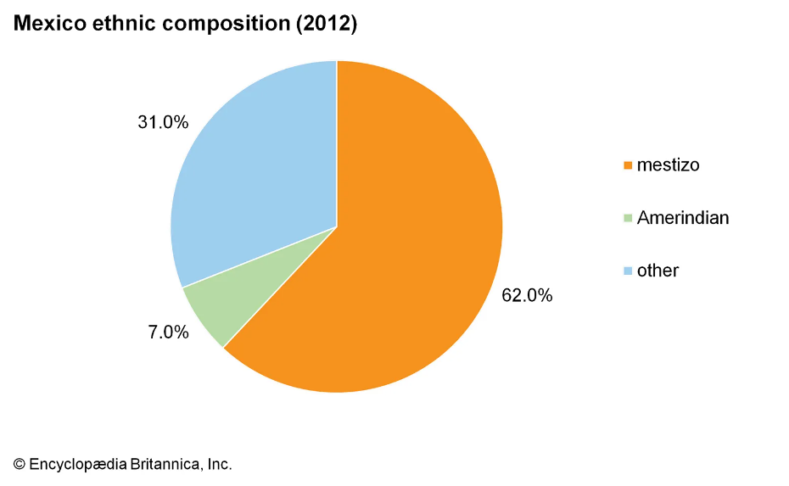
Explain to students that ethnicity refers to a group of people who share a common cultural background. This pie chart shows:
- 62% of Mexico’s population was mestizo in 2012. Mestizo is defined as being of mixed race, especially one having Spanish and indigenous descent.
- 7.0% of Mexico’s population was Amerindian in 2012. Amerindian is defined as being a member of an indigenous group of the Americas.
- 31.0% of Mexico’s population identified as “other” in 2012. Meaning, individuals in this category did not identify as either mestizo or Amerindian.

Explain to students that modern Mexico is composed of people from various cultural groups as different groups interacted with each other throughout Mexico’s history. Inform students that they will now explore modern Mexico in more detail by revisiting the Maya and the Seri. While the Maya and the Seri were indigenous groups that were a part of Mexico’s past, members of these groups and their descendants are still present in Mexico today.

Provide each student with a T-chart, such as the one below, to record information as they learn how the Maya and Seri are different today than in the past:

How is Maya culture different today than in the past? | How is Seri culture different today than in the past?

Show students the video clip Modern Day Maya, explaining that this is a short glimpse at the Maya today. As students watch, consider pausing the video to discuss and compare how the Maya are portrayed in the past and today. The video explains that the Maya have endured challenges throughout their history such as European conquest. Explain to students that people from Europe came to Mexico and encountered the Maya, which caused conflict between these groups.

Read the following excerpt of Maya Civilization with students:

The Maya today number about six million people, making them the largest single block of indigenous peoples north of Peru. Some of the largest Maya groups are found in Mexico, the most important of these being the Yucatecs (300,000), the Tzotzil (120,000) and the Tzeltal (80,000)

Explain to students that there are many Maya in Mexico still today and that they are now divided into different groups. Ask students to recall what they learned about the Maya from the past and today and Turn and Talk to a partner about the following question:

How is Maya culture different today than in the past?

After partners have had time to discuss, ask students to share with the class. Some student responses will likely be general to show that different aspects of their culture and daily living has changed over time. Responses may include, but are not limited to: the Maya dress differently today, they have modern technology today that they did not have in the past and they get food in different ways than in the past. Record student responses to this question on the T-chart.

Next, explain that the Seri are also still found in Mexico today. Read the following excerpts from Seri together, clarifying challenging vocabulary and providing support for student understanding as you read:

Seri, a tribe of Mesoamerican Indians who live on Tiburón Island in the Gulf of California and on the adjacent mainland in Sonora. Early 21st-century population estimates indicate approximately 800 individuals in the tribe.

Although the Seri now engage in commercial fishing and farm labour, traditionally they lived by gathering, hunting, and fishing for such edibles as shellfish, turtles, pelicans, and cactus fruit.

After an unsuccessful missionization attempt in the 18th century, the Seri were little influenced by Spanish colonizers. Although their population has declined, they retain most of their aboriginal social and religious customs.

Settlements
Although the Seri now reside in two permanent villages, the population of each fluctuates greatly as people move freely between them. Some traditional camps are still used during fishing or foraging expeditions.

Here the Seri have built both Mexican-style jacales of wattle and daub, and small wood-frame structures. During the 1960s and 1970s the Mexican government constructed cinder-block bungalows for the Seri.

After reading, discuss these excerpts as a class to ensure comprehension. Explain to students that they will investigate an additional source with images of the Seri today to learn about how the Seri today are different from the past. Then, show the following images from An Intimate Look at Mexico’s Indigenous Seri People that portray the Seri today. Just as they did in the previous investigation, students will work together as a class to analyze the images using the Photo Analysis Tool.

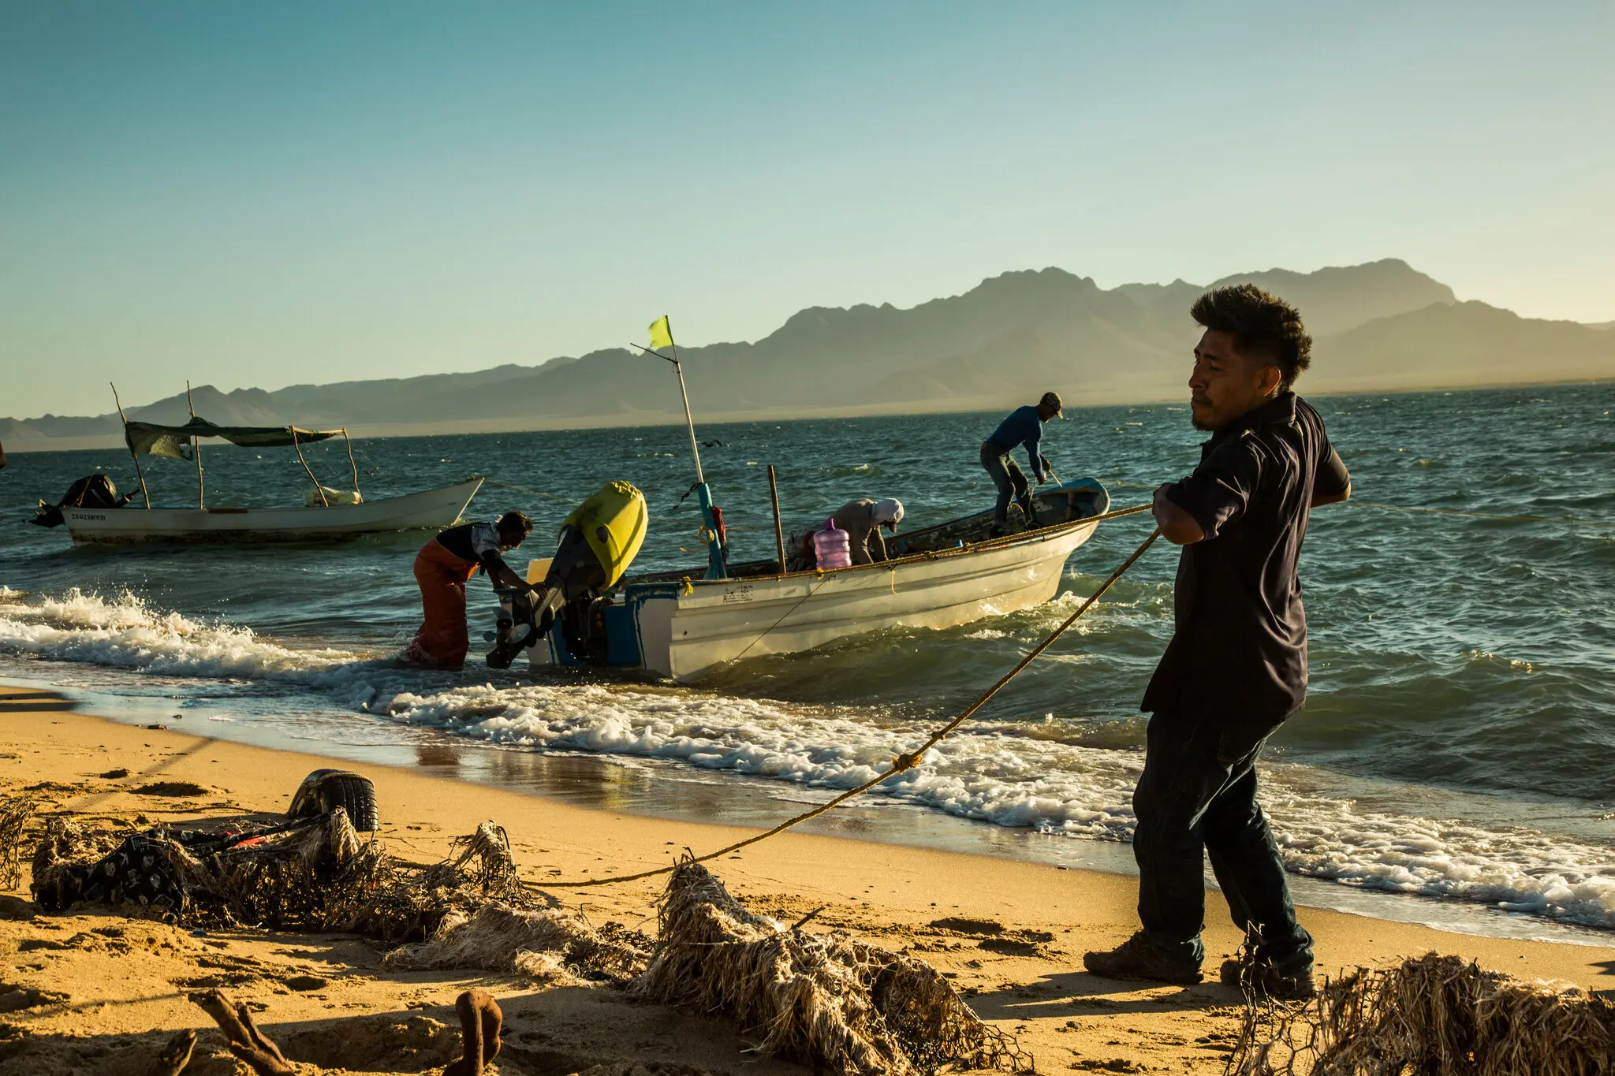
Fishermen return to Punta Chueca at dusk after fishing all day in Canal del Infiernillo, or Tiny Hell’s Channel, the waterway between the coastal town and Tiburón Island.

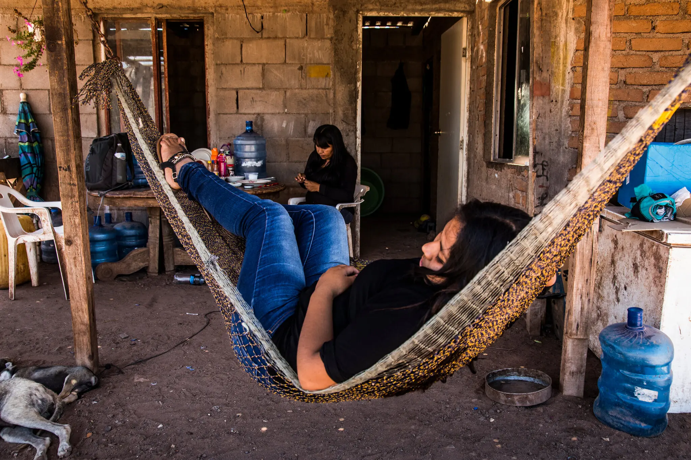
A Seri woman makes handicrafts with the shells she collected that morning, while her niece rests on a hammock.

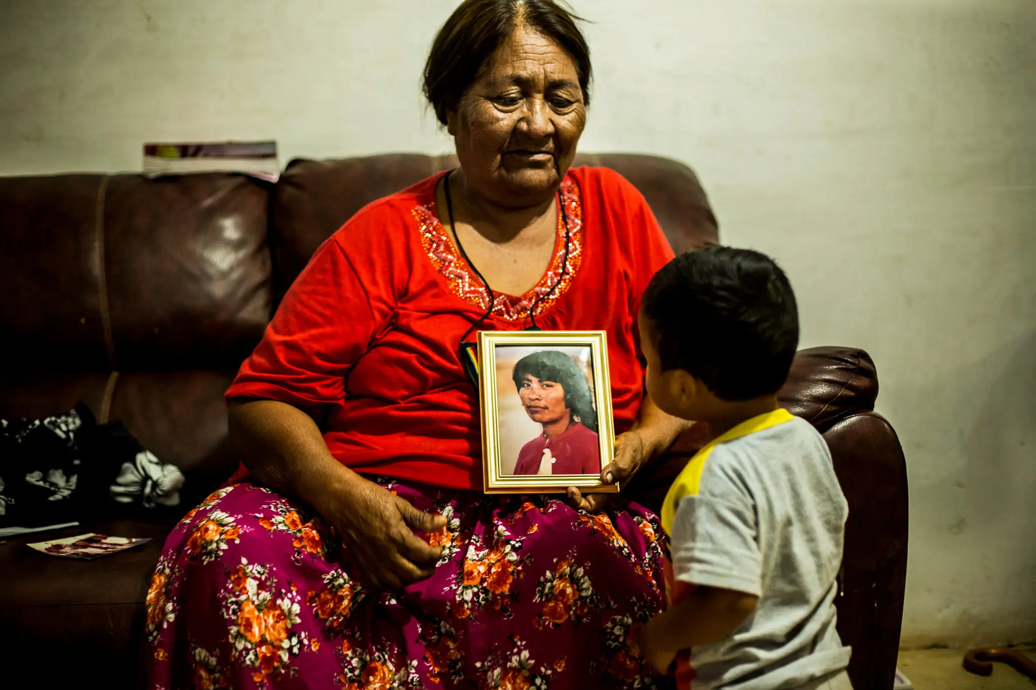
Lydia shows her great-grandson a photograph of her when she was young.

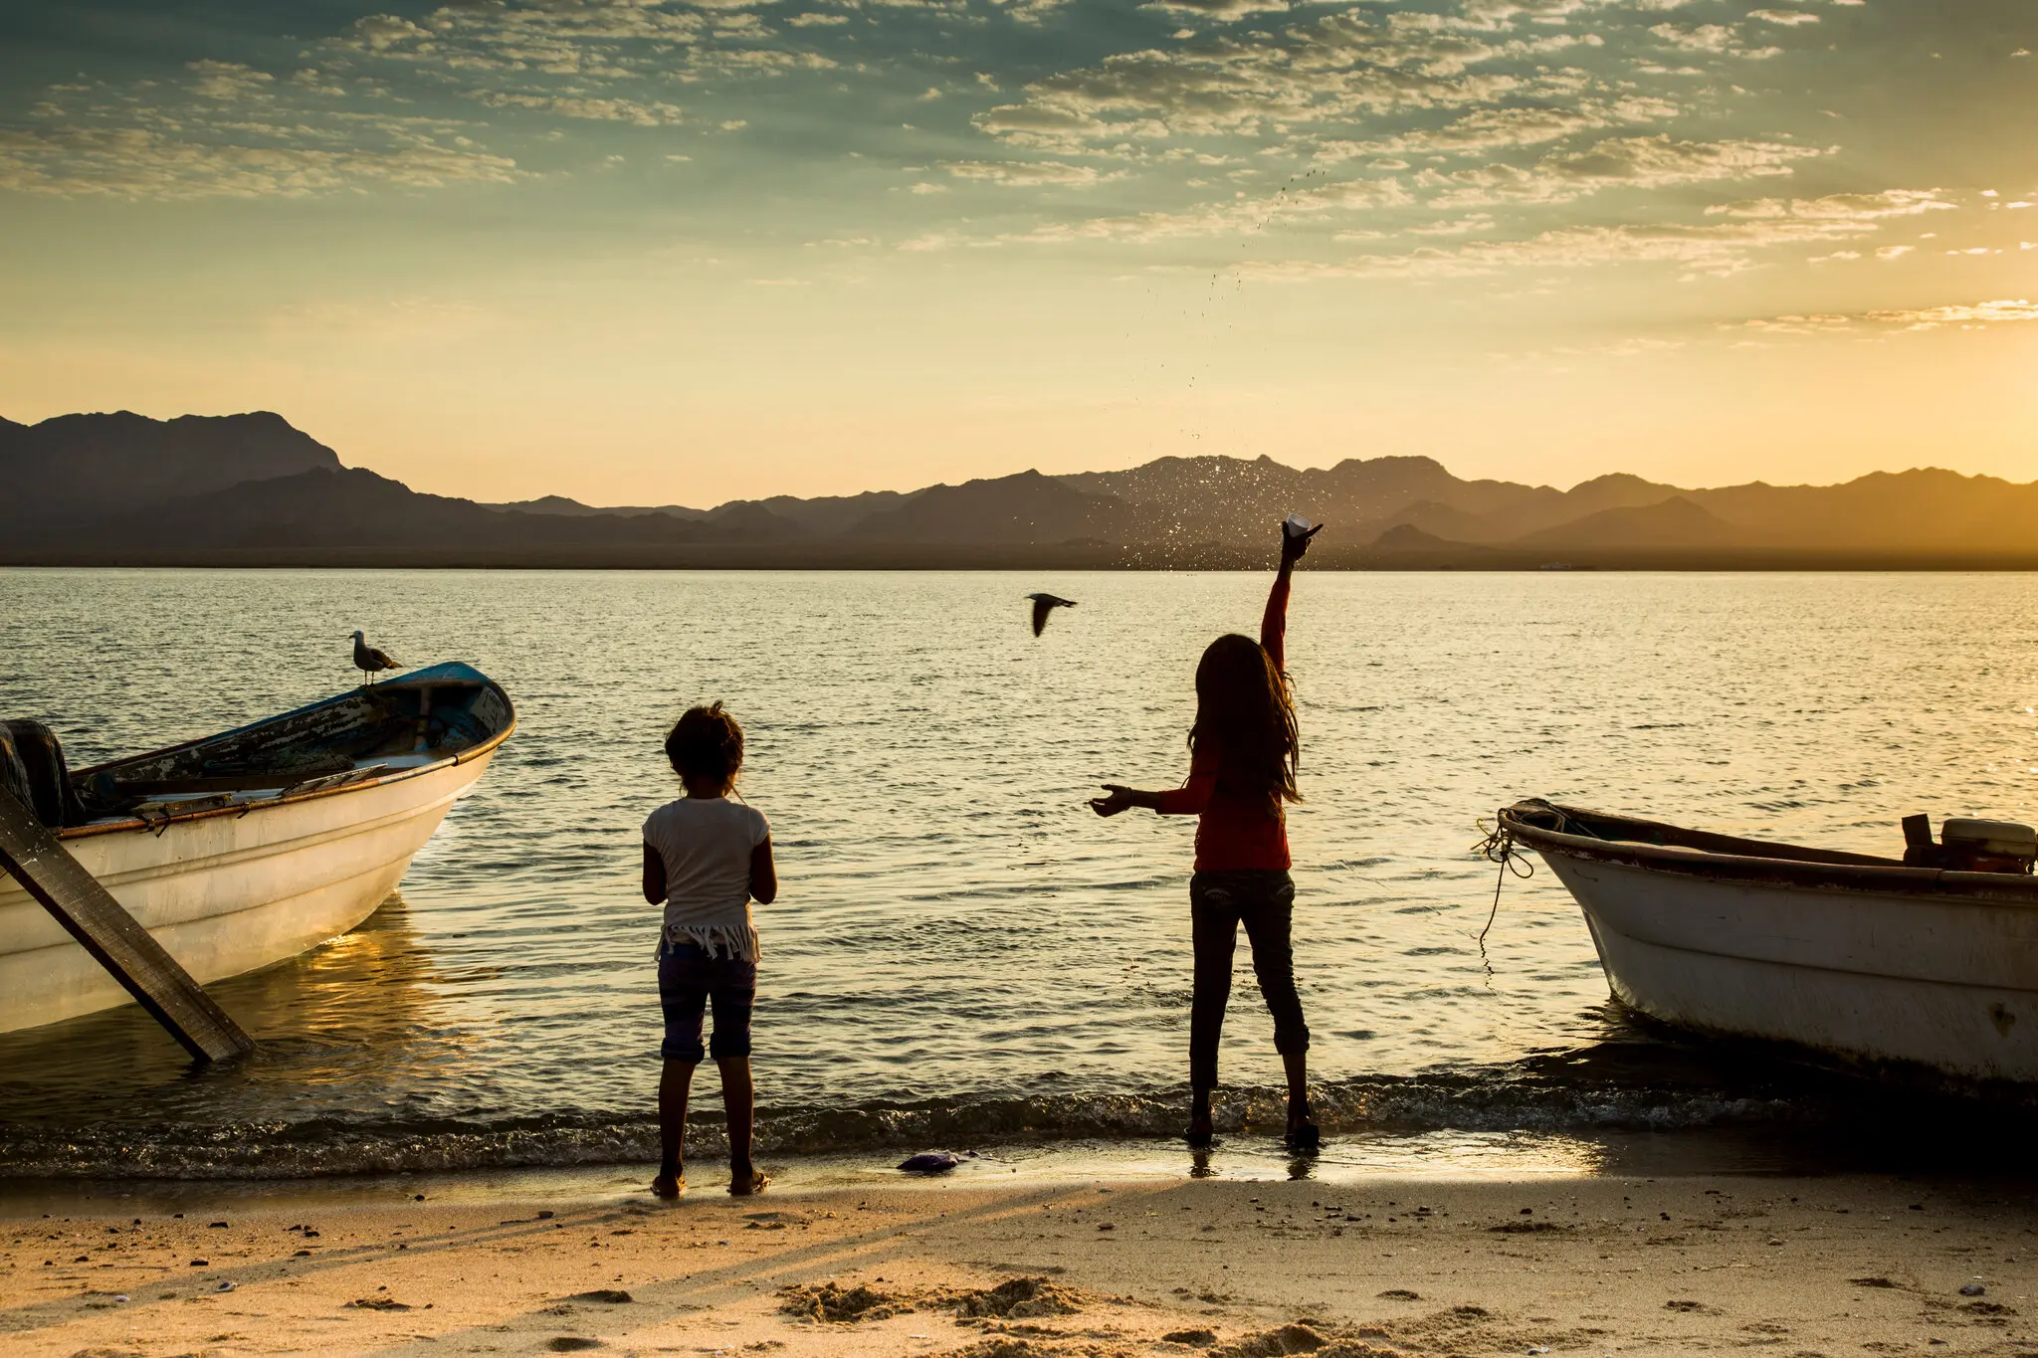
Girls play on the shore of Punta Chueca, in front of Tiburón Island.

As students examine each photo, prompt them to consider how the Seri in these images live differently today than in the past based on what they see. After analyzing each photo, ask students to recall what they learned about the Seri in the past and today and have them Turn and Talk to a partner about the following question:

How is Seri culture different today than in the past?

After partners have had time to discuss, ask students to share with the class. Ensure that students understand and identify how they have changed due to modern influences. Students may observe that, while they are still keeping many of their traditions alive, there are many differences from the past, such as their clothing, housing and technology. Record student responses on the T-chart.

In a whole group discussion, ask students to consider the following question:

Why did the culture of the Maya and Seri change over time?

During discussion, ensure students recognize that culture often changes over time due to cultures connecting and interacting with one another. For example, students may discuss the changes in clothing and technology from the past to today. Prompt students to consider how being connected with other groups around the world influence these changes.

Task Aligned to the Supporting Question:
KAS for Social Studies alignment:
- 2.I.Q.2 Identify supporting questions that help answer compelling questions about communities found in North America.
- 2.H.CH.1 Identify and compare the diverse North American cultural groups of the past and today.
- 2.I.UE.4 Construct responses to compelling and supporting questions, using reasoning, examples and details, about the diversity of communities in North America.

Task Aligned to the Supporting Question:
Construct a response to the supporting question, “How do cultural groups interact in Mexico today?”

In your response, use reasoning, examples and details using what you have learned about diverse communities in Mexico.

To prepare for this task, determine what format you would like students’ responses to take. Responses can take forms other than written paragraphs, such as posters, using technology to create slides, videos or voice recordings. Once you have determined the format for students’ responses, discuss the expectations and procedures for using this format with students.

To prepare students for this task, read the prompt together, clarifying challenging vocabulary and discuss expectations with students. You may ask students to plan their responses on a graphic organizer with sentence starters (see sample below) after working with a partner to discuss and plan their responses. Explain to students that the first box requires students to provide an overall response to how cultural groups in Mexico interact today. Ask students to Turn and Talk to a peer about how they would respond to this question. Then, discuss as a class, asking students to share their responses. Provide support as needed during the discussion to ensure that students’ responses are appropriate. Students’ responses will likely be very general ways that cultural groups interact among themselves today. Prompt them to provide examples from the sources they investigated. Ask students to record their response in the first box.

Cultural groups in Mexico interact today by…
One example of the Maya interact today is…
Another example of how the Seri interact today is…

Repeat this process for the second and third boxes of the organizer. Ask students to consider everything they learned about the Maya and Seri today to help them identify examples of how cultural groups in Mexico interact today, both among themselves and with each other, and discuss with a partner, followed by a whole group discussion. Ask students to share their examples and clarify any misconceptions and ensure all examples are correct. Student examples may include, but are not limited to: the Maya are now live all across Mexico interact with other cultural groups across the country every day; the Seri go on fishing and foraging expeditions together. Then, ask students to complete the second and third boxes of their organizers.

These completed graphic organizers can be used to create the product in the chosen format. For example, if students are creating a voice recording, they can produce their script based on the information they collected in this graphic organizer. If the teacher wishes for students to develop explanatory informational paragraphs, this graphic organizer can be utilized to help plan and structure their paragraphs.

Student Work Samples:
Below are student work samples from Kentucky classrooms of the Task Aligned to the Supporting Question.

Strongly Aligned Example
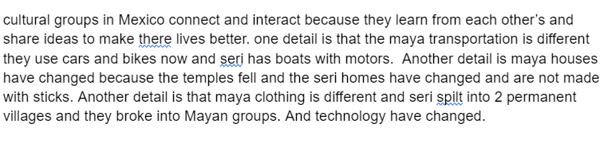

Partially Aligned Example
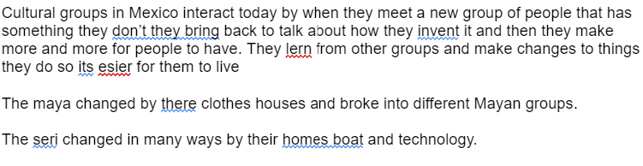

Partially Aligned Example
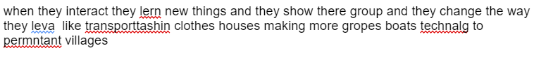

Investigation: Part 3
2.G.HI.1 Compare the ways various cultural groups connect and interact within North America.

Supporting Question: How have cultural groups in the past and today shaped Mexico?

Inform students that they are now going to explore modern Mexican culture to understand how cultural groups in the past and today have shaped Mexico. To introduce modern Mexican culture, have students watch the video clip Mexican Culture: Customs and Traditions. This video displays images and text that describe Mexican culture today. As students watch this clip, have them identify Mexican culture (cultural groups, language, religion, holidays, etc.). Consider stopping the video and discussing the text with students to check for understanding.

Inform students they will now examine a variety of sources to learn about the culture of Mexico today. Present them with the graphic organizer below to record evidence from each source:

Source | What does this source tell us about the culture of Mexico? | What does this source tell us about how cultural groups of the past and today shaped Mexico?
The CIA Factbook
The Day of the Dead
KAIA Kids Around the World: The Music of Mexico
Spice Up Your Life: Discover Mexico’s 7 culinary Regions
Ancient Ball Game: Indigenous game Ulama is being practiced again

First, read the following excerpt from The CIA Factbook to students, clarifying any challenging vocabulary:

Ethnic groups

Mestizo (Amerindian-Spanish) 62%, predominantly Amerindian 21%, Amerindian 7%, other 10% (mostly European) (2012 est.)

Languages
Spanish only 93.8%, Spanish and indigenous languages 5.4%, indigenous only 0.6%, unspecified 0.2%; note - indigenous languages include various Mayan, Nahuatl, and other regional languages (2020 est.)

Discuss with students how the majority of people in Mexico are Mestizo, meaning they have both indigenous and Spanish heritage, and the second most common ethnic group is people who are indigenous or mostly indigenous. Explain to students how European contact in Mexico influenced the ethnic group composition of Mexico today. Additionally, discuss the language spoken today. Ask students to recall the infographic in the last investigation which stated that hundreds of languages were originally spoken in Mexico. However, nearly 94% of people in Mexico speak only Spanish today. Explain to students that while Spanish wasn’t a language that ancient Maya or Seri spoke, as the indigenous population connected and interacted with Spanish Conquistadors, the use of Spanish language increased to being the most spoken language in Mexico today. As a class, record information from this source in the graphic organizer.

Next, read the Day of the Dead article aloud to students as they follow along. Clarify challenging vocabulary as you read and check for student understanding. Ask students to follow along and pay attention to what this article tells us about Mexican culture and how people connect and interact in Mexico today. After reading, discuss the questions on the graphic organizer with students. Ensure that students understand that the Day of the Dead combines the Aztec (an ancient indigenous group from Mexico) custom of celebrating ancestors with All Souls' Day, which was a holiday that Spanish invaders brought to Mexico. Therefore, the interactions with the Spanish in the 1500s influenced the creation of the Day of the Dead. This tradition is part of modern Mexico’s culture, as it is still maintained and celebrated in Mexico today. Work with students to add this information to the graphic organizer.

Show KAIA Kids Around the World: The Music of Mexico to students. This video discusses and demonstrates mariachi music. After watching, discuss the questions in the graphic organizer with students. Ensure that they understand that mariachi music is a traditional form of Mexican music that is still played today in Mexico and other parts of the world. Add to the graphic organizer together.

Next, explore the excerpt below from Spice Up Your Life: Discover Mexico’s 7 culinary Regions with students to examine two different dishes from Mexico. Clarify challenging vocabulary for students as you read.

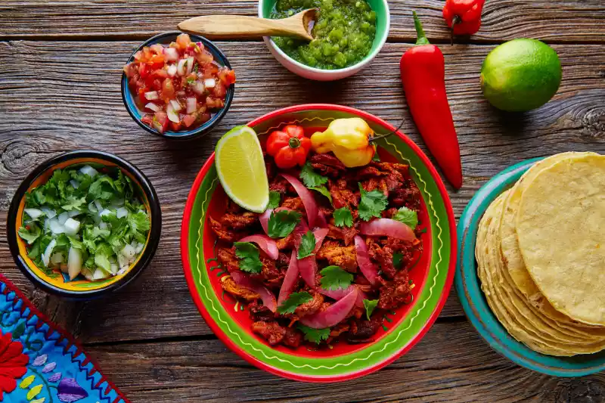
Yucatan: Cochinita Pibil

The Yucatan peninsula in southeast Mexico has one of the country's richest culinary heritages. Yucatecan cuisine is heavily influenced by Mayan, Spanish, and Lebanese cuisines. The most popular dish in the region is cochinita pibil, slow-roasted pork flavored with citrus and annatto seeds that give its signature burnt orange color.

Other notable dishes: panuchos, sopa de Lima, poc chuc

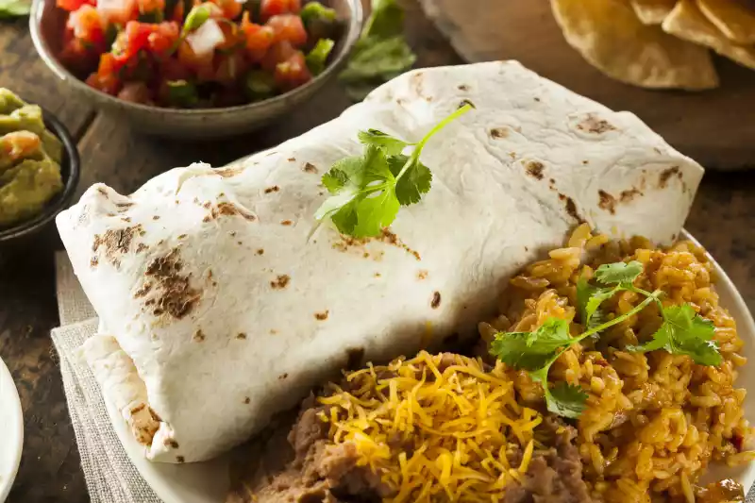
Northern Mexico: Burrito

Northern Mexico (El Norte) is a loose geographical region comprised of nine states including Sonora, Chihuahua, and Nuevo León. The cuisine of this region is heavily influenced by the cowboy/vaquero culture and also the coast. Perhaps the most well-known dish of El Norte is the burrito, which means "little donkey" in Spanish. Before it became synonymous with Tex-Mex and Mexi-Cali food, the Mexican burrito consisted of simply meat and refried beans.

Other notable dishes: machaca, arrachera, cabrito

Ask students to consider the description and images of these two foods from different parts of Mexico, as well as the “other notable dishes” listed. Discuss the questions from the graphic organizer with students. Ensure that students understand that connections and interactions in Mexico today caused these dishes to become popular throughout the country and also in other countries around the world. Students may share that they are familiar with some of these foods and that they are popular in the United States also. Complete the graphic organizer for this source together.

Next, show students the video Ancient Ball Game: Indigenous game Ulama is being practiced again, asking them to consider the questions from the graphic organizer as they watch. Then, discuss the questions from the graphic organizer as a class. Ensure that students understand that Ulama was an ancient game played long ago, and that it is being studied and played again today to honor the tradition. Ask students to identify similarities among Ulama and games we play today in both the United States and Mexico, such as soccer, basketball and baseball. Students may notice that like many other sports, a ball is used, there is a ceremony or ritual before it starts, music plays during the game. The connections and interactions among cultural groups in Mexico and throughout the world caused indigenous games to spread and evolve and these ancient games evolved and influenced today’s sports. Complete the graphic organizer for this source together.

Now that students have investigated how cultural groups from the past and today shaped Mexico, they will complete the task aligned to the supporting question.

Task Aligned to the Supporting Question:
KAS for Social Studies alignment:
- 2.I.Q.2 Identify supporting questions that help answer compelling questions about communities found in North America.
- 2.G.HI.1 Compare the ways various cultural groups connect and interact within North America.
- 2.I.UE.4 Construct responses to compelling and supporting questions, using reasoning, examples and details, about the diversity of communities in North America.

Task Aligned to the Supporting Question:
Using your understanding of the characteristics of culture, answer the supporting question:

“How have cultural groups in the past and today shaped Mexico?”

Be sure to use reasoning, examples and details about the ways various cultural groups connect and interact in Mexico in the past and today in your response.

To prepare for this task, determine what format you would like students’ responses to take. Responses can take forms other than written paragraphs, such as posters, using technology to create slides, videos or voice recordings. Once you have determined the format for students’ responses, discuss the expectations and procedures for using this format with students. For example, students could create a video of themselves responding to this task with accompanying visuals.

Begin preparing students for this task by reading the prompt together and clarifying any challenging vocabulary. Provide students with a graphic organizer with sentence starters (see below) and facilitate a class discussion about how cultural groups from the past and today shaped Mexico. Visit Leading Discussions for more information on how to conduct whole group discussions. Provide support as needed during the discussion to ensure that students’ responses are appropriate. An example student response is: Cultural groups from the past and today shaped Mexico because Mexico’s culture today includes many of their traditions. Ask students to record their response in the first box and then continue finishing each sentence in each of the remaining boxes. to help plan their responses to this task.

Cultural groups from the past and today shaped Mexico because…
One example of how cultural groups shaped Mexico is…
Another example of how cultural groups shaped Mexico is…

Then, work together as a class to find examples of how cultural groups from the past and today shaped the culture of Mexico with respect to different cultural characteristics. A graphic organizer such as the one below may be used to record this information:

Cultural characteristic | How did cultural groups in Mexico shape this?
Holidays/Celebrations
Music
Food
Sports

Facilitate a class discussion about each of these cultural elements and how they were shaped by cultural groups in Mexico. Refer to sources from this investigation as needed. Check for understanding and clear up any misconceptions during the class discussion. An example of a completed graphic organizer is below:

Cultural characteristic | How did cultural groups in Mexico shape this?
Holidays/Celebrations | Day of the Dead is still a popular holiday in Mexico today that started long ago from ancient Aztec and Spanish traditions.
Music | Traditional mariachi music is still heard in Mexico today, although it originated long ago.
Food | Popular food in Mexico today is inspired by different cultures based on their tradition and geographical features.
Sports | Ulama is an ancient ball game that is being practiced today, and indigenous ball games such as this inspired the sports that are popular in Mexico today.

Ask students to choose two of these examples and write about them in the second and third boxes in their graphic organizers. The completed graphic organizers can be used to create the product in the chosen format. For example, this information can be discussed in a video with accompanying visuals. If the teacher wishes for students to develop explanatory informational paragraphs, the graphic organizer can be utilized to help plan and structure their paragraphs.

Students have now investigated three supporting questions that will help them answer the compelling question, “How does culture shape communities?” However, they have not learned enough yet to fully answer this question. Below is a task aligned to the compelling question. Since the theme of Grade 2 is North American Interactions (United States, Mexico and Canada), students will need the opportunity to investigate additional supporting questions related to the culture of other places in North America, such as Canada, in order to successfully complete the task aligned to the compelling question.

Student Work Samples:
Below are student work samples from Kentucky classrooms of the Task Aligned to the Supporting Question. Each sample has an accompanying Student Work Review Protocol that evaluates alignment to the KAS for Social Studies.

Strongly Aligned Example
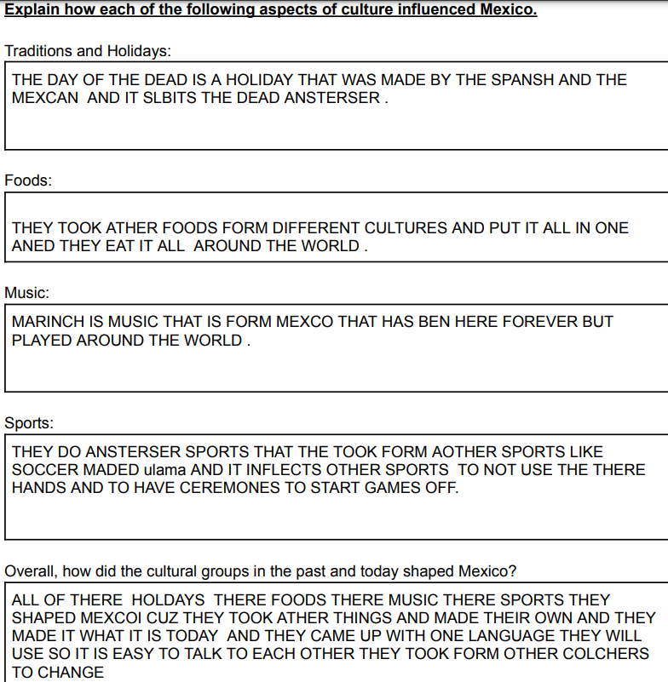

Partially Aligned Example
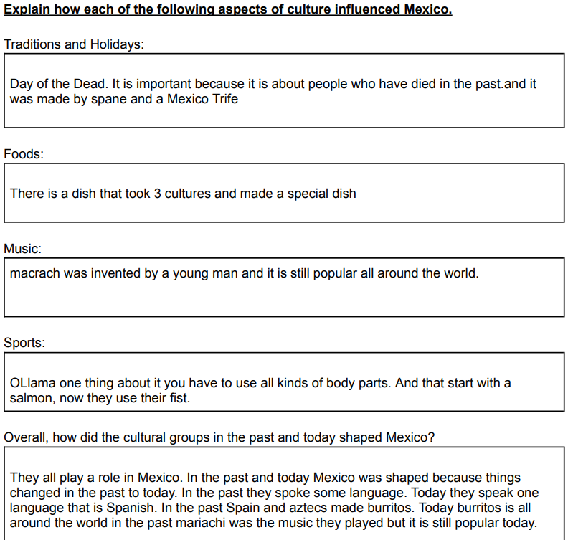

Weakly Aligned Example
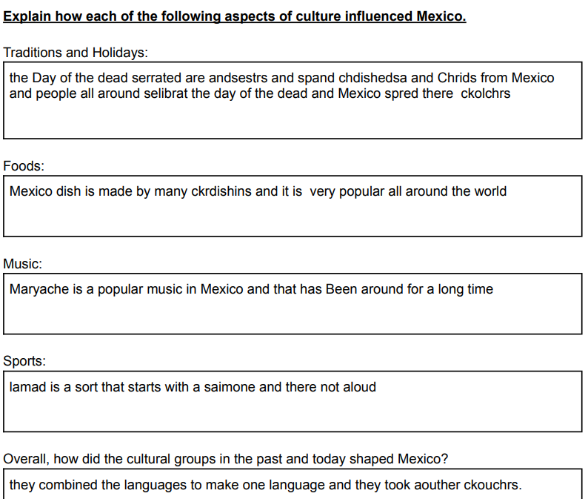

Task Aligned to the Compelling Question:
KAS for Social Studies alignment:
- 2.I.Q.1 Ask compelling questions about communities found in North America.
- 2.I.UE.4 Construct responses to compelling and supporting questions, using reasoning, examples and details, about the diversity of communities in North America.
- 2.I.CC.1 Construct an explanation, using correct sequence and relevant information, to provide information on a community in North America.

Task Aligned to the Compelling Question:

Using your knowledge of the ways various cultural groups connect and interact, construct an explanation to answer the following question:

How does culture shape communities?

In your response, use correct sequence and relevant information to provide examples from communities in North America.

