Second Grade Math Assignment
This assignment is strongly aligned to the standards.
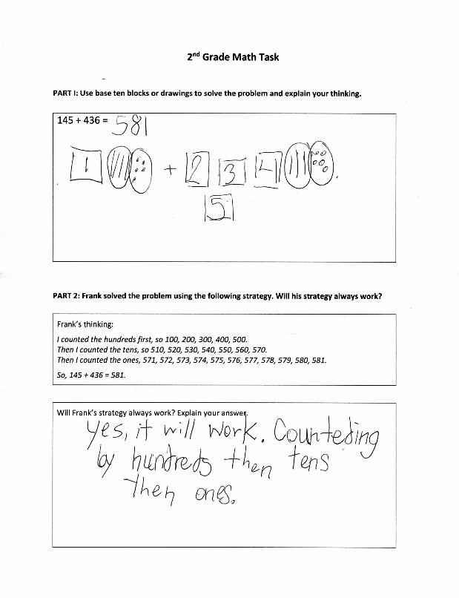
Overview
Second-grade students add within 1000 and explain whether a provided addition strategy will work. This assignment is strong because it builds upon the conceptual understanding of addition that students developed in earlier grades, but with increasingly larger numbers, as is appropriate for second grade.

Related Standards
KY.2.NBT.7: Add and subtract within 1000. a. Represent and solve addition and subtraction problems using concrete models or drawings strategies based on place value properties of operations the relationship between addition and subtraction and relate drawings and strategies to expressions or equations. b. Understand that in adding or subtracting three-digit numbers, one adds or subtracts hundreds and hundreds, tens and tens, ones and ones; and sometimes it is necessary to compose or decompose tens or hundreds.
KY.2.NBT.9: Explain why addition and subtraction strategies work, using place value and the properties of operations.

Why is this assignment strongly aligned?
​This assignment is well-aligned with both second-grade standards KY.2.NBT.7 and KY.2.NBT.9:
Standard KY.2.NBT.7 requires students to add and subtract within 1000 using various representations and strategies. In part one of this assignment, students are asked to add 145 + 436 using physical or visual representations (base-ten blocks or drawings).
Standard KY.2.NBT.9 requires students to explain why addition and subtraction strategies work. In part one of this assignment, students have to explain the strategy they used to add 145 + 436. In part two, students have to critique the addition strategy used by another student.
This assignment builds students’ conceptual understanding of addition, in both standards KY.2.NBT.7 and KY.2.NBT.7. Representing numbers physically or visually—for example, through quick drawings of hundreds squares, tens sticks, and ones dots—and explaining strategies ensures that students continue building understanding of place value and addition within the base-ten system that they began developing in earlier grade levels (as students add conceptually within 10 in kindergarten, within 100 in first grade, and within 1000 in second grade). The specific addition strategy used in part two of the assignment (adding hundreds first, then counting on to add the tens and ones) also appropriately builds students’ conceptual understanding by reinforcing place value.
Practice Standards
This assignment allows students to engage meaningfully with multiple mathematical practice standards. Directing students to use base-ten blocks or drawings to add and allowing students to choose which representation they want to use gives students the chance to engage with Mathematical Practice Standard #5 ("Use appropriate tools strategically"). Asking students to explain their addition strategy and evaluate the strategy used by another student gives students the chance to engage with Mathematical Practice Standard #3 (“Construct viable arguments and critique the reasoning of others”) and Mathematical Practice Standard #6 (“Attend to precision”). Asking students to evaluate an addition strategy that involves decomposing a three-digit number into hundreds, tens, and ones also gives students the chance to engage with Mathematical Practice Standard #7 ("Look for and make use of structure").

