2nd Grade Reading & Writing Assignment
This assignment is strongly aligned to the standards.

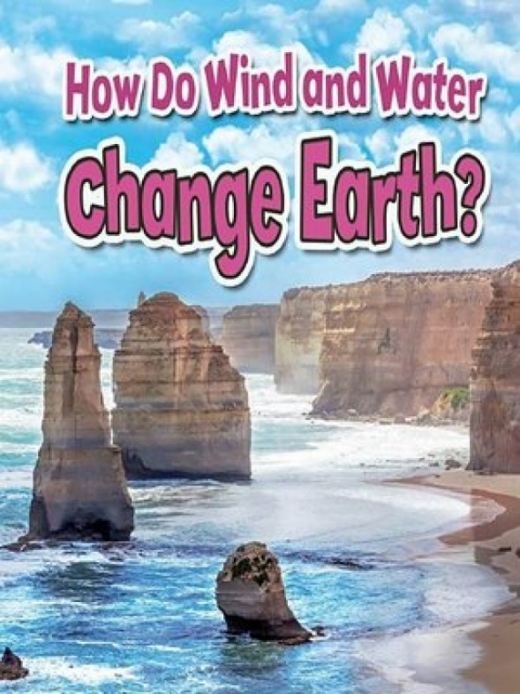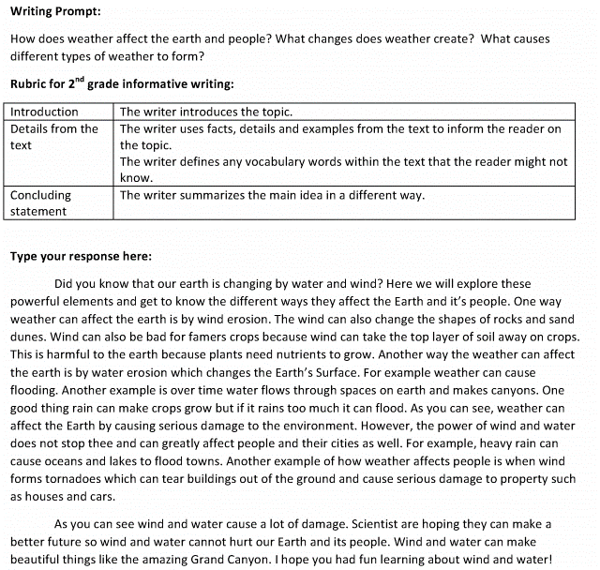

Overview
Second-grade students read an adequately complex text, then write an informational piece about key ideas in the text. The assignment exposes students to a worthwhile text about changes to the Earth’s surface, and poses a question that focuses students on the key ideas. It allows students to develop the skill and craft of writing that explains or informs.

About the Text
Title and Author | "How Do Wind and Water Change Earth?" by Natalie Hyde
What is the Lexile Level of this text? | 620L
Based on Lexile, which grades is this text intended for? | 2-3
Is the text qualitatively complex enough for the grade? | Yes
Is this text fiction or non-fiction? | Non-Fiction
Is this text authentic or was it written for educational purposes? | Authentic
Does the text provide sufficient detail to build knowledge of a worthwhile topic and/or is it worth reading closely and re-reading? | Yes

Related Standards
RI.2.1: Ask and answer such questions as who, what, where, when, why and how, and make and support logical inferences to construct meaning from the text.
The assignment is strongly aligned to this standard. The writing prompt requires students to infer and demonstrate understanding of the key details to describe how weather changes the Earth’s surface and impacts people.
RI.2.3: Describe the connection between individuals, historical events, scientific ideas or concepts or steps in technical procedures over the course of a text.
The assignment is strongly aligned to this standard. The writing prompt requires students to demonstrate understanding and describe the connection between weather, changes in Earth’s surface, and the impact on people.
RI.2.10: By the end of the year, flexibly use a variety of comprehension strategies (i.e., questioning, monitoring, visualizing, inferencing, summarizing, using prior knowledge, determining importance) to read, comprehend and analyze grade-level appropriate, complex informational texts independently and proficiently.
The assignment is strongly aligned to this standard. To respond to this writing prompt, students must read and comprehend the information and key ideas in the non-fiction text about changes to the Earth’s surface. The text is appropriately complex for second grade.
C.2.2: Compose informative and/or explanatory texts, using writing and digital resources, to establish a topic and provide information about the topic.
The assignment is strongly aligned to this standard. The writing prompt and supporting rubric set clear expectations for student writing that reflect the demands of the Grade 2 standards. Specifically, students are asked to introduce the topic they are writing about, providing some relevant context; select relevant facts and definitions to develop their points; and draft an effective concluding statement or section.
L.2.1F: In writing or speaking, demonstrate appropriate use of producing, expanding and rearranging complete simple and compound sentences.
The assignment is strongly aligned to this standard. The writing prompt provides an opportunity for students to use a variety of sentence structures.
L.2.4F: Determine or clarify the meaning of unknown and multiple-meaning words and phrases based on grade 2 reading and content, choosing flexibly from an array of strategies. Use words and phrases acquired through conversations, reading and being read to, and responding to texts, including using adjectives and adverbs to describe.
The assignment is strongly aligned to this standard. The writing prompt provides an opportunity for students to use precise academic and domain-specific vocabulary acquired through reading and conversations about text (e.g., elements, erosion, crops, nutrients, surface, damage, environment).

Why is this assignment strongly aligned?
The assignment allows students to read an engaging and worthwhile text that is adequately complex. The text contains useful information about changes to the Earth’s surface and offers complex vocabulary and beautiful photographs.
It requires students to read carefully and focus on important information in the text. Students are required to answer a question about the impact of weather on people, using evidence from the text.
It allows students to share what they learned in writing and practice the skill and craft of writing that explains or informs. The expectations for student writing are clearly communicated through the rubric and reflect the demands of the grade-level standards. Students are asked to introduce the topic they are writing about, provide relevant context, select key facts and definitions to develop their points, and draft an effective concluding statement or section.
The task allows students to apply their developing language skills to their writing. Practicing the correct use of grammar and spelling is important for improving both reading and writing skills. (In this task, however, this opportunity appears to be incidental rather than intentional, as the directions do not include clear expectations for use of grammatical conventions beyond writing in complete sentences.)

