Second Grade Math Assignment
This assignment is partially aligned to the standards.
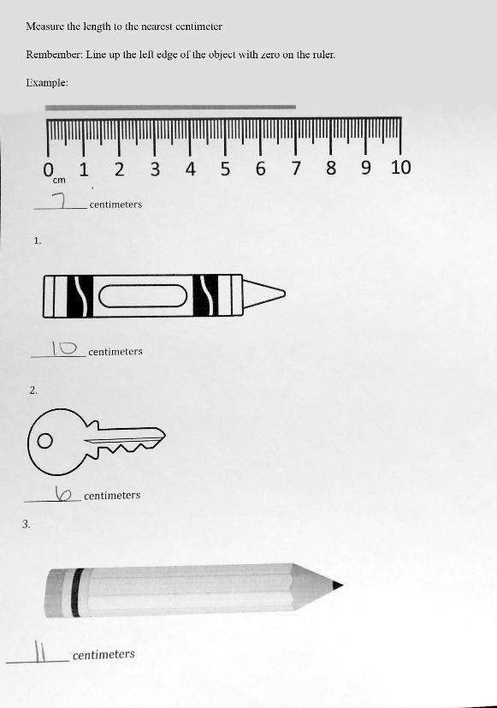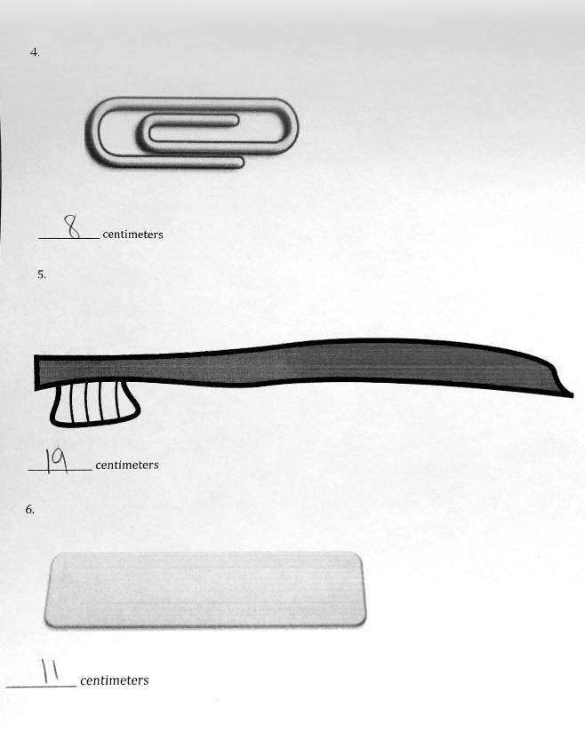

Overview
Second-grade students use a ruler to measure the length of several objects in centimeters, which is only partially aligned with a second-grade standard. Measuring length in centimeters is appropriate, but the assignment doesn’t ask students to choose the most appropriate tool to use based on the objects to be measured, as the second-grade standard requires.
Related Standards
We looked at how well the assignment aligned to the following standard:
KY.2.MD.1: Measure the length of an object by selecting and using appropriate tools such as rulers, yardsticks, meter sticks and measuring tapes.
Why is this assignment partially aligned?
This assignment is partially aligned with second-grade standard KY.2.MD.1, which requires students to select and use various standard tools such as meter sticks to measure length. In this assignment, students use a centimeter ruler to measure the length of several objects. Measuring length in centimeters with a ruler is appropriate, but students didn’t get to select the most appropriate tool to use given the objects being measured. This is a key aspect of KY.2.MD.1, because part of measurement proficiency is understanding that unit size matters and that it’s more efficient to measure objects of different sizes with different units. For example, centimeters are appropriate when measuring the length of a paper clip, while meters are better suited for measuring the length of a room.
This assignment builds students’ procedural skill, outlined in standard KY.2.MD.1. Students have multiple opportunities to practice using a concrete tool (centimeter ruler) to measure length. Students must use the tool correctly (for example, aligning the edge of the object at the zero mark on the ruler) to accurately complete the problems.
Practice Standards
This assignment gives students a chance to superficially engage with Mathematical Practice Standard #5 ("Use appropriate tools strategically"). Students repeatedly practice using the tool of a centimeter ruler to measure length but aren’t required to select the most appropriate tool to use given the objects to be measured. Selecting the most appropriate tool would give students a meaningful opportunity to engage with the practice standard.

