2nd Grade Reading & Writing Assignment
This assignment is partially aligned to the standards.

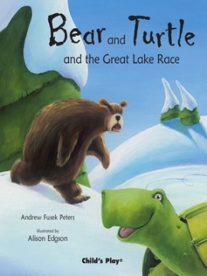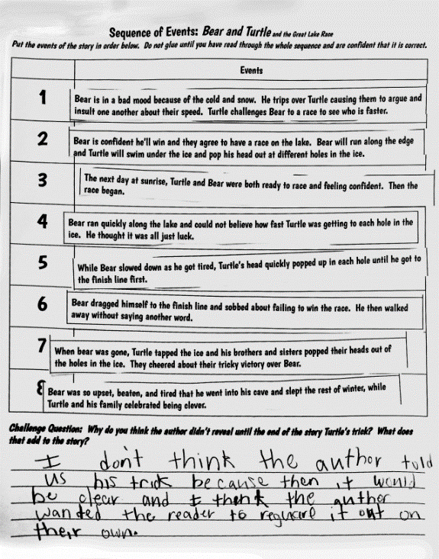
Overview
Second-grade students read an engaging adaptation of a Native American folk tale, then sequence the events in the story and respond to a question about the author’s craft. The text is worthwhile and adequately complex, but the associated task does not reflect the full demands of the grade-level reading standards. Students are only asked to recall the details of the story and do not have to demonstrate understanding of the overall structure or the central message.

About the Text

Title and Author | "Bear and Turtle and the Great Lake Race" by Andrew Fusek Peters
What is the Lexile Level of this text? | 500-600L
Based on Lexile, which grades is this text intended for? | 2-3
Is the text qualitatively complex enough for the grade? | Yes
Is this text fiction or non-fiction? | Fiction
Is this text authentic or was it written for educational purposes? | Authentic
Does the text provide sufficient detail to build knowledge of a worthwhile topic and/or is it worth reading closely and re-reading? | Yes

Related Standards
RL.2.2: Identify implicit and explicit information from a summary to determine the author’s message, lesson learned and/or moral, including but not limited to fables, folktales and myths from diverse cultures.
The assignment is weakly aligned to this standard. There are no story strips that do NOT apply to the story; therefore, students are simply sequencing events, not identifying implicit and explicit information from a summary. In this case, because the students do not identify implicit and explicit information, but rather they are provided with pre-selected strips, the alignment to and measurement of comprehension and analysis is weak. They also do not have to determine the author’s message/lesson/moral. Thus, there is no connection to the analysis required in the standard.

RL.2.5: Describe how parts of the text contribute to the overall structure of poems, stories and dramas, including but not limited to linear, nonlinear and circular structures.
The assignment is partially aligned to this standard. While students do have to put the strips in the correct sequence, they are only asked to describe how the trick at the end adds to the story. They are not asked to consider how the beginning and middle portions of this linear structure build to that discovery at the end. To achieve strong alignment, they might also have been asked to consider how what happens at the beginning and middle of the story set him up to be tricked by the end.

RL.2.10: By the end of the year, flexibly use a variety of comprehension strategies (i.e., questioning, monitoring, visualizing, inferencing, summarizing, using prior knowledge, determining importance) to read, comprehend and analyze grade-level appropriate, complex literary texts independently and proficiently.
The assignment is partially aligned to this standard. While the text is adequately complex for the grade, the associated tasks provide students with some opportunity to demonstrate understanding of the text, but miss the opportunity to have students flexibly use a comprehension strategy to reach the full depth of the standard.
NOTE: At the bottom of the assignment, the labeling of the question as being a “challenge” is misleading because the level of analysis in this question is a requirement of the standard and is not an extension to the standard. In fact, as discussed in the rationale above, this one analysis question about the contribution of the trick at the end of the story does not reach the depth of the entire standard.
Why is this assignment Partially aligned?
This assignment is partially aligned because the text is strong, but the questions are not:
The assignment allows students to read a worthwhile and adequately complex text. While this text is not an exemplar, fables, folk tales, and classic stories allow students to build their vocabulary and reading comprehension skills, become familiar with the key elements and parts of a story, and acquire cultural literacy.
It does not require students to demonstrate comprehension of the key ideas in the text. Instead, it focuses on the isolated skill of sequencing events.
The assignment could be stronger if it required students to describe the structure of the story orally or in writing. Students could be asked to include a description of how the beginning introduces the story and how the end concludes the action. Alternatively, the assignment could have focused students on the central message of the story.

