Second Grade Math Assignment
This assignment is weakly aligned to the standards.
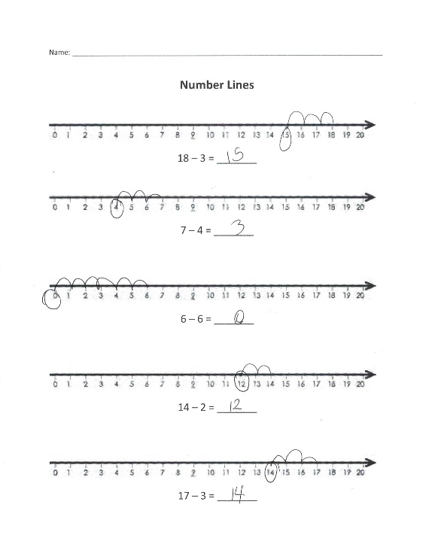
Overview
Second-grade students use a number line to subtract within 20. This assignment is weak because it is more closely aligned with a first-grade standard. Second-grade students should be fluently subtracting within 20 in their heads, not using tools such as number lines to help them subtract.

Related Standards
We looked at how well the assignment aligned to the following standard:
KY.2.OA.2: Fluently add and subtract within 20 using mental strategies. (counting on, making ten, decomposing a number leading to a ten, using the relationship between addition and subtraction, creating equivalent but easier or known sums.

Why is this assignment weakly aligned?
This assignment is aligned to a first-grade standard (KY.1.OA.6), not a second-grade one. In second grade, students should build on what they learned in first grade to mentally add and subtract fluently within 20. In this assignment, three of the five problems appropriately involve minuends in the teens (for example, 18-3), but two problems only involve subtracting within 10 (again, more closely aligned to KY.1.OA.6). The use of number lines is inappropriate for second grade, and students are not required to use any of the mental strategies outlined in second-grade standard KY.2.OA.2.
Second-grade standard KY.2.OA.2 targets procedural skill and fluency through the focus on using mental strategies to add and subtract fluently. The use of number lines does not give students an opportunity to use mental strategies to solve the problem.

Practice Standards
This assignment involves one mathematical practice standard, but it does so in an inappropriate way. Students are given number lines to help them subtract, which is related to Mathematical Practice Standard #5 (“Use appropriate tools strategically”). However, this is an inappropriate use of a tool given that standard KY.2.OA.2 targets procedural skill and fluency; students should be solving the problems using mental strategies, not tools like number lines. Furthermore, some problems can easily be solved without using a number line, which makes the focus of the assignment more about how to use the tool than about building students’ ability to choose the most appropriate tool (if needed) to solve a specific problem.

