2nd Grade Reading & Writing Assignment
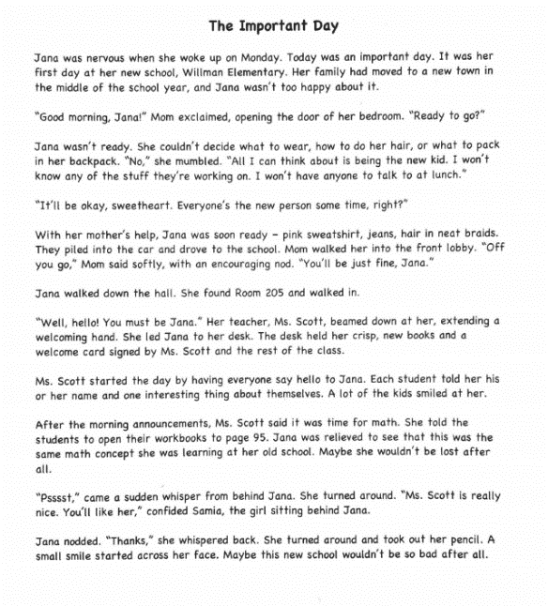
This assignment is weakly aligned to the standards.

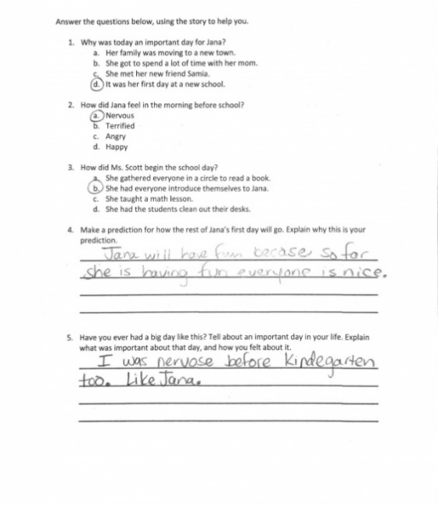
Overview
Second-grade students read a short text, then respond to three selected-response questions and two short answer questions. The text is not adequately complex or worthwhile. Students are asked text-dependent questions, but they do not have the opportunity to demonstrate an understanding of the main idea and key details in the text.
About the Text

Title and Author | "The Important Day"
What is the Lexile Level of this text? | 500L
Based on Lexile, which grades is this text intended for? | 2-3
Is the text qualitatively complex enough for the grade? | No
Is this text fiction or non-fiction? | Fiction
Is this text authentic or was it written for educational purposes? | Written for educational purposes
Does the text provide sufficient detail to build knowledge of a worthwhile topic and/or is it worth reading closely and re-reading? | No

Related Standards
RL.2.1: Ask and answer such questions as who, what, where, when, why and how, and make and support logical inferences to construct meaning from the text.
The assignment is weakly aligned to this standard. The assignment does not allow students to construct meaning from the text. The questions require only simple recall of information and do not require students to make inferences.

RL.2.10: By the end of the year, flexibly use a variety of comprehension strategies (i.e., questioning, monitoring, visualizing, inferencing, summarizing, using prior knowledge, determining importance) to read,

comprehend and analyze grade-level appropriate, complex literary texts independently and proficiently.
The assignment is weakly aligned to this standard. The assignment does not use a complex text so students are not able to practice a variety of comprehension skills or analyze text independently. The text is not adequately complex for second grade or worthy of student time and attention. Additionally, students are not asked to demonstrate deep understanding of the information and ideas in the text.

Why is this assignment weakly aligned?
The text does not build students’ knowledge of a topic or cultural competence. It was commissioned for educational purposes and explores an experience common to second grade readers. It contains simple sentence structures, familiar and conversational language, and one level of meaning. It is not worthy of students’ time and attention because it does not warrant reading and re-reading.
The assignment does not allow students to demonstrate understanding of the main idea of the text or key details. The questions require only simple recall of information and do not require students to demonstrate deep understanding.
The assignment does not require students to read with purpose. Students are not required to read carefully in order to answer the questions using evidence from the text.

