Grade 3 Assignment
This assignment is strongly aligned to the Kentucky Academic Standards (KAS) for Social Studies
Teacher Notes

Introduction
This Teacher Notes document provides instructional support for implementing the strongly aligned assignments to the KAS for Social Studies. To examine why this assignment is strongly aligned to the KAS for Social Studies, engage with the Grade 3 Assignment Review Protocol for this assignment.
It is important to note that the assignment(s), indicated throughout the Teacher Notes, and related resource(s) represent one example. It is not a requirement nor a suggestion for school curriculum. While the Kentucky Department of Education (KDE) is responsible for the development of high-quality academic standards, state law assigns each local district the authority to develop the school’s curriculum and determine appropriate instructional resources based on language found in Kentucky Revised Statute (KRS) 160.345. It is under the discretion of the superintendent to determine the local curriculum, including the evaluation and selection of instructional resources. The KDE does not adopt or select specific curricula for coursework. Per KRS 160.345(g), “the local superintendent shall determine which curriculum, textbooks, instructional materials, and student support services shall be provided in the school after consulting with the local board of education, the school principal, and the school council and after a reasonable review and response period for stakeholders in accordance with local board of education policy.”
KAS for Social Studies alignment:
- 3.I.Q.1 Ask compelling questions about the interactions of diverse groups of people.
- 3.I.Q.2 Develop supporting questions that help answer compelling questions about the interactions of diverse groups of people.
- 3.E.ST.1 Describe examples of economic interdependence.
- 3.G.GR.1 Explain how physical and cultural characteristics of world regions affect people, using a variety of maps, photos and other geographic representations.
- 3.I.UE.2 Explain the relationship between two or more sources on the same theme or topic.
- 3.I.UE.3 Construct responses to compelling and supporting questions about the interactions of diverse groups of people using evidence and reasoning.
- 3.I.CC.1 Construct an explanation, using relevant information, to address a local, regional or global problem.

Educators may have to engage with a standard multiple times throughout a year in order to meet the full intent of the standard. As a result, the following assignment example may not encompass the entire scope of the standards identified.

Overview:
After reading a children’s text, How to Make an Apple Pie and See the World by Marjorie Priceman, to introduce economic interdependence, students will research world regions to see how physical and cultural characteristics impact the goods a region can produce. Students demonstrate their knowledge of economic interdependence by constructing an argument to answer the compelling question: “How does where we live affect how we live?”

Setting the Stage: Compelling Question

3.I.Q.1 Ask compelling questions about the interactions of diverse groups of people.

Compelling Question:
“How does where we live affect how we live?”

Compelling questions are open-ended, enduring and center on significant unresolved issues. This assignment provides a compelling question to demonstrate alignment because Grade 3 students are not required to ask compelling questions without teacher support. It is not the expectation of the standard that students develop compelling questions on their own. For more information on compelling questions, visit Section B: “What are Compelling Questions and how do students ask them?” from the Inquiry Practices of the KAS for Social Studies module.

Introduce the compelling question, “How does where we live affect how we live?” to students by discussing the characteristics and unique qualities of where we live. First, have students do the following:

Turn and Talk to a partner to answer the following question:

What are the characteristics of where we live in Kentucky?
If needed, prompt them to think about the climate, landforms, natural resources, animals, etc. Once they have had time to share ideas, create a list on the board or chart paper and record students’ ideas. Some responses may include, but are not limited to, the following:
- mild climate/all four seasons
- rainfall throughout the year
- grassy
- many hills
- some mountains
- rivers
- lakes
- forests/many trees
- many animals (they may list common ones like squirrels, deer, etc.)
- coal
- farming

Once the class has developed a list, ask students to do the following:

Turn and Talk to a partner again, this time responding to the following question:

How do these characteristics of Kentucky affect how we live?

If needed, prompt students to think about how the climate impacts what we wear and things we do, how the geography of Kentucky (or our community) impacts the type of food we can grow, etc. After their peer discussion, ask students to share their ideas. Some responses may include:

- We must prepare for all types of weather in Kentucky and may wear anything from shorts and sandals to thick winter coats and boots, depending on the season and weather.
- Many different types of crops, such as soybeans, hay, corn and wheat, are grown here and can be sold or consumed.
- Many people hunt and eat the animals that are available, such as deer, turkey, squirrel and rabbit.
- Our community gets its drinking water from a variety of sources, such as the Kentucky River.
- Forests provide wood/lumber that can be used for building things that can be used and sold.
- Resources like coal can be mined and used for energy.
- People can swim in the summer and go sledding in the winter.

Once students have demonstrated that they understand how the environment where they live impacts their lifestyles, pose the question, “How might we live differently if we lived in a hot, dry climate?” Then ask, “What about a cold, wet climate?” Ask students to give examples of how their lives might differ from ours based on the characteristics of where they live. Explain to students that you will be thinking about how where you live affects how you live as you explore a variety of supporting questions that will help answer this compelling question.

Supporting Question

3.I.Q.2 Develop supporting questions that help answer compelling questions about the interactions of diverse groups of people.

Supporting Question:
“Why do countries depend on each other to produce products?”

Supporting questions are aligned to the compelling question and can be answered though using the concepts and practices of each social studies discipline. In grade 3, students are expected to develop supporting questions. Strategies such as Think, Puzzle Explore, may be used to support students in this work. For more information on developing supporting questions, visit “Section C: What are Supporting Questions, and how do students ask them?”
from the Inquiry Practices of the KAS for Social Studies module.

Investigation: Part 1
3.E.ST.1 Describe examples of economic interdependence.

In order to investigate economic interdependence, the following resources may be utilized:
- Priceman, M. (1994). How to Make an Apple Pie and See the World. New York, NY: Dragonfly Books.
- United States Department of Agriculture. (2019). Canada remains the top destination for U.S. exports in 2018 [chart]. https://www.ers.usda.gov/data-products/chart-gallery/gallery/chart-detail/?chartId=58374.
- Martin, Will. (2017, December 23). This amazing visualisation shows how the world's ships move goods around the globe. https://www.businessinsider.com/map-of-global-shipping-interactive-2017-12.

Explain to students that they are going to investigate the supporting question, “Why do countries depend on each other to produce products?” Ensure that students understand the vocabulary presented in this question and discuss what the question means. Explain to students that you are now going to investigate why countries depend on each other to produce products.

Read How to Make an Apple Pie and See the World aloud to the class. This is a picture book that is a fictional story, but the situation presented in the story helps provide context for understanding economic interdependence. During and after reading, the following questions can guide discussion to help students understand economic interdependence as presented in the story:
- Why did the character have to travel around the world to get the ingredients she needed?
- Why do you think those countries specialized in those items?
- Do you think there are other products and recipes that require items from different countries around the world, like the apple pie did?
- Can we always get everything we need in our own country or community?
- What are some other situations where we depend on other countries for certain products?
Next, explain to students that they are going to examine two sources to investigate why countries depend on each other to produce products. The first source is a chart showing the top U.S. agricultural exports:

- 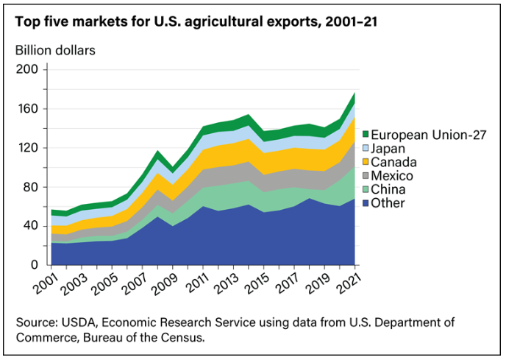

Present the chart to the class and ensure that students understand that “agricultural” refers to farming, and that exports are goods that are sold from the U.S. to other countries. Identify the top countries the U.S. exports agricultural goods to and identify the location of these countries on a world map or globe for students. Ask students to review the chart and do the following:

Work with a partner to conduct a See, Think, Wonder. Discuss the following questions:

- What do you see?
- What do you think about that?
- What does it make you wonder?

After students have had time to discuss with their partner, discuss as a whole group, allowing partners to share. Then, pose the following questions to students:

- Why might we trade so much with Canada and Mexico? Students may respond that since they are our closest neighbors, it would be easier and cheaper to transport goods to and from these countries.
- Why might we trade with faraway places such as China, Japan, and Europe? Students may respond that although they are further away and it is probably expensive to transport goods that far, these countries may have very different resources available due to their different climate, landforms, etc. Additionally, these countries may want things that the U.S. specializes in that are not available to them.

Students can then examine the interactive map (at the bottom of the article) that shows the flow of goods as freighter ships travel across the globe. Ask students to explore the map to see the flow of goods in and out of regions throughout the world. Some discussion questions as students explore this source may include, but are not limited to, the following:

- What regions in the world are trading goods with the United States? Students may respond that the map shows goods coming in and out of the United States and traveling in all directions toward other regions across the globe.
- Why do all these regions trade with each other instead of just using what they have in their own regions? Students may respond that different regions may have different goods and products to offer, so trading can help everyone get what they want or need.
- Using this map, make an inference: Why do certain places specialize in different types of products for trade? Students may respond that different regions across the globe have different climate, resources, culture, etc. that influence the goods they produce, and that the surplus of these items can be traded with other regions for other goods they desire that may not be available in their own region.
- Consider the book and two sources we have explored so far. What did you learn about world trade from the book and sources you have explored so far? Students may respond that each source shows that different regions across the globe depend on each other. In the book, different countries specialize in producing the goods that together make up a product (apple pie). The chart shows us that the United States trades many agricultural products with countries both near and far, and the map shows us that regions across the world are trading goods with one another.

Next, discuss the meaning of “economic interdependence” as a class and develop a definition. Then, have students work in small groups to reexamine and consider the book and the two sources they have examined to complete the following graphic organizer:

Book/Source | What does this book/source tell us about economic interdependence?
How to Make an Apple Pie and See the World
Chart showing the top U.S. agricultural exports
Interactive map

Check students’ graphic organizers as they work to ensure that they are developing an understanding of economic interdependence. Students’ organizers should include that the economy is global, and trade happens throughout the world so different places can obtain a variety of goods that may not be available to them otherwise.

Investigation: Part 2
3.G.GR.1 Explain how physical and cultural characteristics of world regions affect people, using a variety of maps, photos and other geographic representations.

To have students further investigate the economic interdependence that takes place in order to produce a product, the following is a task that students can complete in small groups:

Identify a product and research THREE ingredients/components needed to produce the product. Once the ingredients/components are identified, research the country of origin of each ingredient/component. Discuss what factors of production allow that country to specialize in the production of that ingredient/component. Be sure to cite the website where you found this information.
Product: _________________________
Ingredient/Component | Country of Origin | Why does the country of origin specialize in this product?

Students can choose a product with which they are familiar, or products may be pre-selected for students based on their needs. Also, a goal or limit may be set for the number of components of the product for students to research, as some products may contain a large quantity of parts. In the examples provided, students select three components or ingredients of the product to research.
Explain to students that they are going to research the parts that make up the product and identify the country from which this product came. If students chose a food product like the apple pie, they may research which countries specialize in each ingredient, or which countries the U.S. imports these goods from in order to select a country of origin.
They will then look at a climate or physical map or research the physical characteristics of the country of origin to determine why they believe this country specializes in this product. It may be helpful to work through an example as a class, modeling how to complete the chart. This could be accomplished by using the apple pie with examples from the book, or by choosing a different product to explore as a class prior to students researching their own products.

Here is an example of how students may complete the chart based on a product that has parts from various countries. Note that students should cite the sources used. In these examples, the sources are cited below the chart. While we have sources cited in APA format, it is appropriate for Grade 3 students to cite their sources in a more simplified way at your discretion, such as listing the title of the website with the link.

Product: iPhone
Ingredient/Component | Country of Origin | Why does the country of origin specialize in this product?
speaker | Mongolia | The speakers require four rare earth materials. 90% of the world’s rare earth materials are found in this region.
battery | Korea/Taiwan | This area has the top 2 chipmaker companies: Samsung and Sk Hynix.
assembly | China | China has Foxconn, which is the world’s largest electronics manufacturer.

Source used:
Tweney, Dylan. (2013). Your iPhone: Made in China, Korea, Texas, Kentucky, and...Inner Mongolia?. https://venturebeat.com/2013/07/31/iphone-manufacturing-graphic/.

Additionally, here is an example of how a student might complete a chart based on a food product that is created with different ingredients that may be imported from different countries:

Product: banana pudding
Ingredient/Component | Country of Origin | Why does the country of origin specialize in this product?
banana | Ecuador | Ecuador is the biggest exporter of bananas in the world. Bananas need a warmer climate to grow, and Ecuador is near the equator.
cinnamon | Indonesia | Most of the world’s cinnamon comes from trees in the jungles of Indonesia.
flour | United States | Flour is made from wheat, which is grown throughout the United States. Kentucky ranks 14th in the country for wheat production. Wheat is grown best in cooler climates, so it is grown here during the fall, winter and spring.

Sources Used:
Andreas. (2022, March 16). Top 10 Largest Banana Producing Countries. Mappr. https://www.mappr.co/largest-banana-producing-countries/.

Fessenden, Maris. (2015, April 22). Here’s How Cinnamon is Harvested in Indonesia. Smithsonian Magazine. https://www.smithsonianmag.com/smart-news/heres-how-cinnamon-harvested-valley-indonesia-180955063/#:~:text=Most%20of%20so%2Dcalled%20%22true,the%20Food%20and%20Agriculture%20Organization.

KY Foods and Farm. (n.d.). Kentucky’s Wheat Industry. https://www.kyfoodandfarm.info/wheat.

Here is an example from a Kentucky classroom:

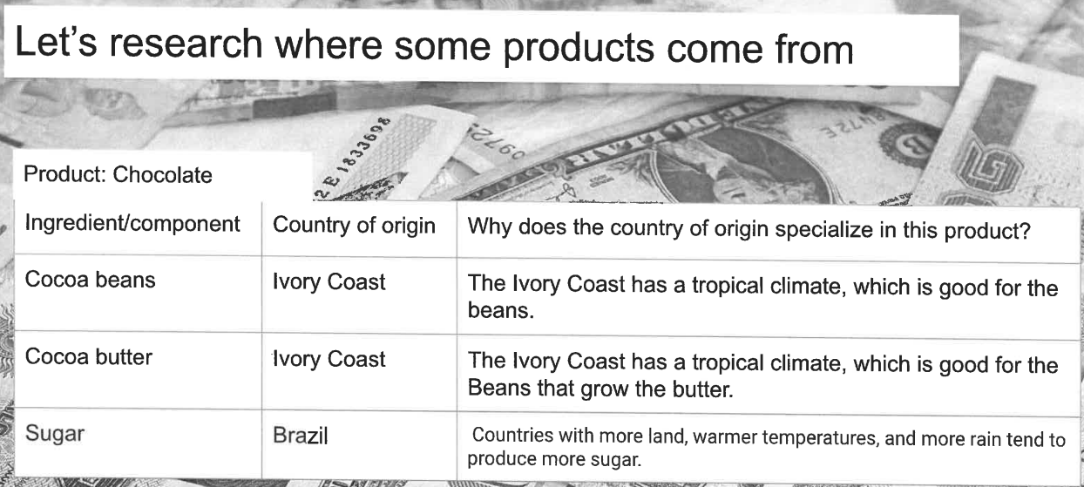

As students work, provide support when needed. As groups are concluding their work, come back together for a whole group discussion. Visit Leading Discussions for guidance on whole group discussions. Some questions to pose may include:

- How does the climate impact the production of the ingredients/components of the product?
- How might the available resources impact the production of the ingredients/components of the product?
- How might the physical features of the country impact the production of the ingredients/components of the product?
- Why is one country unable to produce all the resources needed to produce the product?

Once students have had time to research their product and complete their chart, ask them to do the following:

Do a Quick Write to answer the following question:

“Why do countries specialize in certain products?”

Include at least two examples to support your explanation and cite information from sources.

Check their responses to ensure that they understand that their environment influences what they can produce effectively, so they often choose to specialize in products from the resources that are available and may be unique to their area so they can trade with other countries who are not able to produce this product effectively.

Task Aligned to the Supporting Question:
KAS for Social Studies alignment:
- 3.I.Q.2 Develop supporting questions that help answer compelling questions about the interactions of diverse groups of people.
- 3.E.ST.1 Describe examples of economic interdependence.
- 3.G.GR.1 Explain how physical and cultural characteristics of world regions affect people, using a variety of maps, photos and other geographic representations.
- 3.I.UE.2 Explain the relationship between two or more sources on the same theme or topic.

In this task, students are required to synthesize information learned through engaging with the disciplinary strand standards to answer the supporting question. To prepare students for this task, allow students to use information from previous investigations that can help them answer the supporting question, including the book and two sources, their graphic organizers and Quick Write.

Assign students to small groups and provide them with chart paper. Use the Claim, Support, Question strategy to have students do the following:

With your small group, consider the supporting question: “Why do countries depend on each other to produce products?” Then, discuss and record your answers to the following on your chart paper.

“Why do countries depend on each other to produce products?
Make a claim:  Countries depend on each other to produce products because… | Identify support for your claim by quoting information from two of the sources you investigated.
Ask a question related to your claim. What isn’t explained?

As groups work, provide support as needed. Encourage students to utilize and cite evidence from the sources as they identify support for their claim. Once students finish, hang the chart papers and allow groups to travel to each one and read their classmates’ responses. Then, facilitate a whole class discussion about the supporting question, “Why do countries depend on each other to produce products?” Visit Leading Discussions for guidance on whole group discussions. Some questions to guide this discussion may include:

- Claims:
  - What trends do you notice about the claims written in response to this question?
  - How were the claims similar and how were they different?
  - Which claim from other groups do you think is the strongest and why?
- Evidence:
  - Identify two sources that support your understanding of why countries depend on each other to produce products. What did you learn about each country from each source?
  - What trends do you see in the evidence that was used to support these claims?
  - What is some of the strongest support you noticed from other groups, and why?
  - How does this evidence support the claim?
  - Was information from the sources cited in the evidence provided?
- Question:
  - What trends do you observe in the questions being asked?
  - Are there any questions we can answer together now using what we have learned so far?
  - Are there any questions we can research to find answers to?

Explain to students that they are now going to independently complete the Task Aligned to the Supporting Question, which is below. Read the task together as a class, clarifying any challenging vocabulary and allowing students the opportunity to ask questions. Review the standards that are being assessed with students, so they are aware that you are looking for evidence of their mastery of the two disciplinary standards and the inquiry standards of questioning and using evidence. For example, students may explain the relationship between the chart showing the top U.S. agricultural exports and the interactive map. The exports chart shows where U.S. goods are going, which helps explain the concept of economic interdependence and products in our country are needed and/or wanted in other countries. The interactive map further helps illustrate economic interdependence by demonstrating how goods are imported and exported throughout the globe. Emphasize with students the importance of explaining the relationship of two or more sources in their response as they provide the evidence for their claim. Additionally, you may consider providing scaffolds to help them plan their responses, such as graphic organizers or sentence stems, depending on the needs of your students.

Task Aligned to the Supporting Question:
Using your knowledge of economic interdependence and how physical and cultural characteristics of world regions affect people, answer the supporting question.
Supporting question: Why do countries depend on each other to produce products?
Be sure to explain the relationship between two or more sources in your response.

Student Work Samples:
Below are authentic student work samples from Kentucky classrooms of the Task Aligned to the Supporting Question.

Strongly Aligned Work Sample:
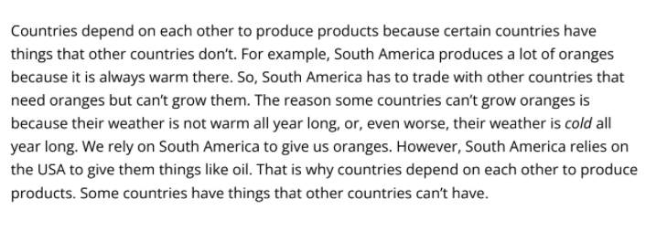

Partially Aligned Work Sample:
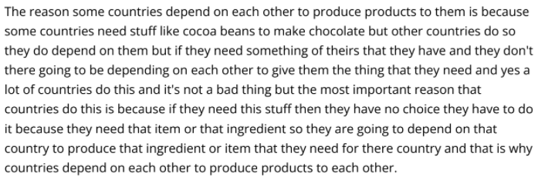

Weakly Aligned Work Sample:

Task Aligned to the Compelling Question:

KAS for Social Studies alignment:
- 3.I.Q.1 Ask compelling questions about the interactions of diverse groups of people.
- 3.I.UE.3 Construct responses to compelling and supporting questions about the interactions of diverse groups of people using evidence and reasoning.
- 3.I.CC.1 Construct an explanation, using relevant information, to address a local, regional or global problem.

Assignments aligned to the compelling question are designed to provide guidance on how to have students synthesize the knowledge learned from engaging with the supporting question(s) to investigate enduring and significant unresolved issues addressed by the compelling question. In this example, one supporting question is provided that is aligned to a compelling question. However, students may need to engage with more than one supporting question in order to fully engage with a compelling question. This assignment culminates with students using their historical thinking skills to address how a specific problem can manifest itself at local, regional and global levels over time.

Task Aligned to the Compelling Question:
Part One: Construct an explanation to answer the following question: How does where we live affect how we live? Be sure to include information about the interactions of diverse groups of people and use evidence and reasoning in your response.

Part Two: Using your knowledge of how where we live affects how we live, construct an explanation, using relevant information from the sources, to address a local, regional or global problem.

The focus of Grade 3 is the extension of students’ understanding of the concept of community to include global communities. Students explore interactions between groups of people in Africa, the Americas, Asia, Europe and Oceania (Australasia, Melanesia, Micronesia and Polynesia). The culminating assignment is students’ synthesis, or integration of knowledge and ideas, of the KAS for Social Studies after students have investigated a series of supporting questions that equip students to complete the assignment aligned to the compelling question. Students could present their explanations in a variety of ways, including an essay, PowerPoint presentation, poster, video or other multimedia format. They can present these products, bringing awareness to the problems they researched and introducing possible ways to confront or solve the problems. This will extend students’ learning by exposing them to the many ways where we live affects how we live.

