Third Grade Math Assignment
This assignment is strongly aligned to the standards.
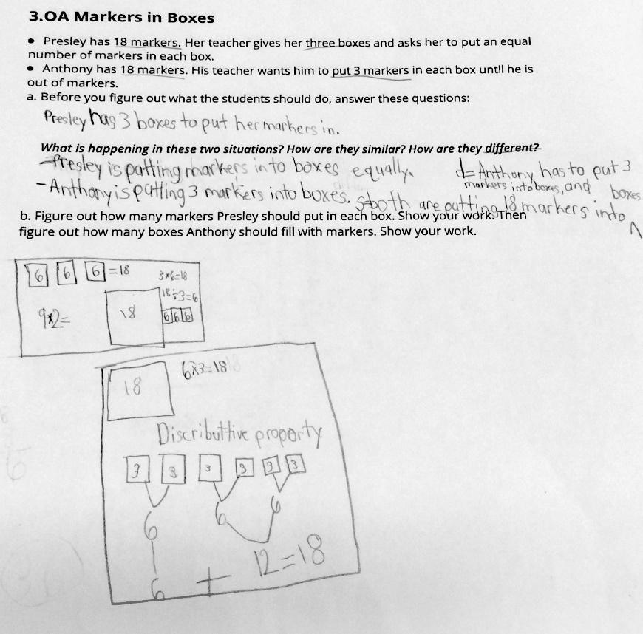

Overview
Third-grade students interpret and solve two division word problems. This assignment is strong because it builds students' conceptual understanding of division by asking them to explain what is happening in two similar but different real-world scenarios and to use visual models to solve both problems.
Related Standards
We looked at how well the assignment aligned to the following standards:
KY.3.OA.2 Interpret and demonstrate whole-number quotients of whole numbers, where objects are partitioned into equal shares.
KY.3.OA.3 Use multiplication and division within 100 to solve word problems in situations involving equal groups, arrays and measurement quantities, by using drawings and equations with a symbol for the unknown number to represent the problem.

Why is this assignment strongly aligned?
This assignment is well-aligned with both target third-grade standards:
KY.3.OA.2 requires students to interpret quotients in two scenarios and the assignment includes both. In problem 1, students find the unknown group size, and in problem 2, they find the unknown number of groups.
KY.3.OA.3 requires students to solve division problems in the context of word problems, and the assignment includes two word problems about putting markers in boxes. The numbers used (dividing 18 by 6 and 3) are also appropriate because third-graders should be working on dividing whole numbers within 100.
This assignment addresses conceptual understanding and application. Third grade is the first year that students begin studying multiplication and division in depth, and a huge focus of third grade math instruction is developing students' conceptual understanding of these operations so that they’re able to tackle more advanced work with multiplication and division in future grades. For example, students must understand that division represents splitting a set of objects into equal groups and division problems can require either finding the unknown number of groups or the unknown group size. Asking students to interpret and explain what is happening in the two scenarios in the assignment gives them a chance to build that conceptual understanding. The word problem format also allows students to apply that mathematical understanding to a real-world situation.
Practice Standards
This assignment allows students to engage with multiple mathematical practice standards. Interpreting what is happening in both scenarios gives students the chance to engage with Mathematical Practice Standard #1 ("Make sense of problems and persevere in solving them"). Representing the real-world topic (number of markers in boxes) mathematically with drawings gives students the chance to engage with Mathematical Practice Standard #4 ("Model with mathematics"). Asking students to explain how the two scenarios are similar and different gives students the chance to engage with Mathematical Practice Standard #3 (“Construct viable arguments and critique the reasoning of others”).

