3rd Grade Reading & Writing Assignment
This assignment is strongly aligned to the standards.

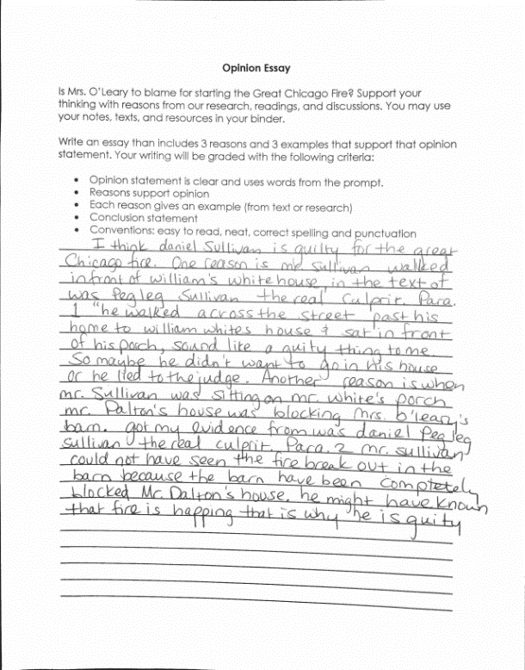

Overview
Third-grade students read a series of grade-appropriate texts and primary sources about the Great Chicago Fire of 1871, then write an essay. The texts, which were compiled by the Chicago Historical Society, include Catherine O’Leary’s testimony before the board of inquiry investigating the fire. After analyzing the texts, students are required to write an essay making an argument about who is to blame for starting the fire. This assignment exposes students to a series of content-rich, worthwhile texts and asks students to make a claim and support their ideas in writing, using textual evidence.
About the Text

Title and Author | Various texts and primary sources about the Great Chicago Fire of 1871 compiled by the Chicago Historical Society
What is the Lexile Level of this text? | Varies
Based on Lexile, which grades is this text intended for? | 2-3
Is the text qualitatively complex enough for the grade? | Yes
Is this text fiction or non-fiction? | Non-Fiction
Is this text authentic or was it written for educational purposes? | Both
Does the text provide sufficient detail to build knowledge of a worthwhile topic and/or is it worth reading closely and re-reading? | Yes

Related Standards
RI.3.1: Ask and answer questions, and make and support logical inferences in order to construct meaning from the text.
The assignment is strongly aligned to this standard. Students have the opportunity to demonstrate understanding of the texts by developing an opinion supported by logical reasons and textual evidence.
RI.3.3: Describe the relationship between individuals, a series of historical events, scientific ideas or concepts or steps in technical procedures over the course of a text.
The assignment is strongly aligned to this standard. Students have the opportunity to explore the relationship between a series of events and examine the causes of the Great Chicago Fire of 1871.
RI.3.10: By the end of the year, flexibly use a variety of comprehension strategies (i.e., questioning, monitoring, visualizing, inferencing, summarizing, using prior knowledge, determining importance) to read, comprehend and analyze grade-level appropriate, complex informational texts independently and proficiently.
The assignment is strongly aligned to this standard. Students need to comprehend the information presented in a series of adequately complex and worthwhile texts on the topic to respond to this writing prompt.
C.3.1: Compose opinion pieces, using a combination of writing and digital resources, on topics or texts, with supporting reasons.
The assignment is strongly aligned to this standard. Students are expected to clearly state an opinion, create an organizational structure that lists reasons that support their point of view, provide evidence from text to support the opinion, and provide a concluding section related to the opinion presented.
C.3.6: Summarize information from experiences or gather information from print and digital sources; take brief notes on information from various print/digital sources, and analyze by sorting into appropriate categories.
The assignment is strongly aligned to this standard. As they draft their opinion piece, students reference the notes, texts and resources in their binders.
L.3.2: When writing: a. Capitalize appropriate words in titles; b. Use commas in addresses; c. Use commas and quotation marks in dialogue; f. Use spelling patterns and generalizations in writing words.
The assignment is strongly aligned to this standard. The writing prompt sets expectations for students’ command of the conventions of standard English spelling and punctuation.
Why is this assignment strongly aligned?
The assignment exposes students to a series of worthwhile texts and primary sources. The texts contain useful information about conditions that made Chicago in the 1870s susceptible to a massive fire, and about the impact the fire had on city planning. The connections between events described in the texts are subtle and the language is sometimes unfamiliar, making the texts worth reading and re-reading.
The assignment requires students to identify and examine the textual evidence. Students are asked to make an argument about who was responsible for starting the fire and to support that claim with evidence.
The assignment requires students to demonstrate understanding and present a well-defended opinion in writing. Students are expected to clearly state an opinion, present a list of reasons that support their point of view, provide evidence from the text, and craft a concluding section.
The assignment provides an opportunity for students to apply the conventions of standard English. Students practice using important, grade-appropriate literacy skills, including correct grammar and punctuation.
While the task is strongly aligned to the standards, the student response does not fully reflect the expectations of the standards. It would be stronger if the student explained how the selected evidence supports their point of view.

