Third Grade Math Assignment
This assignment is partially aligned to the standards.
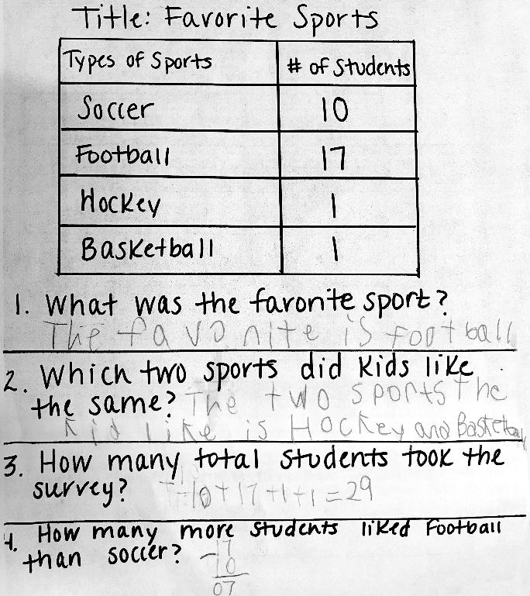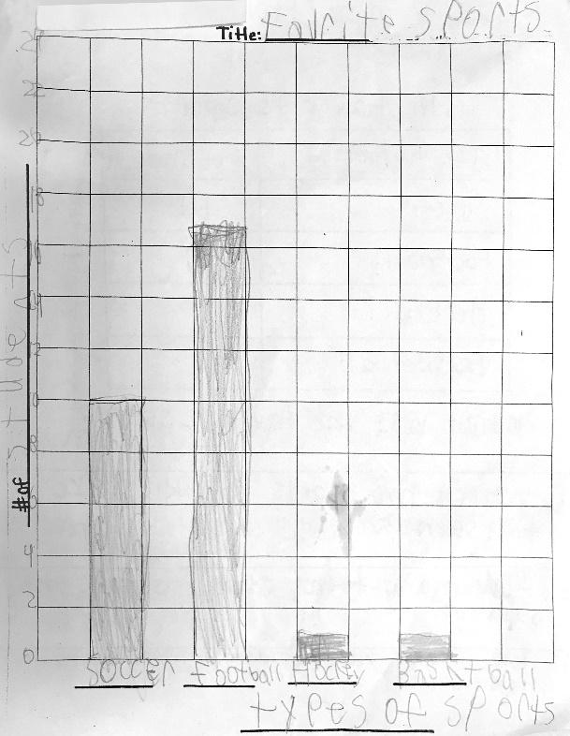

Overview
Third-grade students answer questions about a data set and draw a bar graph to represent the data set. This assignment gives students a chance to model a real-world situation (students’ favorite sports) mathematically, but it is only partially aligned with a third-grade standard and does not connect to any of the main topics that students should be learning about in third grade.

Related Standards
We looked at how well the assignment aligned to the following standard:
KY.3.MD.3: Investigate questions involving categorical data.
a. Identify a statistical question focused on categorical data and gather data;
b. Create a scaled pictograph and a scaled bar graph to represent a data set (using technology or by hand);
c. Make observations from the graph about the question posed, including “how many more” and “how many less” questions.

Why is this assignment partially aligned?
This assignment is partially aligned with third-grade standard KY.3.MD.3. Students draw a bar graph to represent a data set with four categories (soccer, football, hockey, and basketball), which aligns with the “several” categories the standard calls for. The bar graph is scaled appropriately for third grade (the scale is two units, compared to the second-grade standard KY.2.MD.10 that only requires bar graphs with a single-unit scale). However, the third-grade standard also requires students to solve one- and two-step "how many more/less" problems about the data set. Only one of the four problems in this assignment is a one-step “how many more” problem, and there are no two-step problems. The first three questions are more closely aligned with first-grade standard KY.1.MD.4 and second-grade standard KY.2.MD.10.
The critical areas for third grade include solving problems with all four operations—adding and subtracting within 1000 and multiplying and dividing within 100. The type of addition and subtraction that students were asked to do in this assignment (adding 17+10+1+1=29 and subtracting 17-10=7) is below grade level.
Practice Standards
This assignment connects math to a real-world topic (students' favorite sports) and representing the real-world topic mathematically with a bar graph gives students the chance to engage with Mathematical Practice Standard #4 ("Model with mathematics").

