3rd Grade Reading & Writing Assignment
This assignment is partially aligned to the standards.

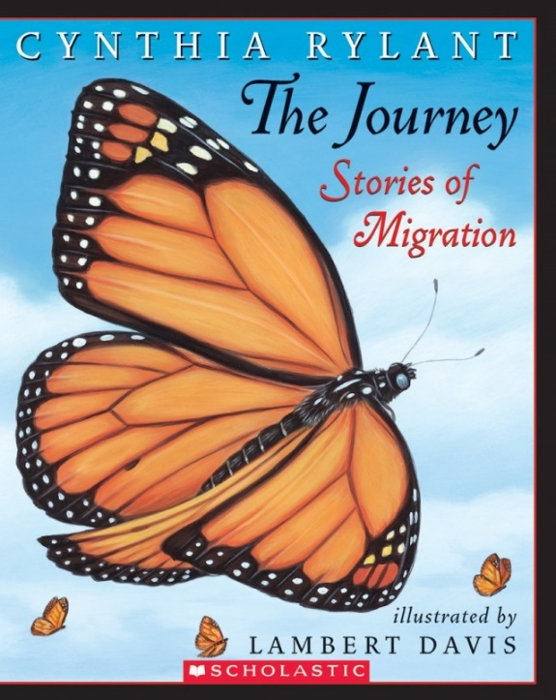
Directions: Use information from the text to compare and contrast the migratory journeys of whales and locust. Use the Venn diagram to organize the information.
The Journey

Overview
Third-grade students read a grade-appropriate text about animal migration, then use a Venn diagram to compare and contrast the migratory journeys of whales and locusts. This assignment exposes students to a worthwhile non-fiction text, but the task does not require students to engage in a grade-appropriate analysis of time, sequence, and cause and effect within the text. Students are not required to develop a deep understanding of the information presented in the text in order to complete the task.

About the Text
Title and Author | "The Journey: Stories of Migration" by Cynthia Rylant
What is the Lexile Level of this text? | AD900L
Based on Lexile, which grades is this text intended for? | 4-5
Is the text qualitatively complex enough for the grade? | Yes
Is this text fiction or non-fiction? | Non-Fiction
Is this text authentic or was it written for educational purposes? | Authentic
Does the text provide sufficient detail to build knowledge of a worthwhile topic and/or is it worth reading closely and re-reading? | Yes

Related Standards
RI.3.1: Ask and answer questions, and make and support logical inferences in order to construct meaning from the text.
The assignment is partially aligned to this standard. Students are instructed to refer explicitly to the text as the basis for their answers, but are not asked to make or support logical inferences.

RI.3.3: Describe the relationship between individuals, a series of historical events, scientific ideas or concepts or steps in technical procedures over the course of a text.
The assignment is partially aligned to this standard. Students categorize and explore scientific ideas (i.e., a Venn diagram of the migratory journey of whales and locusts) but they are not prompted to formally describe the relationship.

RI.3.10: By the end of the year, flexibly use a variety of comprehension strategies (i.e., questioning, monitoring, visualizing, inferencing, summarizing, using prior knowledge, determining importance) to read, comprehend and analyze grade-level appropriate, complex informational texts independently and proficiently.
The assignment is strongly aligned to this standard. Students do need to comprehend the information presented in an adequately complex and worthwhile text to complete this task.
Why is this assignment Partially aligned?
This assignment is partially aligned because the text is adequately complex and the task has some strengths, but the questions could be more strongly aligned to the depth of the standards:
The assignment exposes students to a grade-appropriate, worthwhile text. The text contains useful information about the migratory journeys of six different animals (locusts, gray whales, American silver eels, monarch butterflies, caribou, and terns) and complex vocabulary (e.g., words like “migrate,” “profound” and “survival”). The text is written in poetic prose and includes vibrant illustrations of the different animals.
The assignment requires students to consider the relationship between two scientific ideas but does not ask students to describe that relationship orally or in writing. Students are required to use a Venn diagram to explore the migratory journeys of whales and locusts, but do not have the opportunity to describe that relationship using language that pertains to time, sequence, and cause/effect.
The task could be stronger if students were asked to write an informational piece using evidence from the text after completing the Venn diagram. Students could be asked to compare the migratory journeys of animals in writing and integrate definitions and details from the text. However, as a stand-alone assignment, the Venn diagram does not reflect the demands of the grade-level standards.

