Third Grade Math Assignment
This assignment is weakly aligned to the standards.
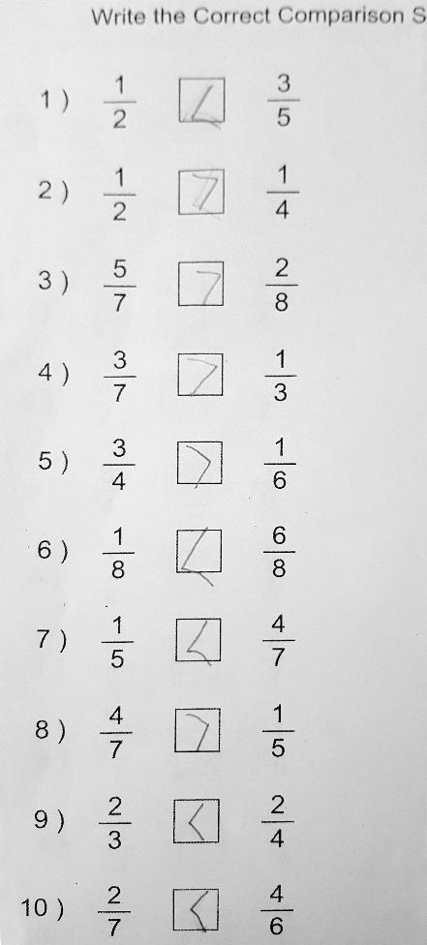
Overview
Third-grade students compare fractions with different numerators and/or different denominators. This assignment is weak because it only requires students to procedurally complete the comparisons and is therefore more closely aligned to a fourth-grade standard; it doesn’t help build a conceptual understanding of fraction size that third-graders need as a foundation for future work with fractions.

Related Standards
We looked at how well the assignment aligned to the following standard:

KY.3.NF.3: Explain equivalence of fractions in special cases, and compare fractions by reasoning about their size.
- Compare two fractions with the same numerator or the same denominator by reasoning about their size. Recognize that comparisons are valid only when the two fractions refer to the same whole. Record the results of comparisons with the symbols <, =, or >, and justify the conclusions. Note: grade 3 expectations in this domain are limited to fractions with denominators 2, 3, 4, 6 and 8.

Why is this assignment weakly aligned?
This assignment is more closely aligned with a fourth-grade standard. The third-grade standard KY.3.NF.3 calls for comparing two fractions with different numerators or different denominators, but only three of the ten problems (#2, 6, 9) fit that description. The other seven problems involve comparing two fractions with different numerators and denominators, which more closely aligns with fourth-grade standard KY.4.NF.2.
This assignment doesn’t help students build conceptual understanding, which is required by standard KY.3.NF.3. Third grade is the first year that students begin seeing fractions as numbers, and a huge focus of third grade math instruction is developing students' conceptual understanding of fractions so that they’re able to tackle more advanced work with fractions in future grades. For example, students must understand that the size of a fractional part depends on the size of the whole. To help students gain this foundational understanding, fractions are represented not only numerically but also visually and physically (for example, drawing fraction models or using fraction manipulatives). In this assignment, fractions are only represented numerically.
Practice Standards
This assignment doesn’t allow students to engage with any mathematical practice standards. Standard KY.3.NF.3 calls for students to reason about fraction sizes and justify their conclusions, which is aligned with Mathematical Practice Standard #3 (“Construct viable arguments and critique the reasoning of others”). In this assignment, students have to fill in inequality symbols but aren’t asked to explain their answers.

