Grade 4 Assignment
This assignment is strongly aligned to the Kentucky Academic Standards (KAS) for Social Studies.

Teacher Notes

Introduction
This Teacher Notes document provides instructional support for implementing the strongly aligned assignments to the KAS for Social Studies. To examine why this assignment is strongly aligned to the KAS for Social Studies, engage with the Grade 4 Assignment Review Protocol for this assignment.

It is important to note that the assignment(s), indicated throughout the Teacher Notes with shaded boxes, and related resource(s) represent one example. It is not a requirement nor a suggestion for school curriculum. While the Kentucky Department of Education (KDE) is responsible for the development of high-quality academic standards, state law assigns each local district the authority to develop the school’s curriculum and determine appropriate instructional resources based on language found in Kentucky Revised Statute (KRS) 160.345. It is under the discretion of the superintendent to determine the local curriculum, including the evaluation and selection of instructional resources. The KDE does not adopt, select or recommend specific curricula for coursework. Per KRS 160.345(g), “the local superintendent shall determine which curriculum, textbooks, instructional materials, and student support services shall be provided in the school after consulting with the local board of education, the school principal, and the school council and after a reasonable review and response period for stakeholders in accordance with local board of education policy.”

KAS for Social Studies alignment:
- 4.I.Q.1 Ask compelling questions about migration and settlement.
- 4.I.Q.2 Develop supporting questions to answer compelling questions about migration and settlement.
- 4.H.CH.1 Describe how migration and settlement impacted diverse groups of people as they encountered one another from European Exploration to the Thirteen Colonies.
- 4.H.CO.1 Explain examples of conflict and collaboration among various groups of people from European Exploration to the Thirteen Colonies as they encountered one another.
- 4.I.UE.1 Integrate evidence from two or more sources to answer compelling and supporting questions.
- 4.I.UE.3 Develop claims with evidence to answer compelling and supporting questions.
- 4.I.CC.1 Construct an explanation, using reasoning and relevant information, to examine the causes and effects of an issue around migration and settlement.

Educators may have to engage with a standard multiple times throughout a year in order to meet the full intent of the standard. As a result, the following assignment example may not encompass the entire scope of the standards identified.

Overview:
Students will investigate the impact of forced migration in early Colonial America by examining a variety of sources about enslaved Africans and the actions they took to resist. In this assignment, students engage with the KAS for Social Studies to build knowledge that will enable them to construct an argument to answer the compelling question: “Why do people resist oppression even at great personal risk?” In these investigations, students build knowledge to answer the compelling question by investigating the supporting question, “How did enslaved Africans resist?”

Setting the Stage: Compelling Question

4.I.Q.1 Ask compelling questions about migration and settlement.

Compelling Question: “Why do people resist oppression even at great personal risk?”

Compelling questions are open-ended, enduring and center on significant unresolved issues. This assignment provides a compelling question to demonstrate alignment because Grade 4 students are not required to ask compelling questions without teacher support. It is not the expectation of the standard that students develop the compelling questions on their own. For more information on compelling questions, visit Section B: “What are Compelling Questions and how do students ask them?” from the Inquiry Practices of the KAS for Social Studies module.

Introduce the compelling question, “Why do people risk oppression even at great personal risk?” by providing the meaning of oppression. This resource, What is Oppression?, may help provide meaning and clarity around oppression. This resource defines oppression as “the systemic and institutional abuse of power by one group at the expense of others and the use of force to maintain this dynamic.” This simplified language may be presented to students for discussion. Ask students to discuss oppression in the past and today and to provide examples. In the historical context of the theme of grade 4, students may already have some knowledge about the oppression of American Indian groups that began upon the arrival of the European explorers and settlers, and also the forced migration of Africans who were enslaved in the Americas. Some other examples of oppression provided in this resource that may be worthy of discussion are: patriarchy, sexism, ageism, racism and ableism.

For guidance on civil discourse in the classroom, visit Civil Discourse in the Classroom: Chapter 4: Teaching Controversy.

Ask students to consider why the oppression taking place within any of the examples students provided was not often challenged. Students may respond that it was dangerous and risky. Explain to students that the compelling question asks us to consider why some people did challenge this oppression, even at a great personal risk. Students will examine different groups that were oppressed during early American history and how and why they resisted oppression in order to help answer this compelling question.

Supporting Question

4.I.Q.2 Develop supporting questions to answer compelling questions about migration and settlement.

Supporting Question: “How did enslaved Africans resist?”

Supporting questions are aligned to the compelling question and can be answered though using the concepts and practices of each social studies discipline. In grade 4, students are expected to develop supporting questions. Strategies such as See, Think, Wonder may be used to support students in this work. For more information on generating supporting questions, visit “Section C: What are Supporting Questions, and how do students ask them?” from the Inquiry Practices of the KAS for Social Studies module.

Introduce the supporting question, “How did enslaved African resist?” to students. Refer to Exploration One for guidance on explaining the meaning of resistance to students.

Before learning about how enslaved Africans resisted, students should understand how the institution of slavery began in the colonies with forced migration, and how racist ideas and economic benefits ensured its continuation. Prepare students that there are many different ways that enslaved Africans resisted, and some of these ways will be demonstrated throughout the resources they investigate.

The following resource may be utilized to help introduce enslaved African resistance:
- Winter, J. (2008). Follow the Drinking Gourd. New York: Knopf.

Prior to reading aloud Follow the Drinking Gourd as a class, explain to students that they are going to explore resistance through a literary source. Therefore, while the story may be similar to actual events that happened in history, the events and characters are not necessarily true to history. As you read aloud, questions for class discussion may include:

- How was resistance demonstrated in this story by enslaved people? Students may respond that the enslaved people resisted by running away.
- What dangers did they face along the way that made the resistance a great personal risk to them? Students may respond that they were being chased by the master’s hounds, they had to find food, they had to avoid encountering “slave catchers” and other people who would alert their master and send them back.
- In this story, how did people help the enslaved individuals resist? Students may respond that Peg Leg Joe taught the enslaved people a song with directions to escape and helped them cross the river, someone saw them hiding and secretly brought them food instead of reporting them, and people in safehouses helped them hide as they traveled north to Canada.
- How does this story demonstrate conflicting ideas about forced migration? Students may respond that enslaved people and some non-enslaved people were against slavery and willing to take risks to help with resistance, while others, including slaveholders and slavecatchers, were in favor of slavery and took action to ensure that people remained enslaved.

Students may have questions about whether Peg Leg Joe and the song, “Follow the Drinking Gourd”, were real. They are based on stories passed down over generations, and have not been proved to be factual accounts. To support further exploration of this topic, the following resources provide additional information: The True Story of the Drinking Gourd and Follow the Drinking Gourd: A Cultural History.

Additionally, Myths of the Underground Railroad provides information on myths and truths of the Underground Railroad, which may be useful for helping students put these events in context.

It is important to note that while this literary text provides some historical context and engages students, it is not an actual source. Students must investigate, evaluate and synthesize evidence from primary and secondary sources to develop and support a claim in order to answer compelling and supporting questions effectively.

Investigation: Part 1
4.H.CH.1 Describe how migration and settlement impacted diverse groups of people as they encountered one another from European Exploration to the Thirteen Colonies.

In order to investigate the impact of forced migration, the following sources may be utilized:
- National Humanities Center Resource Toolbox. (2009). The Making of African American Identity” Vol I, 1500-1865. http://nationalhumanitiescenter.org/pds/maai/enslavement/text8/virginiarunawayads.pdf.
- PBS Learning Media. (2013). Hutchinson’s Rebellion. https://ket.pbslearningmedia.org/resource/mr13.socst.us.hutchinson/hutchinsons-rebellion/.
- Smithsonian. (2016). The New York Slave Revolt of 1712 was a Bloody Prelude to Decades of Hardship. https://www.smithsonianmag.com/smart-news/new-york-slave-revolt-1712-was-bloody-prelude-decades-hardship-180958665/.

Explain to students that they are going to investigate how enslaved Africans resisted. The first source, The New York Slave Revolt of 1712 was a Bloody Prelude to Decades of Hardships, is written above a grade 4 level, so it would be most appropriate to be read aloud to the class. As you read, provide support for challenging vocabulary. Consider Chunking the text by pausing after each paragraph to summarize the paragraph. As students learn about the New York Slave Revolt of 1712, pose both funneling questions, which have a “known end point” for students to reach, and focusing questions, which help deepen students’ understanding (Hattie, Stern, Fisher and Fry, 2020).

Funneling questions help with the acquisition of foundational knowledge presented in the text. Examples of funneling questions to ask students as you read together, along with possible responses, are provided below:

- How did forced migration impact diverse groups of people in New York in the early 1700s? Students may answer that enslaved people on southern plantations were isolated, but in New York, enslaved people had frequent interaction with free people and other enslaved people. Working alongside free people made enslaved people resentful.
- Describe the events of the New York Slave Revolt of 1712. Students may respond that the 23 armed enslaved people gathered in town and tried to inspire other enslaved individuals to join them in a revolt. They set fire to a master’s shed and fired at others who approached. They eventually fled north and most were captured.

After reading the text together and asking funneling questions to check for understanding, facilitate a class discussion to ask focusing questions that build on the funneling questions. Focusing questions will promote deeper thinking, as they require students to make inferences from the text and synthesize information. Some examples of focusing questions to pose, along with possible student responses, are below:

- What personal risk was involved in this revolt? Students may discuss how the enslaved people knew they were likely to be killed, either during the revolt or later after being tried.
- What does the great amount of risk involved in the revolt show about how forced migration and enslavement impacted these individuals? Students may respond that it shows how much they hated being enslaved and were willing to risk their lives in order to attempt to be free.

To prepare students for the following source, explain that the next event they will investigate took place in South Carolina. Show students a modern map of the United States so they can gain a perspective of where South Carolina is in relation to Kentucky. Then, show a historic map, such as this 1755 map of Colonial America by John Mitchell, to provide a historical perspective of the political boundaries around the time of Hutchinson’s Rebellion in 1739. Using both maps, show the distance an individual would need to travel from South Carolina to Canada to escape the institution of slavery. This was nearly impossible for enslaved people living in the deep south, so their most viable option was to travel south to Florida, where many were able to hide in rural communities or among the American Indians living there. Show students the difference in distance from South Carolina to Florida compared to the distance from South Carolina to Canada. Students will notice that the enslaved people who participated in Hutchinson’s Rebellion moved south instead of north because of the longer distance to travel to Canada. To gain a perspective of the local area where the rebellion took place, show students the 1711 map of Charleston, South Carolina. Then, ask students to watch the video clip on Hutchinson’s Rebellion and to pay attention to the events and effects of this rebellion. After watching the video, facilitate a class discussion around the following questions:

- Describe the events of Hutchinson’s Rebellion of 1739. Students may respond that a group of enslaved people, whose leaders were from Congo, began a rebellion in South Carolina that moved south toward Florida. They gathered materials from nearby shops and recruited more enslaved people to join them, marching and beating drums. They were eventually caught and most were executed.
- What were the effects of the Rebellion? Students may respond that South Carolina banned drumming and literacy and strengthened punishments for enslaved people who ran away.
- Based on the personal risk involved, what impact did forced migration and enslavement have on the enslaved people of South Carolina? Students may respond that since they took such a large risk by knowing they were likely to be killed, enslavement must have been unbearable and not a life they were willing to live.

After discussing the video, provide students time to record information in their Evidence Log. Students will now view examples of runaway slave advertisements printed in Virginia newspapers from 1745-1777. Explain that this is primary source material, as these contain the actual language published in the newspapers. Place students in small groups and distribute two to three different advertisements to each group. For guidance on how to organize students into small groups, teachers may reference Using Roles in Group Work or Setting up and managing small group work. Ask students to analyze the language of the advertisements and to respond to the following questions, citing evidence from the sources:

- What are some ways the enslaved runaways are described in these advertisements? Students may respond that they are giving specific qualities that help identify them to others. Some are described as speaking no English or being able to read and write, having scars, having been whipped many times, good looking, dimples, hair length, height, build, facial hair, etc.
- What does the way the runaways are described say about how their slaveholders may have viewed their enslaved people? Students may respond that they are described as property that they are entitled to, not as humans who have feelings and value.
How do you think forced migration impacted the enslaved people who ran away, and how did it impact the slaveholders? Students may respond that the enslaved people were not content with being the property of someone else, so they were willing to risk their lives by running away, knowing their slaveholders and “slave catchers” would be looking for them. They may also respond that the slaveholders felt entitled to owing people and were willing to spend money to offer rewards for others to capture and return them.

After students have had time to respond to these questions in small groups, facilitate a class discussion around the questions above, asking members of small groups to share their responses. Then, ask students to synthesize the information from the sources they have investigated so far to complete the following:

Work in pairs or small groups to answer the following question:

“How did forced migration impact diverse groups and their interactions?”

Write your explanation together, including at least three pieces of evidence from the sources.

Below is a student sample to this prompt from a Kentucky classroom:

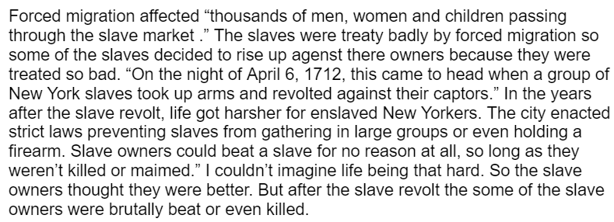

Understanding the impact of forced migration on diverse groups is foundational for students to answer the supporting question, “How did enslaved Africans resist?”

Investigation: Part 2
4.H.CO.1 Explain examples of conflict and collaboration among various groups of people from European Exploration to the Thirteen Colonies as they encountered one another.

In order to investigate how conflict and collaboration impacted enslavement and enabled resistance, the following source may be utilized:

George Washington’s Mount Vernon. (n.d.). Resistance and Punishment. https://www.mountvernon.org/george-washington/slavery/resistance-and-punishment.

Ask students to recall the meaning of conflict and collaboration. For your reference, the KAS for Social Studies Glossary of Terms defines conflict as “the opposition of persons or forces which leads to disagreement”, and collaboration as “to work jointly together or to cooperate with others”. Ask students to recall the sources they have investigated so far by reviewing their Evidence Log, and have them Turn and Talk to a partner or small group about examples of conflict and collaboration that happened throughout the enslaved peoples’ resistance that they have learned about so far. Circulate and listen to ensure that students understand some examples of how conflict and collaboration took place.

Remind students that resistance took many different forms. Ask them to recall the types of resistance they have learned about so far. They may respond that most of the resistance has been running away, violent revolts and rebellions. Ask students to recall the great personal risk involved with these types of resistances.

Explain to students that some enslaved people were not able to run away or revolt for a variety of reasons. Some may have not had access to weapons, they may not have known where to run to seek freedom, and they may have had families that they were not willing to leave behind, among many other reasons. However, there were other ways to demonstrate resistance to enslavement.
Introduce the source Resistance and Punishment by explaining to students that this resource includes primary source information found in letters to and from George Washington, who was a slaveholder from 1743 until his death in 1799. (Note: this Timeline of George Washington and Slavery provides additional information). These letters describe different ways enslaved people at his estate at Mount Vernon resisted. Explain to students that they will read this article in two halves, Marking the Text as they read, and complete a series of Think, Pair Share activities to think about and discuss this article. First, ask students to do the following:

Read the first half of the source about resistance (stop before you reach the heading “Forms of Punishment”), marking the text as you read. Then, discuss the following question with a partner in a Think, Pair Share:

“What were some ways resistance was demonstrated by enslaved people at Mount Vernon?”

After students have had time to share with a partner, discuss their responses as a class. Student responses may include the following:
- Feigning illness
- Working slowly
- Theft
- Breaking tools and supplies
- Running away
- Attempting to poison slaveholders

Next, ask students to do the following:
Read the second half of the source, “Forms of Punishment”, marking the text as you read. Then, discuss the following question with a partner in a Think, Pair Share:

“How were acts of resistance punished at Mount Vernon?”

After students have had time to share with a partner, discuss their responses as a class. Student responses may include the following:
- Whipping
- Demotion to an even less desirable job
- Sale

Explain to students that while there may have been less personal risk involved with resisting by feigning illness, working slowly, breaking supplies, etc., there was still a great risk involved.

Next, ask students to do the following:
Conduct a final Think, Pair Share with your partner to discuss the following question:

“Why would enslaved people be willing to put themselves at risk in order to demonstrate their resistance to enslavement?”

After pairs have had time to think and discuss together, ask pairs to share their responses during a class discussion. Next, have students complete the graphic organizer below to explain how conflict and collaboration created and enabled resistance. Have students use the sources provided previously to complete this graphic organizer.

Source | How did conflict among various groups create resistance? | How did collaboration among various groups enable resistance?
Slave Revolt of 1712
Hutchinson’s Rebellion (1739)
Advertisement for Runaway Slaves
Resistance and Punishment (George Washington)
Provide assistance, scaffolding and prompting for students as they work. Remind students to use the information presented in the source as evidence, and allow them to make inferences based on this information. Below is an example of how students may complete the chart:
Source | How did conflict among various groups create resistance? | How did collaboration among various groups enable resistance?
Slave Revolt of 1712 | The enslaved people in New York were resentful of the free people they worked alongside and the fact that they were in bondage. | The enslaved people were able to communicate with one another in town and formulated a plan to revolt.
Hutchinson’s Rebellion (1739) | Enslaved people in South Carolina demonstrated conflict about their enslavement by their willingness to rebel violently. | The people involved in the rebellion worked together to carry out the rebellion and recruit others along the way. The larger the group, the more difficult it is to stop them.
Advertisement for Runaway Slaves | The enslaved people who ran away must have had conflict with their slaveholders and their enslavement in order to run away. It is obvious from the advertisements that the slaveholders were angry at their escape. | Some of the advertisements show that two or three enslaved people ran away together, which shows their collaboration in their efforts to escape.
Resistance and Punishment (George Washington) | This source shows that enslaved people had conflict with their slaveholders, because they attempted to avoid their work and sometimes stole from slaveholders and damaged property. | The source states that “most fugitives could not read or write and had few resources or connections to help them escape from Virginia. Without help, they risked dying from starvation or exposure as they traveled great distances on foot.” Therefore, collaboration with others helped their chances of escaping successfully.
Here is a student sample of this task from a classroom in Kentucky:
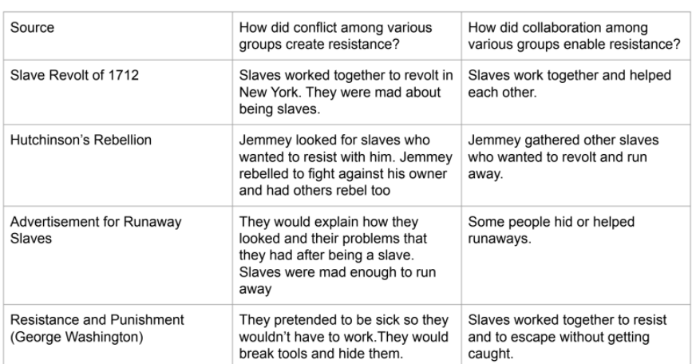
Now that students understand the impact of forced migration on various groups, how conflict and collaboration created and enabled resistance, and various forms in which resistance took, students are ready to complete the Task Aligned to the Supporting Question.
Task Aligned to the Supporting Question:
KAS for Social Studies alignment:
- 4.I.Q.2 Develop supporting questions to answer compelling questions about migration and settlement.
- 4.H.CH.1 Describe how migration and settlement impacted diverse groups of people as they encountered one another from European Exploration to the Thirteen Colonies.
- 4.H.CO.1 Explain examples of conflict and collaboration among various groups of people from European Exploration to the Thirteen Colonies as they encountered one another.
- 4.I.UE.1 Integrate evidence from two or more sources to answer compelling and supporting questions.
- 4.I.UE.3 Develop claims with evidence to answer compelling and supporting questions.

In the task aligned to the supporting question, students are required to synthesize information learned through engaging with the disciplinary strand standards to answer a supporting question. To prepare students for responding to the task below, allow them to access the sources they have previously investigated, their writing task from Investigation 1 and their graphic organizer from Investigation 2. These resources will help students recall and collect evidence to use in their responses to support their claims.

Task Aligned to the Supporting Question:
Using examples of conflict and collaboration and your knowledge of migration and settlement, develop a claim with evidence to answer the following question: “How did enslaved Africans resist?” Integrate evidence from two or more sources in your response.

Have students underline or highlight important words and phrases in the task to help emphasize what is expected of their response. Next, review the standards that align to this task with students. Remind them that they are being asked to demonstrate mastery of these standards and should focus on these as they begin thinking about their responses. Discuss the success criteria for this assignment:

- I can use examples of conflict and collaboration to develop a claim.
- I can use my knowledge of migration and settlement to develop a claim.
- I can develop a claim with evidence to answer the supporting question, “How did enslaved Africans resist?”
- I can integrate evidence from two or more sources in my response.

After reviewing the success criteria, ask students to reread the prompt, highlighting or annotating important words and phrases. Explain that the prompt is asking students to provide more than a list of the ways enslaved Africans resisted; they must fully explain these actions and provide evidence from at least two sources. Conduct a prewriting activity to help students with planning. You may provide a graphic organizer, such as the one below, for students to use:

How did enslaved Africans resist?
Claim:
Support #1: | Support #2:
Evidence for Support #1: | Evidence for Support #2:

Remind students to utilize the sources they investigated previously, as well as any writing they have completed, including their graphic organizers from Investigation 2 and Evidence Logs to help them prepare for their task. As students complete their pre-writing, provide support as needed and ensure students are remembering to integrate evidence from two or more sources. When the pre-writing is complete, ask students to draft their responses to the Task Aligned to the Supporting Question.

After students have drafted their responses, give students the opportunity to provide feedback for their peers. Provide the following questions for peers to ask one another as they review each other’s work:

- Did you use examples of conflict and collaboration to develop a claim?
- Did you use your knowledge of migration and settlement to develop a claim?
- Did you integrate evidence from two or more sources in your response?
- Did you develop a claim with evidence to answer the supporting question, “How did enslaved Africans resist?”

For more information on feedback in the social studies classroom, visit KDE’s Evidence-Based Instructional Practices 6: Social Studies. For further guidance on how to support student construction of claims, visit KDE’s Composition in the Classroom. This resource was developed to help Kentucky educators provide students with opportunities to develop into confident, independent and proficient writers who are transition ready.

Student Work Samples:
Below are student work samples from Kentucky classrooms of the Task Aligned to the Supporting Question. Each sample has an accompanying Student Work Review Protocol that evaluates alignment to the KAS for Social Studies.

Strongly Aligned Work Sample
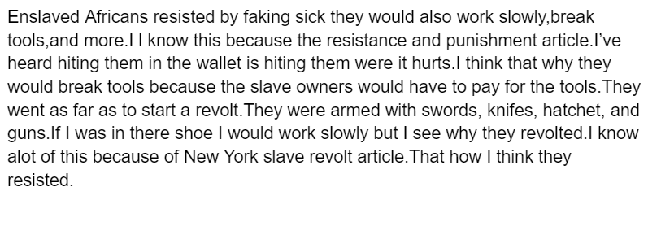
Partially Aligned Work Sample
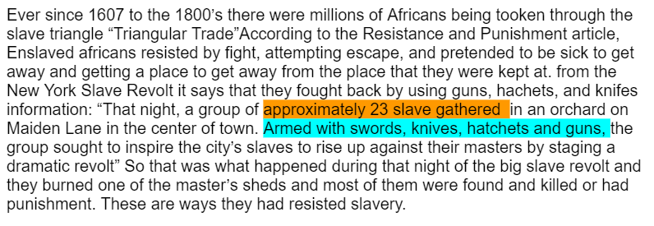

Weakly Aligned Work Sample
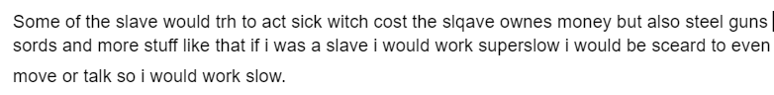

It is important to note that these are examples of writing to demonstrate learning, not writing to publish. For more information, visit KDE’s Composition in the Classroom.

According to the progression of the composition strand for standard 6 in the KAS for Reading and Writing, students are not expected to cite sources in APA or MLA format until grade 6 (C.6.6). However, in grade 4, students are expected to provide a list of sources (C.4.6). Therefore, it is appropriate for grade 4 students to cite sources in their responses using the source title or a clear identifier such as “Source A”.

Task Aligned to the Compelling Question:

KAS for Social Studies alignment:
- 4.I.Q.1 Ask compelling questions about migration and settlement.
- 4.I.UE.1 Integrate evidence from two or more sources to answer compelling and supporting questions.
- 4.I.CC.1 Construct an explanation, using reasoning and relevant information, to examine the causes and effects of an issue around migration and settlement.

Assignments aligned to the compelling question are designed to provide guidance on how to have students synthesize the knowledge learned from engaging with the supporting question(s) to investigate enduring and significant unresolved issues addressed by the compelling question. In this example, one supporting question is provided that is aligned to a compelling question. However, students may need to engage with more than one supporting question in order to fully engage with a compelling question. This assignment culminates with students using their historical thinking skills to address how a specific problem can manifest itself at local, regional and global levels over time.

The culminating assignment is students’ synthesis, or integration of knowledge and ideas, of the KAS for Social Studies after students have investigated a series of supporting questions that equip students to complete the assignment aligned to the compelling question. Students could present their explanations in a variety of ways, including an essay, PowerPoint presentation, poster, video or other multimedia format.

Task Aligned to the Compelling Question:

Construct an explanation to answer the following question: “Why do people resist oppression at great personal risk?” Be sure to examine the causes and effects of resistance, which impacted and/or resulted as an effect of migration and settlement, using reasoning and relevant information from two or more sources.

